Assignment 3 CSD311

By Samarth Gupta (1910110338), Ridham Bhagat (1910110316)

Prefix or suffix of List

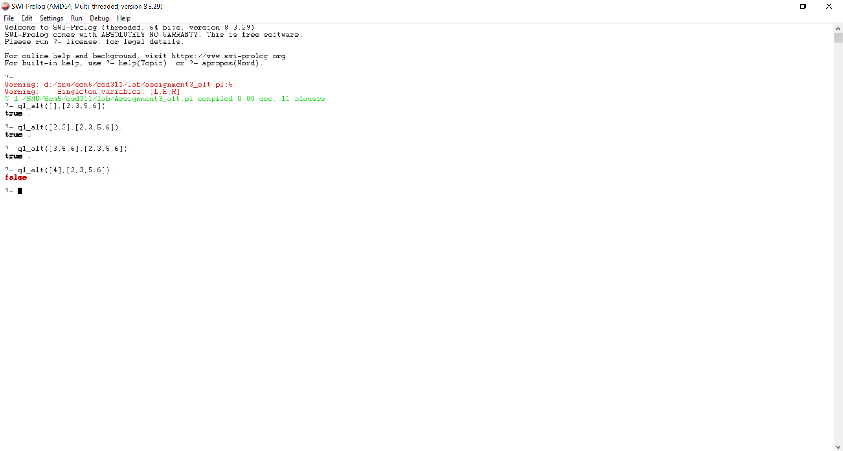

Insert in a binary search tree and create binary search tree using insert

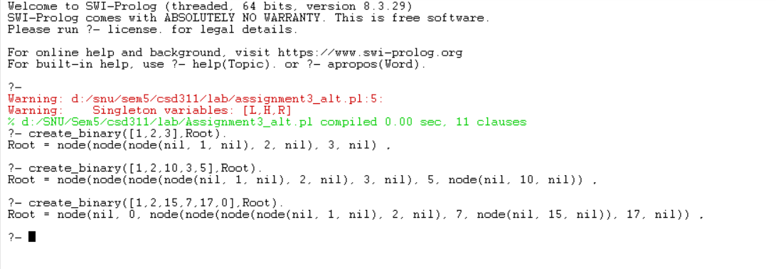

Create mirror image (transpose)

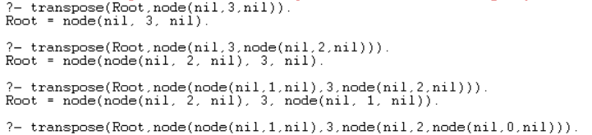

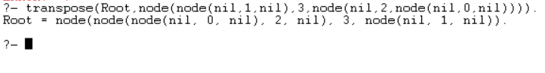

Given Test cases:

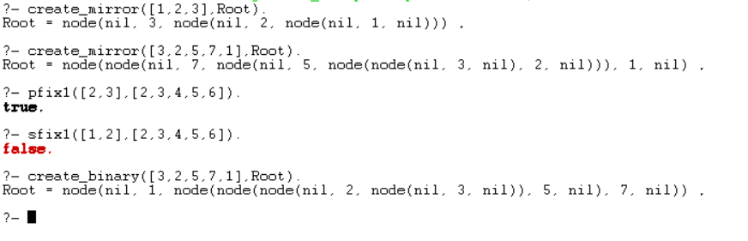

Code:

pfix1(L,M) :- append(L,_,M).

sfix1(L,M) :- append(_,L,M).

q1_alt(L,M) :- pfix1(L,M); sfix1(L,M).

node(L,H,R).

insert_key(K,nil,node(nil,K,nil)).

insert_key(K,node(LS,H,RS),node(NLS,H,RS)):-K<H,insert_key(K,LS,NLS).

insert_key(K,node(LS,H,RS),node(LS,H,NRS)):-K>H,insert_key(K,RS,NRS).

create_binary([],nil).

create_binary([H|T],T1):- create_binary(T, Res), insert_key(H,Res,T1).

transpose(nil,nil).

transpose(tree(Left,Head,Right), NewTree) :-

transpose(Left,NewLeft),

transpose(Right,NewRight),

NewTree = tree(NewRight,Head,NewLeft).

mirror(K,nil,node(nil,K,nil)).

mirror(K,node(LS,H,RS),node(NLS,H,RS)):-K>H,mirror(K,LS,NLS).

mirror(K,node(LS,H,RS),node(LS,H,NRS)):-K<H,mirror(K,RS,NRS).

create_mirror([],nil).

create_mirror([H|T],T1):- create_mirror(T, Res), mirror(H,Res,T1).