# Terminilogy

* **Disjoint sets**: Two sets are disjoint when they have no elements in common.
  + In example below, S1 contains all comparisons as (A[1] > A[2], A[1] > A[3], A[1] > A[4]…)
  + S2 contains all comparisons where (A[2] > A[3…n]).
* **Family of sets**: A set of sets (S1, S2… Sn-1) which are disjoint. Note, there are n-1 such sets (n-1, n-2, n-3… 1 comparisons).
* **Sum Principle**: *The size of a union of a family of mutually disjoint finite sets*

*is the sum of the sizes of the sets.* As shown in the example below (Sum Rule).

* **Partition of a set**: When a set S is a union of disjoint sets (S1, S2, S3…Sn), then S1, S2, S3… form a partition of S. Example, set S = {1,2,3,4,5}, {{1}, {2,3}, {4,5}} form 3 sets that are partitions of the set S. These are also called **blocks of the partition**.
* Product Rule: The size of a union of m disjoint sets, each of size n is mn. (NOTE: This does not work for example 1 as there the size of the m disjoint sets keeps changing).
* Bijection Principle: Two sets have the same size if and only if there is a one to one function from one set to another. (Page 22 Bogart has an example)

# [Examples of sum rule and product rule and a combination](https://math.dartmouth.edu/archive/m19w03/public_html/Section1-1.pdf)

Discussion from above examples:

1. Sum Rule: Summation of loops and inner loops. Consider the example: 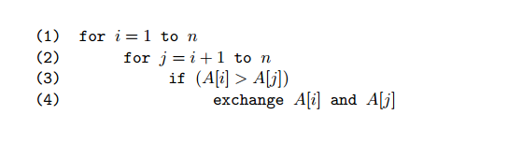

|  |  |  |
| --- | --- | --- |
| Index i | Index j range | Total |
| i = 1 | j = (2) to n | n-1 🡪 (n-2) + 1 |
| I = 2 | j = (3) to n | n-2 🡪 (n-3) + 1 |
| i = 3 | j = (4) to n | n-3 🡪 (n-4) + 1 |
| i = k | j = (k+1) to n | (n-(k+1))+1 🡪 n-k |
| i = n | j = (n+1) to n | 0 |

Summation is: (n-1) + (n-2) + (n-3) + (n-4) + …. (n-k) +…. 1 + 0 = (n)(n-1)/2.

This means the loops are executed (n*(n-1))/2 times.

1. Product rule. Consider the below code: 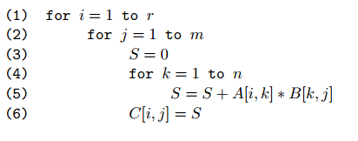

In above code:

* i goes from 1 to r, i.e. r times.
* For each (i), j goes from 1 to m, i.e. m times.
* For each (j), k goes from 1 to n i.e. n times.
* Thus, the total is rmn times. This is because each loop is starting from 1.

1. Product and Sum Rule:

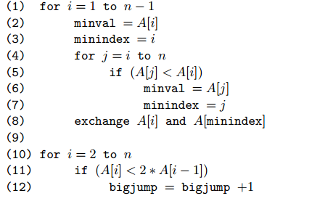

i goes from 1 to n-1, i.e. (n-1) times.

j goes from i to n for every i, this means

|  |  |  |
| --- | --- | --- |
| i | j range | Total (n – i +1), i.e. add the ith value |
| i = 1 | j = 1 to n | n -1 +1 🡪 n |
| i = 2 | j = 2 to n | n-2 + 1 🡪 n-1 |
| i = 3 | j = 3 to n | n-3 +1 🡪 n-2 |
| i = k | j = k to n | n-k+1 🡪 n-k+1 |
| i = n-1 | j = n-1 to n | n-(n-1) +1 🡪 2 |

Now, the summation of all these terms is

n + (n-1) + (n-2) + (n-3) + (n-4) + … (n-k+1) + …. 2

This is equal to n(n+1)/2 -1 as summation from n to 1 is (n*(n+1))/2. We subtract 1 as we stop at 2.

Lines (10-12) go from 2 to n, i.e. (n-1). Therefore, total is n(n + 1)/2 + n − 2

1. Above rule using product rule:
   1. Notice that for each i, and j, there is a single comparison, i.e. for i = 2, j starts from 3.
   2. the number of comparisons we make is the same as the number of two element subsets of the set {1, 2,...,n}. For example, for i = 2, j is 3, 4, 5…., so the subsets are {1,2}, {1,3}, … {2,3}, {2,4}…
   3. Number of ways to choose a 2 element subset from a set of n values is (n)*(n-1).
   4. However, in above rule, j always follows i, so, choosing i = 2 and j = 5 is ok but i = 5 and j = 2 is not ok, i.e. (n)(n-1) gives an ordered pair ((2,5), (5,2)) but in the above loop, only half the order matters, thus the number of ways to choose a 2 pair is (n)(n-1)/2.
   5. This is the result of product rule, i.e. (n)(n-1)/2. This is also C(n,2).
2. Sum of first n numbers:



1. If there were 3 loops with (I, j, k) forming an increasing triple, the principle applies that there are C(n,3) ways of choosing the set and hence the number of operations. (Page 22, Bogart, Stein).
2. C(n,3): The number of 3 element subsets of the set {1,2,…n}. **NOTE: The set has unique elements.**
3. **K-Element subsets of N is: C(N,k**).
4. **K-Element permutation of N**: A list of k-distinct elements chosen from a set N. E.G< {1,2,3…n} and k = 2, you can choose {1,2}, {2, 1} … etc. Page (23)
   1. 2 element permutation (n)(n-1)
   2. 3 element permutation (n)(n-1)(n-2)
   3. This means for n_k, i.e. choosing k terms from a set of n terms, there can be (n)(n-1)….(n-k+1) choices.
   4. NOTE: This contains terms that are the same but have different order, (1,2) and (2,1).
   5. ***The number k-element permutations of an n-element set is (n)(n-1)(n-2)..(n-k+1) = n!/(n-k)!***
5. Consider a set S={1,2,3,4} and a 3 element set {1,3,4}. How many times does this set appear in the 3 element permutations of the set S
   1. The set {1,3,4} appears 6 times in the k-element permutation of N
   2. Number of permutations for 3 elements is (n)(n-1)(n-2)
   3. Number of subsets of 3 elements = C(n,3).
   4. Each of the subsets appear 6 times in the permutation list
   5. (n)(n-1)(n-2) = 6*C(n,3).
   6. 3 element permutations of {1,2,…n} are either 6 disjoint sets of size C(n,3) or C(n,3) subsets of size 6
   7. Number 6 is just permutations of how {1,3,4} can be arranged i.3. 3*2*1
   8. This, for a set of n elements, k-element permutation of N is: 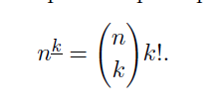
   9. For integers n and k, with 0<=k<=n, the number of k element subsets of an n element set is: 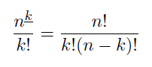
6. Choosing a K element subset from N is equivalent of choosing (N-K) element subset of elements we do not want.

# [Counting Lists, Permutations, Subsets](https://math.dartmouth.edu/archive/m19w03/public_html/Section1-2.pdf)

* Binomail coefficient sums, pascal triangle (sum of the row)
* <http://www.cs.columbia.edu/~cs4205/files/CM4.pdf>
* In this link, you can see that summation of different values in a row is 2^n. This is total number of subsets in a set of n elements.