APEX-AI Framework – Lite Implementation Guide

Purpose of This Guide
This Lite version of the APEX-AI Framework is designed to help leaders and practitioners understand, assess, and begin applying the framework without overwhelming detail.
It answers three practical questions:
- Where should we start with AI adoption?
- How do we move from experimentation to execution?
- How do we prepare responsibly for autonomous and agentic AI?
This guide is intentionally concise. A deeper, implementation-ready playbook exists for organizations moving into active execution.

What Is APEX-AI?
APEX-AI stands for Adopt → Productivity → Execution.
It is a governance-first, execution-driven framework that helps organizations:
- Adopt AI safely and responsibly
- Convert productivity gains into measurable outcomes
- Scale AI across workflows
- Prepare for autonomous processes and agentic AI
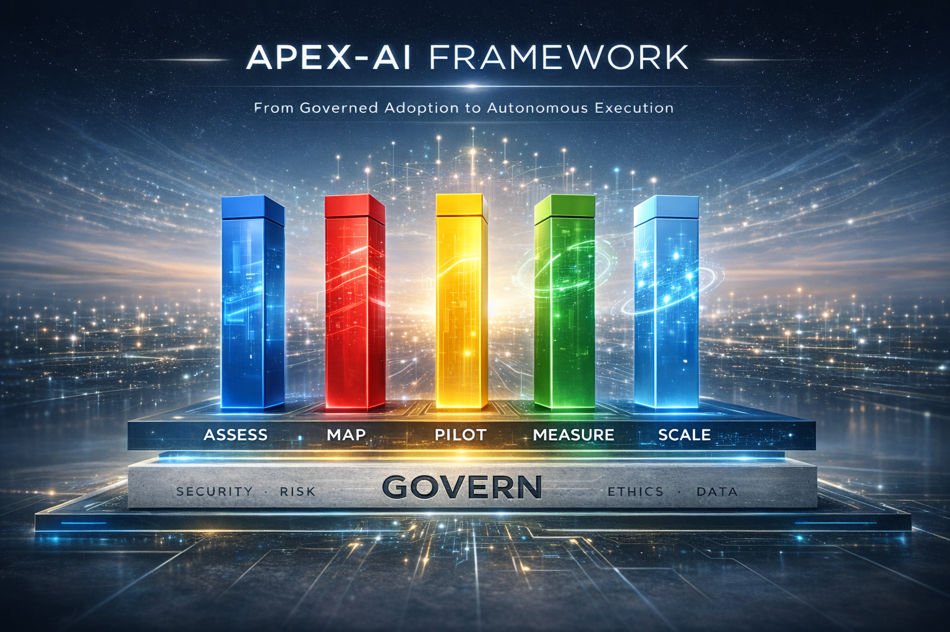
The APEX-AI Framework is structured in two layers:
- APEX-AI Core Framework, which focuses on Levels 1 and 2 — enabling governed adoption and scaled execution of assisted and augmented AI.
- APEX-AI Agent Framework, which addresses Level 3 — autonomous and agentic AI operating within defined enterprise guardrails.
Together, the Core Framework and Agent Framework form a single, end-to-end maturity system under APEX-AI.

The Foundation: GOVERN
Before scaling AI, organizations must establish a GOVERN foundation. Governance here is not bureaucracy—it is enablement.

GOVERN Covers:
- Security – Data protection, access control, model usage boundaries
- Risk – Operational, legal, and reputational risk awareness
- Ethics – Responsible AI use, bias awareness, transparency
- Compliance – Regulatory and organizational policy alignment
- Data – Data quality, ownership, and lifecycle clarity
Outcome: Teams can experiment and scale AI with confidence, not fear.

The Five Pillars
The five execution pillars below form the foundation of the APEX-AI Core Framework, enabling organizations to move from experimentation to repeatable, measurable AI execution.
1️⃣ ASSESS — Find Where AI Actually Matters
Not "AI for everything." Find specific pain points with real business impact.
Example: One organization identified customer support (20,000 tickets/month, 18-hour response time) as ideal for automation.
Result: 85% autonomous resolution, <1 hour response time.
Key question: Where does AI deliver 10x impact, not 10% improvement?
Lite Deliverables:
- Short list of AI-suitable use cases
- Readiness assessment (people, process, data)

2️⃣ MAP — Connect Tools to Workflows
Most organizations deploy AI tools but don't map them to workflows.
APEX-AI creates clarity: → Which tool for which task? → Where does AI assist vs. execute? → What's the adoption roadmap?
Example: Rather than "use GitHub Copilot," map it specifically: "Copilot generates boilerplate code (30% faster), humans handle architecture and edge cases."
This includes modern practices such as “vibe coding” — where developers use AI to rapidly generate, iterate, and refine code — and then intentionally mapping those behaviors into governed, repeatable workflows.
Result: Teams know exactly how to use AI. Adoption jumps from 20% to 70%.
Lite Deliverables:
- High-level workflow maps
- AI touchpoints clearly identified

3️⃣ PILOT — De-Risk Before You Scale
Run focused 30-90 day experiments with: ✓ Clear success criteria ✓ Defined scope (not "test AI everywhere") ✓ Three possible outcomes (scale, iterate, or pivot)
The APEX-AI difference: Phased approach (Shadow Mode → Supervised → Autonomous)
This reduces risk while building confidence.
Real result: One pilot achieved 93% accuracy, 72% autonomous completion before full rollout.
No surprises. No failures in production.
Lite Deliverables:
- Pilot charter
- Defined success metrics
- Lessons learned summary

4️⃣ MEASURE — Prove Value at 3 Levels
"AI saves time" isn't enough.
Track impact where executives care:
Layer 1: Activity (30 days) → 62% time savings on documentation → Individual productivity gains
Layer 2: Project (90 days) → 7.5 FTE capacity freed → $250K cost reduction
Layer 3: Organization (6-18 months) → $1.4M annual value → NPS +14 points → Market leadership
No measurement = no scaling.
Organizations using APEX-AI prove ROI in 6 months, not "eventually."
Lite Deliverables:
- Simple KPI set
- Baseline vs post-pilot comparison

5️⃣ SCALE — Make AI the Default Operating Model
Scaling isn't "do more pilots."
It's: → Standardizing what works → Building AI literacy across teams → Embedding AI into processes → Creating cultural momentum
Example: One organization went from 1 successful pilot to: • 5 agents operational • 15 FTE freed • $1.4M annual value • 80%+ employee satisfaction
Timeline: 18 months from pilot to portfolio.
Lite Deliverables:
- Scaling decision criteria
- Adoption roadmap

The Path Forward: From Copilots to Autonomous Agents
Here's where most organizations miss the opportunity:
Level 1: AI-Assisted (Tools help humans) → 30-50% productivity gains → Copilot, ChatGPT, etc.
Level 2: AI-Augmented (AI executes sub-tasks) → 50-70% workflow automation → Humans validate, AI executes
Level 3: Autonomous Agents (AI runs processes end-to-end) → 80-95% process automation → Humans oversee, agents execute
Level 3 represents the transition to agentic AI and autonomous operations, where AI systems can plan, decide, and act within clearly defined guardrails.
This capability is addressed through the APEX-AI Agent Framework—a deliberately advanced extension of APEX-AI, intended for organizations that have already established strong governance, execution discipline, and operational trust through the Core Framework.
Most organizations stop at Level 1.
APEX-AI prepares you for all three levels — with the same proven methodology: Govern → Assess → Map → Pilot → Measure → Scale
When governance is strong and execution is disciplined, autonomous agents aren't risky.
They're inevitable.

Where This Leads: Autonomous & Agentic AI
APEX-AI is designed to prepare organizations for:
- Autonomous workflows
- AI agents operating within guardrails
- Reduced manual orchestration
APEX-AI prepares organizations for autonomous AI through a progression from the Core Framework to the Agent Framework.
Autonomy is not the starting point—it is the outcome of disciplined adoption.

Why This Framework Works
I've seen the APEX-AI Framework applied across: • Customer support (85% automation) • Finance operations (88% invoice processing automated) • Engineering (65% code deployment automated) • HR (95% meeting scheduling automated)
Consistent results: ✅ 60-85% adoption rates ✅ 6-month timeline to measurable ROI ✅ $1M-$2.5M value within 18 months ✅ 300-800% ROI demonstrated
What makes it different:
Executives get: Measurable ROI, not hype Teams get: Clear playbooks, not theory Governance gets: Control without killing innovation Practitioners get: Templates, not principles
APEX-AI meets organizations where they are—and delivers wins in 30-90 days.

Beyond This Lite Guide
This Lite Guide introduces the philosophy, structure, and execution flow of APEX-AI.
For organizations ready to move from understanding to implementation, two deeper playbooks are available:
- APEX-AI Core Framework (Detailed) — Templates, metrics, governance models, and execution patterns for Levels 1 and 2
- APEX-AI Agent Framework (Detailed) — Agent design patterns, autonomy guardrails, operating models, and escalation controls for Level 3
These materials are intentionally not public and are shared selectively with leaders and teams preparing for active execution.

How to Use This Lite Guide
You can use this guide to:
- Assess your organization’s current AI maturity
- Structure early AI initiatives
- Align leadership, governance, and delivery teams
- Decide when deeper execution support is needed
Use this guide as a conversation starter, alignment tool, and readiness filter—not as a substitute for implementation rigor.
A more detailed, implementation-ready playbook expands each section with templates, checklists, metrics, and scaling patterns.

Closing Thought
AI adoption succeeds when governance enables execution and execution builds trust.
That is the philosophy behind the APEX-AI Framework.
Autonomy is not a leap—it is a consequence of doing the fundamentals exceptionally well.

How to Use the Lite Framework Strategically (Very Important)

1️⃣ Where the Lite Version Fits in Your Strategy
Think of your content stack like this:
Public (Broad Reach)
- LinkedIn article
- Hero visual
- Carousel
Semi-Private (Credibility + Conversation)
- ✅ Lite Implementation Guide (this document)
Private / High-Value
- Full implementation playbook (detailed framework)
This is exactly how consultancies, VCs, and senior advisors operate — intentionally.

2️⃣ When and How to Share the Lite Version

✅ Best moments to share it
- When someone comments: “Do you have more details?”
- When someone DMs asking: “How do you actually implement this?”
- When a recruiter / leader asks about your AI experience

❌ When NOT to share it
- Not as a public link
- Not attached to the article
- Not dropped casually in comments

3️⃣ What to Say When You Share It (Copy/Paste Ready)
Use something like this in DM or email:
Sharing a Lite implementation guide for the APEX-AI Framework.
It’s designed to help teams understand how to start applying the framework without going too deep all at once.
Curious which parts resonate most with your organization.
This does three things:
- Positions the doc as intentional
- Signals there is a deeper version
- Invites dialogue (not consumption)

4️⃣ One Small Addition I Recommend (Optional but Powerful)
Add this one sentence to the end of the LinkedIn article:
For those interested, I also have a concise implementation-oriented Lite guide that translates this framework into practical steps.
That’s it. No link. No pitch.
Curiosity will do the work.

5️⃣ What This Unlocks for You
With this Lite guide, you can now:
- Confidently say “Yes, there’s an implementation version”
- Show you’re not just a strategist
- Start 1:1 conversations with leaders
- Gradually move toward workshops, advisory, or roles
You’ve effectively built:
Thought leadership → Credibility → Optionality

What I Can Do Next (High Leverage Options)
If you want to keep momentum, I can:
- Convert the Lite guide into a polished PDF layout (executive-ready)
- Create a one-page executive summary of the Lite version
- Draft DM response templates for different audiences (CXO, recruiter, practitioner)
- Map a 30-day APEX-AI content sequence that steadily reveals depth
You’ve built something solid. Now we just let it work for you.

