Databricks under the hood and legacy Big Data Systems
What goes on behind the scenes of Databricks that you do not see.
Ever wonder how a cluster is spun up without starting, configuring or stopping it? Why Kubernetes is so important? How Map Reduce really works?
Lets begin with starting a Spark Session aka kicking off the Databricks Cluster.
When you push “start cluster” on your Databricks Compute tab you are creating a spark session as shown below. Notice the configurations. I am sure everyone has added configuration to their delta table to add enable logging for historical checkpoints.
Databricks version of adding log retention…I am sure you have done this
spark.sql( "ALTER TABLE delta.`/path/to/table` SET TBLPROPERTIES ('delta.logRetentionDuration' = 'interval 90 days')" )
The above configuration would be placed in the builder below if you were really running a legacy system or wanted more control.
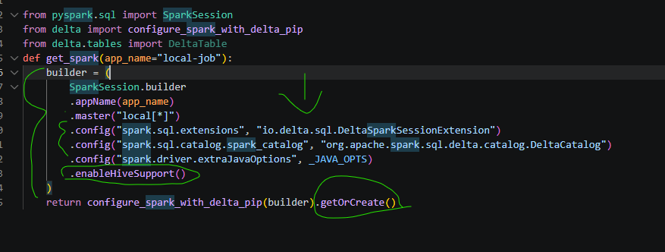
Now, let’s move onto a pipeline example. In this example I am pulling from Yahoo Finance API, performing some transformations and saving it to a local Hive Metastore. Now, we have Unity Catalog which has replaced traditional Hive Metastore.

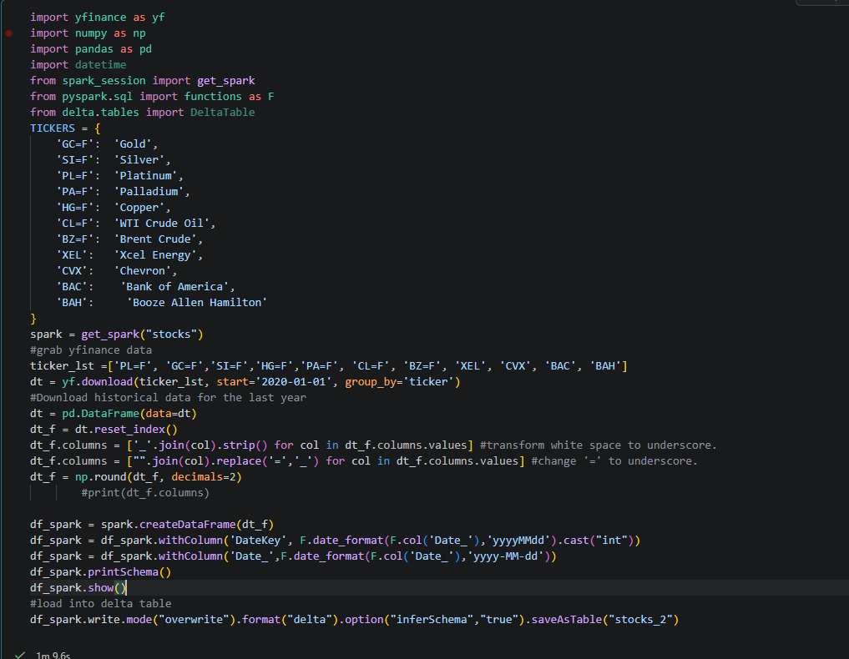

Let’s look at the Spark UI and you can see the Docker Kubernetes tasks that Map Reduce created from the script above. In this case Spark created 8 different tasks to handle this one transformation, this is our Map Reduce. Notice how it broke the data into evenly distributed blocks of data for each task ~66kb.
When you run a Databricks notebook it is creating Docker Images to pull the data hence, the term Distributed Data System.
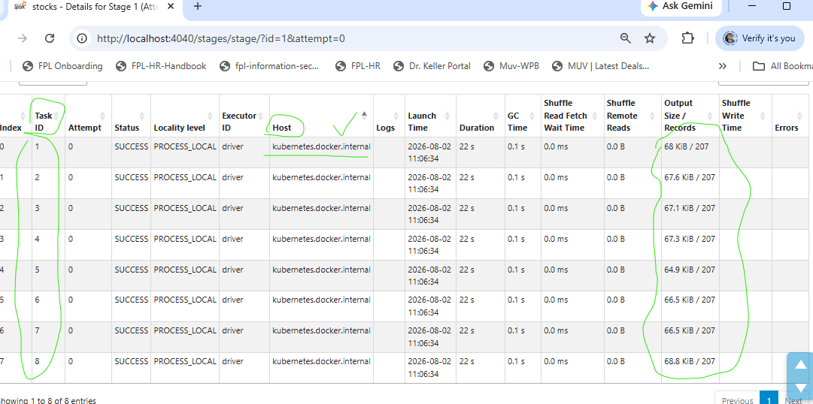
Here is the DAG it created which is made of RDD’s Resilient Distributed Datasets. I clicked the “Map” selection in the image to left. It then shows the RDD’s that were created for the yfinance pipeline while mapping.
