**Figure 2. Dynamics of the COVID-19 and associated response policies in the Caribbean.** a) Temporal changes in COVID-19 incidence (confirmed cases per million people) for 21 countries and dependencies. b) Temporal changes of the strength of reponse policies (Stringency Index) for 12 countries and dependecies. * For Guadeloupe and Martinique, the Stringency Index of France is plotted as the local authorities of both French Caribbean islands followed the French national response policies. See table XXX for the country codes.

**a**

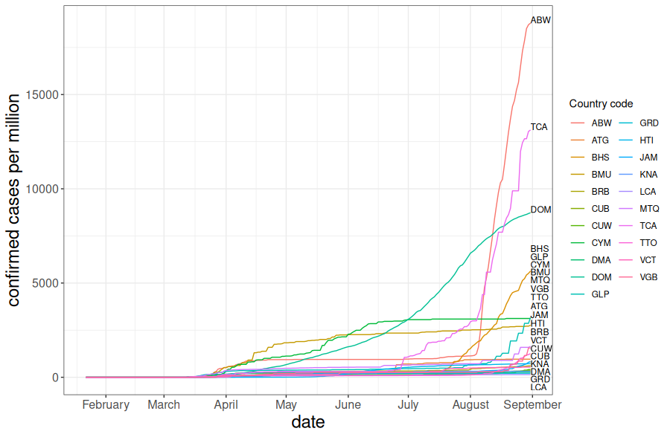

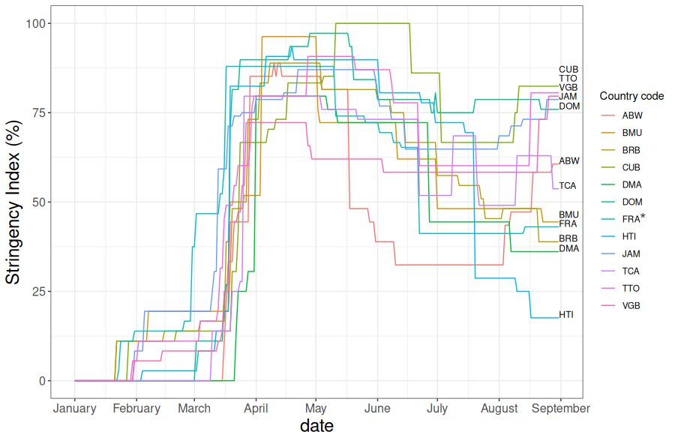

**b**