Preparation of DNA Ladder

-We use a 2-Log DNA Ladder from New England Biolabs (catalog # N3200L). This ladder is preferred by our lab because of its broad range (100 bp to 10,000 bp) and even intervals. Its stock concentration is 1 µg/µl of DNA.

The ladder is diluted to a 1:4 solution in water for use (3 parts water for 1 part ladder).

To make 100 µl, 75 µl of water are combined with 25 µl of the DNA ladder. Then, 20 µl of 6X loading dye is added and the solution is split into 60 µl aliquots (0.5 ml microcentrifuge tubes) and stored at -20 C.

3 µl of this diluted ladder is used per lane for a typical small (40 ml) agarose gel, which results in a concentration of approximately 0.63 µg of ladder DNA per lane.

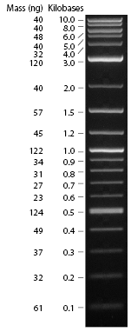

See: http://www.neb.com/nebecomm/products/productN3200.asp

