--CREATE DATABASE

CREATE DATABASE PRODUCTMANAGEMENT;

--USE DB

USE PRODUCTMANAGEMENT;

CREATE TABLE PRODUCTS

(

PID INT NOT NULL,

PNAME VARCHAR(30),

PRICE FLOAT,

CID INT,

PRIMARY KEY (PID)

);

--CREATE CATEGORIES TABLE

CREATE TABLE CATEGORIES

(

CID INT NOT NULL,

CNAME VARCHAR(30),

CDESCRIPTION VARCHAR(50),

PRIMARY KEY (CID)

);

--CREATE CUSTOMERS TABLE

CREATE TABLE CUSTOMERS

(

CUSTID INT NOT NULL,

CUSTNAME VARCHAR(30),

EMAIL VARCHAR(30),

ORDERID INT,

PRIMARY KEY (CUSTID)

);

--CREATE ORDERS TABLE

CREATE TABLE ORDERS

(

ORDERID INT NOT NULL,

CUSTID INT,

PID INT,

QUANTITY INT,

PRIMARY KEY (ORDERID)

);

|  |
| --- |
| PRODUCTS |
| PID |
| PNAME |
| PRICE |
| CID |

|  |
| --- |
| CATEGORIES |
| CID |
| CNAME |
| CDESCRIPTION |

|  |
| --- |
| CUSTOMERS |
| CUSTID |
| CUSTNAME |
| EMAIL |
| ORDERID |

|  |
| --- |
| ORDERS |
| ORDERID |
| CUSTID |
| PID |
| QUANTITY |

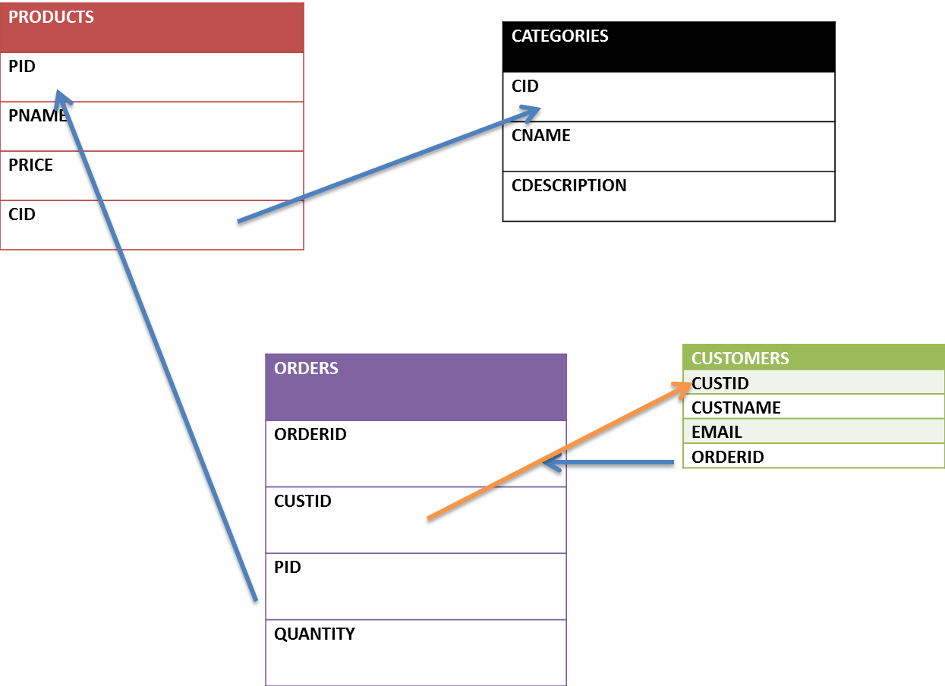

**--WE ARE CREATING A FOREIGN KEY ON TABLE = PRODUCTS**

**-- REFERRING TO THE COLUMN CID WHICH IS IN TABLE CATEGORIES**

**ALTER TABLE PRODUCTS**

**ADD FOREIGN KEY (CID) REFERENCES CATEGORIES(CID);**

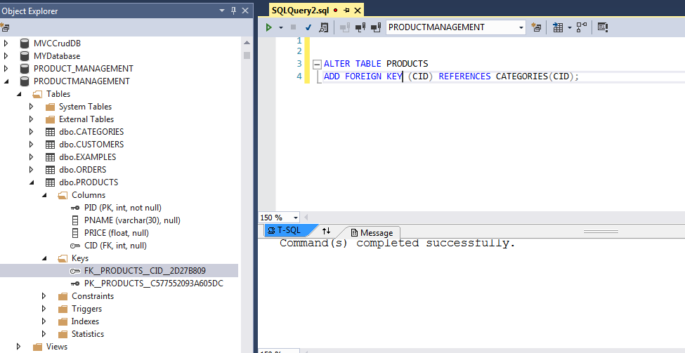

**--WE ARE CREATING A FOREIGN KEY ON TABLE = CUSTOMERS**

**-- REFERRING TO THE COLUMN ORDERID WHICH IS IN TABLE ORDERS**

**ALTER TABLE CUSTOMERS**

**ADD FOREIGN KEY (ORDERID) REFERENCES ORDERS(ORDERID);**

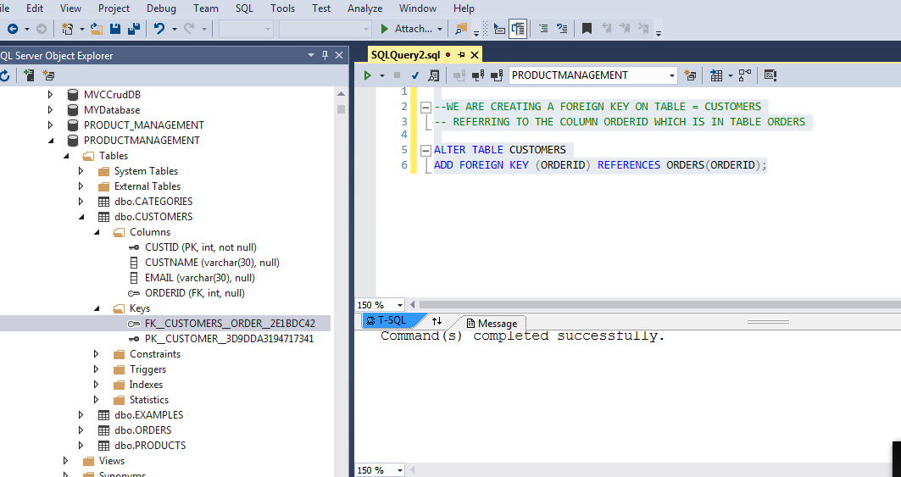

--WE ARE CREATING A FOREIGN KEY ON TABLE = ORDERS

-- REFERRING TO THE COLUMN CUSTID WHICH IS IN TABLE CUSTOMERS

ALTER TABLE ORDERS

ADD FOREIGN KEY (CUSTID) REFERENCES CUSTOMERS(CUSTID)

--REFERRING TO TABLE = PRODUCTS ON KEY PID

ALTER TABLE ORDERS

ADD FOREIGN KEY (PID) REFERENCES PRODUCTS(PID)

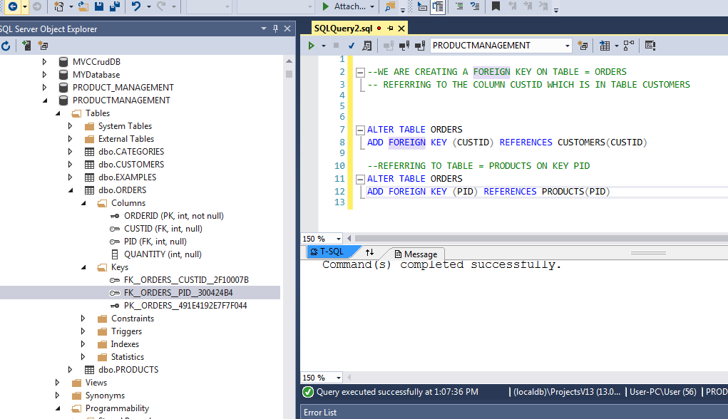

--INSERTION AT CATEGORIES SHOULD BE DONE FIRST AS THE PRODUCTS DEPENDS ON CID

INSERT INTO CATEGORIES VALUES(100,'SOAPS','BATHING SOAPS');

INSERT INTO CATEGORIES VALUES(101,'PASTE','DENTAL PRODUCTS');

INSERT INTO CATEGORIES VALUES(102,'SHAMPOOS','HAIR PRODUCTS');

INSERT INTO CATEGORIES VALUES(103,'CREAMS','FACIAL PRODUCTS');

INSERT INTO CATEGORIES VALUES(104,'SANITIZATION','CLEANING PRODUCTS');

SELECT * FROM CATEGORIES;

**CID CNAME CDESCRIPTION**

**100 SOAPS BATHING SOAPS**

**101 PASTE DENTAL PRODUCTS**

**102 SHAMPOOS HAIR PRODUCTS**

**103 CREAMS FACIAL PRODUCTS**

**104 SANITIZATION CLEANING PRODUCTS**

**INSERT RECORDS TO PRODUCTS TABLE**

insert into PRODUCTS VALUES(1,'LUX',45,100);

insert into PRODUCTS VALUES(2,'LIRIL',55,100);

insert into PRODUCTS VALUES(3,'LIZOL',75,104);

insert into PRODUCTS VALUES(4,'HARPIC',85,104);

insert into PRODUCTS VALUES(5,'COLGATE',45,101);

insert into PRODUCTS VALUES(6,'SUNSILK',65,102);

insert into PRODUCTS VALUES(7,'PONDS',110,103);

insert into PRODUCTS VALUES(8,'GARNIER',95,103);

insert into PRODUCTS VALUES(9,'HIMALAYAS',85,102);

insert into PRODUCTS VALUES(10,'PEPSODENT',45,101);

SELECT * FROM PRODUCTS;

**PID PNAME PRICE CID**

**1 LUX 45 100**

**2 LIRIL 55 100**

**3 LIZOL 75 104**

**4 HARPIC 85 104**

**5 COLGATE 45 101**

**6 SUNSILK 65 102**

**7 PONDS 110 103**

**8 GARNIER 95 103**

**9 HIMALAYAS 85 102**

**10 PEPSODENT 45 101**

**WE ARE GOING TO REMOVE ORDER ID FROM THE CUSTOMERS TABLE SINCE IT SHOULD ONLY HAVE THE CUSTOMER DETAILS AND WILL BE EASY TO MAP WIH ORDERS TABLE, ELSE IT WILL BE IN DEAD LOCK KIND OF SITUATION WITH RESPECT TO ORDRS AND CUSTOMERS TABLE IN INSERTION OF THE ROWS**

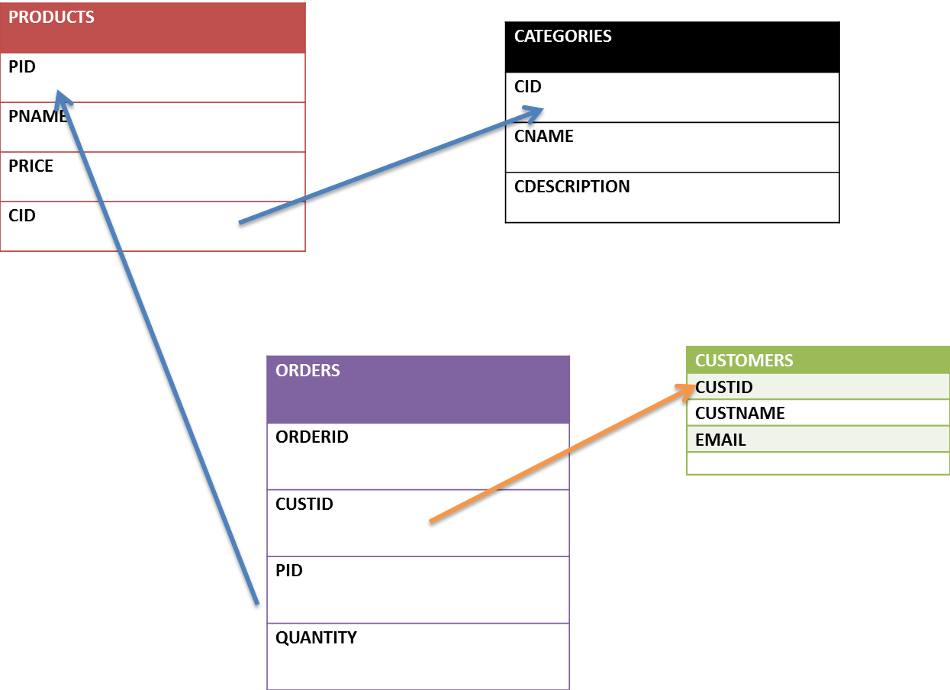

**FIRST DROP THE CONSTRAINT FOREIGN KEY (IF YOU HAVE GIVEN A NAME FOR THE KEY USE IT ELSE COPY THE SYSTEM GENERATED NAME UNDER KEYS SECTION IN DB WRT TABLE )**

--ALTERING (DROPPING THE CONSTRAINT CREATED FIRST)

ALTER TABLE CUSTOMERS

 DROP CONSTRAINT FK__CUSTOMERS__ORDER__2E1BDC42;

--ALTERING THE TABLE CUSTOMERS ( WE ARE DELETING COLUMN ORDERID  )

ALTER TABLE  CUSTOMERS

DROP COLUMN ORDERID

INSERT THE ROWS INTO CUSTOMERS

INSERT INTO CUSTOMERS VALUES(1000,'SANJAY','SANJAY@GMAIL.COM')

INSERT INTO CUSTOMERS VALUES(1001,'AJAY','AJAY@GMAIL.COM')

INSERT INTO CUSTOMERS VALUES(1002,'SANDHYA','SANDHYA@GMAIL.COM')

INSERT INTO CUSTOMERS VALUES(1003,'CHANDANA','CHANDANA@GMAIL.COM')

INSERT INTO CUSTOMERS VALUES(1004,'AARTI','AARTI@GMAIL.COM')

INSERT INTO CUSTOMERS VALUES(1005,'DEEPAK','DEEPAK@GMAIL.COM')

SELECT * FROM CUSTOMERS;

CUSTID CUSTNAME EMAIL

1000 SANJAY SANJAY@GMAIL.COM

1001 AJAY AJAY@GMAIL.COM

1002 SANDHYA SANDHYA@GMAIL.COM

1003 CHANDANA CHANDANA@GMAIL.COM

1004 AARTI AARTI@GMAIL.COM

1005 DEEPAK [DEEPAK@GMAIL.COM](mailto:DEEPAK@GMAIL.COM)

INSERTING ORDER ROWS

INSERT INTO ORDERS VALUES(500,1001,3,4);

INSERT INTO ORDERS VALUES(501,1002,6,3);

INSERT INTO ORDERS VALUES(502,1001,3,4);

INSERT INTO ORDERS VALUES(503,1003,8,2);

INSERT INTO ORDERS VALUES(504,1005,9,4);

INSERT INTO ORDERS VALUES(505,1004,8,3);

INSERT INTO ORDERS VALUES(506,1003,4,4);

INSERT INTO ORDERS VALUES(507,1003,7,2);

SELECT * FROM  ORDERS;

ORDERID CUSTID PID QUANTITY

500 1001 3 4

501 1002 6 3

502 1001 3 4

503 1003 8 2

504 1005 9 4

505 1004 8 3

506 1003 4 4

507 1003 7 2

ADD

INSERT INTO ORDERS VALUES(508,1006,7,2);

**INSERT INTO CUSTOMERS VALUES(1006,'CHANDANA','CHANDANA1@GMAIL.COM')**

NESTED QUERIES

--PULL OUT THE CUSTIDS WRT CHANDANA

SELECT CUSTID

FROM CUSTOMERS

WHERE CUSTNAME = 'CHANDANA'

--DISPLAYS THE ORDERS PLACED BY CUSTOMER NAME=’CHANDANA’

SELECT ORDERID

FROM ORDERS

WHERE CUSTID IN (SELECT CUSTID

FROM CUSTOMERS

WHERE CUSTNAME = 'CHANDANA')

ORDERID

503

506

507

508

LIST PRODUCT NAME AND ORDER ID WITH RESPECT TO CUSTOMER NAME CHANDANA

SELECT PNAME ,ORDERS.ORDERID

FROM PRODUCTS,ORDERS

WHERE PRODUCTS.PID IN(

SELECT PID

FROM ORDERS

WHERE CUSTID IN (SELECT CUSTID

FROM CUSTOMERS

WHERE CUSTNAME = 'CHANDANA')) AND PRODUCTS.PID=ORDERS.PID;

PNAME ORDERID

GARNIER 503

GARNIER 505

HARPIC 506

PONDS 507

PONDS 508

SELECT PNAME ,ORDERS.ORDERID,CUSTOMERS.CUSTID=> WHATS THE OUTPUT THAT I GET

FROM PRODUCTS,ORDERS,CUSTOMERS = > TABLES INVOLVED

WHERE PRODUCTS.PID IN( => CONDITION THAT HELPS YOU TO GET A SET OF PID FROM SUBQUERY

SELECT PID

FROM ORDERS

WHERE CUSTID IN (SELECT CUSTID

FROM CUSTOMERS

WHERE CUSTNAME = 'CHANDANA')) AND PRODUCTS.PID=ORDERS.PID AND ORDERS.CUSTID = CUSTOMERS.CUSTID; => JOINING OF TABLES BASED ON COMMON COLUMNS

SELECT PNAME ,ORDERS.ORDERID,CUSTOMERS.CUSTID

FROM PRODUCTS,ORDERS,CUSTOMERS

WHERE PRODUCTS.PID IN(

SELECT PID

FROM ORDERS

WHERE CUSTID IN (SELECT CUSTID

FROM CUSTOMERS

WHERE CUSTNAME = 'CHANDANA')) AND PRODUCTS.PID=ORDERS.PID AND ORDERS.CUSTID = CUSTOMERS.CUSTID;

PNAME ORDERID CUSTID

GARNIER 503 1003

GARNIER 505 1004

HARPIC 506 1003

PONDS 507 1003

PONDS 508 1006

SELECT P.PID,P.PNAME,P.PRICE,P.CID,C.CNAME,C.CDESCRIPTION

FROM PRODUCTS AS P,CATEGORIES AS C

WHERE P.CID=C.CID

SELECT P.*,C.CNAME,C.CDESCRIPTION

FROM PRODUCTS AS P,CATEGORIES AS C

WHERE P.CID=C.CID

**PID PNAME PRICE CID CNAME CDESCRIPTION**

**1 LUX 45 100 SOAPS BATHING SOAPS**

**2 LIRIL 55 100 SOAPS BATHING SOAPS**

**3 LIZOL 75 104 SANITIZATION CLEANING PRODUCTS**

**4 HARPIC 85 104 SANITIZATION CLEANING PRODUCTS**

**5 COLGATE 45 101 PASTE DENTAL PRODUCTS**

**6 SUNSILK 65 102 SHAMPOOS HAIR PRODUCTS**

**7 PONDS 110 103 CREAMS FACIAL PRODUCTS**

**8 GARNIER 95 103 CREAMS FACIAL PRODUCTS**

**9 HIMALAYAS 85 102 SHAMPOOS HAIR PRODUCTS**

**10 PEPSODENT 45 101 PASTE DENTAL PRODUCTS**

LISTS THE CUSTOMER IDS/NAMES WHO HAVE PLACED MORE THAN 1 ORDER

SELECT CUSTOMERS.CUSTNAME,CUSTOMERS.CUSTID,COUNT(ORDERS.CUSTID)

FROM CUSTOMERS,ORDERS

WHERE CUSTOMERS.CUSTID=ORDERS.CUSTID AND  CUSTOMERS.CUSTID IN (

SELECT CUSTID

FROM ORDERS

GROUP BY CUSTID

HAVING COUNT(CUSTID) > 1)

GROUP BY CUSTOMERS.CUSTNAME,CUSTOMERS.CUSTID;

CUSTNAME CUSTID (No column name)

AJAY 1001 2

CHANDANA 1003 3

SELECT ORDERS.ORDERID,ORDERS.CUSTID,PRODUCTS.PID,PRODUCTS.PRICE,ORDERS.QUANTITY,PRODUCTS.PRICE*ORDERS.QUANTITY AS NEWPRICE

FROM PRODUCTS,ORDERS

WHERE ORDERS.PID = PRODUCTS.PID

ORDERID CUSTID PID PRICE QUANTITY NEWPRICE

500 1001 3 75 4 300

501 1002 6 65 3 195

502 1001 3 75 4 300

503 1003 8 95 2 190

504 1005 9 85 4 340

505 1004 8 95 3 285

506 1003 4 85 4 340

507 1003 7 110 2 220

508 1006 7 110 2 220

TO DISPLAY ALL THE CUSTOMER ID WITH NO OF ORDERS PLACED AND TOTAL PRICE OF ITEMS THEY SELECTED WRT QUANTITY

SELECT O.CUSTID,COUNT(O.CUSTID) AS NOOFORDERS,SUM(P.PRICE*O.QUANTITY) AS NEWPRICE

FROM ORDERS O,PRODUCTS P

WHERE O.PID = P.PID

GROUP BY O.CUSTID

HAVING COUNT(O.CUSTID)>=1

**CUSTID NOOFORDERS NEWPRICE**

**1001 2 600**

**1002 1 195**

**1003 3 750**

**1004 1 285**

**1005 1 340**

**1006 1 220**

LEFT JOIN

SELECT *

FROM ORDERS

LEFT JOIN CUSTOMERS

ON ORDERS.CUSTID = CUSTOMERS.CUSTID

**ORDERID CUSTID PID QUANTITY CUSTID CUSTNAME EMAIL**

**500 1001 3 4 1001 AJAY AJAY@GMAIL.COM**

**501 1002 6 3 1002 SANDHYA SANDHYA@GMAIL.COM**

**502 1001 3 4 1001 AJAY AJAY@GMAIL.COM**

**503 1003 8 2 1003 CHANDANA CHANDANA@GMAIL.COM**

**504 1005 9 4 1005 DEEPAK DEEPAK@GMAIL.COM**

**505 1004 8 3 1004 AARTI AARTI@GMAIL.COM**

**506 1003 4 4 1003 CHANDANA CHANDANA@GMAIL.COM**

**507 1003 7 2 1003 CHANDANA CHANDANA@GMAIL.COM**

**508 1006 7 2 1006 CHANDANA CHANDANA1@GMAIL.COM**

**RIGHT JOIN**

SELECT *

FROM ORDERS

RIGHT JOIN CUSTOMERS

ON ORDERS.CUSTID = CUSTOMERS.CUSTID

**ORDERID CUSTID PID QUANTITY CUSTID CUSTNAME EMAIL**

**NULL NULL NULL NULL 1000 SANJAY SANJAY@GMAIL.COM**

**500 1001 3 4 1001 AJAY AJAY@GMAIL.COM**

**502 1001 3 4 1001 AJAY AJAY@GMAIL.COM**

**501 1002 6 3 1002 SANDHYA SANDHYA@GMAIL.COM**

**503 1003 8 2 1003 CHANDANA CHANDANA@GMAIL.COM**

**506 1003 4 4 1003 CHANDANA CHANDANA@GMAIL.COM**

**507 1003 7 2 1003 CHANDANA CHANDANA@GMAIL.COM**

**505 1004 8 3 1004 AARTI AARTI@GMAIL.COM**

**504 1005 9 4 1005 DEEPAK DEEPAK@GMAIL.COM**

**508 1006 7 2 1006 CHANDANA CHANDANA1@GMAIL.COM**

**NULL NULL NULL NULL 1007 SHANKAR SHANKAR@GMAIL.COM**