create database Employee_oct4;

go

use Employee_oct4;

UNIQUE KEY

create table Employee

(

email varchar(50) primary key,

empname varchar(50) ,

empaddress varchar(50),

empphone varchar(10) unique

);

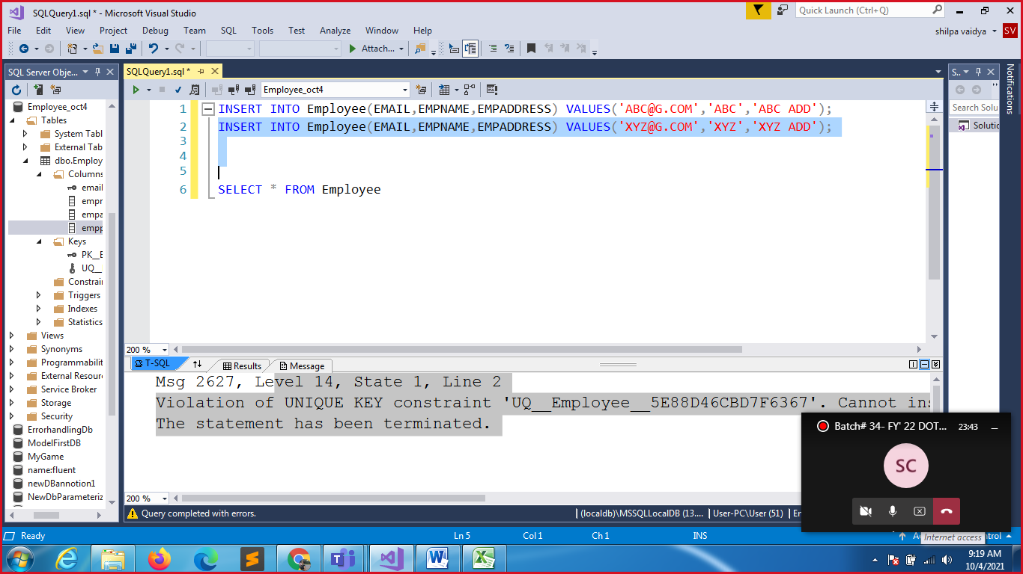

COMPOSITE KEYS

CREATE TABLE EMP_WORKS

(

EMPID INT,

DEPTID INT,

PROJID INT,

PROJNAME VARCHAR(50),

PROJDUR INT,

PRIMARY KEY(EMPID,DEPTID,PROJID)

);

INSERT INTO EMP_WORKS VALUES(111,11,1,'FIRST',44);

INSERT INTO EMP_WORKS VALUES(111,22,1,'FIRST-22',44);

INSERT INTO EMP_WORKS VALUES(111,11,2,'SECOND',44);

SELECT * FROM EMP_WORKS

DEFAULT CONSTRAINT

CREATE TABLE EMP_PERSONALINFO

(

EMPID INT NOT NULL,

EMPNAME VARCHAR(50),

NATIONALITY VARCHAR(50) DEFAULT 'INDIAN',

PRIMARY KEY(EMPID)

);

INSERT INTO EMP_PERSONALINFO VALUES(11,'ABC','AMERICAN');

INSERT INTO EMP_PERSONALINFO(EMPID,EMPNAME) VALUES(12,'XYZ');

SELECT * FROM EMP_PERSONALINFO;

CHECK CONSTRAINT

CREATE TABLE SALES

(

SALESID INT PRIMARY KEY,

NOOFSALES INT,

SALESMANAGERID INT CHECK(SALESMANAGERID>2345)

);

INSERT INTO SALES VALUES(333,40,3111)

SELECT * FROM SALES

DELETE THE TABLE FROM DB WITH STRUCTURE

DROP TABLE SALES;

AUTOINCREMENT

CREATE TABLE SALES

(

SALESID INT IDENTITY(1,22) PRIMARY KEY ,

SALESNO INT,

SALES_NAME VARCHAR(50)

)

INSERT INTO SALES(SALESNO,SALES_NAME) VALUES(44,'SHREK');

INSERT INTO SALES(SALESNO,SALES_NAME) VALUES(41,'JAMES');

INSERT INTO SALES(SALESNO,SALES_NAME) VALUES(24,'NATASHA');

SELECT * FROM SALES

|  |  |  |
| --- | --- | --- |
| SALESID | SALESNO | SALES_NAME |
| 1 | 44 | SHREK |
| 23 | 41 | JAMES |
| 45 | 24 | NATASHA |
|  |  |  |
|  |  |  |

RENAME TABLE

EXEC sp_rename 'SALES','SALESINFO'

SELECT * FROM SALESINFO

RENAME COLUMN

EXEC sp_rename 'SALESINFO.SALESID','SID','COLUMN';

SELECT * FROM SALESINFO

RENAME DB

EXEC sp_renamedb 'Employee_oct4' , 'Oct4_Employee'

CASE STATEMENT

SELECT * FROM SALESINFO;

SELECT SALES_NAME,SALESNO,

CASE WHEN SALESNO >40 THEN 'GREAT SALES !'

WHEN SALESNO>30 AND SALESNO<=40 THEN 'GOOD WORK!'

ELSE 'TRY HARD TO ACHIEVE TARGET'

END AS MESSAGE_SALESTEAM

FROM SALESINFO

|  |  |  |
| --- | --- | --- |
| SALES_NAME | SALESNO | MESSAGE_SALESTEAM |
| SHREK | 44 | GREAT SALES ! |
| JAMES | 41 | GREAT SALES ! |
| NATASHA | 24 | TRY HARD TO ACHIEVE TARGET |
| NATASHA | 24 | TRY HARD TO ACHIEVE TARGET |

DEMONSTRATE HAVING CLAUSE

INSERT INTO EMP_WORKS VALUES(222,22,2,'SECOND-22',88)

INSERT INTO EMP_WORKS VALUES(222,33,1,'FIRST-33',44)

SELECT * FROM EMP_WORKS;

EMPID DEPTID PROJID PROJNAME PROJDUR

111 11 1 FIRST 44

111 11 2 SECOND 44

111 22 1 FIRST-22 44

222 22 2 SECOND-22 88

222 33 1 FIRST-33 44

SELECT DEPTID,COUNT(DEPTID)

FROM EMP_WORKS

GROUP BY DEPTID

HAVING COUNT(DEPTID)>=1

ORDER BY DEPTID

|  |  |
| --- | --- |
| DEPTID | (No column name) |
| 11 | 2 |
| 22 | 2 |
| 33 | 1 |

ADD ANOTHER COLUMN TO EXISTING TABLE

SELECT * FROM SALESINFO;

ALTER TABLE SALESINFO

ADD MGRID INT

UPDATE SALESINFO

SET MGRID=1111

MODIFY COLUMN OF EXISTING TABLE

SELECT * FROM SALESINFO;

ALTER TABLE SALESINFO

ALTER COLUMN MGRID FLOAT

CREATE TABLE SAMPLE

(

KEY1 INT,

KEY2 INT,

SNAME VARCHAR(50)

);

--UNIQUE KEY

ALTER TABLE SAMPLE

ADD UNIQUE (KEY1)

--NOT NULL ADDED TO KEY2 BEFORE PK

ALTER TABLE SAMPLE

ALTER COLUMN KEY2 INT NOT NULL

--ADD PRIMARY KEY

ALTER TABLE SAMPLE

ADD PRIMARY KEY (KEY2)

--ADD COLUMN

ALTER TABLE SAMPLE

ADD CATEGORY VARCHAR(50)

--ADD CHECK CONSTRAINT

ALTER TABLE SAMPLE

ADD CHECK (CATEGORY='SOAP')

--THROW ERROR: INSERT INTO SAMPLE VALUES(11,22,'LUX','SHAMPOO')

INSERT INTO SAMPLE VALUES(11,22,'LUX','SOAP')

SELECT * FROM SAMPLE;

--DROPPING A CONSTRAINT

ALTER TABLE SAMPLE

DROP CONSTRAINT UQ__SAMPLE__6AF90CD4B85D1E46

--ADING A CONSTRAINT NAME

ALTER TABLE SAMPLE

ADD CONSTRAINT UNIQUE_KEY1 UNIQUE (KEY1)