Create MVC Application

Create Database

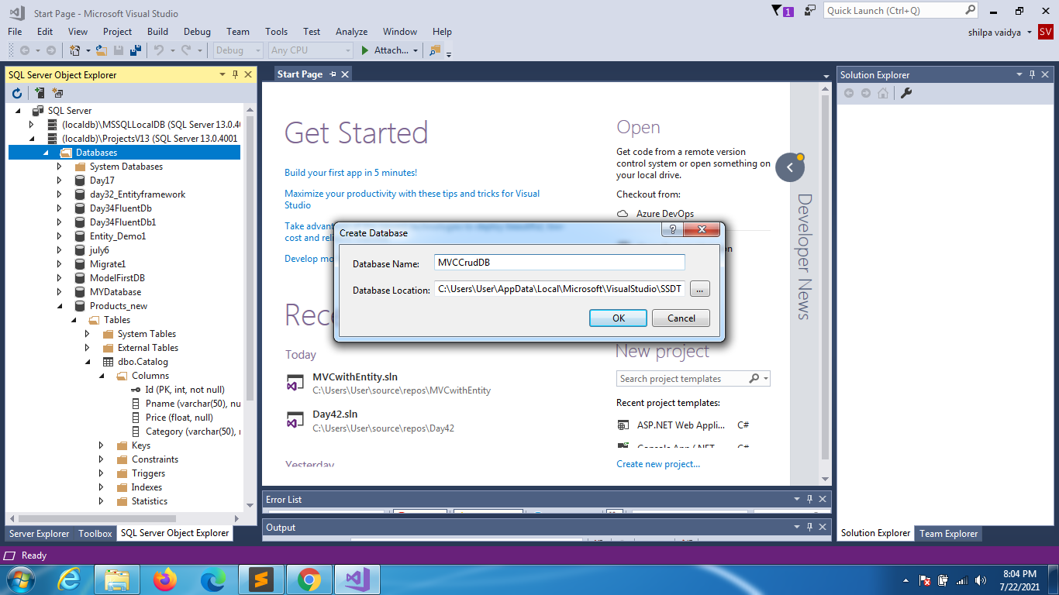

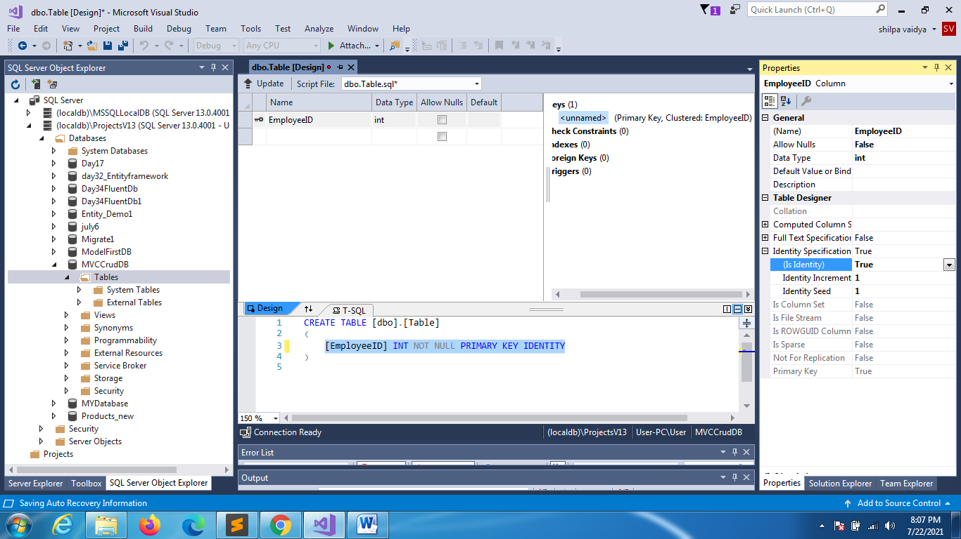

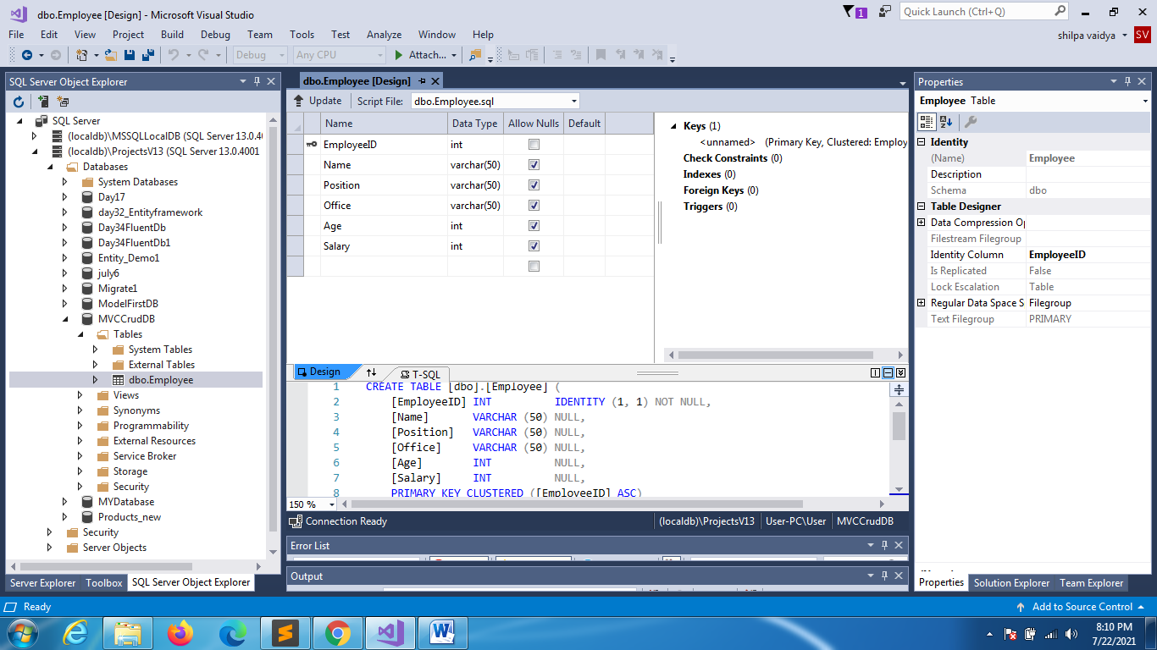

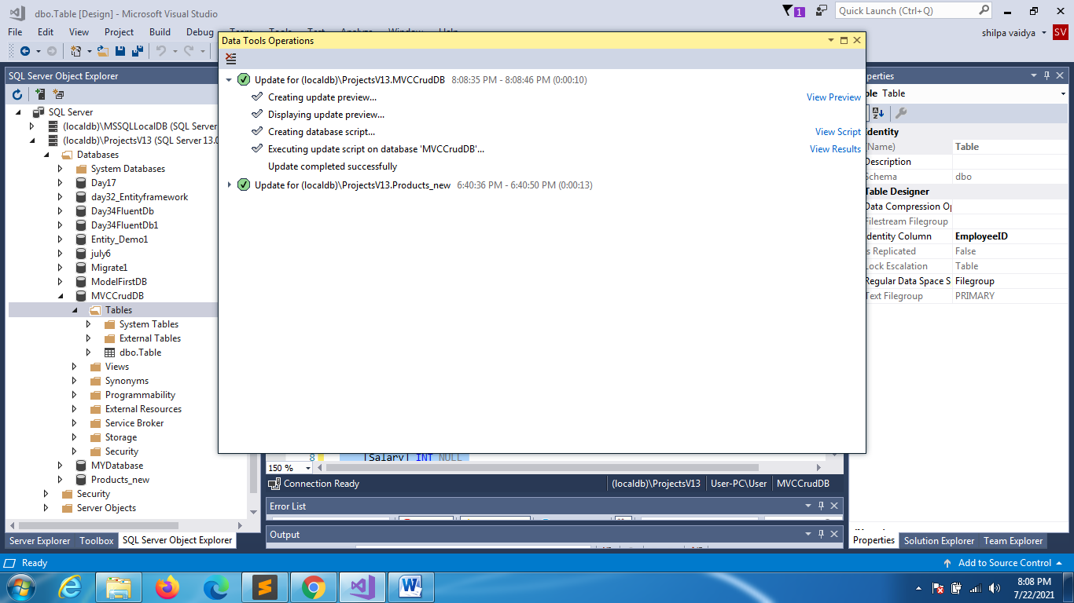

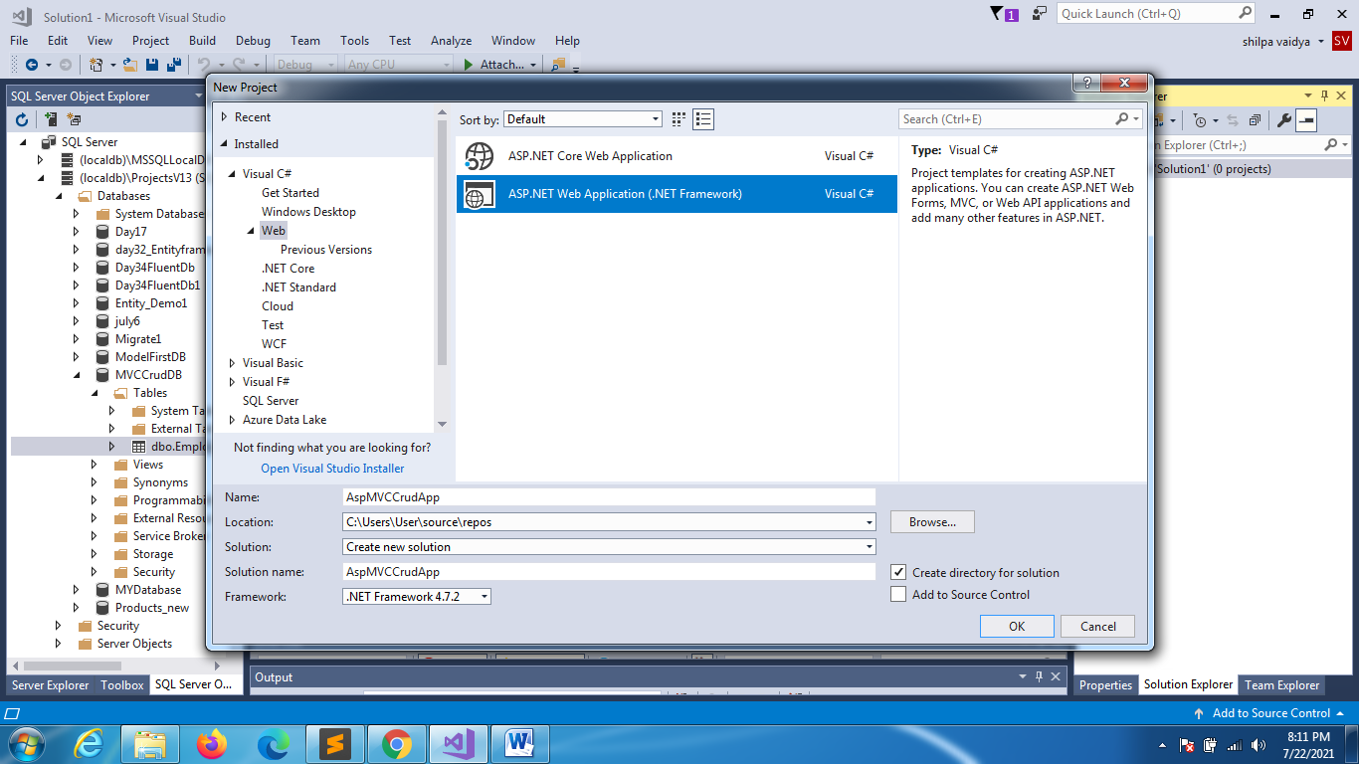

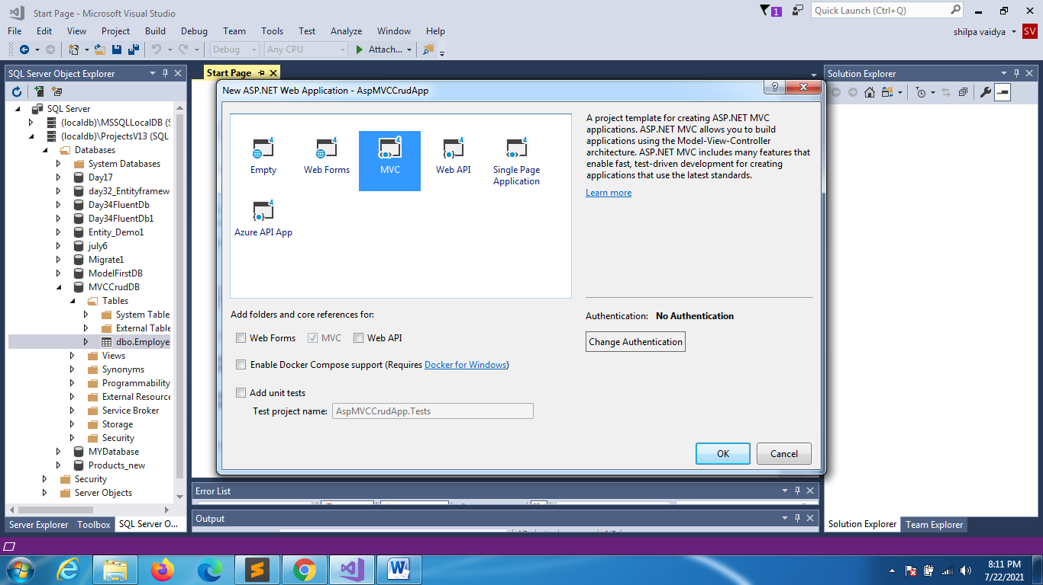

RIGHT CLICK ON MODELS

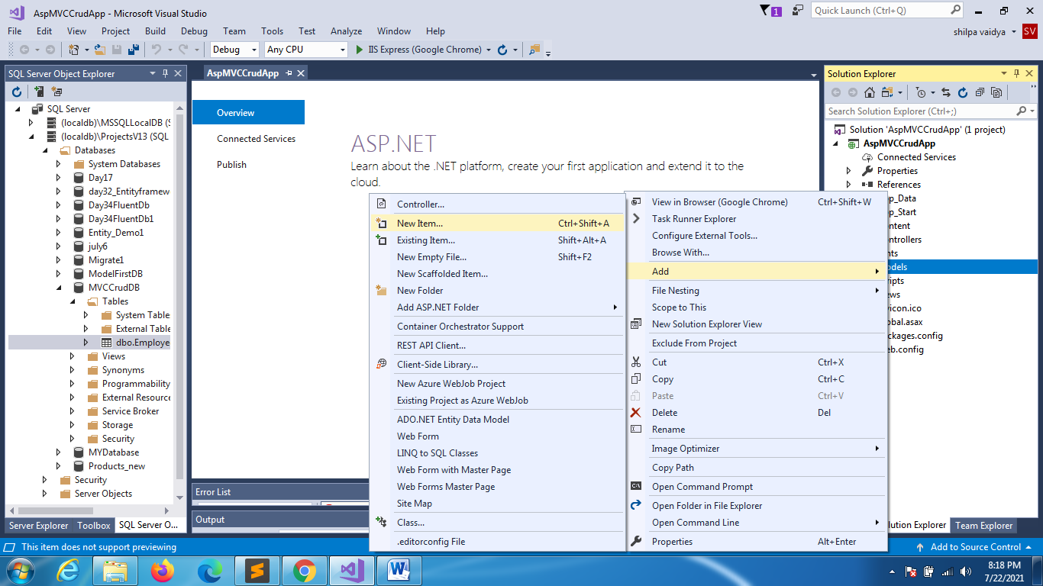

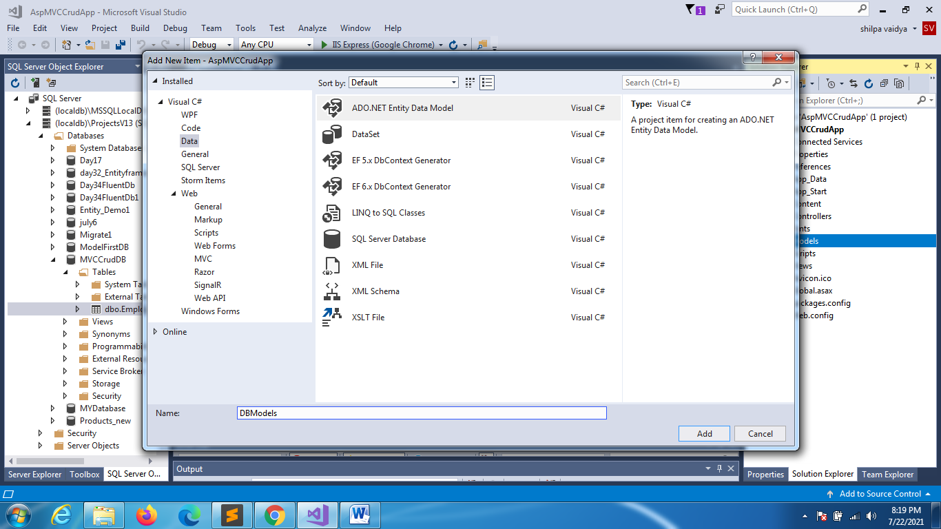

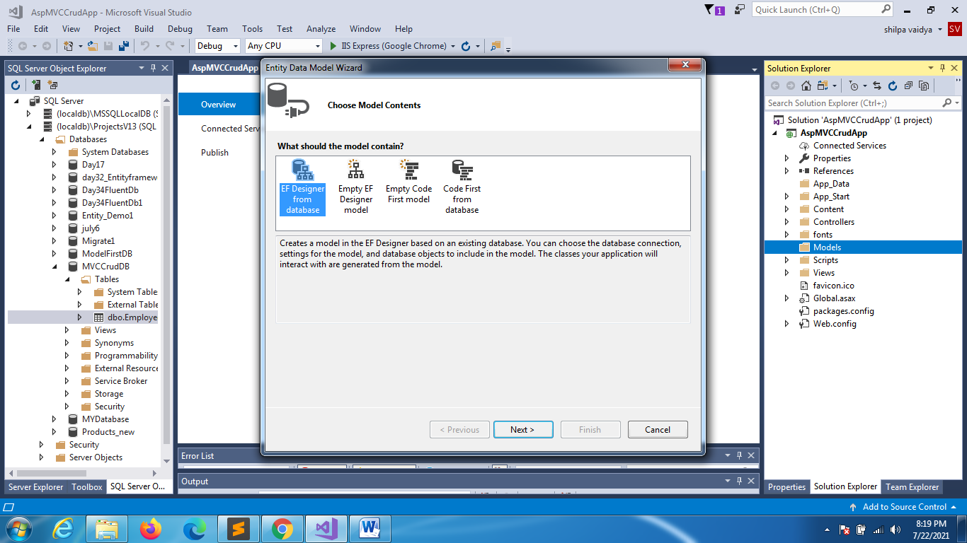

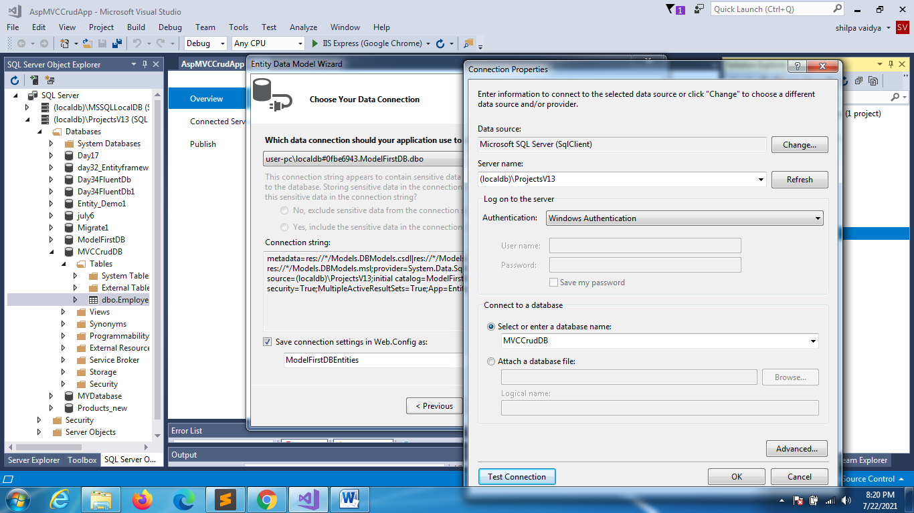

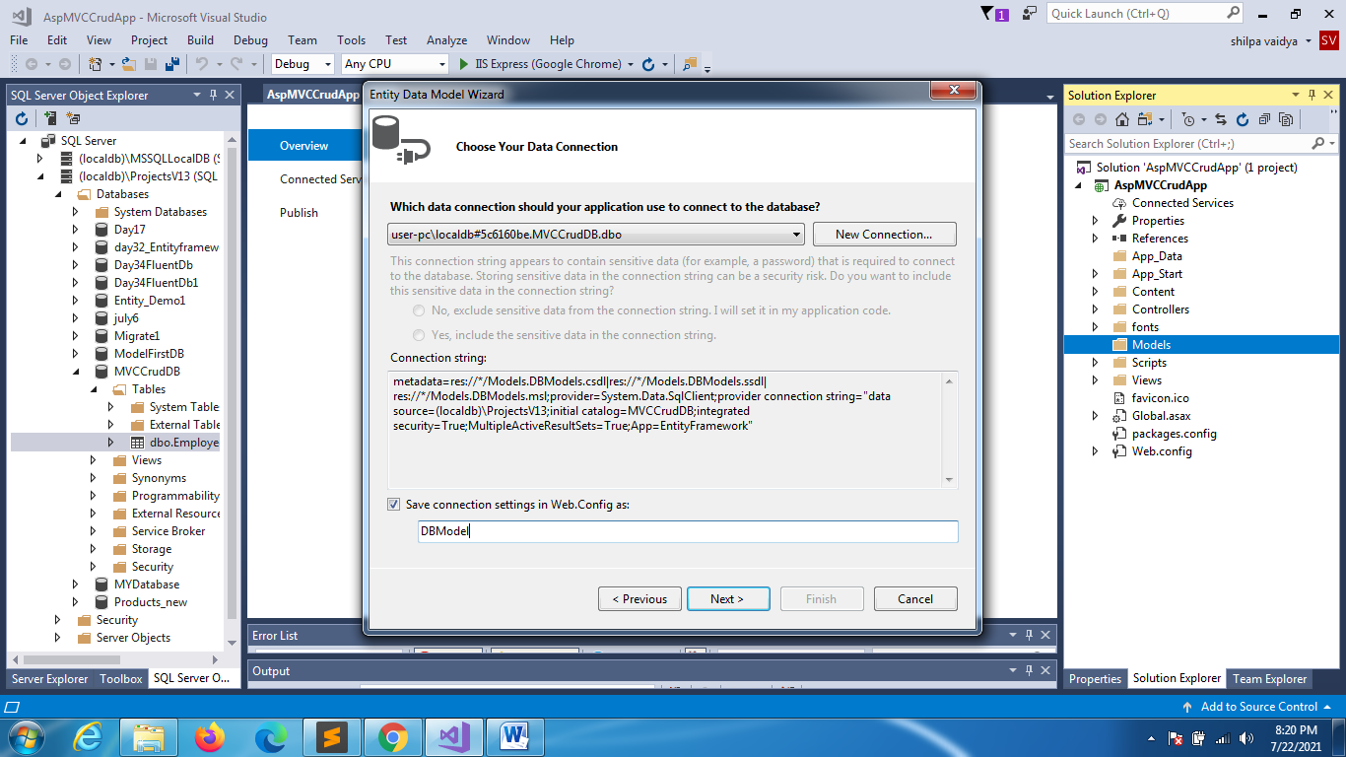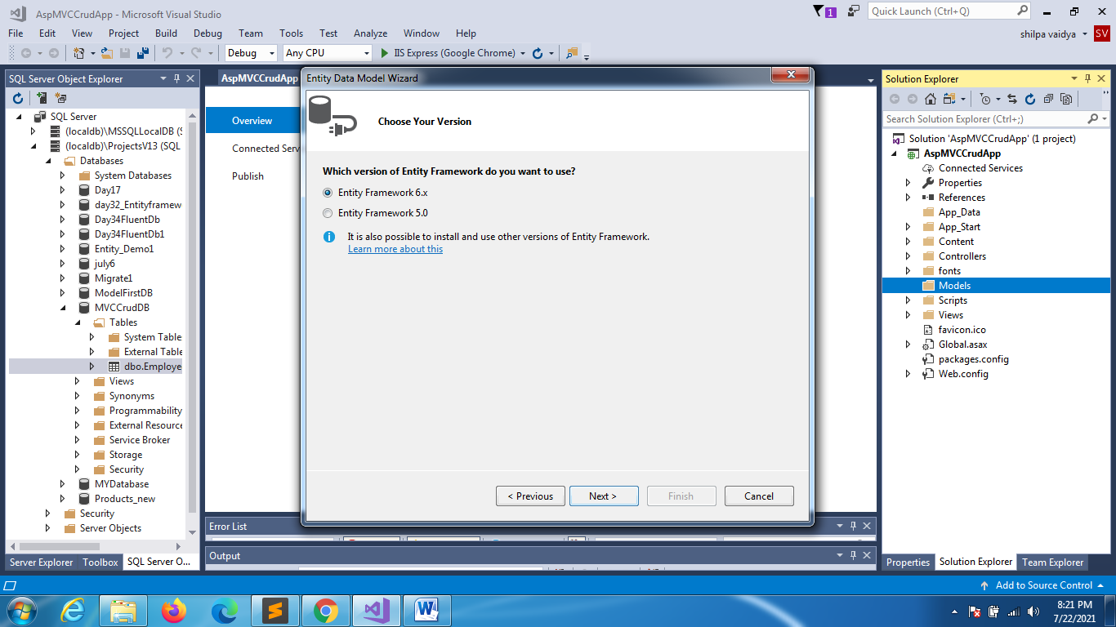

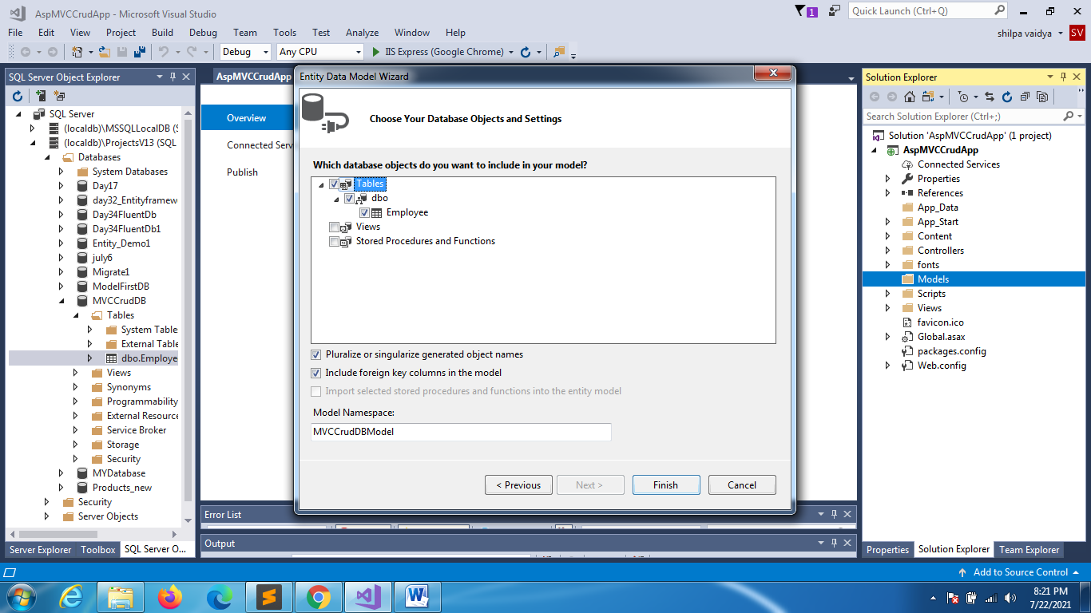

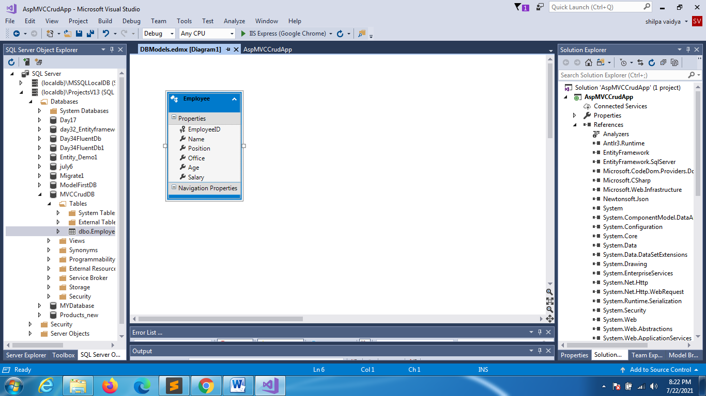

Your MVC Version

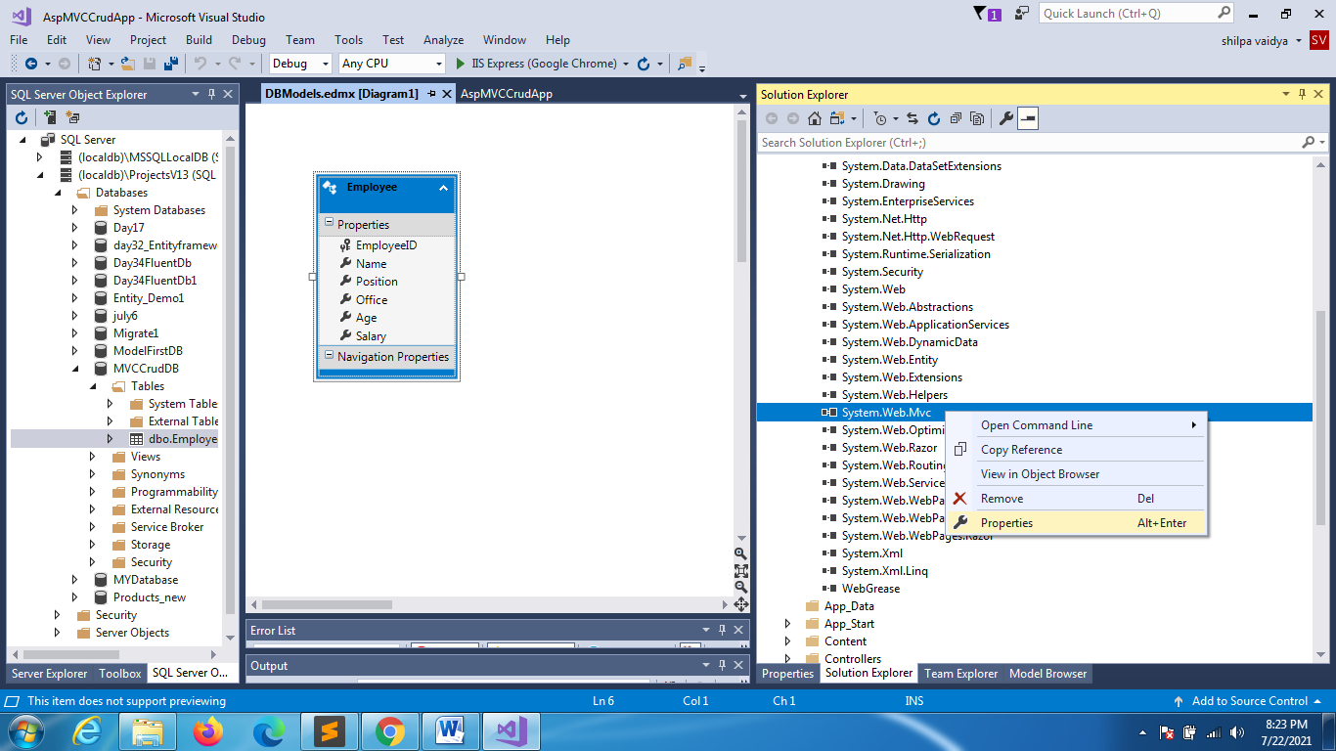

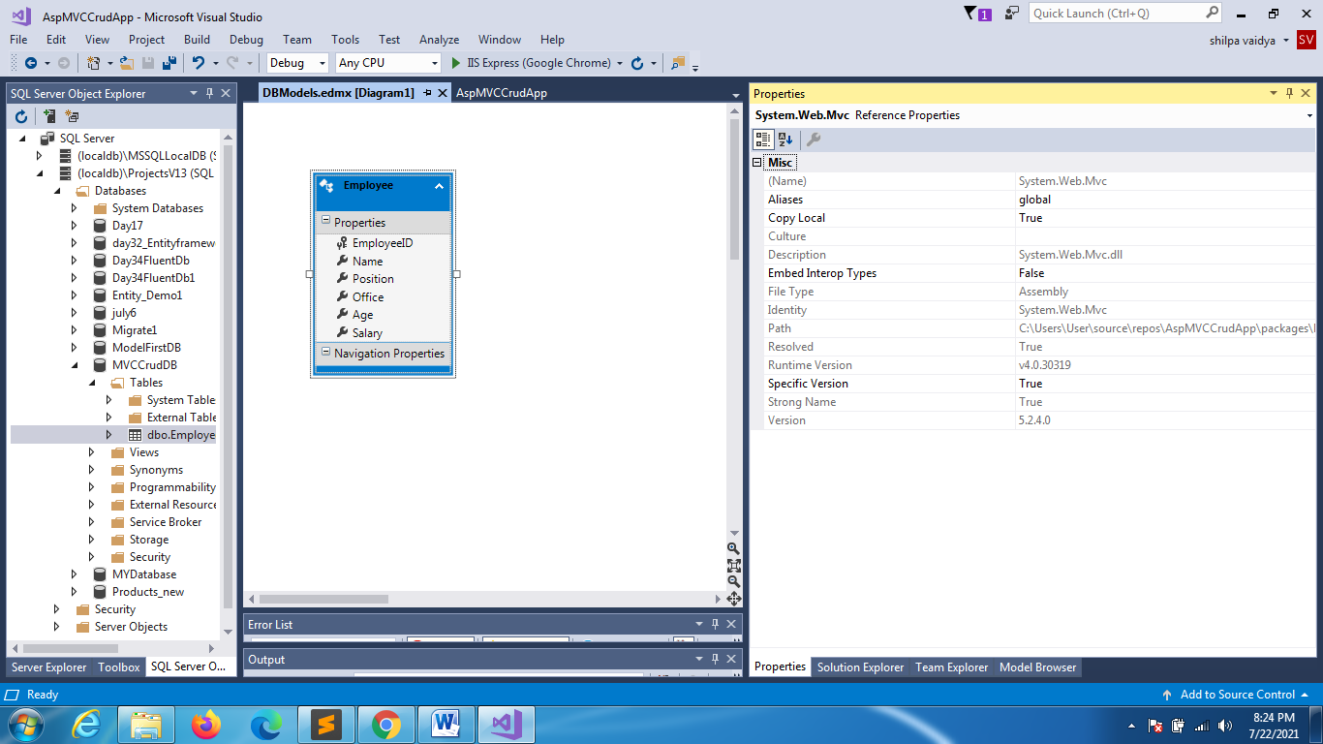

ADD CONTROLLERS

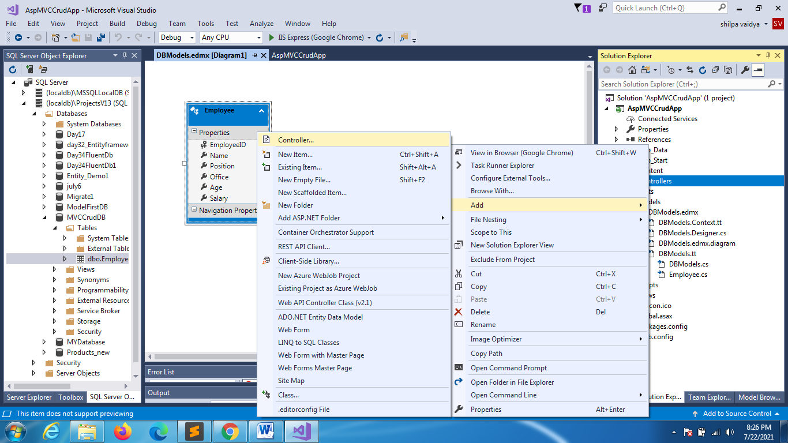

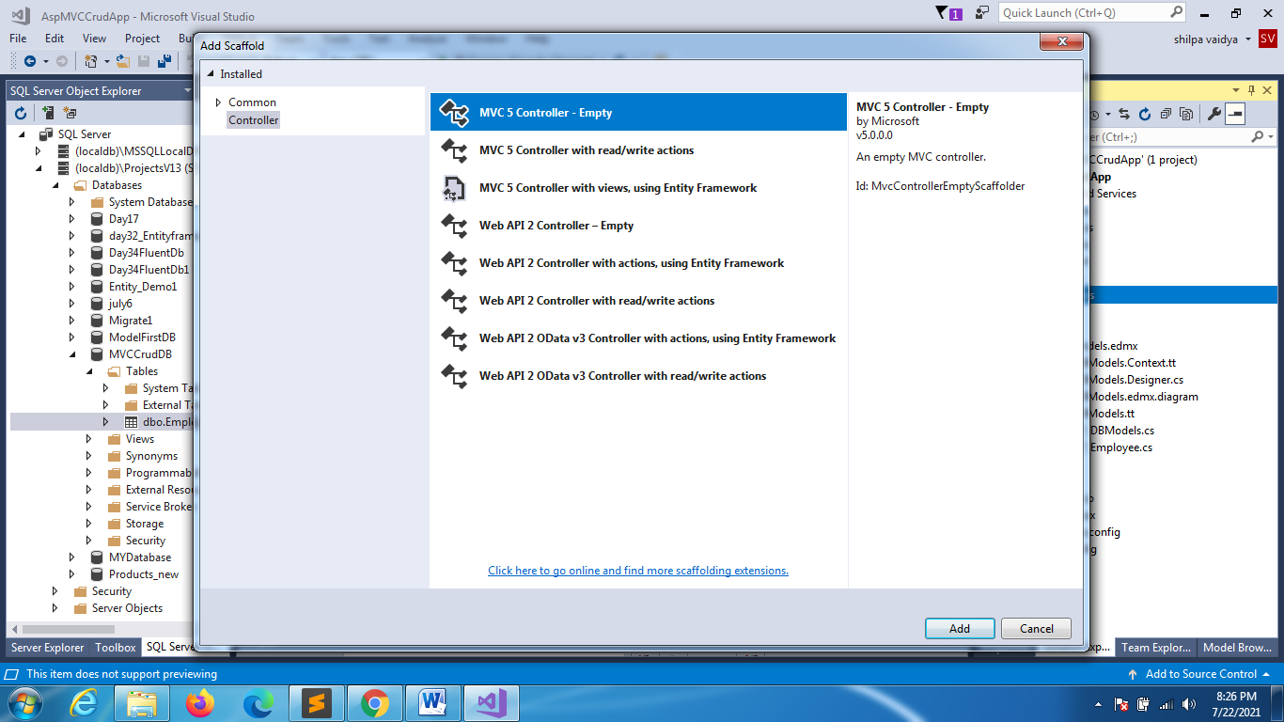

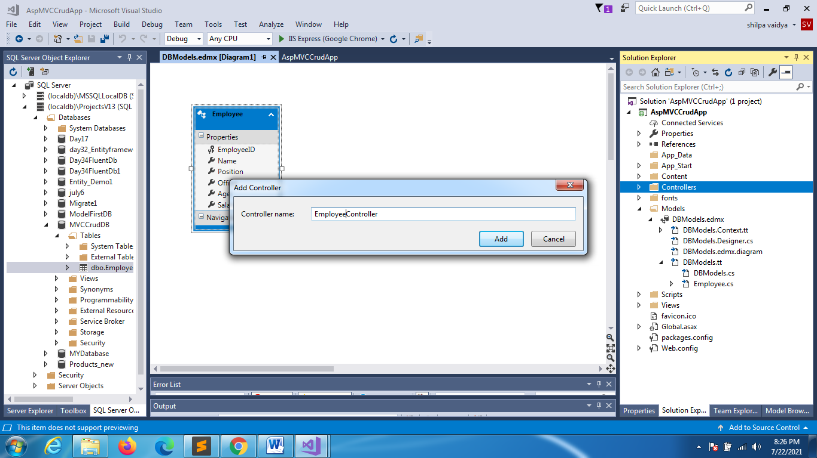

AppStart->RouteConfig

using System;

using System.Collections.Generic;

using System.Linq;

using System.Web;

using System.Web.Mvc;

using System.Web.Routing;

namespace AspMVCCrudApp

{

    public class RouteConfig

    {

        public static void RegisterRoutes(RouteCollection routes)

        {

            routes.IgnoreRoute("{resource}.axd/{\*pathInfo}");

            routes.MapRoute(

                name: "Default",

                url: "{controller}/{action}/{id}",

                defaults: new { controller = "Employee", action = "Index", id = UrlParameter.Optional }

            );

        }

    }

}

ADD VIEW

// GET: Employee

     public ActionResult Index()

     {

         return View();

     }

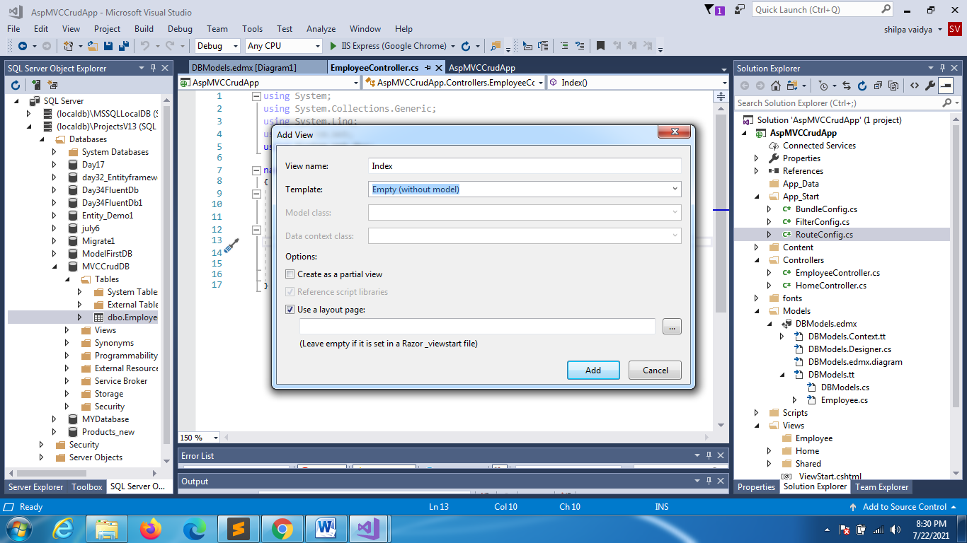

LAYOUT.cshtml

<!DOCTYPE html>

<html>

<head>

    <meta charset="utf-8" />

    <meta name="viewport" content="width=device-width, initial-scale=1.0">

    <title>@ViewBag.Title - My ASP.NET Application</title>

    @Styles.Render("~/Content/css")

    @Scripts.Render("~/bundles/modernizr")

</head>

<body>

    <div class="container body-content">

        @RenderBody()

        <hr />

        <footer>

            <p>&copy; @DateTime.Now.Year - My ASP.NET CRUD OPERATIONS Application</p>

        </footer>

    </div>

    @Scripts.Render("~/bundles/jquery")

    @Scripts.Render("~/bundles/bootstrap")

    @RenderSection("scripts", required: false)

</body>

</html>

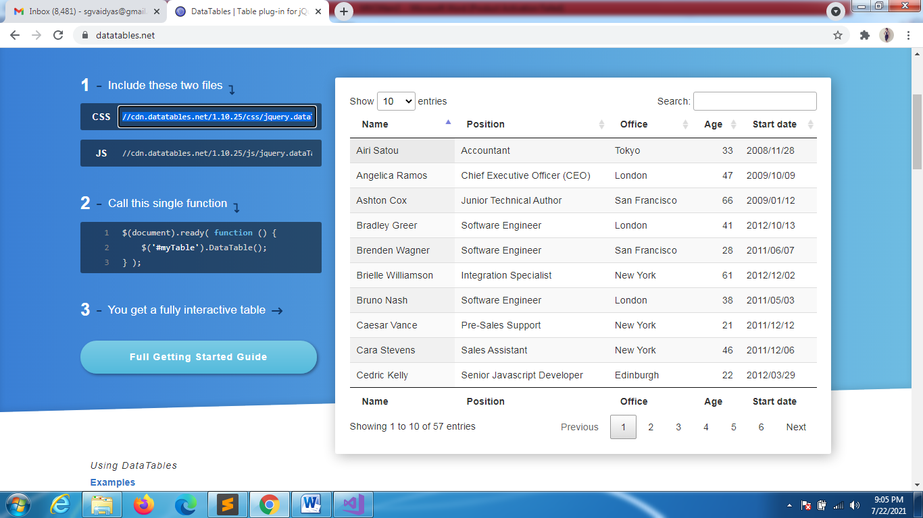

INDEX.CSHTML

@{

    ViewBag.Title = "Index";

}

<h2>Index</h2>

<table id="employeeTable" class="display">

    <thead>

        <tr>

            <th>Name</th>

            <th>Position</th>

            <th>Office</th>

Css/js is copied from the above mentioned link

            <th>Age</th>

            <th>Salary</th>

        </tr>

    </thead>

</table>

<link href="//cdn.datatables.net/1.10.25/css/jquery.dataTables.min.css" rel="stylesheet" />

<@section scripts{

    <script src="//cdn.datatables.net/1.10.25/js/jquery.dataTables.min.js"></script>

    <script>

Getdata is an action method that we need to type inside controller

in get section

And it will return json object

    $(document).ready(function (){

    $("#employeeTable").DataTable({

        "ajax":{

            "url":"/Employee/GetData",

            "type":"GET",

            "datatype":"json"

        },

        "columns":[

            { ["data"]:"Name" },

            { ["data"]:"Position" },

            { ["data"]:"Office" },

            { ["data"]:"Age" },

            { ["data"]:"Salary" },

        ]

        });

    });

    </script>

}

EMPLOYEECONTROLLER

using System;

using System.Collections.Generic;

using System.Linq;

using System.Web;

using System.Web.Mvc;

using AspMVCCrudApp.Models;

namespace AspMVCCrudApp.Controllers

{

    public class EmployeeController : Controller

    {

        // GET: Employee

        public ActionResult Index()

        {

            return View();

        }

        // GET: Employee/Getdata

        public ActionResult GetData()

        {

            using (DBModel db = new DBModel())

            {

                List<Employee> emplist = db.Employees.ToList<Employee>();

                return Json(new { data = emplist }, JsonRequestBehavior.AllowGet);

            }

        }

    }

}

