MVC WITH ENTITY

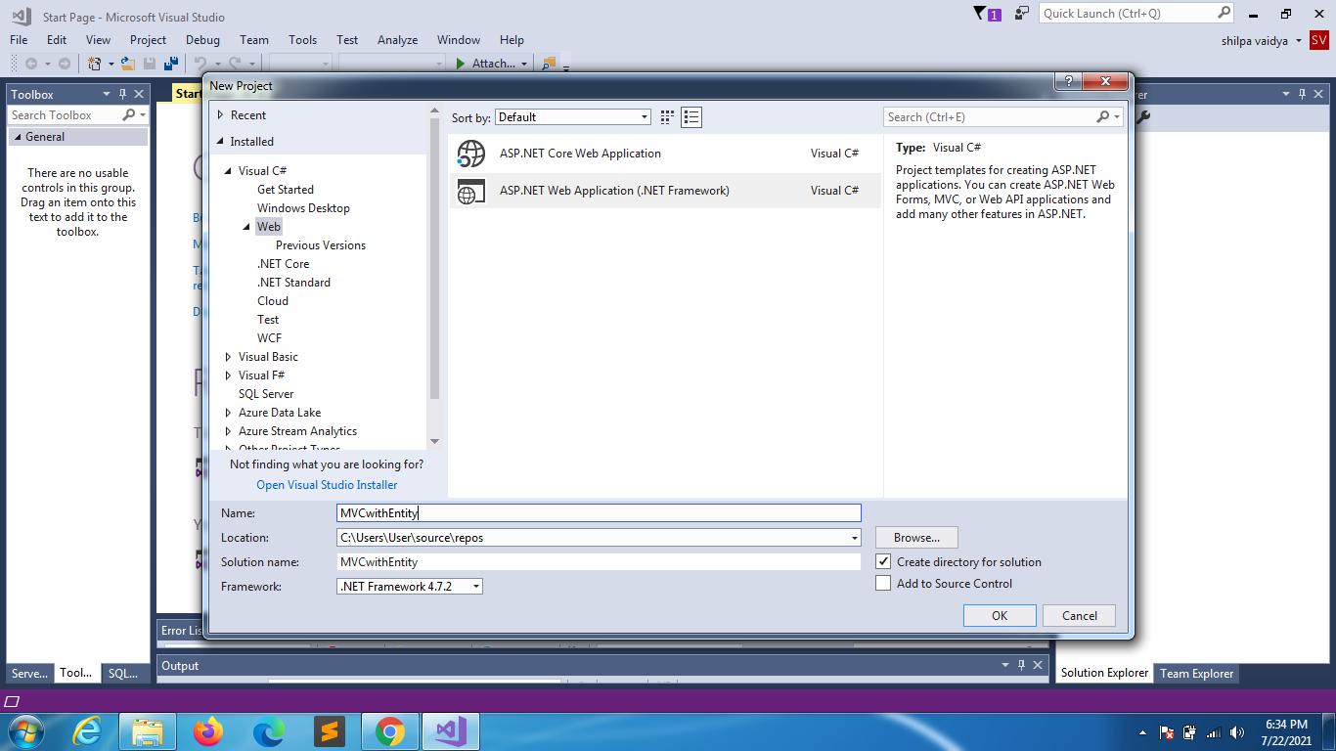

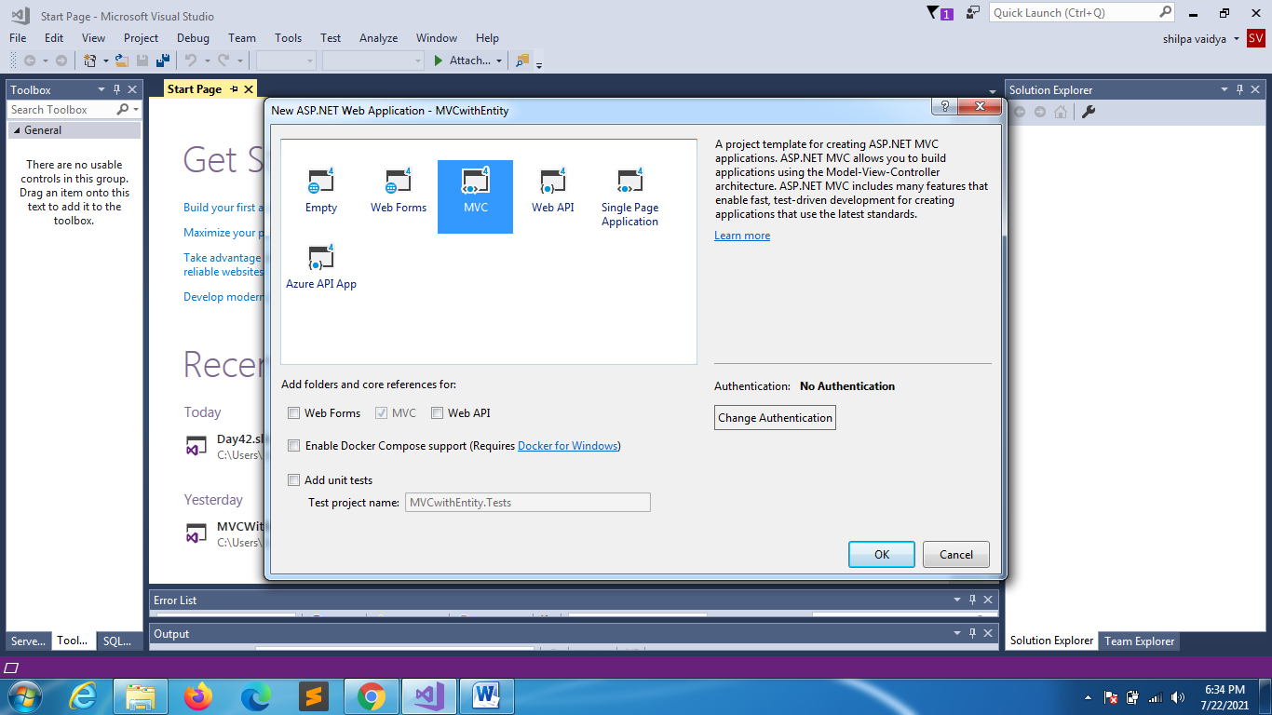

DATABASE WITH AUTOINCREMENT ID

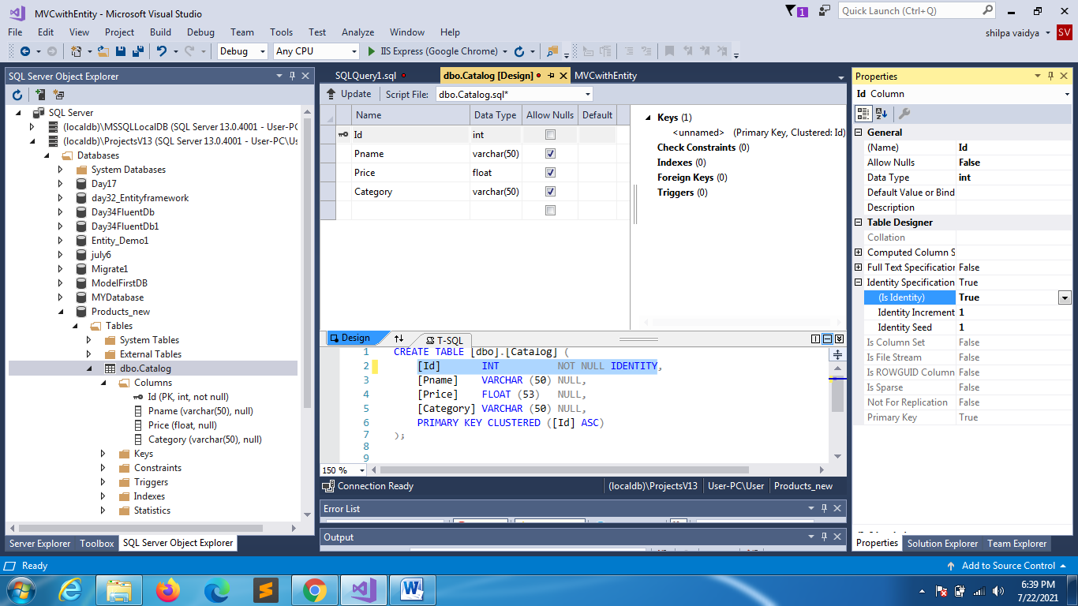

BACK TO SOLUTION EXPLORER

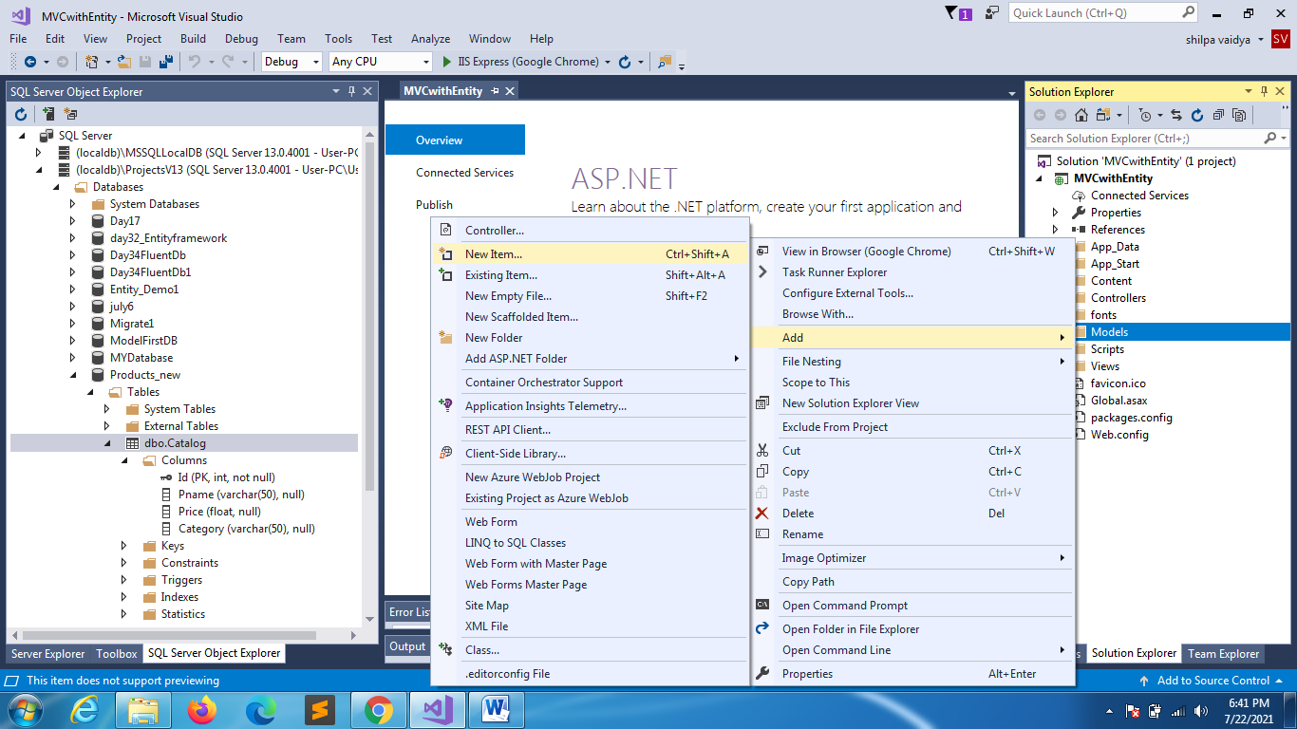

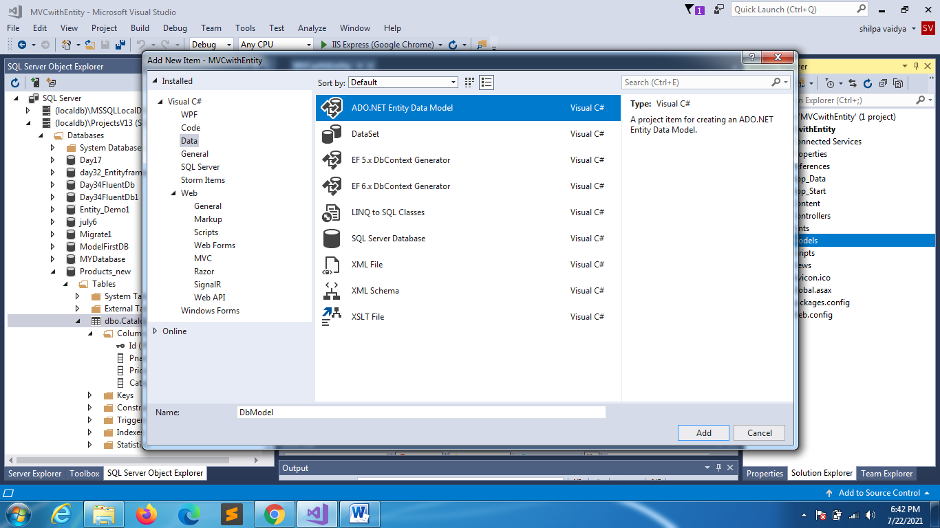

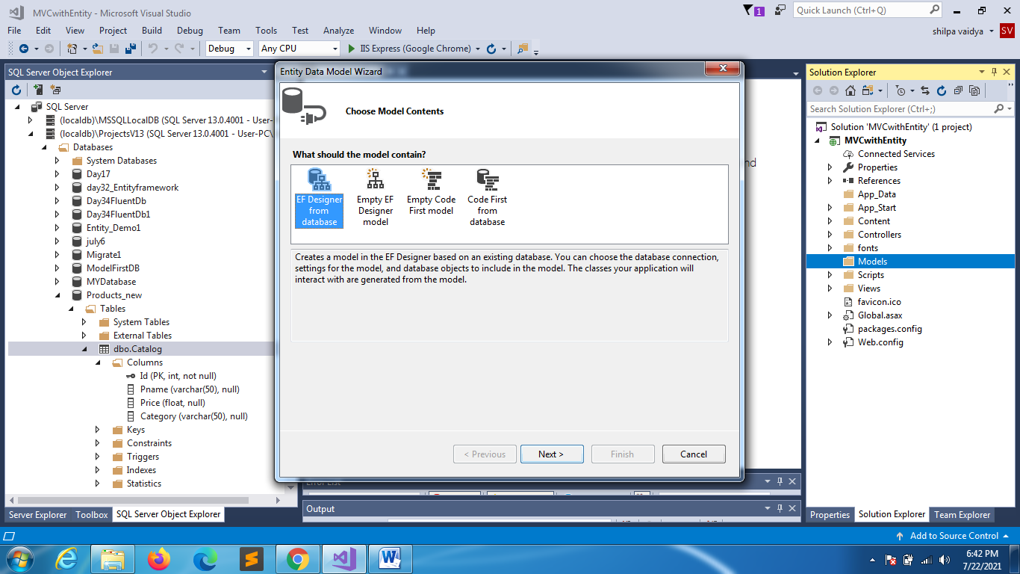

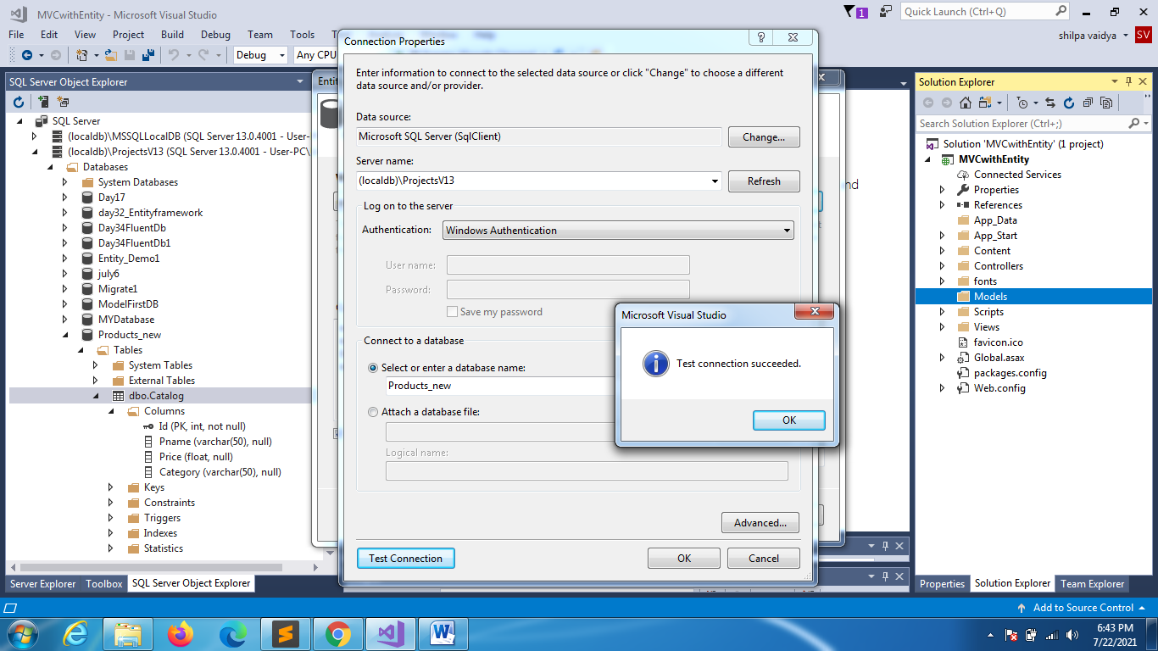

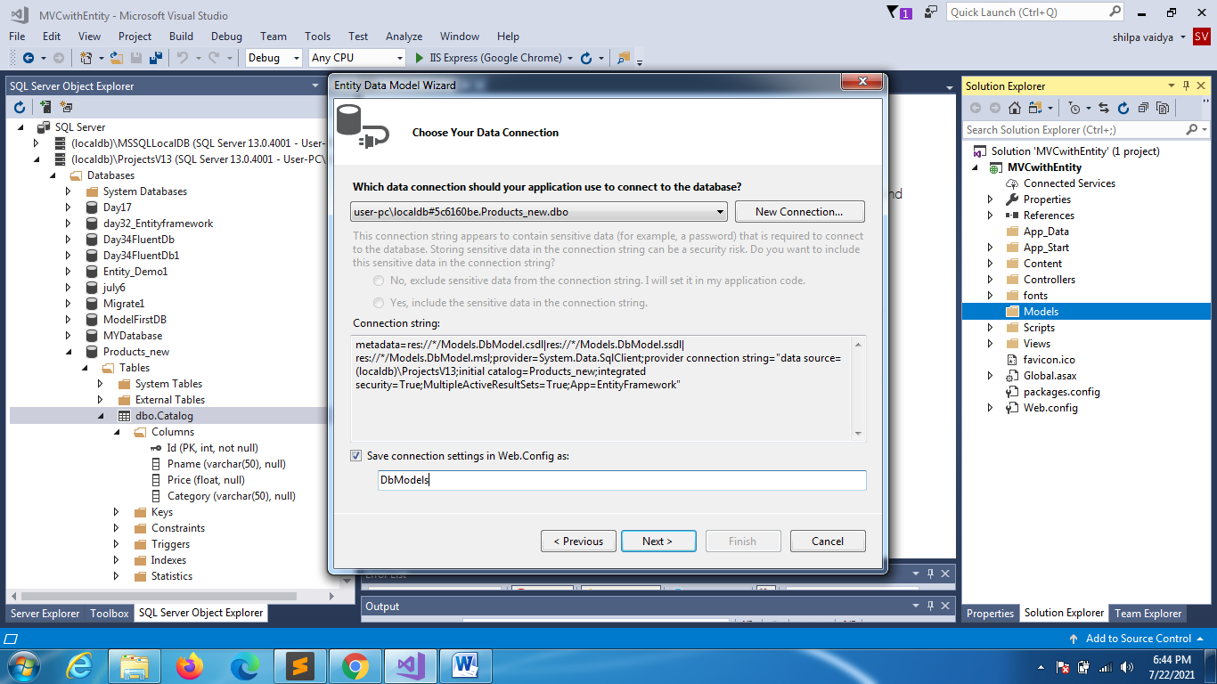

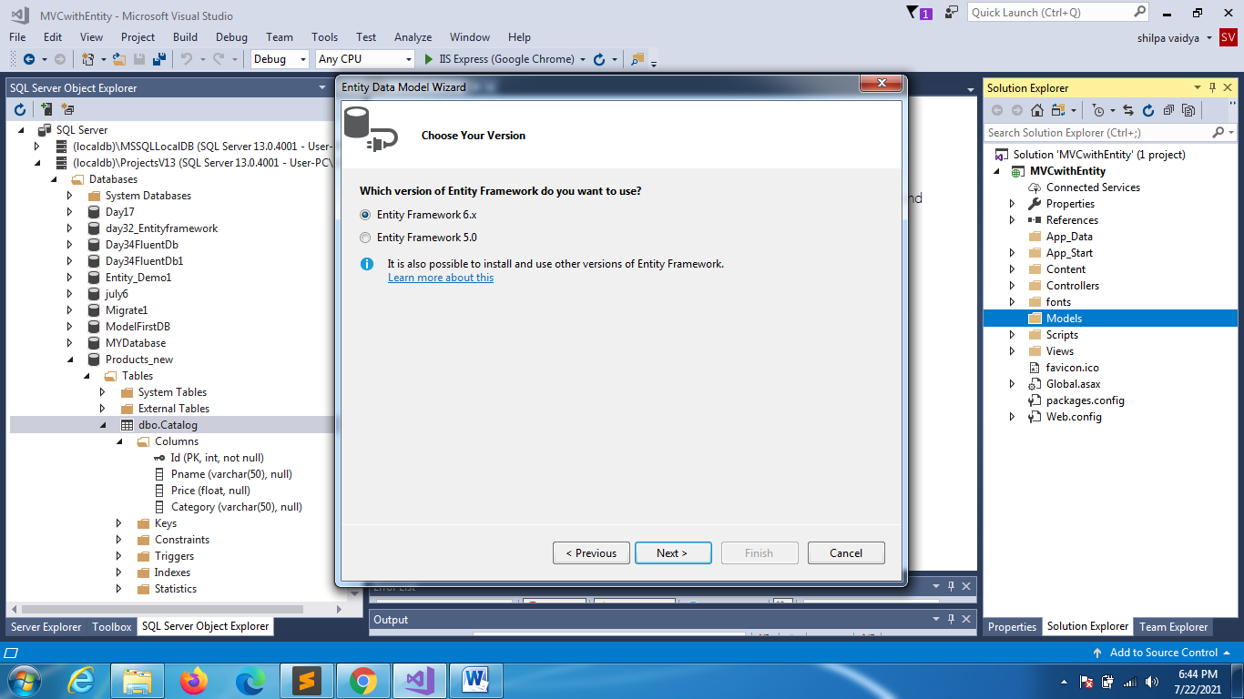

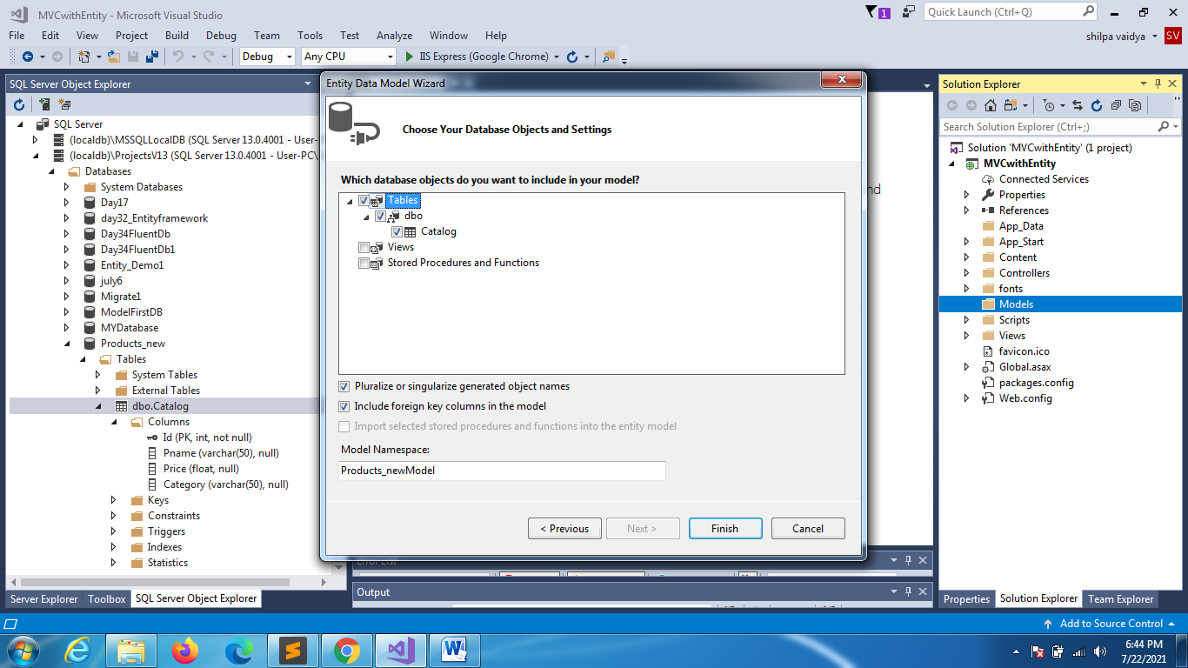

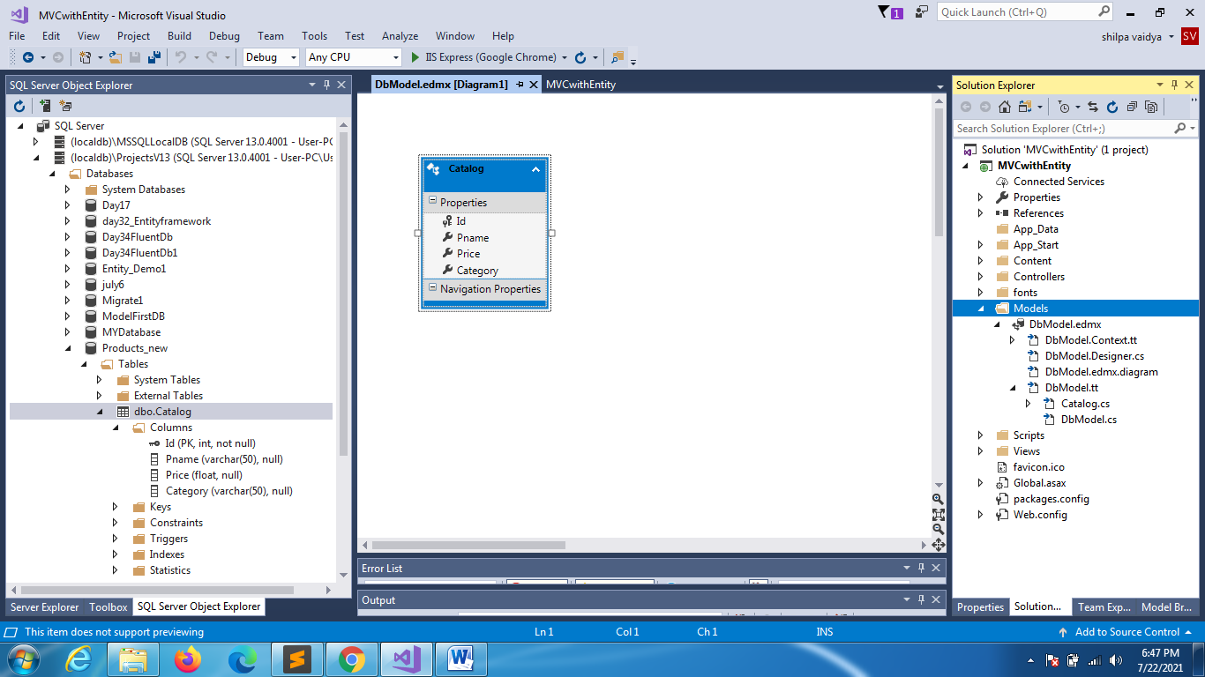

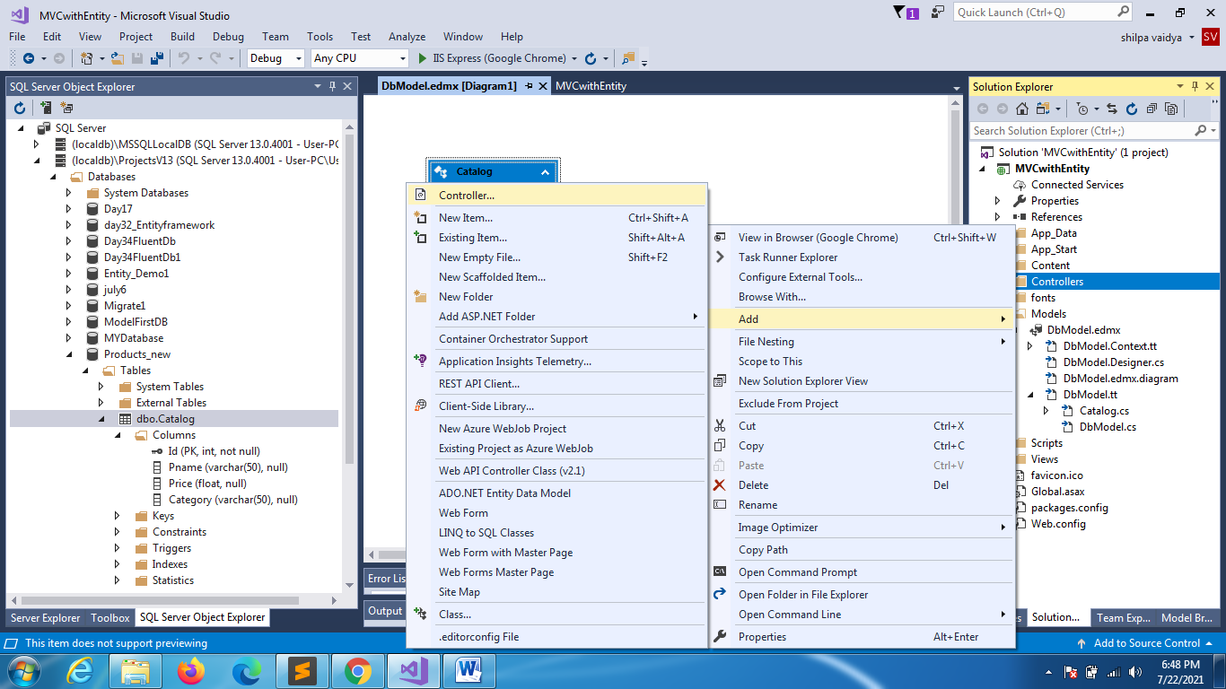

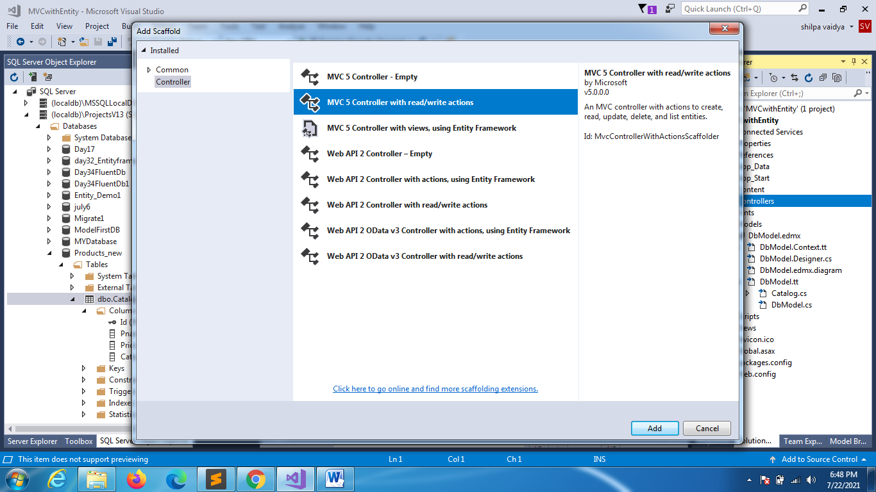

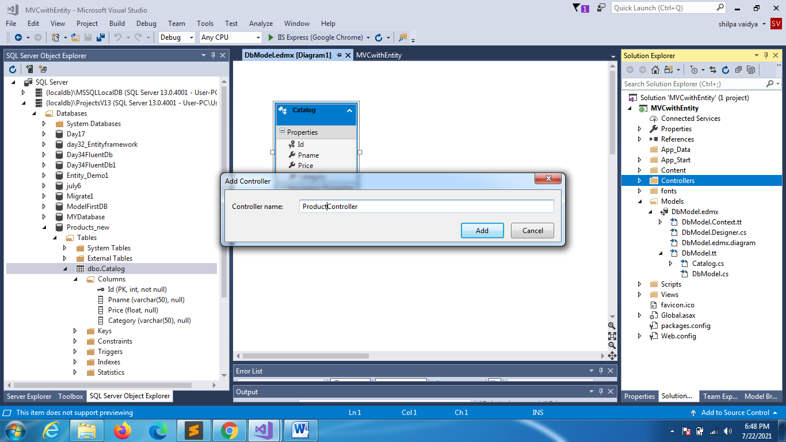

using System;

using System.Collections.Generic;

using System.Linq;

using System.Web;

using System.Web.Mvc;

using MVCwithEntity.Models;

Add view

namespace MVCwithEntity.Controllers

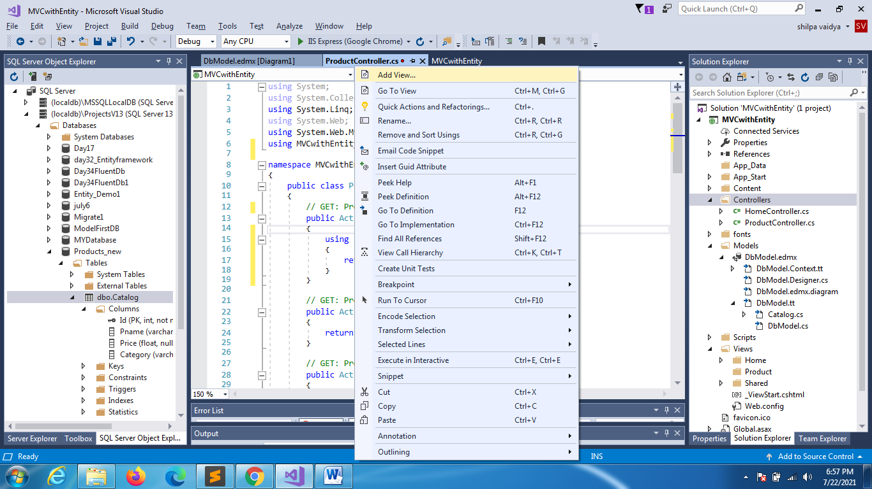

{

    public class ProductController : Controller

    {

        // GET: Product/Index

        public ActionResult Index()

        {

            using (DbModels dbmodel = new DbModels())

            {

                return View(dbmodel.Catalogs.ToList());

            }

        }

        // GET: Product/Details/5

        public ActionResult Details(int id)

        {

            return View();

        }

        // GET: Product/Create

        public ActionResult Create()

        {

            return View();

        }

        // POST: Product/Create

        [HttpPost]

        public ActionResult Create(FormCollection collection)

        {

            try

            {

                // TODO: Add insert logic here

                return RedirectToAction("Index");

            }

            catch

            {

                return View();

            }

        }

        // GET: Product/Edit/5

        public ActionResult Edit(int id)

        {

            return View();

        }

        // POST: Product/Edit/5

        [HttpPost]

        public ActionResult Edit(int id, FormCollection collection)

        {

            try

            {

                // TODO: Add update logic here

                return RedirectToAction("Index");

            }

            catch

            {

                return View();

            }

        }

        // GET: Product/Delete/5

        public ActionResult Delete(int id)

        {

            return View();

        }

        // POST: Product/Delete/5

        [HttpPost]

        public ActionResult Delete(int id, FormCollection collection)

        {

            try

            {

                // TODO: Add delete logic here

                return RedirectToAction("Index");

            }

            catch

            {

                return View();

            }

        }

    }

}

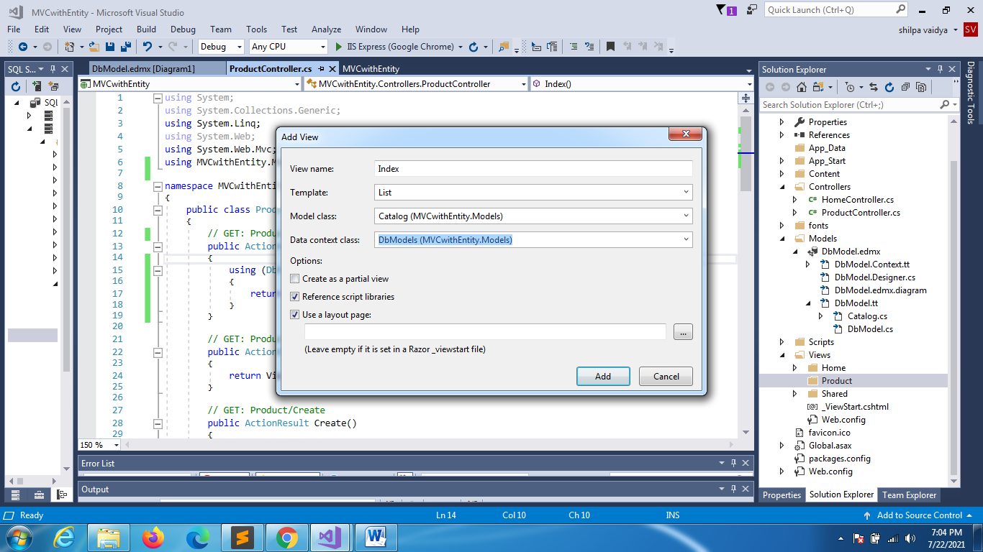

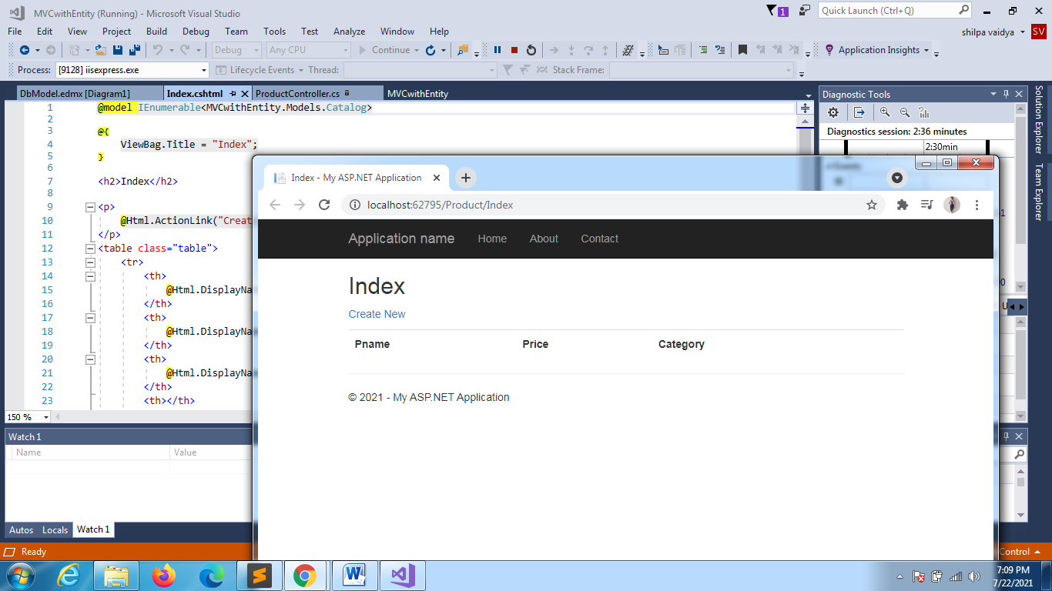

CREATE

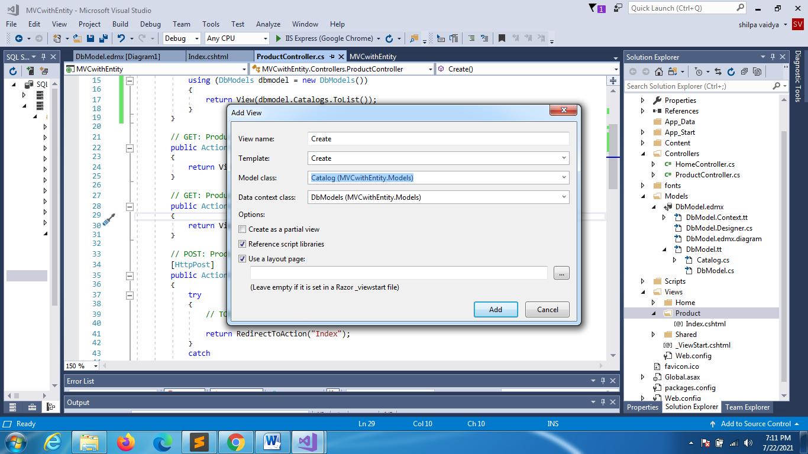

Rightclick ->Addview

Change this in Post

// POST: Product/Create

      [HttpPost]

      public ActionResult Create(Catalog prod)

      {

          try

          {

              // TODO: Add insert logic here

              using (DbModels dbmodel = new DbModels())

              {

                  dbmodel.Catalogs.Add(prod);

                  dbmodel.SaveChanges();

              }

                  return RedirectToAction("Index");

          }

          catch

          {

              return View();

          }

      }

DETAILS

// GET: Product/Details/5

        public ActionResult Details(int id)

        {

            using (DbModels dbmodel = new DbModels())

            {

                return View(dbmodel.Catalogs.Where(x => x.Id == id).FirstOrDefault());

            }

        }

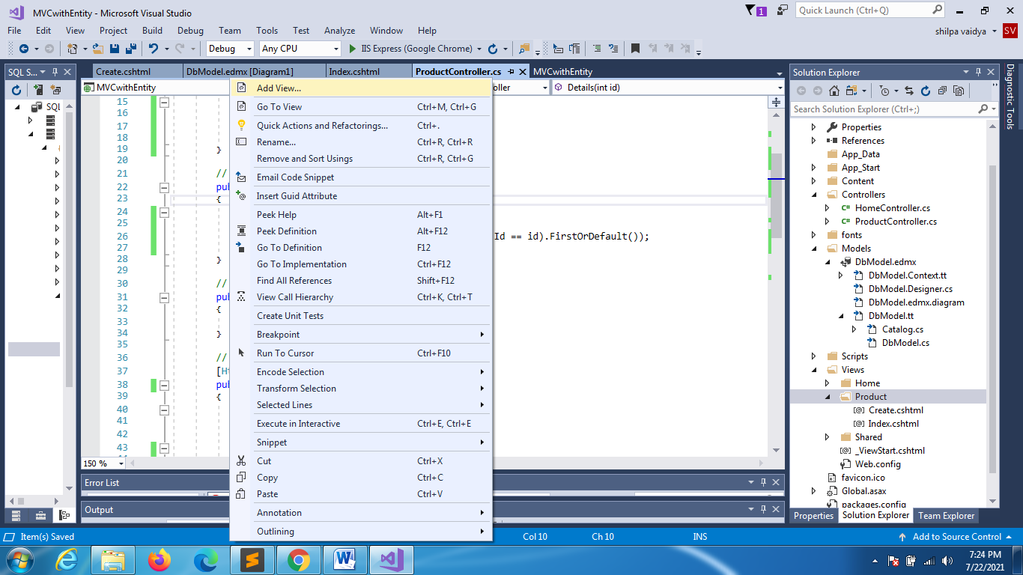 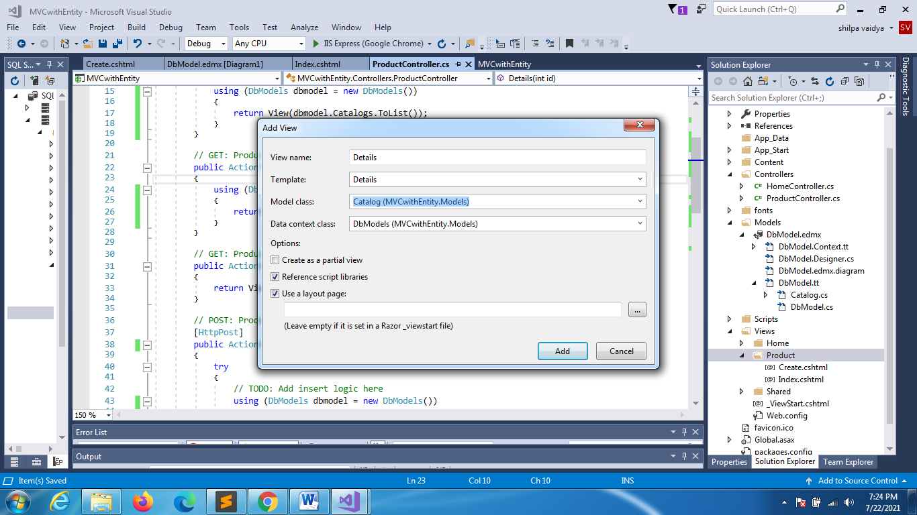

EDIT

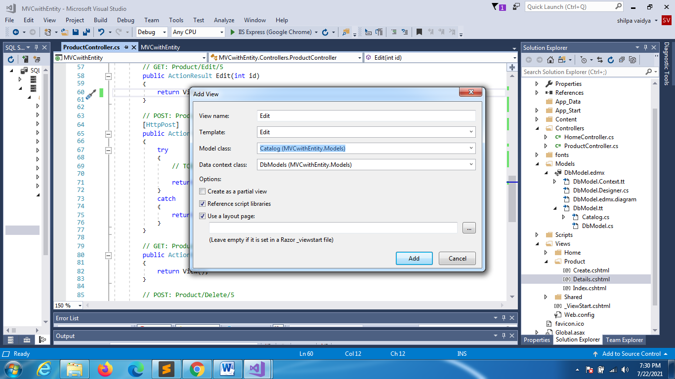

// GET: Product/Edit/5

        public ActionResult Edit(int id)

        {

            using (DbModels dbmodel = new DbModels())

            {

                return View(dbmodel.Catalogs.Where(x => x.Id == id).FirstOrDefault());

            }

        }

// POST: Product/Edit/5

[HttpPost]

public ActionResult Edit(int id, Catalog prod)

{

    try

    {

        // TODO: Add update logic here

        // GET: Product/Edit/5

        using (DbModels dbmodel = new DbModels())

        {

            dbmodel.Entry(prod).State = EntityState.Modified;

            dbmodel.SaveChanges();

        }

        return RedirectToAction("Index");

    }

    catch

    {

        return View();

    }

}

DELETE

// GET: Product/Delete/5

       public ActionResult Delete(int id)

       {

           using (DbModels dbmodel = new DbModels())

           {

               return View(dbmodel.Catalogs.Where(x => x.Id == id).FirstOrDefault());

           }

       }

// POST: Product/Delete/5

        [HttpPost]

        public ActionResult Delete(int id, Catalog prod)

        {

            try

            {

                // TODO: Add delete logic here

                using (DbModels dbmodel = new DbModels())

                {

                    prod = dbmodel.Catalogs.Where(x => x.Id == id).FirstOrDefault();

                    dbmodel.Catalogs.Remove(prod);

                    dbmodel.SaveChanges();

                }

                return RedirectToAction("Index");

            }

            catch

            {

                return View();

            }

        }

