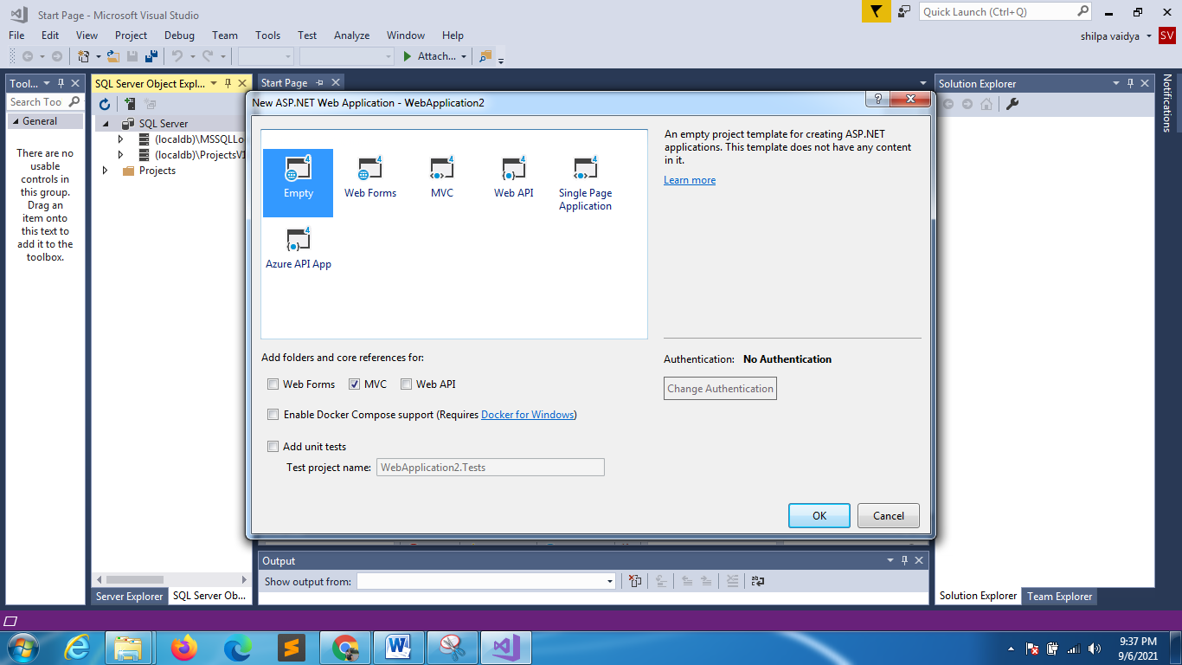
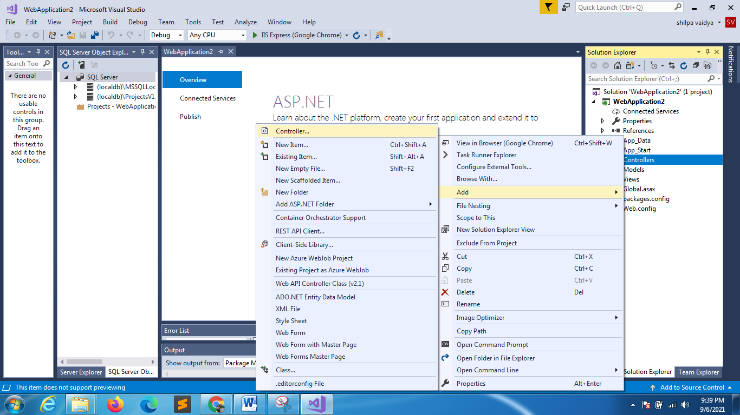
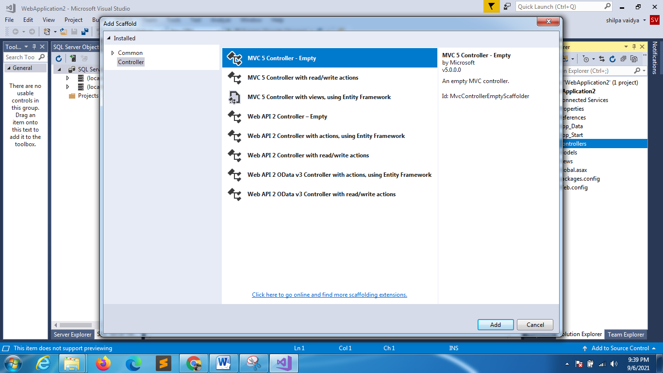
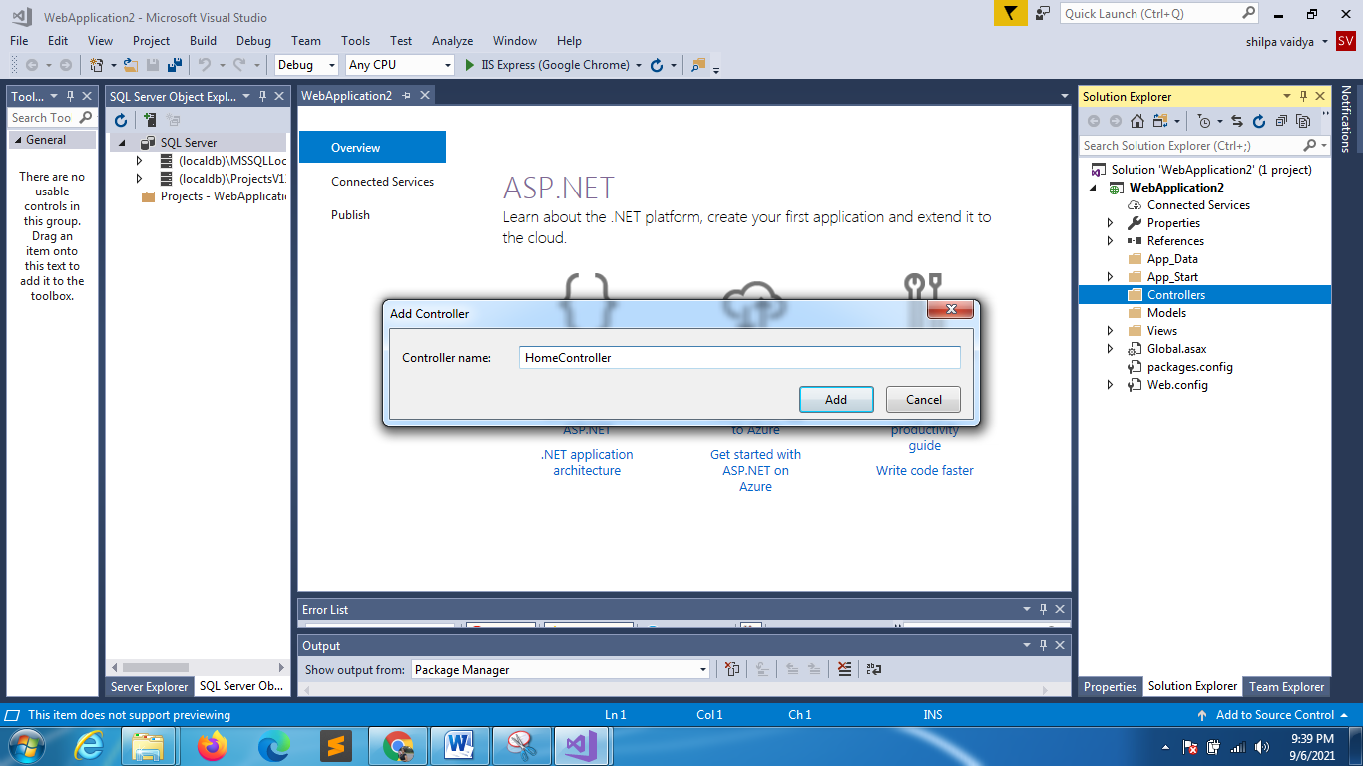

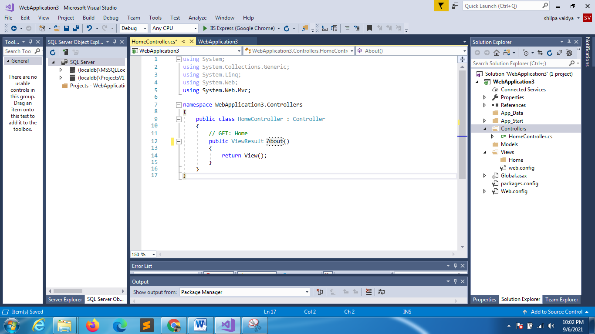
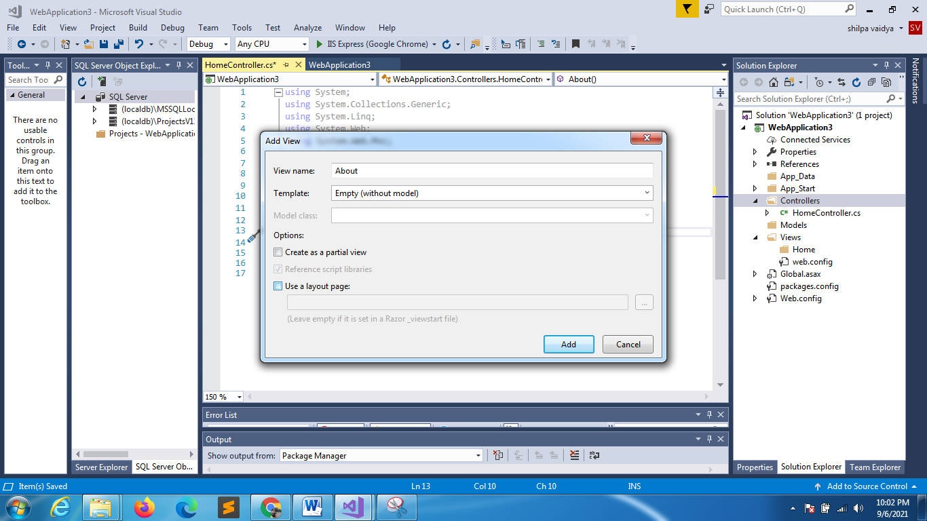
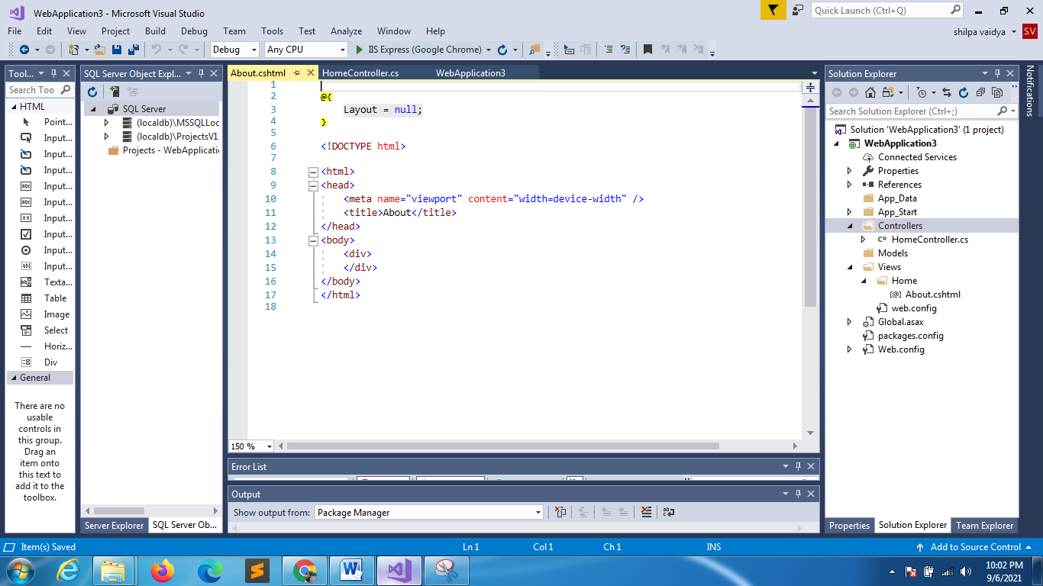
using System;
using System.Collections.Generic;
using System.Linq;
using System.Web;
using System.Web.Mvc;

namespace WebApplication3.Controllers
{
public class HomeController : Controller
{
//ViewResult name = action name
public ViewResult About()
{
return View();
}

//ViewResult name != action name
public ViewResult Prod()
{
return View();
}
}
}
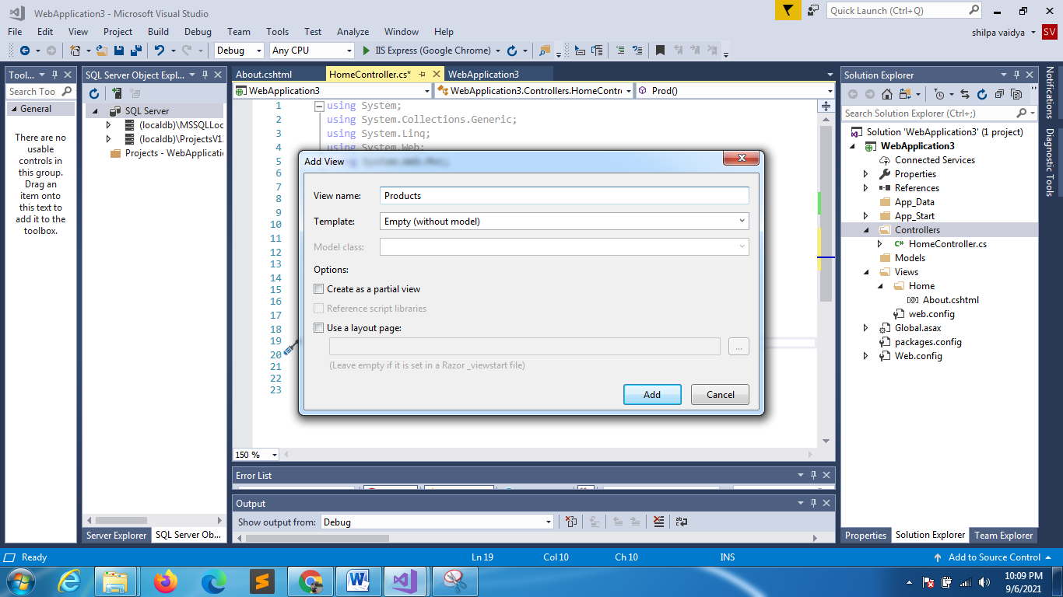
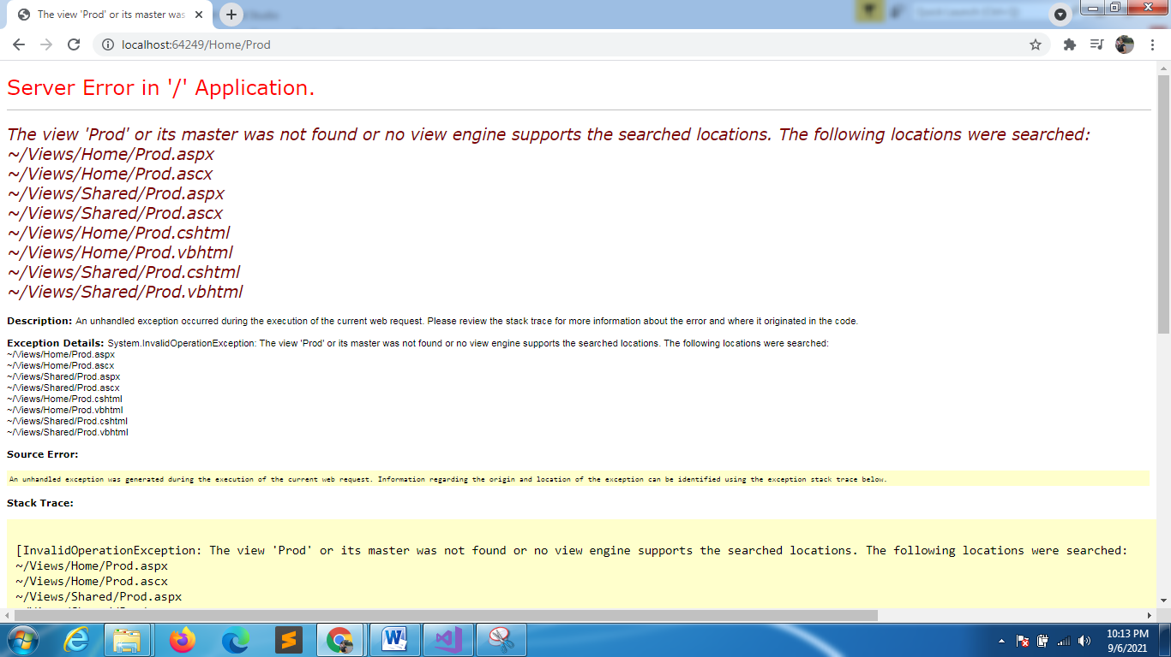
View res and action meth not same

using System;
using System.Collections.Generic;
using System.Linq;
using System.Web;
using System.Web.Mvc;

namespace WebApplication3.Controllers
{
public class HomeController : Controller
{
//ViewResult name = action name
public ViewResult About()
{
return View();
}

//ViewResult name != action name
public ViewResult Prod()
{
return View("Products");
}
}
}
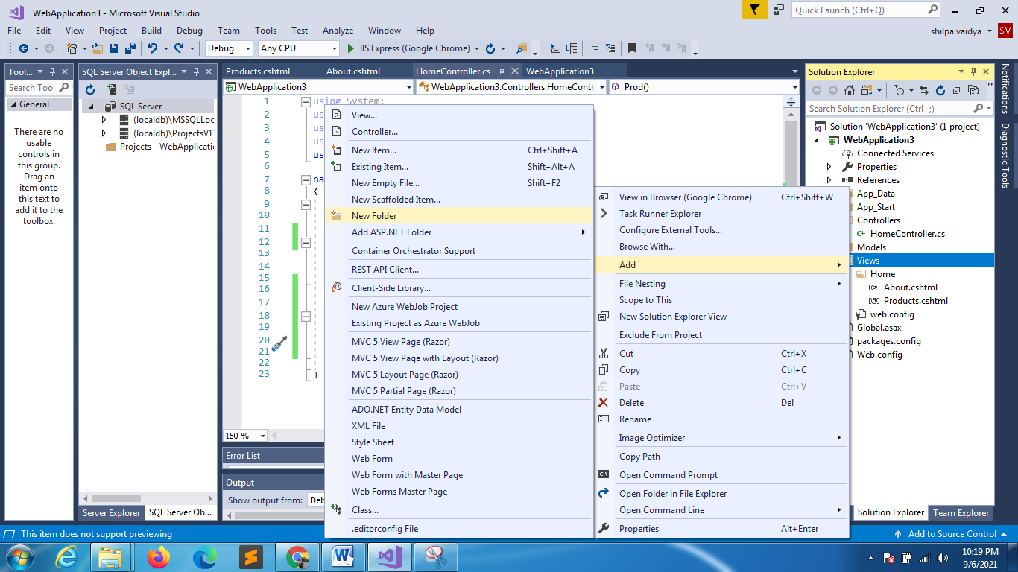
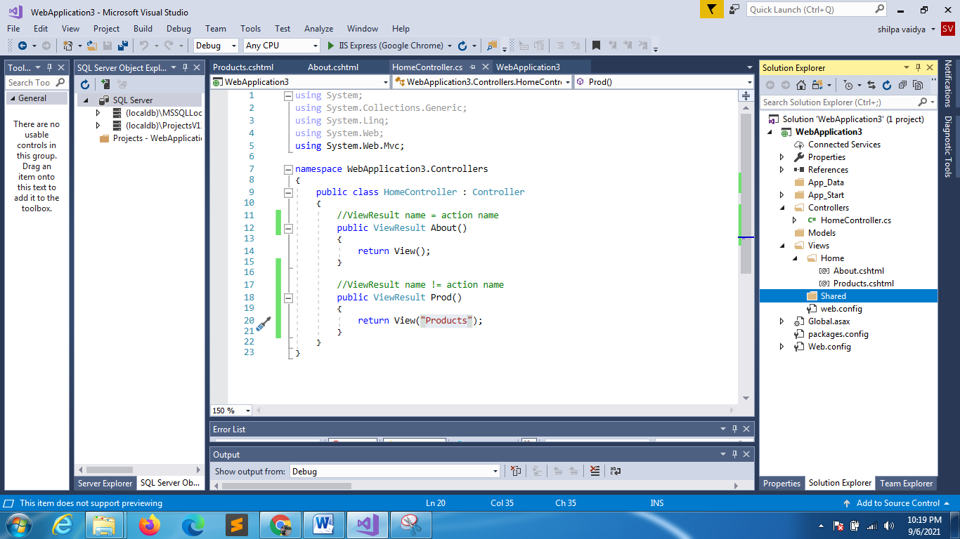
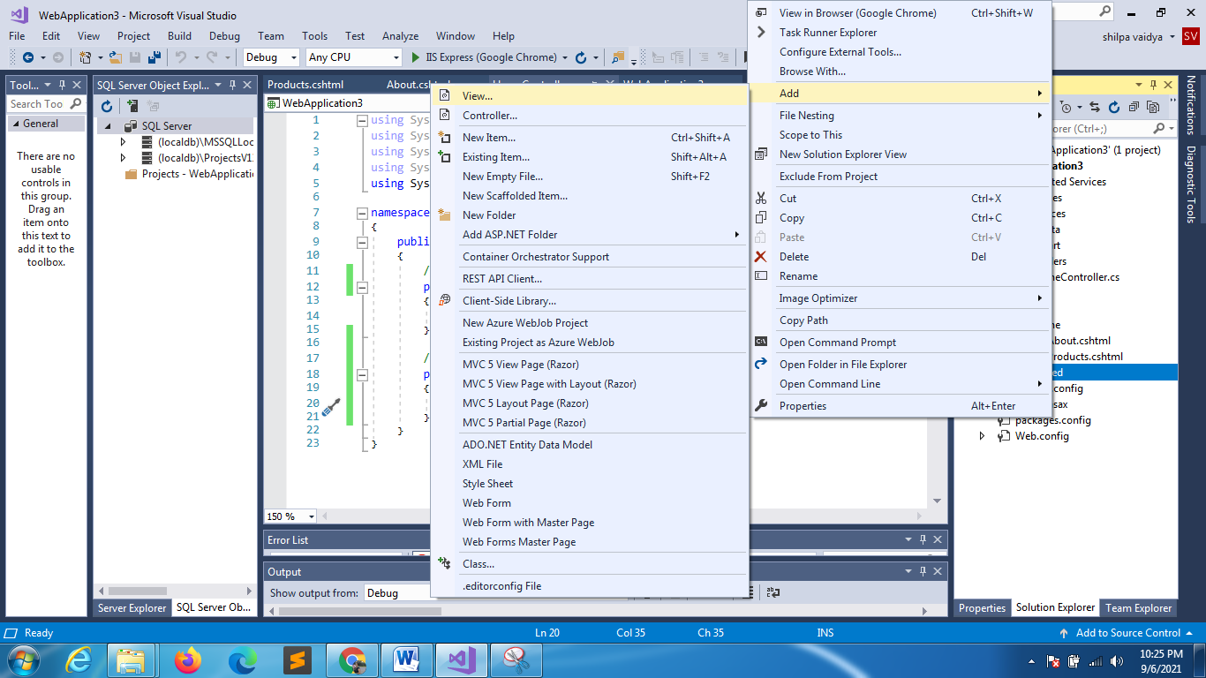
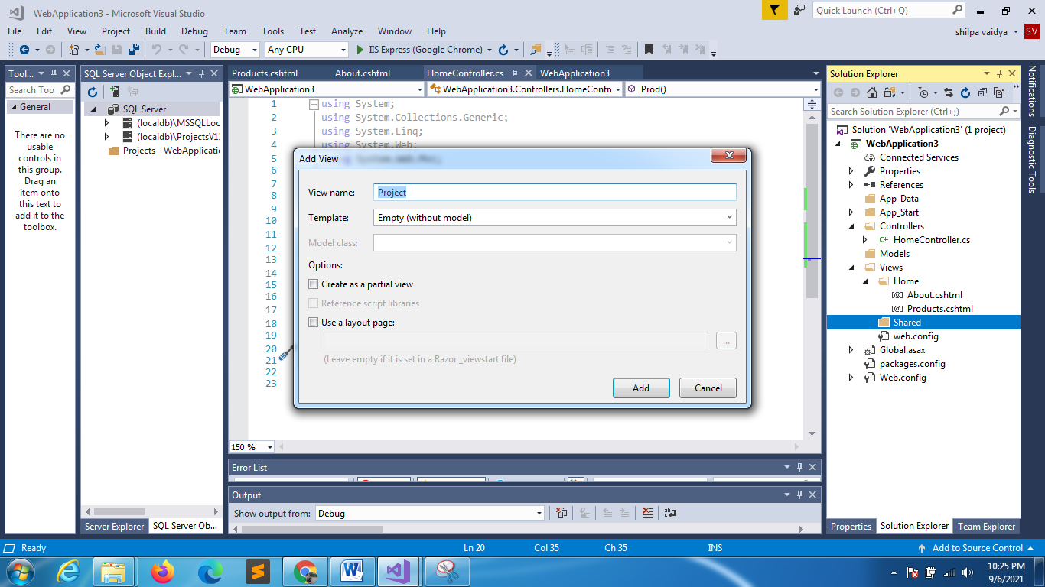

@{
Layout = null;
}

<!DOCTYPE html>

<html>
<head>
<meta name="viewport" content="width=device-width" />
<title>Project</title>
</head>
<body>
<div>
<h1>Projects..........</h1>
</div>
</body>
</html>

using System;
using System.Collections.Generic;
using System.Linq;
using System.Web;
using System.Web.Mvc;

namespace WebApplication3.Controllers
{
public class HomeController : Controller
{
//ViewResult name = action name
public ViewResult About()
{
return View();
}

//ViewResult name != action name
public ViewResult Prod()
{
return View("Products");
}
public ViewResult Project()
{
return View();
}
}
}

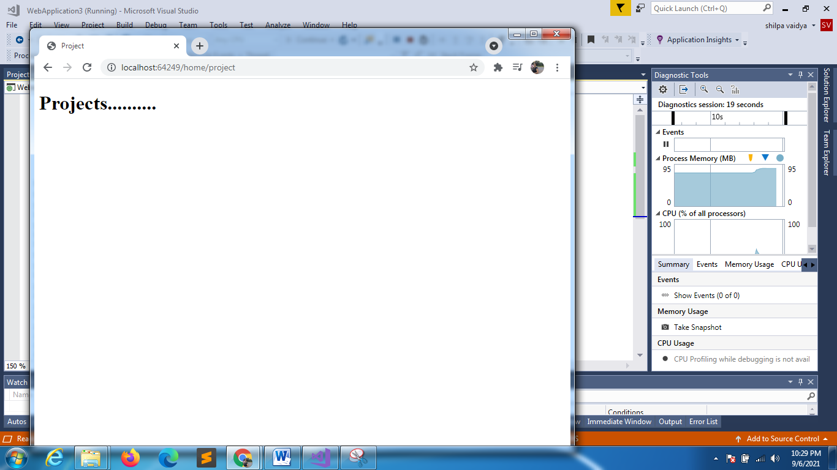
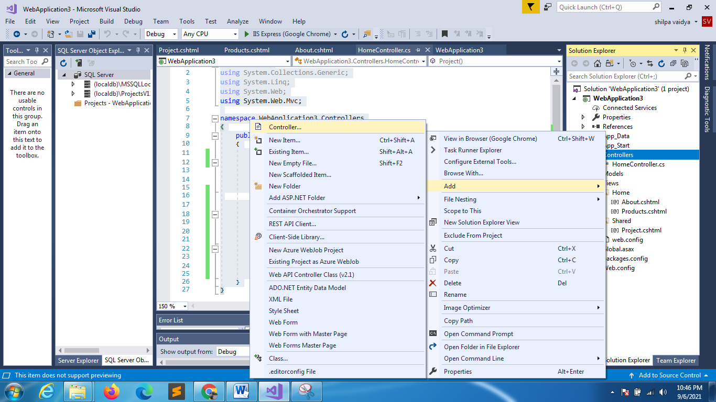
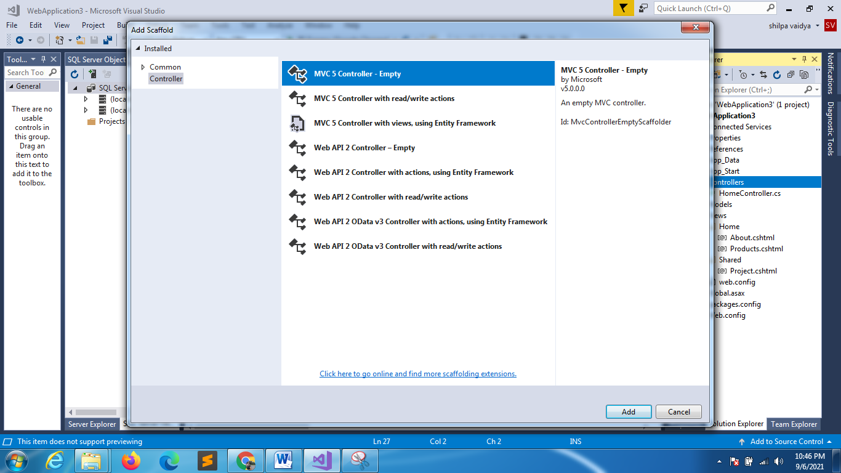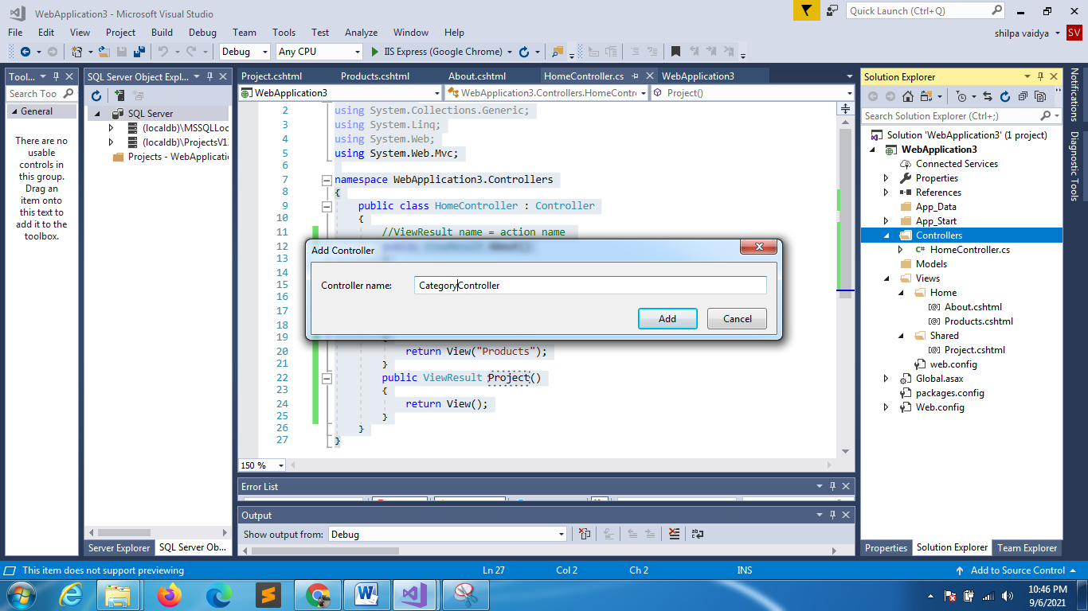

using System;
using System.Collections.Generic;
using System.Linq;
using System.Web;
using System.Web.Mvc;

namespace WebApplication3.Controllers
{
public class CategoryController : Controller
{
// GET: Category
public ViewResult Index()
{
return View();
}
}
}

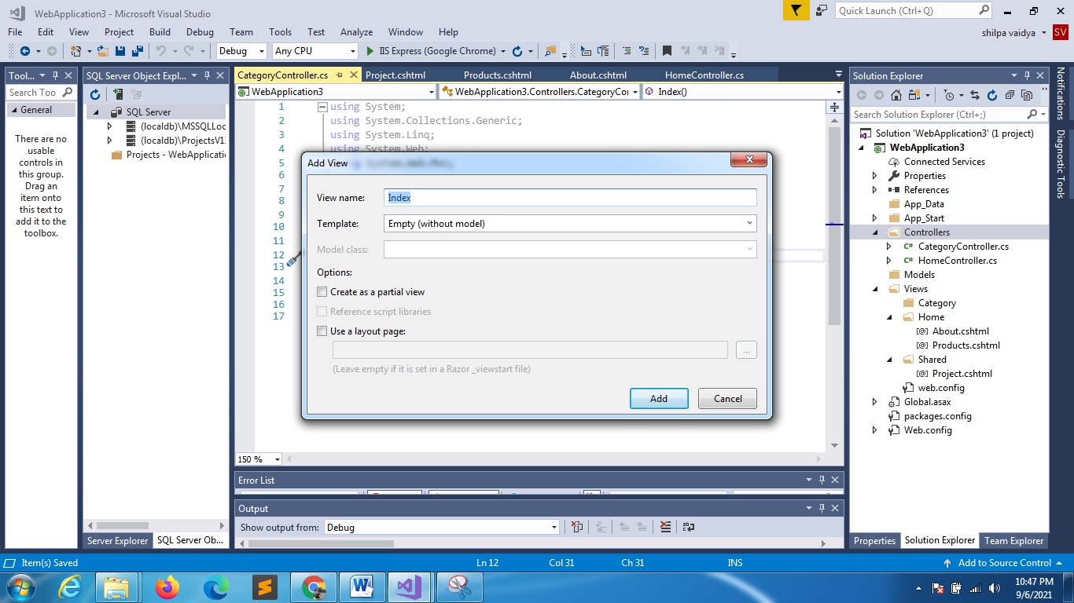

@{
Layout = null;
}

<!DOCTYPE html>

<html>
<head>
<meta name="viewport" content="width=device-width" />
<title>Index</title>
</head>
<body>
<div>
<h1>Welcome to categries!!!</h1>
</div>
</body>
</html>

Home controller
using System;
using System.Collections.Generic;
using System.Linq;
using System.Web;
using System.Web.Mvc;

namespace WebApplication3.Controllers
{
public class HomeController : Controller
{
//ViewResult name = action name
public ViewResult About()
{
return View();
}

//ViewResult name != action name
public ViewResult Prod()
{
return View("Products");
}
public ViewResult Project()
{
return View();
}
public ViewResult Catgoriespage()
{
return View("~/Views/Category/Index.cshtml");
}

}
}

