CONTENT RESULT

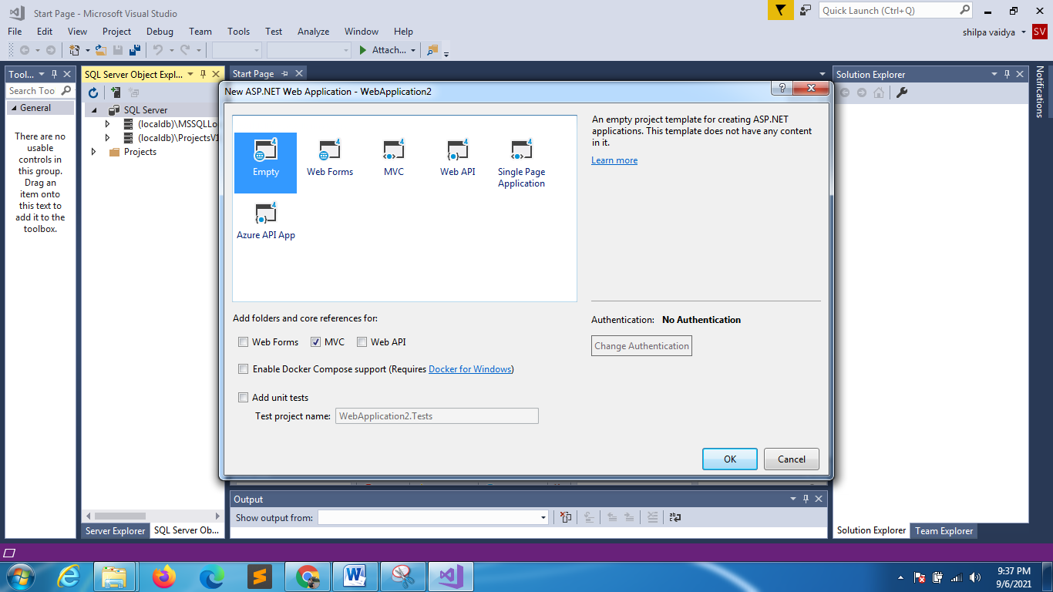
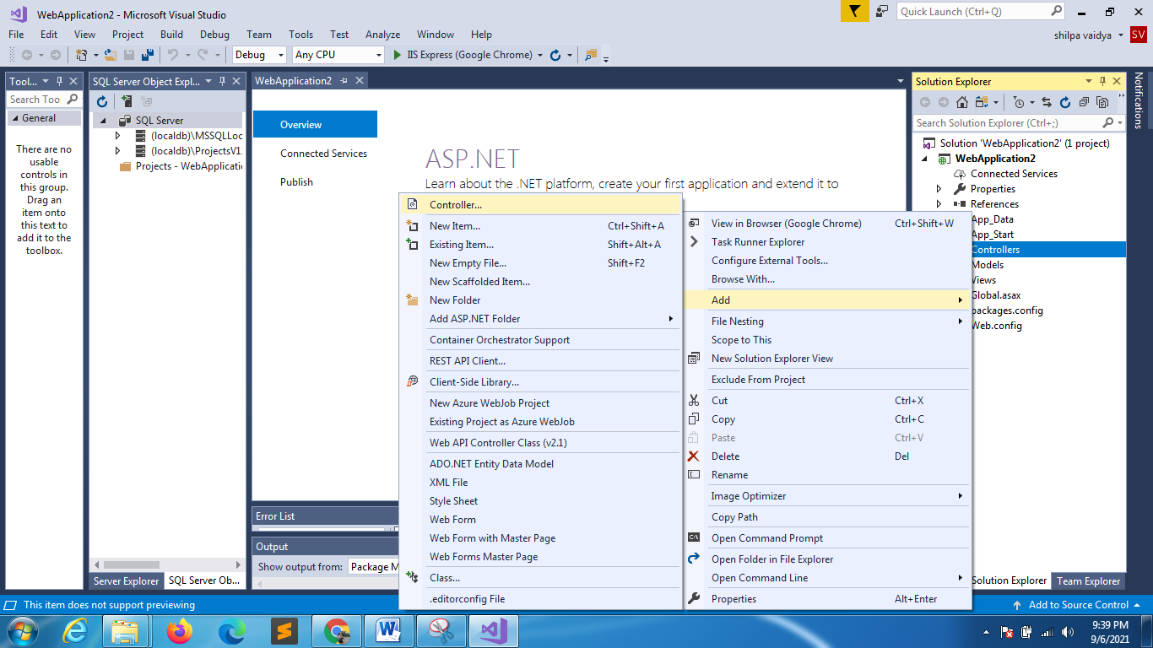
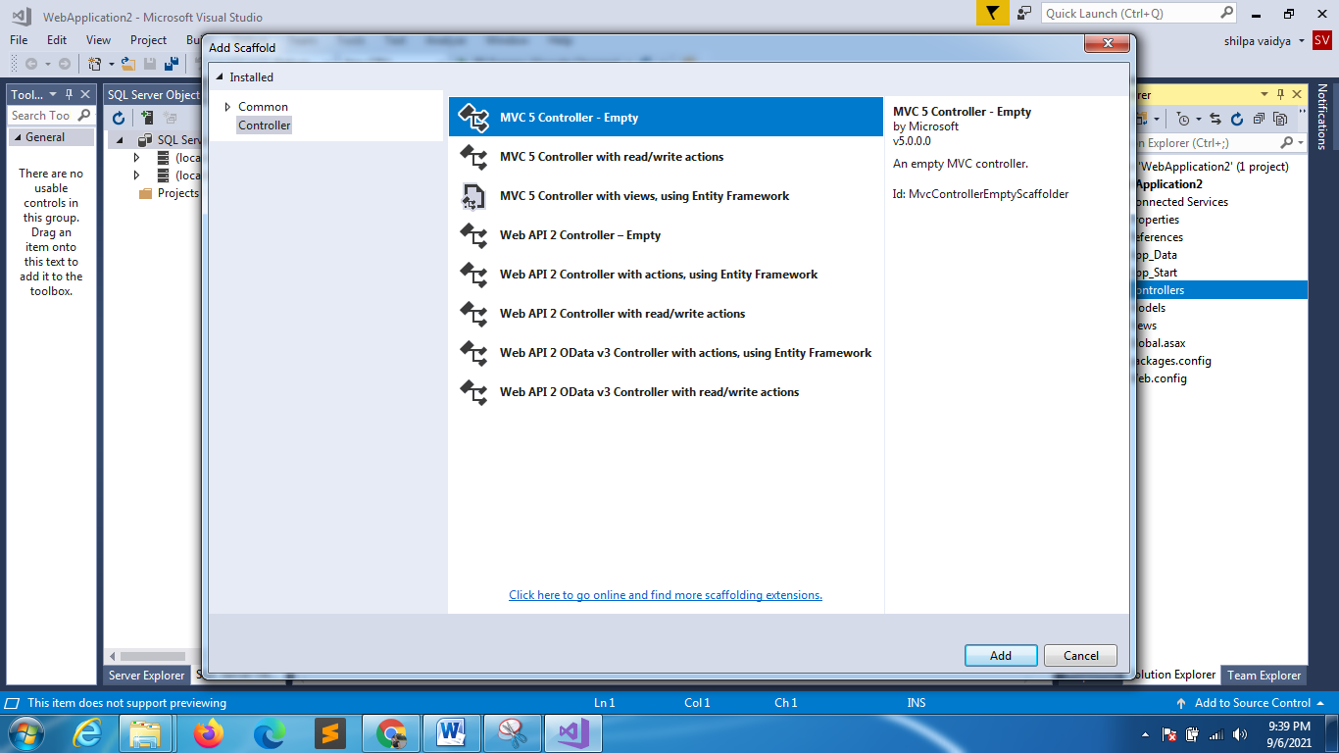
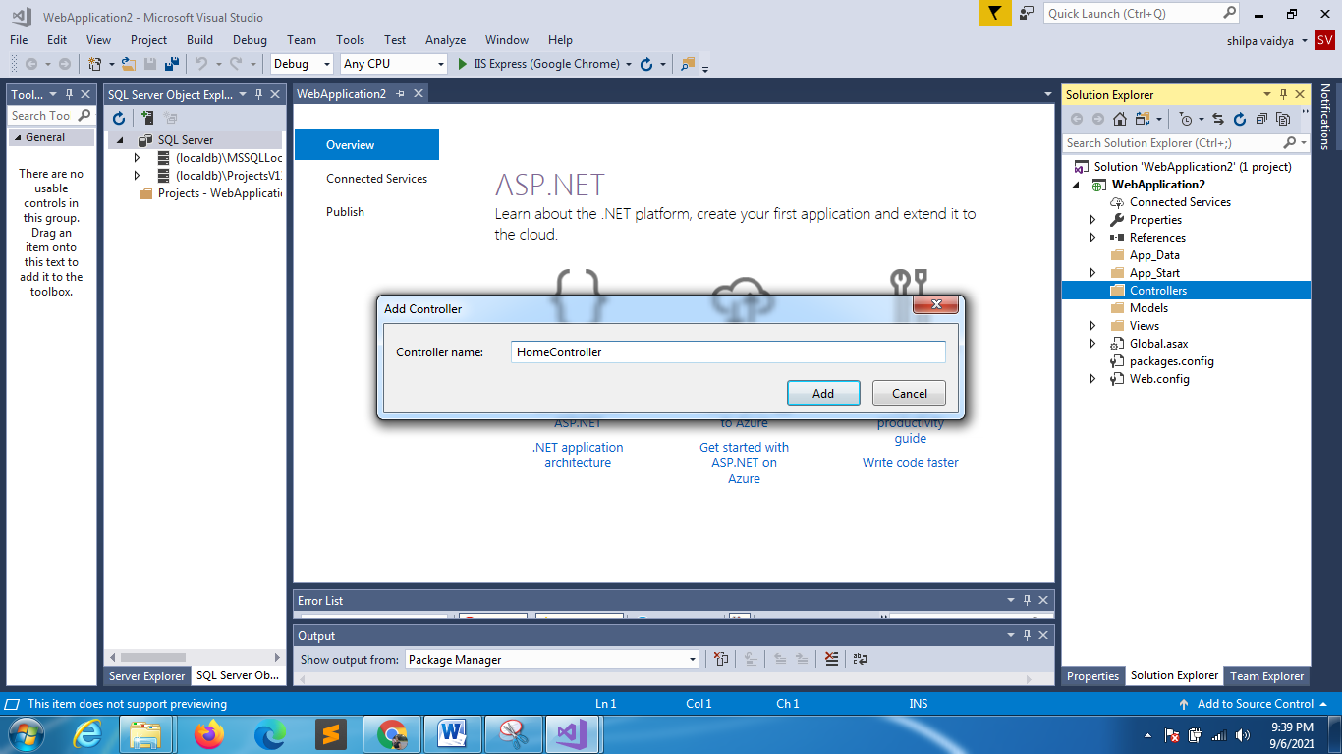

using System;
using System.Collections.Generic;
using System.Linq;
using System.Web;
using System.Web.Mvc;

using System;
using System.Collections.Generic;
using System.Linq;
using System.Web;
using System.Web.Mvc;

namespace WebApplication4.Controllers
{
public class HomeController : Controller
{

public ContentResult MyCont()
{
return Content("Hi do you know my name");
}
//any primitive datatype is treated as the contentresult
public string MyCont1()
{
string s = "hey how are u?";
return s;
}
public int MyCont3()
{
return 60;
}
}
}

