FILERESULT

Create empty mvc proj.
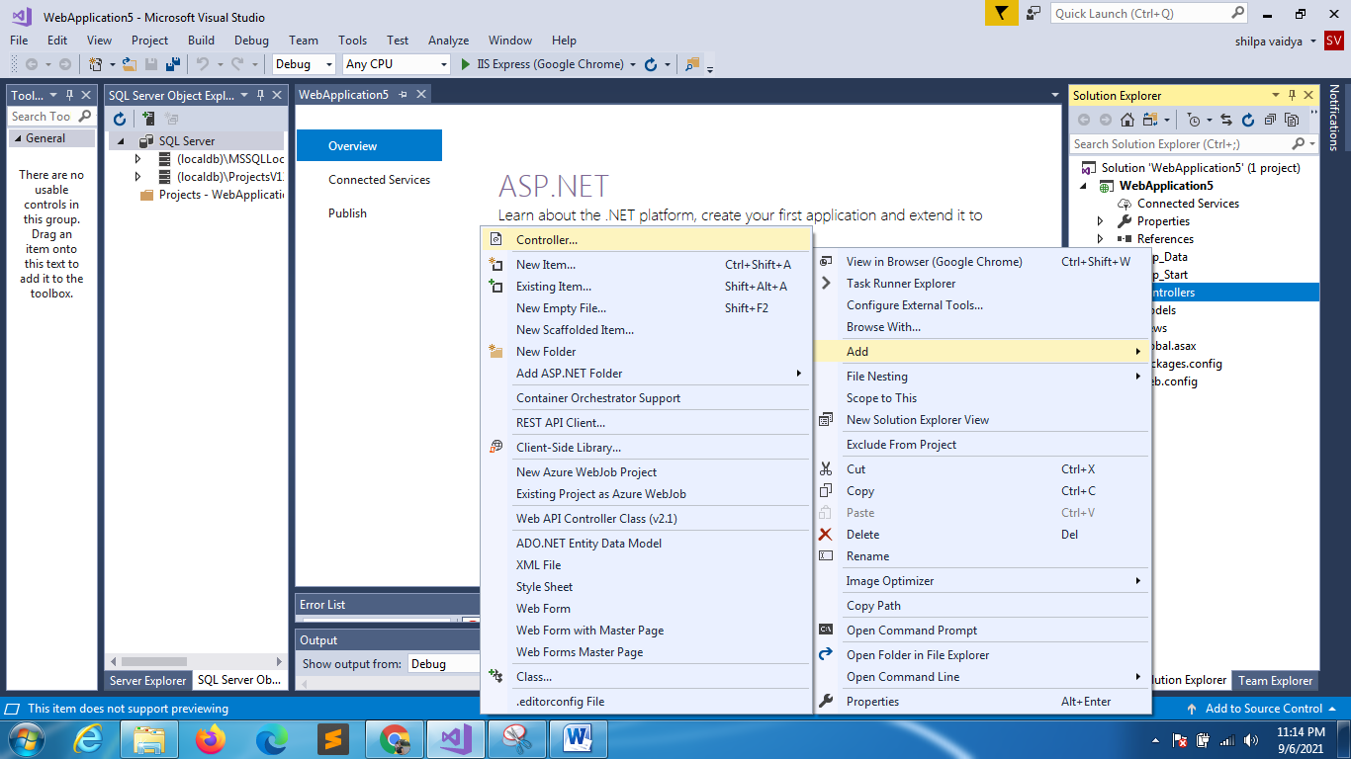
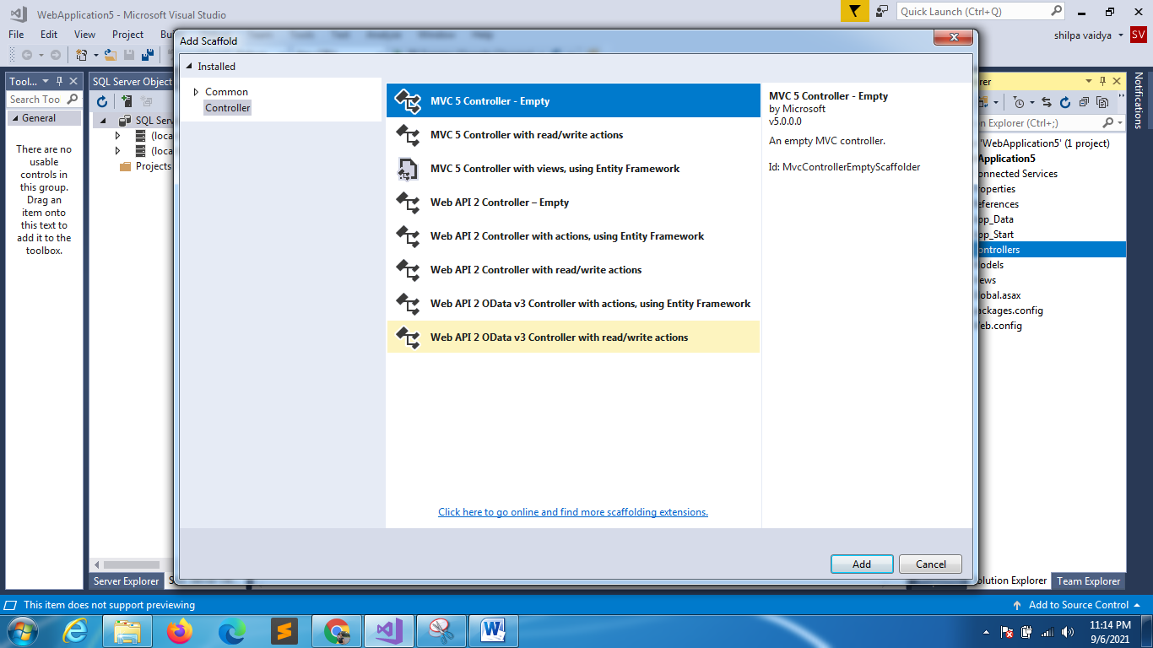
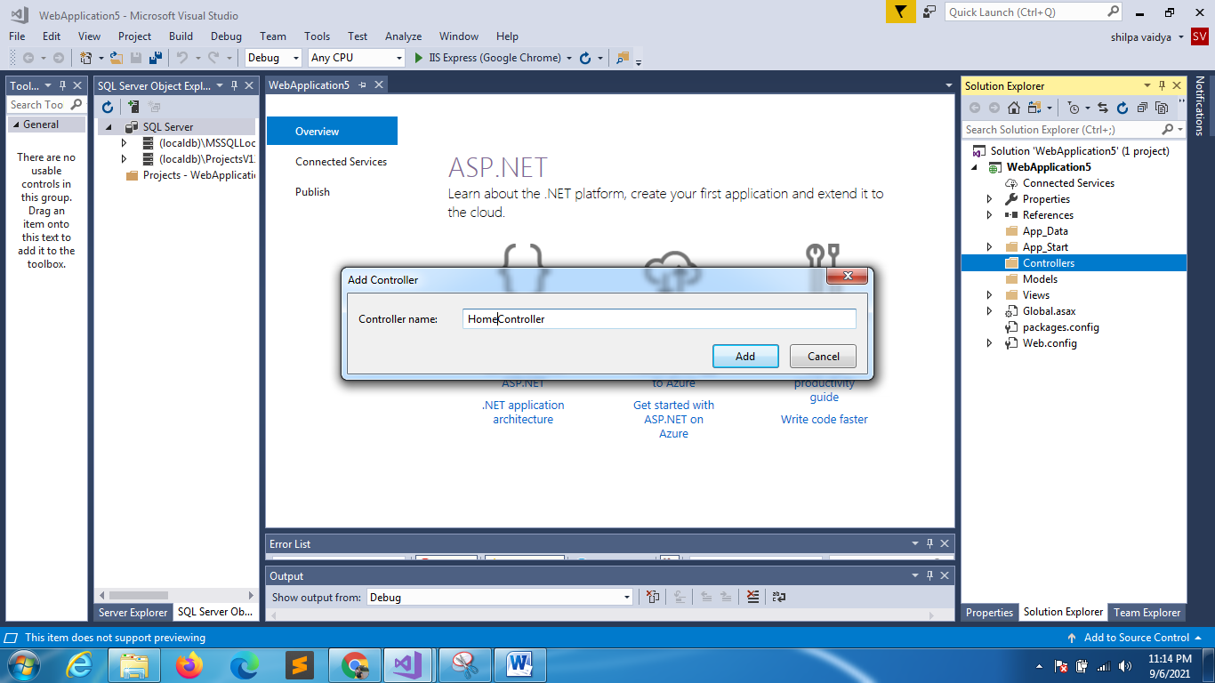

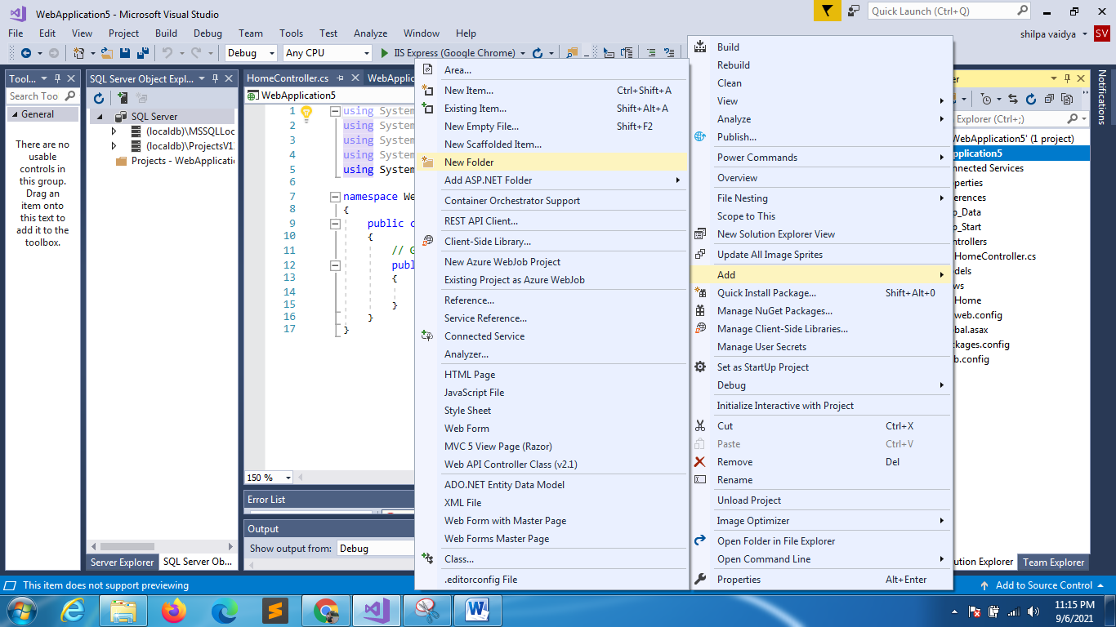
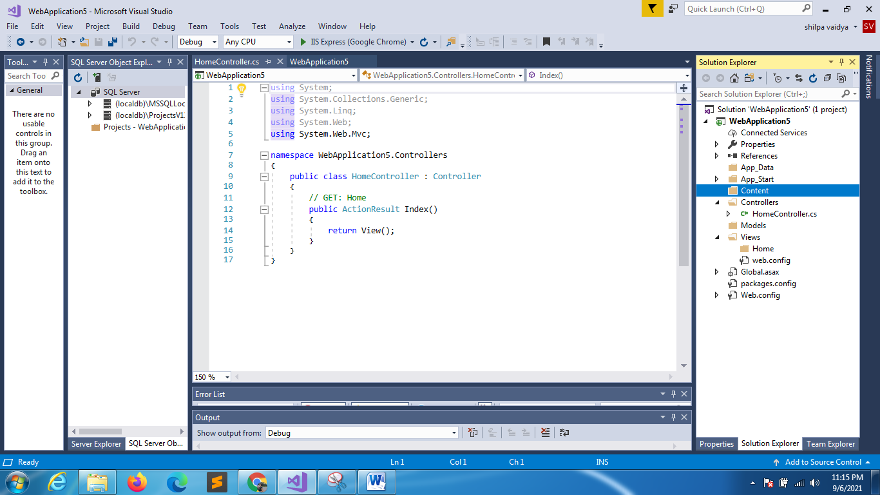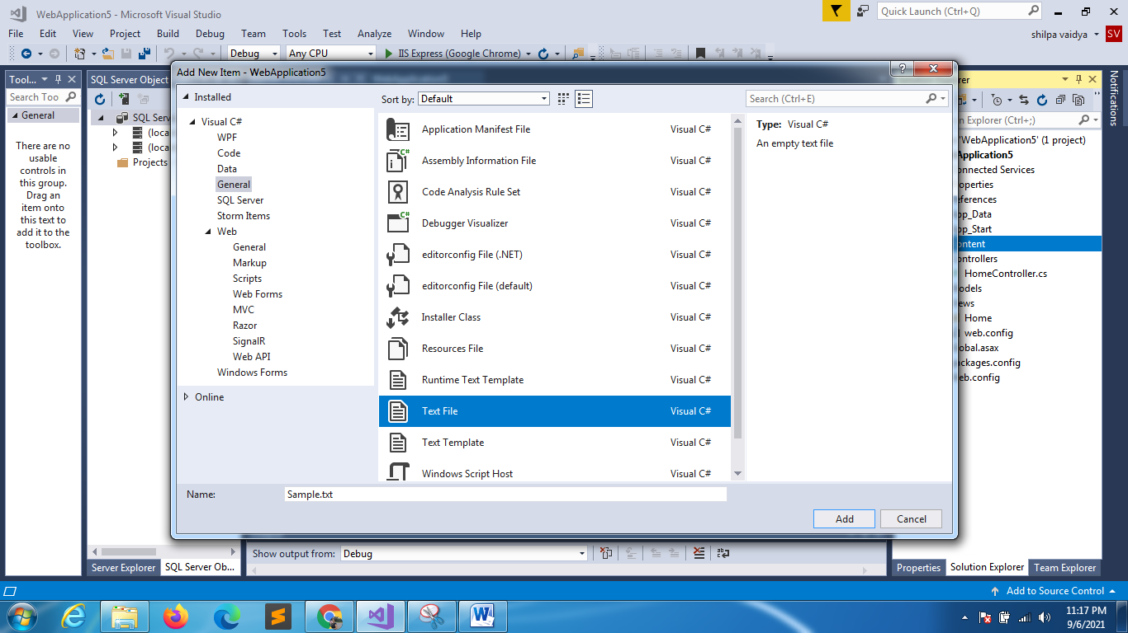

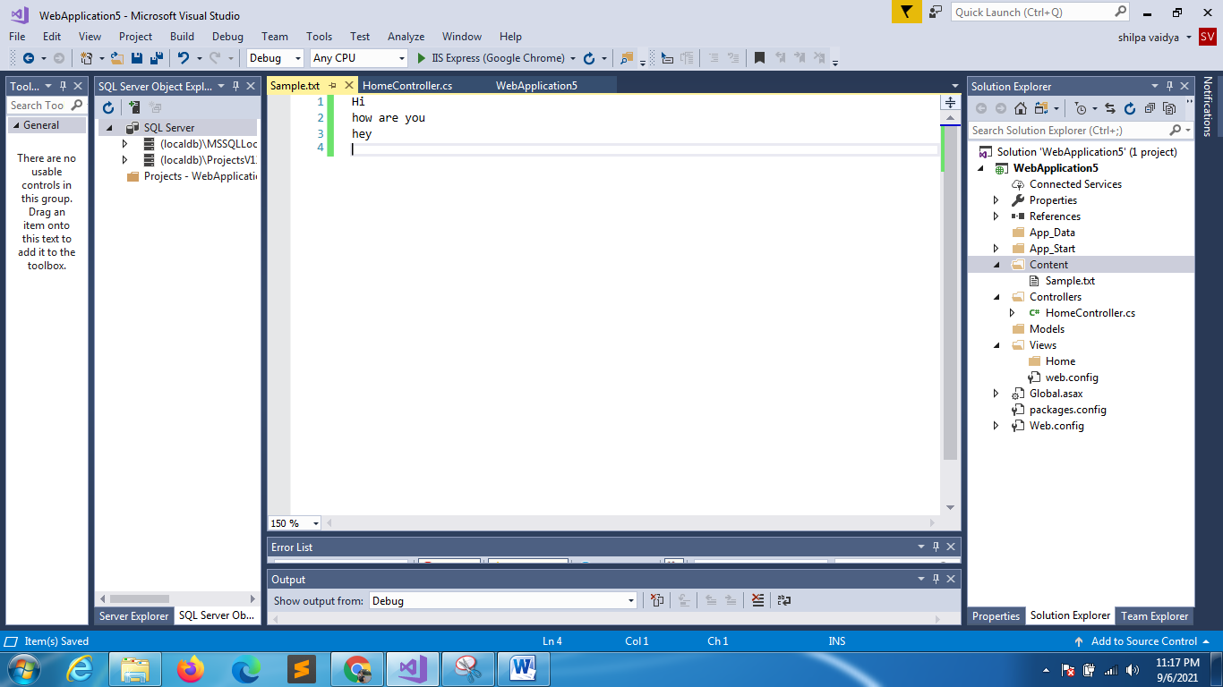
using System;
using System.Collections.Generic;
using System.Linq;
using System.Web;
using System.Web.Mvc;

using System;
using System.Collections.Generic;
using System.Linq;
using System.Web;
using System.Web.Mvc;

namespace WebApplication5.Controllers
{
public class HomeController : Controller
{
// GET: Home
public FileResult ShowText()
{
string path = Server.MapPath("~/Content/Sample.txt");
return File(path,"text/plain");
}
//link to download
public FileResult Downloadfile()
{
string path = Server.MapPath("~/Content/Sample.txt");
return File(path, "text/plain","Mydoc.txt");
}

}
}

