PROJECT

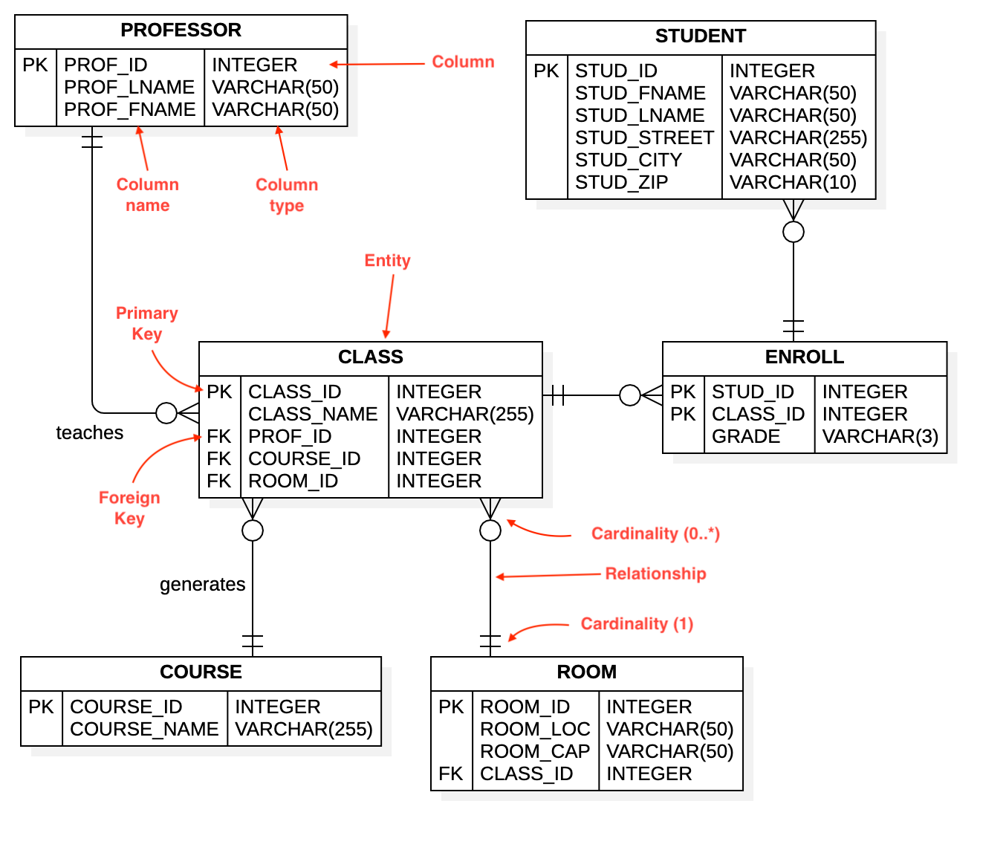

CREATE DATABASE PROJECT1;

USE PROJECT1;

CREATE TABLE STUDENT

(

STUD_ID INT PRIMARY KEY,

STUD_FNAME VARCHAR(50),

STUD_LNAME VARCHAR(50),

STUD_STREET VARCHAR(255),

STUD_CITY VARCHAR(50),

STUD_ZIP VARCHAR(10)

);

CREATE TABLE PROFESSOR

(

PROF_ID INT PRIMARY KEY,

PROF_LNAME VARCHAR(50),

PROF_FNAME VARCHAR(50)

);

CREATE TABLE COURSE

(

COURSE_ID INT PRIMARY KEY,

COURSE_NAME VARCHAR(255)

);

CREATE TABLE CLASS

(

CLASS_ID INT PRIMARY KEY,

CLASS_NAME VARCHAR(255),

PROF_ID INT FOREIGN KEY REFERENCES PROFESSOR(PROF_ID),

COURSE_ID INT FOREIGN KEY REFERENCES COURSE(COURSE_ID),

ROOM_ID INT

);

CREATE TABLE ROOM

(

ROOM_ID INT PRIMARY KEY,

ROOM_LOC VARCHAR(50),

ROOM_CAP VARCHAR(50),

    CLASS_ID INT FOREIGN KEY REFERENCES CLASS(CLASS_ID),

);

ALTER TABLE CLASS

ADD CONSTRAINT FOR_ROOM FOREIGN KEY(ROOM_ID) REFERENCES ROOM(ROOM_ID)

CREATE TABLE ENROLL

(

STUD_ID INT,

CLASS_ID INT,

GRADE VARCHAR(3),

PRIMARY KEY (STUD_ID,CLASS_ID)

);

PROVIDING DATA

INSERT INTO COURSE VALUES(100,'SCIENCE')

INSERT INTO COURSE VALUES(101,'COMMERCE')

INSERT INTO COURSE VALUES(102,'ARTS')

SELECT * FROM COURSE;

|  |  |
| --- | --- |
| COURSE | |
| COURSE_ID | COURSE_NAME |
| 100 | SCIENCE |
| 101 | COMMERCE |
| 102 | ARTS |

INSERT INTO PROFESSOR VALUES(1111,'KASHYAP','VIKAS');

INSERT INTO PROFESSOR VALUES(1112,'JAIRAM','LAKSHMI');

INSERT INTO PROFESSOR VALUES(1113,'SHIRSHAT','SATWIK');

INSERT INTO PROFESSOR VALUES(1114,'PAUL','SATYA');

INSERT INTO PROFESSOR VALUES(1115,'SRIVATSA','ANJALI');

INSERT INTO PROFESSOR VALUES(1116,'DSOUZA','LEO');

INSERT INTO PROFESSOR VALUES(1117,'KHAN','AHMED');

SELECT * FROM PROFESSOR;

|  |  |  |
| --- | --- | --- |
| PROFESSOR | | |
| PROF_ID | PROF_LNAME | PROF_FNAME |
| 1111 | KASHYAP | VIKAS |
| 1112 | JAIRAM | LAKSHMI |
| 1113 | SHIRSHAT | SATWIK |
| 1114 | PAUL | SATYA |
| 1115 | SRIVATSA | ANJALI |
| 1116 | DSOUZA | LEO |
| 1117 | KHAN | AHMED |

DUE TO CONFLICK OF DEADLOCK BETWEEN ROOM TABLE AND CLASS TABLE (FOREIGN KEYS) WILL BE DROPPING CLASS_ID FROM ROOM TABLE AFTER DELETING ITS CONSTRAINTS ON THE DROPPING COLUMN

ALTER TABLE ROOM

DROP FK__ROOM__CLASS_ID__30F848ED

ALTER TABLE ROOM

DROP COLUMN CLASS_ID

INSERT INTO ROOM VALUES(1000,'A BLOCK','1 FLOOR');

INSERT INTO ROOM VALUES(1001,'B BLOCK','1 FLOOR');

INSERT INTO ROOM VALUES(2000,'A BLOCK','2 FLOOR');

INSERT INTO ROOM VALUES(2002,'C BLOCK','2 FLOOR');

INSERT INTO ROOM VALUES(2004,'D BLOCK','3 FLOOR');

SELECT * FROM ROOM;

|  |  |  |
| --- | --- | --- |
| ROOM_ID | ROOM_LOC | ROOM_CAP |
| 1000 | A BLOCK | 1 FLOOR |
| 1001 | B BLOCK | 1 FLOOR |
| 2000 | A BLOCK | 2 FLOOR |
| 2002 | C BLOCK | 2 FLOOR |
| 2004 | D BLOCK | 3 FLOOR |

INSERT INTO CLASS VALUES(111,'BIOLOGY',1111,100,1000);

INSERT INTO CLASS VALUES(222,'ACCOUNTS',1112,101,1001);

INSERT INTO CLASS VALUES(333,'MATHEMATICS',1113,100,1000);

INSERT INTO CLASS VALUES(444,'TALLY',1114 ,101 ,2000);

INSERT INTO CLASS VALUES(555,'PHYSICS',1115 ,100,1001);

INSERT INTO CLASS VALUES(666,'CHEMISTRY',1116,100,2001);

INSERT INTO CLASS VALUES(777,'EXCEL',1117,101,2000);

INSERT INTO CLASS VALUES(888,'HISTORY',1118,102,2004);

|  |  |  |  |  |
| --- | --- | --- | --- | --- |
| CLASSID | CLASSNAME | PROF_ID | COURSE_ID | ROOM_ID |
| 111 | BIOLOGY | 1111 | 100 | 1000 |
| 222 | ACCOUNTS | 1112 | 101 | 1001 |
| 333 | MATHEMATICS | 1113 | 100 | 1000 |
| 444 | TALLY | 1114 | 101 | 2000 |
| 555 | PHYSICS | 1115 | 100 | 1001 |
| 666 | CHEMISTRY | 1116 | 100 | 2001 |
| 777 | EXCEL | 1117 | 101 | 2000 |
| 888 | HISTORY | 1118 | 102 | 2004 |
|  |  |  |  |  |

INSERT INTO STUDENT VALUES(1, 'KANCHANA','NAIK','AAAA','HYDERABAD', '667788');

INSERT INTO STUDENT VALUES(2, 'SUDHEER','BHAT','BBBB','CHENNAI','665577');

INSERT INTO STUDENT VALUES(3, 'KESHAV','KAPOOR','CCCC','BENGALURU','554466');

INSERT INTO STUDENT VALUES(4, 'NAGARJUNA','REDDY','DDDD','MYSURU','556677');

INSERT INTO STUDENT VALUES(5, 'ALBERT','FERNANDES','EEEE','KOCHI','887766');

INSERT INTO STUDENT VALUES(6, 'HEENA','NAAZ','FFFFF','KOLKATTA','554433');

INSERT INTO STUDENT VALUES(7, 'AFRAH','SHAIK','GGGGG','GURUGRAM','334422');

INSERT INTO STUDENT VALUES(8, 'ALEX','DANN','HHHHH','BOMBAY','234567');

INSERT INTO STUDENT VALUES(9, 'SULOCHANA','ROY','IIIII','TRIVENDRUM','765433');

SELECT * FROM STUDENT;

|  |  |  |  |  |  |
| --- | --- | --- | --- | --- | --- |
| STUDENT | | | | | |
| STUD_ID | STUD_FNAME | STUD_LNAME | STUD_STREET | STUD_CITY | STUD_ZIP |
| 1 | KANCHANA | NAIK | AAAA | HYDERABAD | 667788 |
| 2 | SUDHEER | BHAT | BBBB | CHENNAI | 665577 |
| 3 | KESHAV | KAPOOR | CCCC | BENGALURU | 554466 |
| 4 | NAGARJUNA | REDDY | DDDD | MYSURU | 556677 |
| 5 | ALBERT | FERNANDES | EEEE | KOCHI | 887766 |
| 6 | HEENA | NAAZ | FFFFF | KOLKATTA | 554433 |
| 7 | AFRAH | SHAIK | GGGGG | GURUGRAM | 334422 |
| 8 | ALEX | DANN | HHHHH | BOMBAY | 234567 |
| 9 | SULOCHANA | ROY | IIIII | TRIVENDRUM | 765433 |

INSERT INTO ENROLL VALUES(1 ,111, 'A');

INSERT INTO ENROLL VALUES(2 ,222 ,'B');

INSERT INTO ENROLL VALUES(3 ,333 ,'C');

INSERT INTO ENROLL VALUES(4 ,111 ,'A');

INSERT INTO ENROLL VALUES(5 ,222 ,'B');

INSERT INTO ENROLL VALUES(6 ,333 ,'A');

INSERT INTO ENROLL VALUES(7 ,222 ,'A');

INSERT INTO ENROLL VALUES(8 ,333 ,'C');

SELECT * FROM ENROLL;

|  |  |  |
| --- | --- | --- |
| STUD_ID | CLASS_ID | GRADE |
| 1 | 111 | A |
| 2 | 222 | B |
| 3 | 333 | C |
| 4 | 111 | A |
| 5 | 222 | B |
| 6 | 333 | A |
| 7 | 222 | A |
| 8 | 333 | C |

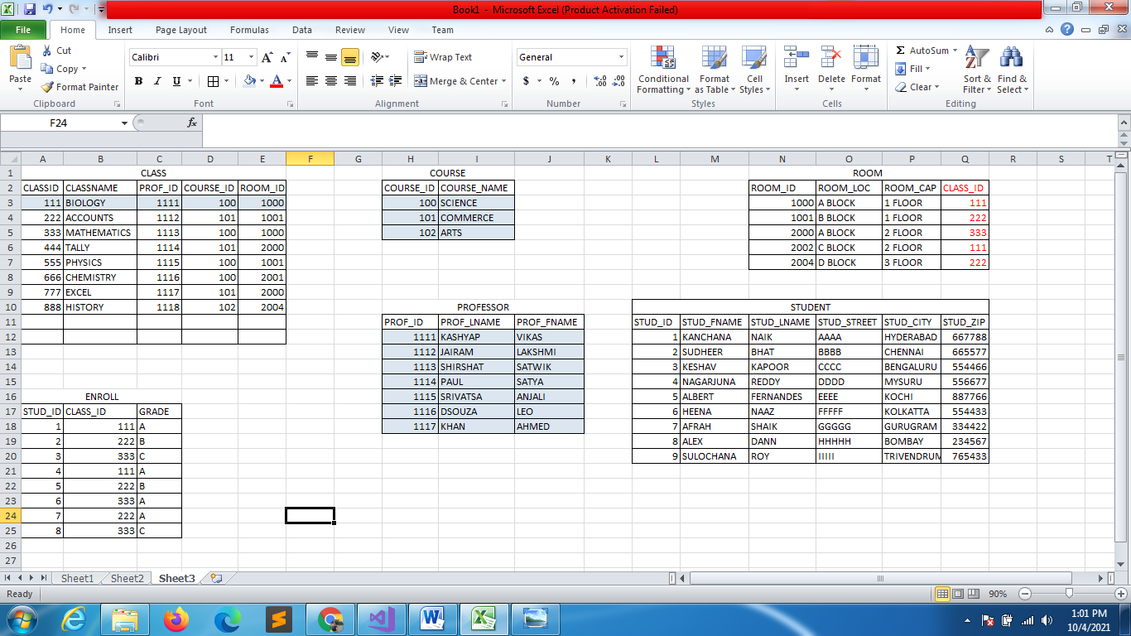

QUERIES

--1 . we need all the students who have taken commerce

SELECT STUD_FNAME,STUD_LNAME FROM STUDENT

WHERE STUD_ID IN

(SELECT STUD_ID

FROM ENROLL

WHERE CLASS_ID IN (

SELECT CLASS_ID

FROM CLASS

WHERE COURSE_ID = (SELECT COURSE_ID FROM COURSE

WHERE COURSE_NAME='COMMERCE' )))

OR USING JOINS

SELECT STUD_FNAME,STUD_LNAME

FROM STUDENT S

INNER JOIN ENROLL E ON S.STUD_ID = E.STUD_ID

INNER JOIN CLASS C ON E.CLASS_ID = C.CLASS_ID

INNER JOIN COURSE CS ON CS.COURSE_ID = C.COURSE_ID AND  CS.COURSE_NAME='COMMERCE'

|  |  |
| --- | --- |
| STUD_FNAME | STUD_LNAME |
| SUDHEER | BHAT |
| ALBERT | FERNANDES |
| AFRAH | SHAIK |

--1 . we need all the students who have taken commerce

SELECT CONCAT(STUD_FNAME,' ' ,STUD_LNAME) AS FULLNAME FROM STUDENT

WHERE STUD_ID IN

(SELECT STUD_ID

FROM ENROLL

WHERE CLASS_ID IN (

SELECT CLASS_ID

FROM CLASS

WHERE COURSE_ID = (SELECT COURSE_ID FROM COURSE

WHERE COURSE_NAME='COMMERCE' )))

|  |
| --- |
| FULLNAME |
| SUDHEER BHAT |
| ALBERT FERNANDES |
| AFRAH SHAIK |

INSERT INTO CLASS VALUES(666,'CHEMISTRY',1116,100,2002);

SELECT * FROM CLASS

--FIND ALL SCIENCE LECTURERS

SELECT PROF_FNAME,PROF_LNAME

FROM PROFESSOR

WHERE PROF_ID IN (SELECT PROF_ID

FROM CLASS WHERE COURSE_ID =

(SELECT COURSE_ID FROM COURSE

WHERE COURSE_NAME = 'SCIENCE'))

|  |  |
| --- | --- |
| PROF_FNAME | PROF_LNAME |
| VIKAS | KASHYAP |
| SATWIK | SHIRSHAT |
| ANJALI | SRIVATSA |
| LEO | DSOUZA |

--SAME QUERY WITHJOINS

--JOINS

SELECT P.PROF_FNAME,P.PROF_LNAME

FROM PROFESSOR P

INNER JOIN CLASS C ON P.PROF_ID=C.PROF_ID

INNER JOIN COURSE AS CS ON C.COURSE_ID = CS.COURSE_ID AND CS.COURSE_NAME = 'SCIENCE'

--STUDENT 1000 & 2002 ROOMS

SELECT STUD_FNAME,STUD_LNAME

FROM STUDENT S

INNER JOIN ENROLL E ON S.STUD_ID = E.STUD_ID

INNER JOIN CLASS C ON E.CLASS_ID = C.CLASS_ID AND C.ROOM_ID IN (1000,2002)

|  |  |
| --- | --- |
| STUD_FNAME | STUD_LNAME |
| KANCHANA | NAIK |
| KESHAV | KAPOOR |
| NAGARJUNA | REDDY |
| HEENA | NAAZ |
| ALEX | DANN |

--STUDENT NAME WITH GRADE A IN COMMERCE

SELECT STUD_FNAME,STUD_LNAME

FROM STUDENT WHERE STUD_ID IN (

SELECT STUD_ID

FROM ENROLL WHERE

GRADE = 'A' AND CLASS_ID IN

(SELECT CLASS_ID

FROM CLASS WHERE

COURSE_ID = (SELECT COURSE_ID

FROM COURSE WHERE COURSE_NAME='COMMERCE')))

OR

SELECT S.STUD_FNAME,S.STUD_LNAME

FROM STUDENT S

INNER JOIN ENROLL E ON S.STUD_ID= E.STUD_ID AND E.GRADE='A'

INNER JOIN CLASS C ON C.CLASS_ID = E.CLASS_ID

INNER JOIN COURSE CS ON CS.COURSE_ID = C.COURSE_ID AND COURSE_NAME='COMMERCE'

|  |  |
| --- | --- |
| STUD_FNAME | STUD_LNAME |
| AFRAH | SHAIK |