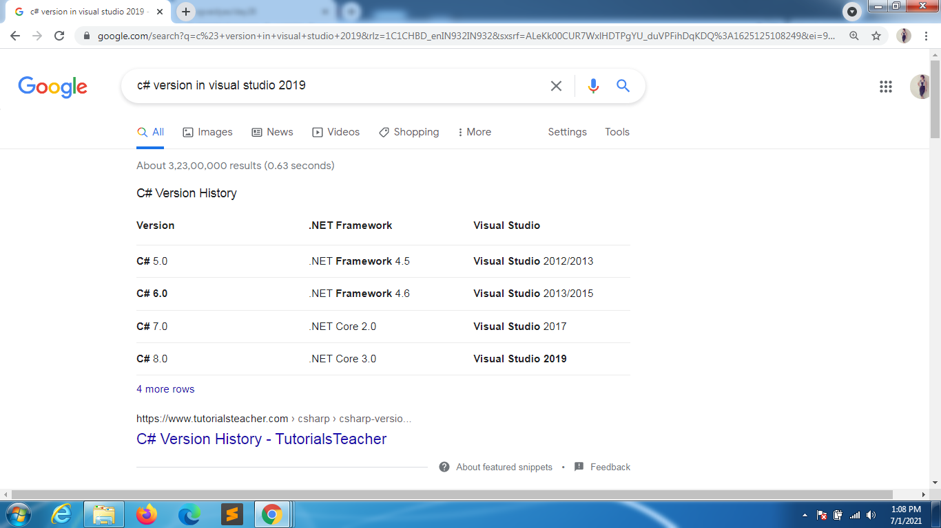

<https://www.guru99.com/java-vs-c-sharp-key-difference.html#:~:text=Java%20is%20a%20class%2Dbased,only%20in%20an%20unsafe%20mode>.

| **Parameters** | **Java** | **C#** |
| --- | --- | --- |
| Creation | Designed by Sun Microsystems. | Designed as part of Microsoft's .NET initiative. |
| Ecosystem | Has a huge opensource ecosystem. | Used to develop software for Microsoft platforms. |
| Support for generics | It is implemented using erasures and casts added upon compilation into bytecode. | Integrated into the CLI and allows type information to be available at runtime |
| Support for delegates | Requires use of an interface to achieve similar functionality. | Has delegates which serve as methods that can be called without knowledge of target object. |
| Checked exceptions | Only has one type of exception | Distinguishes between checked and unchecked exceptions |
| Polymorphism | Invokes the "virtual" keyword in a base class and "override" keyword in a derived class. | Enables polymorphism by default. |
| Designed for | Java programming language is intended to be run on a Java platform, by the help of Java Runtime Environment (JRE). | The C# programming language is designed to be run on the Common Language Runtime (CLR). |
| Safety type | Java type safety is safe. | C# type of safety is unsafe. |
| Built-in Datatype | Built-in data types that are passed by value are called simple types. | Built-in data types that are passed by value are known as primitive types. |
| Arrays | Arrays in Java are a direct specialization of Object. | Arrays in C# are a specialization of System. |
| Support for conditional compilation. | Java doesn't provide support for conditional compilation | C# supports conditional compilation feature with the help of preprocessor directives. |
| Support for Goto statement. | Java doesn't support the goto statement. | C# supports the goto statement. |
| Structure and unions | Java doesn't support structures and unions. | C# supports structures and unions. |
| Suited for | For concurrency and complex project. | It is mainly suited for game app development projects. |
| Installation | Requires JDK to run Java. | .Net framework provides a vast library of codes used by C# |
| Cross-platform support | Java is highly cross-platform with its byte code. | Compared to Java, C# need to improve on this feature. |
| IDE | Eclipse, NetBeans, IntelliJ IDEA | Visual Studio, MonoDevelop |
| Operator Overloading | No support for operator overloading | C# provides support for operator overloading for multiple operators. |
| Number of Public Classes | In Java, there is an only a single public class inside source code, or it will display compilation error. | In C#, there are multiple public classes included in the source code. |
| Control for API | It is controlled by an open community process. | Microsoft controls C# API. |
| Runtime Environment | Java supports JVM(Java Virtual Machine). | C# supports CLR(Common Language Runtime). |
| Platform Dependency | Java is a robust and platform independent language. | Code written in C# is windows specific. |
| Pointers | Java does not support pointers. | In C# you can use pointer only in an unsafe mode. |
| Floating point | Java supports strctfp keyword that means it results for a floating point will be the same for different platform. | C# does not offer support for strictfp keyword. This means that the result of floating point numbers may not be guaranteed to be the same across all platforms. |
| TIOBE Index | 1 | 6 |
| Famous companies using | Airbnb, Instagram, Spotify, Netflix, etc. | Stack Exchange, Microsoft, Coderus, Docplanner, etc. |
| Salary Range | The average salary earned by Java Developer is $102,633 per year in the United States. | The average salary for "C# sharp developer" is approximately $108,145 per year. |

DATA TYPES

<https://www.geeksforgeeks.org/c-sharp-data-types/>

CTS/CLS

<https://www.c-sharpcorner.com/blogs/what-are-cts-and-cls-in-net#:~:text=CLS%20stands%20for%20Common%20Language,said%20to%20be%20CLS%20Compliant>.

<https://docs.microsoft.com/en-us/dotnet/standard/common-type-system>

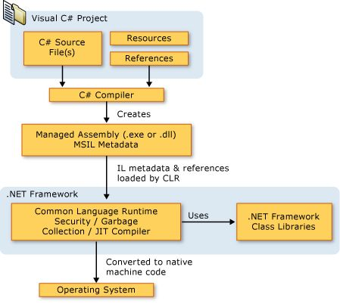

COMPONENT STACK

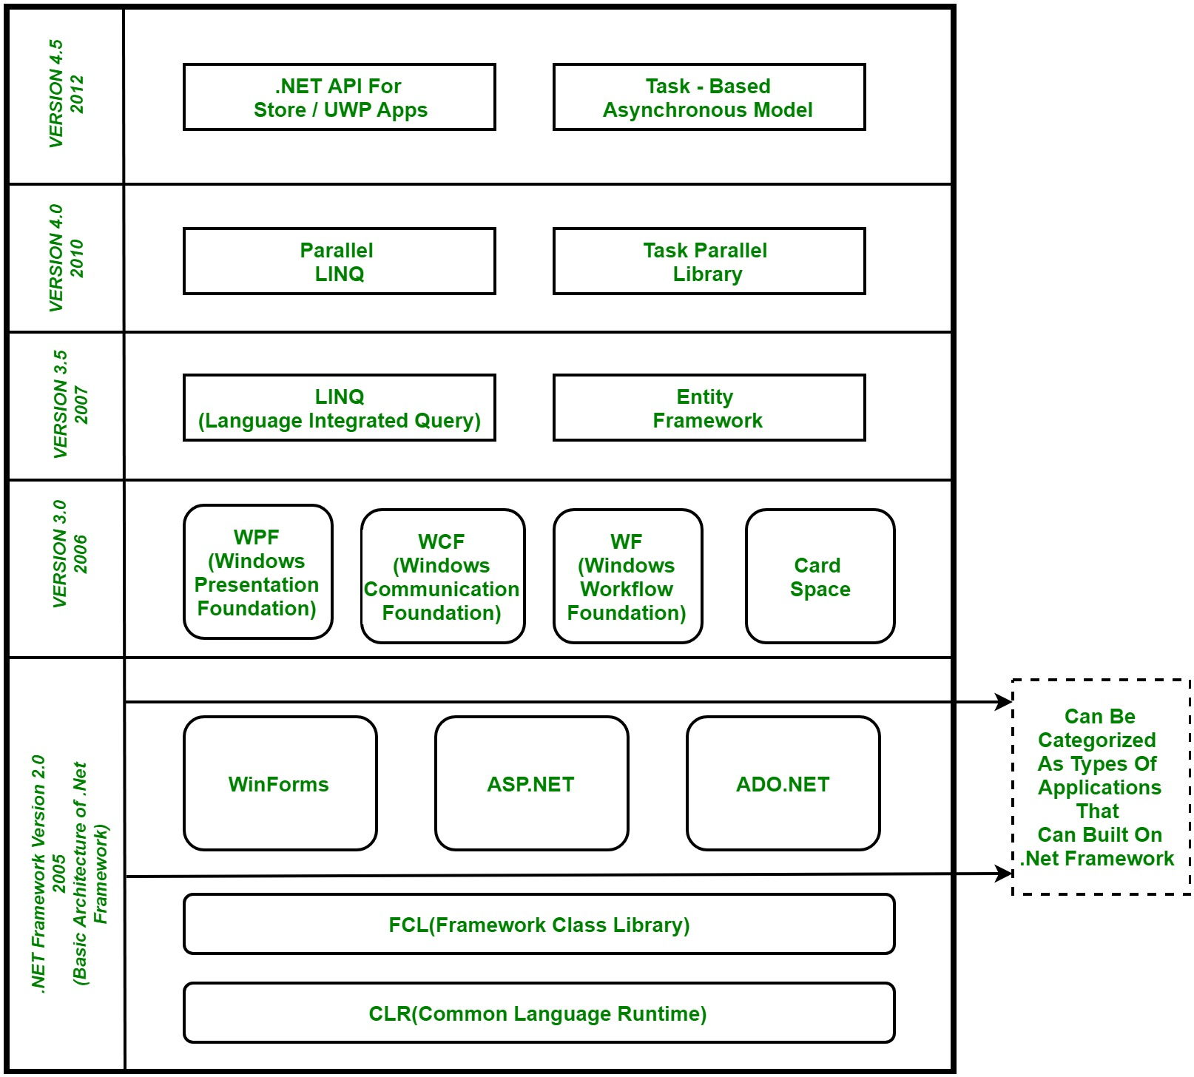

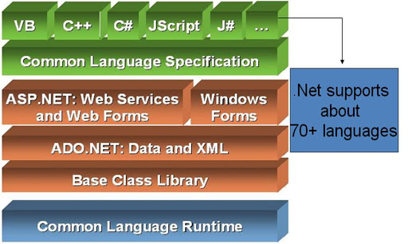

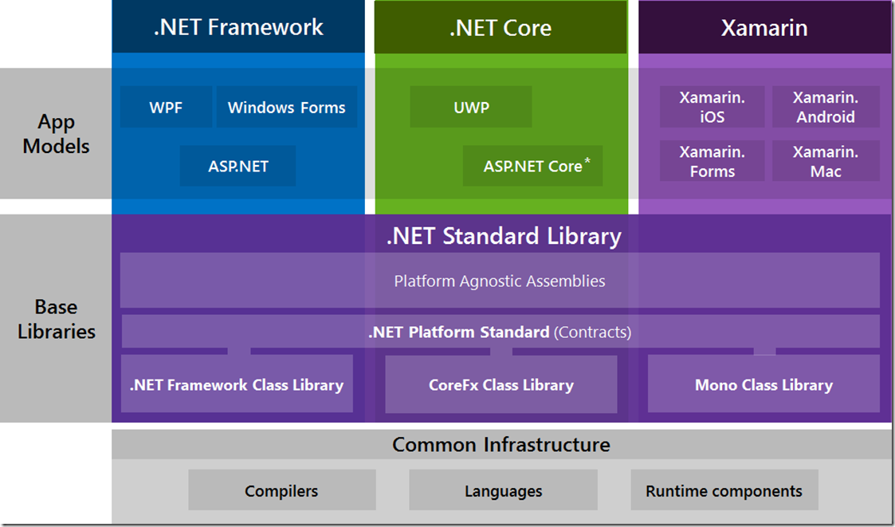

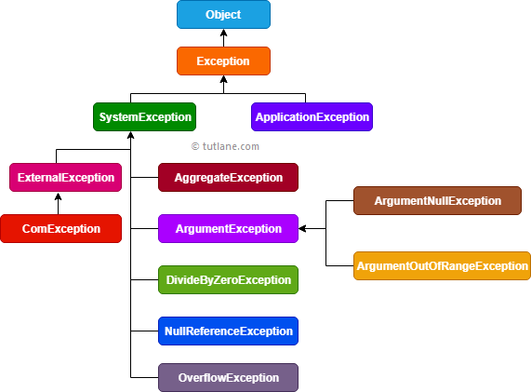

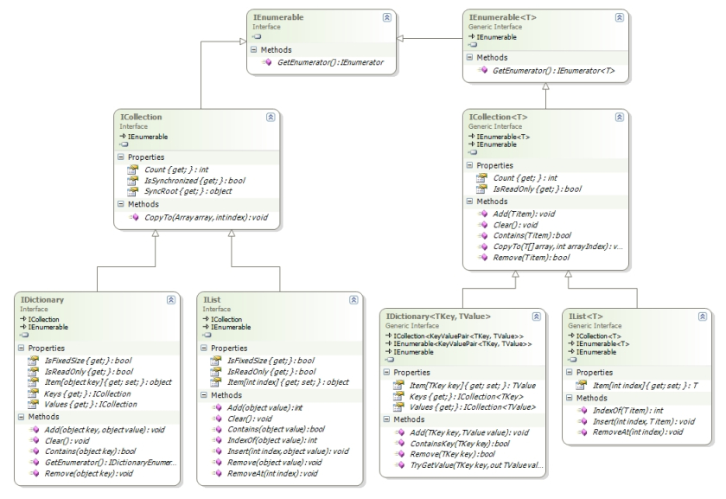

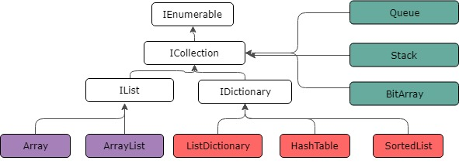

C# | .NET Framework (Basic Architecture and Component Stack)

.NET is a software framework which is designed and developed by Microsoft. The first version of .Net framework was 1.0 which came in the year 2002. In easy words, it is a virtual machine for compiling and executing programs written in different languages like [C#](https://www.geeksforgeeks.org/introduction-to-c/), VB.Net etc.  
It is used to develop Form-based applications, Web-based applications and Web services. There is a variety of programming languages available on the .Net platform, VB.Net and [C#](https://www.geeksforgeeks.org/introduction-to-c/) being the most common ones are . It is used to build applications for Windows, phone, web etc. It provides a lot of functionalities and also supports industry standards.

### ****Basic Architecture and Component Stack of .NET Framework****

The first three components from bottom are considered as the basic architecture of .Net framework which came in the year 2005 and after this more components were added by Microsoft in the .Net Framework as following :

[](https://media.geeksforgeeks.org/wp-content/uploads/Net-Framework.jpg)

**1. CLR (Common Language Runtime) :** It is a run-time environment which executes the code written in any .NET programming language. .Net framework provides the support for many languages like [C#](https://www.geeksforgeeks.org/introduction-to-c/), F#, [C++](https://www.geeksforgeeks.org/c-plus-plus/), Cobra, Jscript.Net, VB.Net, Oxygene etc

**2. FCL (Framework Class Library) :** A large number of class libraries are present in this framework which is known as FCL.

**3. Types of Applications :** Mainly the applications which are built in .Net framework is divided into the following three categories :

* **WinForms :** Form – Based applications are considered under this category. In simple terms, we can say client based applications which read and writes the file system comes under this category.
* **ASP .NET :** Web-Based applications come under this category. ASP.Net is a framework for web and it provides the awesome integration of HTML, CSS and JavaScript which makes it useful to develop the web applications, websites and web services. **Web services were added in .Net Framework 2.0 and considered as a part of ASP.NET web applications.**
* **ADO .NET :** It includes the application which are developed to communicate with the database like MS SQL Server, Oracle etc. comes. It mainly consists of classes that can be used to connect, retrieve, insert and delete data.

**4. WPF (Windows Presentation Foundation) :** Windows Presentation Foundation (WPF) is a graphical subsystem given by Microsoft which uses DirectX and is used in Windows-based applications for rendering UI (User Interface). WPF was initially released as part of .NET Framework 3.0 in 2006 and previously known as **“Avalon”**.

**5. WCF (Windows Communication Foundation) :** It is a framework for building connected and service-oriented applications used to transmit the data as asynchronous from one service endpoint to another service point. It was previously known as the **Indigo**.

**6. WF (Windows Workflow Foundation) :**It is a technology given by Microsoft which provides a platform for building workflows within .Net applications.

**7. Card Space :**It is a Microsoft .NET Framework software client which is designed to let users provide their digital identity to online services in a secure, simple and trusted way.

**8. LINQ (Language Integrated Query) :** It is introduced in .Net framework version 3.5. Basically, it is a query language used to make the query for data sources with VB or [C#](https://www.geeksforgeeks.org/introduction-to-c/) programming languages.

**9. Entity Framework :** It is open–source ORM (Object Relational Mapping) based framework which comes into .Net Framework version 3.5. It enables the .Net developer to work with database using .Net objects. Before entity framework, .Net developers have performed a lot of things related database. Like to open a connection to the database, developers have to create a Data Set to fetch or submit the data to the database, convert data from the Data Set to .NET objects or vice-versa. It creates the difficulties for developers and also it was the error-prone process, then **“Entity Framework”** comes to automate all these database related activities for the application. So, Entity Framework allows the developers to work at a higher level of abstraction.

**Note :** **REST (Representational State Transfer)** and **AJAX**were added in .Net Framework 3.5 as an extension and services of ASP.NET for enhancing web services of .NET Framework.

**10. Parallel LINQ (Language Integrated Query) :** It comes in .Net Framework version 4.0 and also termed as PLINQ. It provides a concurrent query execution engine for **LINQ**. It executes the **LINQ** in parallel such that it tries to use as much processing power system on which it is executing.

**11. TPL (Task Parallel Library) :** It is a set of public types and APIs. It allows the developers to be more productive by simplifying the process of adding concurrency and parallelism to .Net applications.

**12. .NET API For Store/UWP Apps :** In 2012, Microsoft added some APIs for creating **UWP(Universal Windows Platform)** apps for Windows using [C#](https://www.geeksforgeeks.org/introduction-to-c/) or VB.

**13. Task-Based Asynchronous Model :** It is model used to describe the asynchronous operations and tasks in .Net Framework.