**Homework 3**

Data 230 – Data Visualization

Sungwon Lee

017473950

Zero Emission Vehicle in California

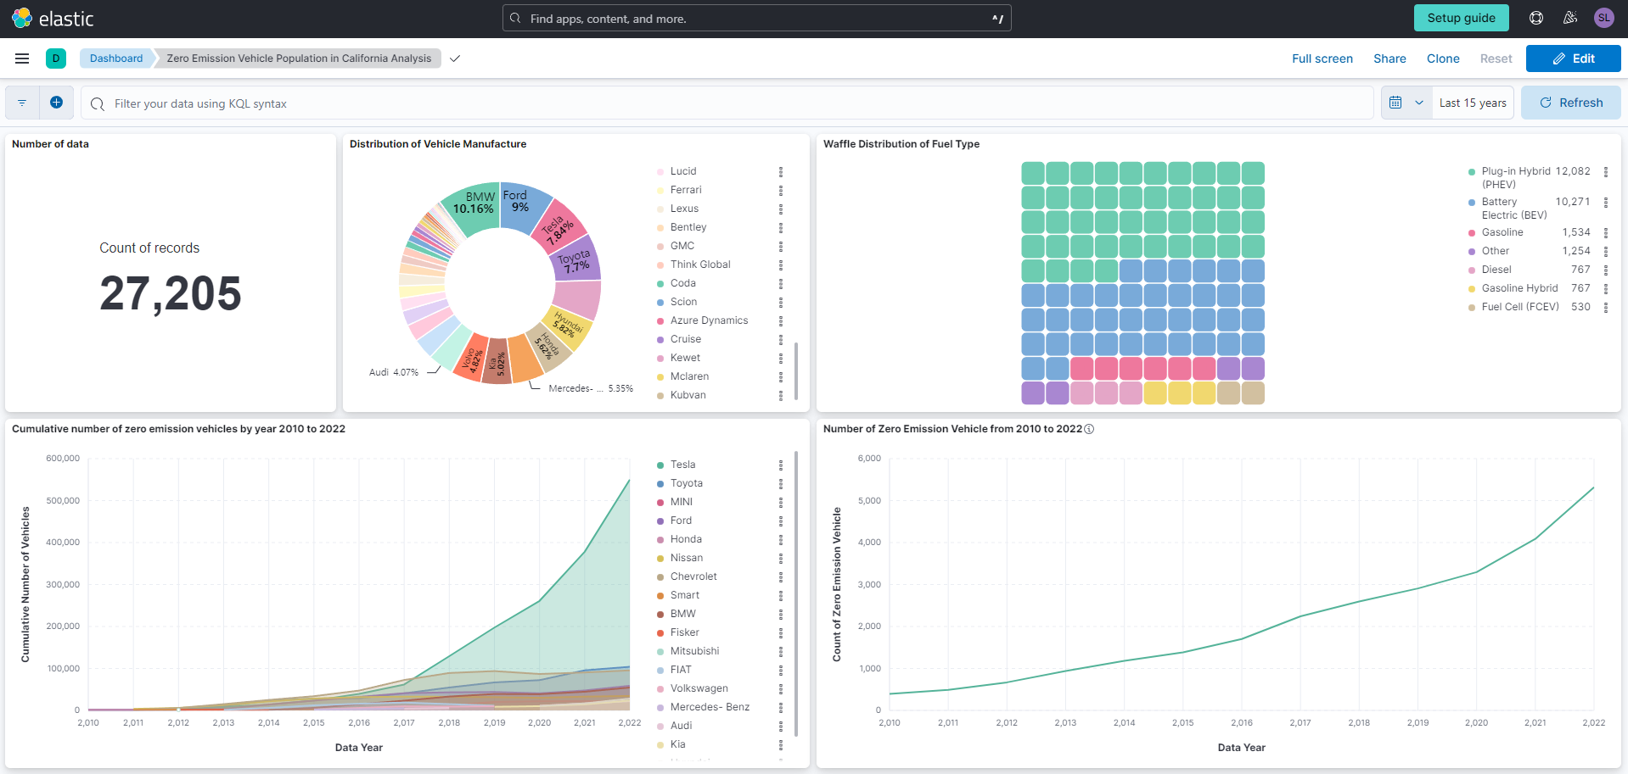

Dashboard Link : <https://homework3.kb.us-central1.gcp.cloud.es.io:9243/app/r/s/ADMNP>

The dataset contains information on the zero emission vehicle population in California from 2010 to 2022. It includes details such as the data year, county, dashboard fuel type, fuel type, manufacturer, model, and the number of vehicles. The population is updated annually each April and reflects vehicles on the road during the previous calendar year. There are categories for regional data, including county, metropolitan statistical area (MSA), or ZIP code levels. The dataset has information on various fuel types, including Battery Electric Vehicles (BEVs), Gasoline vehicles, Flex Fuel, Diesel vehicles, Gasoline Hybrid vehicles, and Natural Gas vehicles.

Examining the dataset provided, we notice a steady increase in the number of eco-friendly cars in California from 2010 to 2022. Among the various companies making these green vehicles, Tesla stands out for a big jump in its car numbers, especially right after introducing its electric cars.

Looking more closely at the kinds of eco-friendly cars, it's clear that Plug-in Hybrid and Battery Electric cars are the most popular types. This means more people are choosing cars that either partly or fully run on electricity. This popularity could be because of improvements in technology, concerns about the environment, and support from the government.

In summary, the dataset tells a story of how the number of eco-friendly cars is growing in California. Tesla's impact is clear, and more people are opting for cars that use electricity, showing a shift towards more sustainable transportation in the state. This dataset is like a window into the changing world of cleaner, greener vehicles in California.