1. **Install java jdk in EC2(ubunto)**

1.1 open terminal use command below to install JRE

sudo apt-get install default-jre

1.2 sudo apt-get install default-jdk

1.3 java -version

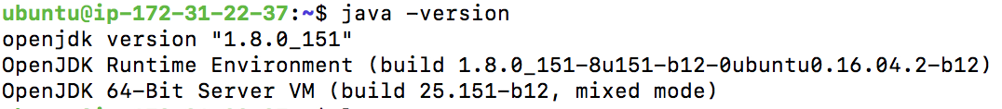

If you see the above text means you have install jdk successfully!

1. **Run my code in EC2**

git clone <https://github.com/sgxshan/StateStreet>

cd StateStreet/

java StateStreet.CurrencyConvert --field 2 --multiplier 0.8 < data.csv > euro.csv

java StateStreet.CurrencyConvert --field 2 --multiplier 1.25 < euro.csv > usd.csv

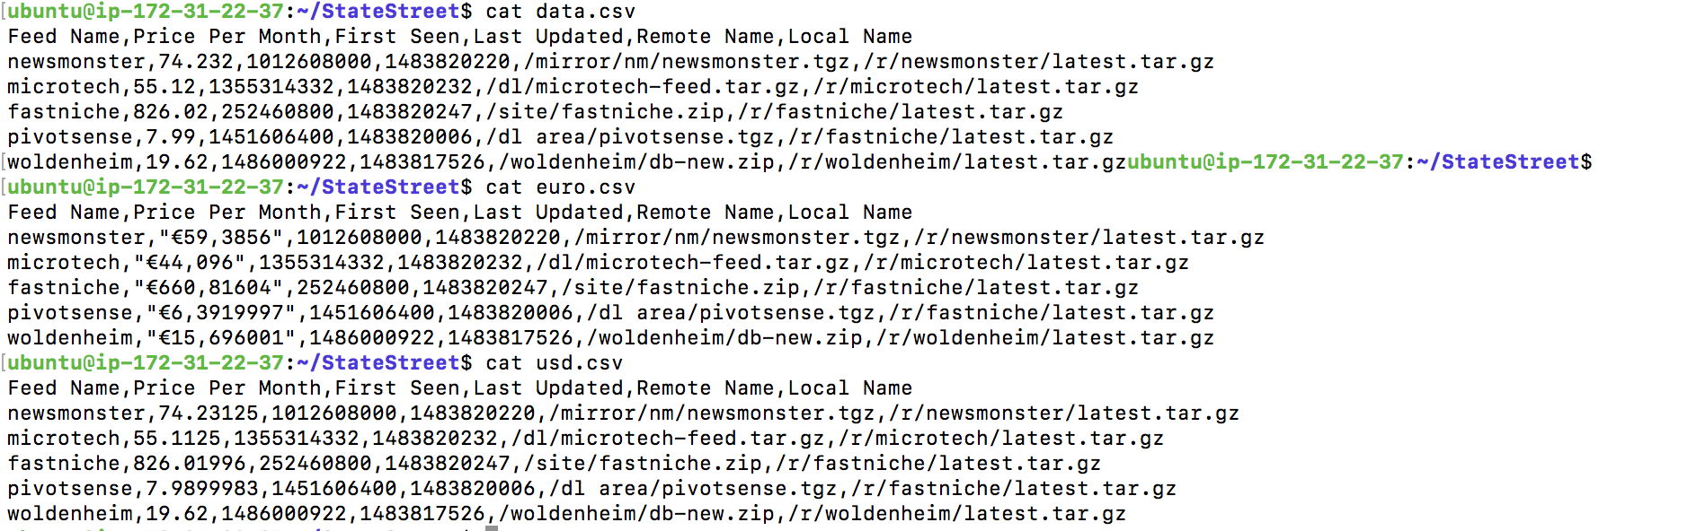

The price can be converted from USD to Euro and be converted from Euro back to USD.

java StateStreet.CurrencyConvert --field 2 --multiplier 1 -i data.csv -o euro.csv

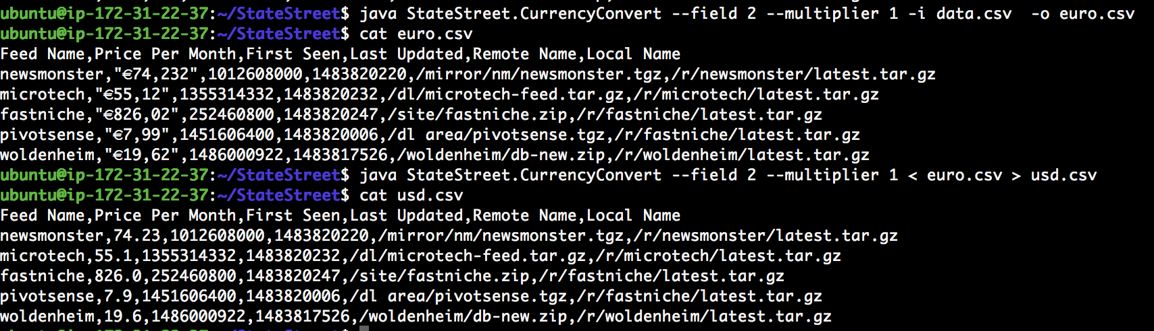

1. **Corner Case to handle exception**

Condition 1: Additional comma

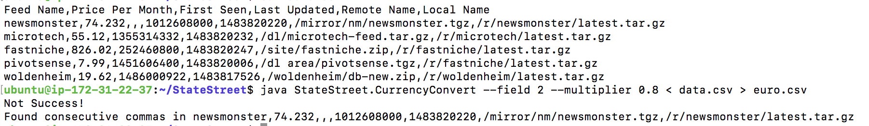

Condition 2: Invalid Quotation Mark

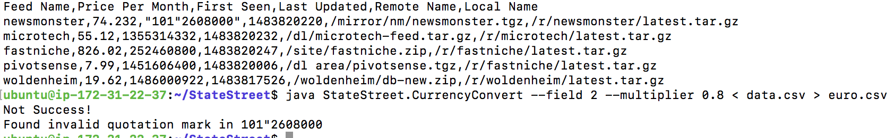

Condition 3: Invalid Price

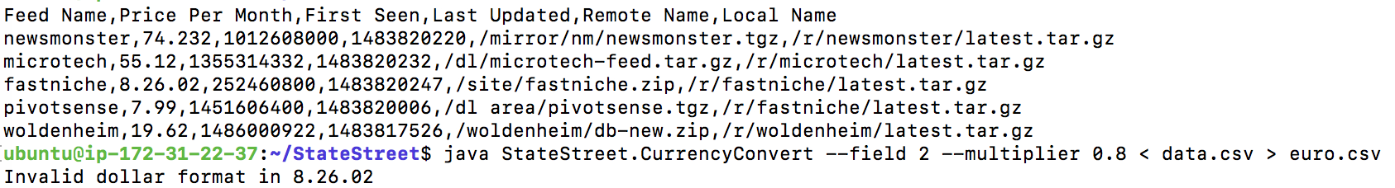

If the input is wrong, the application will give you hint on how to use it

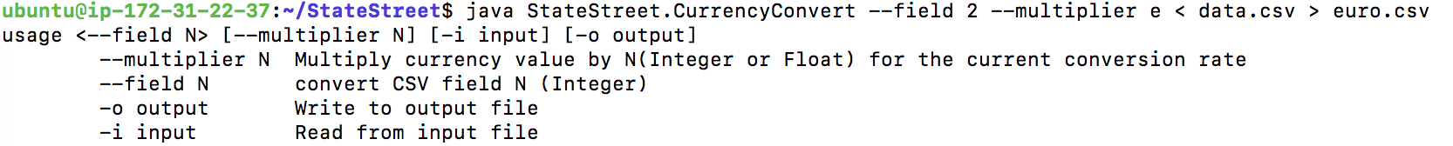

By the way I write the command arguments handler by myself instead of using the library.

**If you have any question when run my code, please let me know**

**xin.shan@mail.utoronto.ca**