USB GPS RECEIVER INSTALLATION GUIDE

Driver No: PL2303_A

Files included in this driver release:

DRemover98_2K.exe

driver_info.txt

serwpl.inf

Win98_ME\ser9pl.sys

Win98_ME\serspl.inf

Win98_ME\serspl.vxd

Win2K_XP\ser2pl.sys

GPSinfo.exe

A: Installation Steps:
- Create a folder on your hard drive called C:\USB-GPS and copy all files on the driver disk to this folder.
- Plug the GPS’s receiver into the USB port of your PC and follow the installation instruction for the driver file as prompted by your computer’s Operating System (O/S). You will be asked for the “location of the (driver) file.”
- Click “Browse” and select a path to: C:\USB-GPS. The installation process will automatically select and load the correct USB driver that matches with your O/S version.
- To verify the COM port assigned to your GPS, you must open the “Control Panel,” click on “System,” select “Devices Manager” and look for the heading “Port (COM & LPT).” Maximize it by clicking on the “+” sign. You should see “USB to Serial Port” assigned to a COM port, (generally COM3, but this may vary from PC to PC).
- Then from within your mapping, or charting software, you will need to configure the COM port which was assigned to the GPS device in order for proper communication. Most software requires you to manually configure the COM port setting for the device to be read.
- If you are unable to set up your PC successfully by following the above procedures of installation, please unplug the GPS device from the USB port and re-insert it after 10 seconds to reset the device.

B: How to test your GPS receiver ?
Users can use the GPSinfo.exe program to verify that the GPS is actually configured properly and working.

- Run the “GPSinfo.exe” to execute the installation procedure of testing program.
- Select the proper COM port for your GPS device as confirmed in step number “A5.”
- Set COM port to Baud rate: 4800
- If no mistakes have been made in the configuration process there should be data being displayed in the window, which is confirmation that the communication between the GPS device and the “GPSinfo.exe” software is working properly.
- If the operations above are unsuccessful and cause errors, please exit the software which you currently use and unplug the GPS from the USB port and reinsert it after 10 seconds to reset the device.

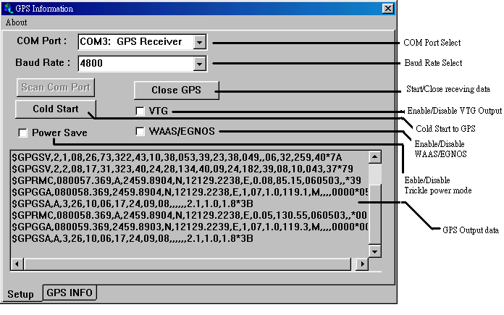

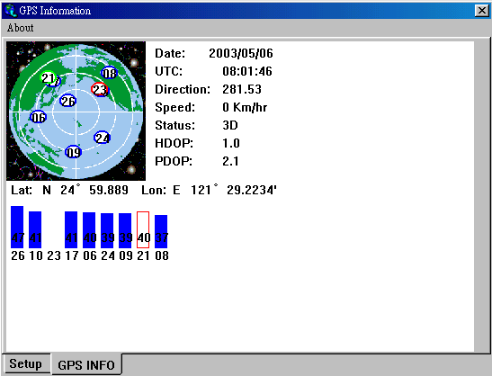

NOTE: Configuration (or selection) of an assigned COM port for the GPS device from within your mapping or charting software must be completed whenever using a software for the first time.

LED Indicator:
LED OFF: Receiver switch off
LED ON: No fixed, Signal searching
LED Flashing: Position Fixed

C: Un-Installation:

1. Run the program “C:\USB-GPS\DRemover98_2k.exe” to uninstall the GPS driver.

D: Troubleshooting:
NO GPS RESPONSE AFTER INSTALLATION:
1. If you have followed the above installation steps but the GPS device still does not work, try exiting the software and unplugging the GPS device from the USB port and wait for at least 10 seconds, then re-connect the GPS device back into your PC. Also note that if you want to re-start your map software, you should also wait at least 10 seconds before re-opening it.

REGARDING ERATTIC MOUSE CURSOR IN WIN2000:
2. If your mouse doesn’t work properly after installation of the GPS driver, this situation is caused by a problem in WIN2000 and is not related to the GPS device. Microsoft has acknowledged and stated that “the serial device (USB is actually converted to serial), may be detected as a serial mouse in WIN2000 O/S.” To best resolve this issue, unplug the GPS device from the USB port during boot-up and only re-insert after boot-up is completed.

Should you have any additional questions regarding the operation of our USB GPS receiver box, please don't hesitate to contact your dealer. Should you encounter a problem, It’s important that you document the following before calling for help:

- Which step or function you were doing when the problem occurred.
- What error message was displayed.
- What operating system you are using.
- The driver file you have installed (Driver No: PL2303_A)

