LAB ASSIGNMENT-1

**Experiment Title: Process Creation and Management Using Python OS Module**

**Task 1: Process Creation Utility**

Write a Python program that creates N child processes using os.fork(). Each child prints:  
- Its PID  
- Its Parent PID  
- A custom message  
The parent should wait for all children using os.wait().

Input-

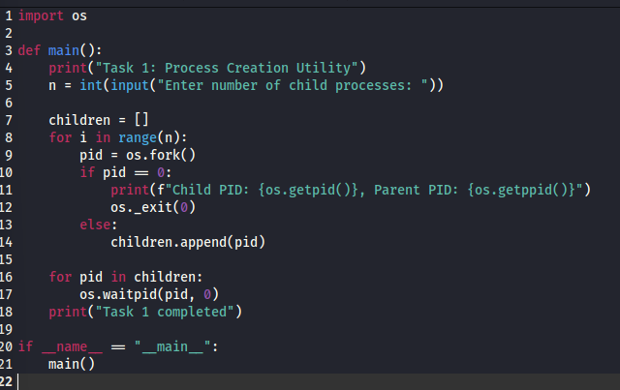

Output-

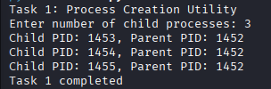

**Task 2: Command Execution Using exec()**

Modify Task 1 so that each child process executes a Linux command (ls, date, ps, etc.) using os.execvp() or subprocess.run().

Input-

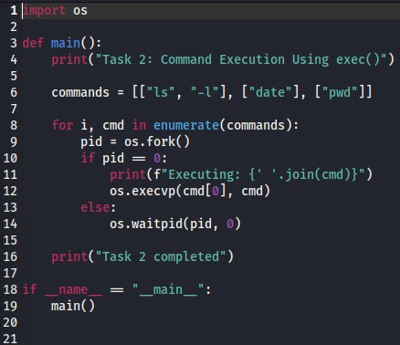

Output-

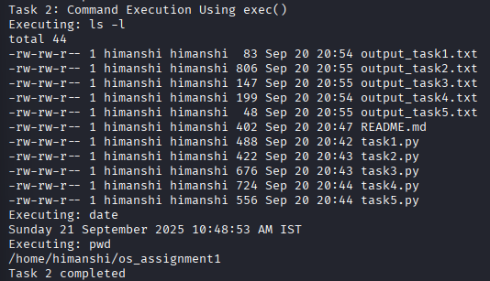

**Task 3: Zombie & Orphan Processes**

Zombie: Fork a child and skip wait() in the parent.  
Orphan: Parent exits before the child finishes.  
Use ps -el | grep defunct to identify zombies.

Input-

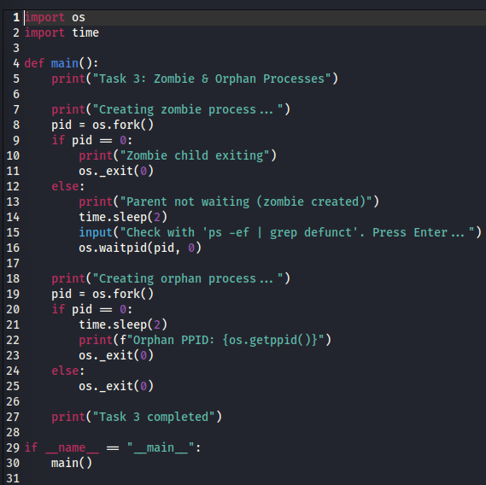

Output-

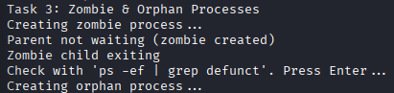

**Task 4: Inspecting Process Info from /proc**

Take a PID as input. Read and print:  
- Process name, state, memory usage from /proc/[pid]/status  
- Executable path from /proc/[pid]/exe  
- Open file descriptors from /proc/[pid]/fd

Input-

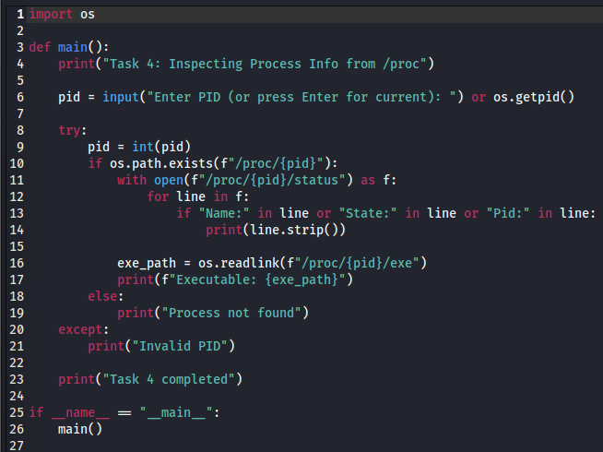

Output-

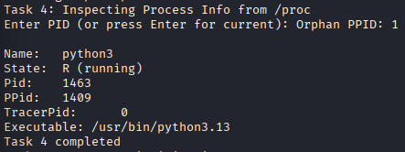

**Task 5: Process Prioritization**

Create multiple CPU-intensive child processes. Assign different nice() values. Observe and log execution order to show scheduler impact.

Input-

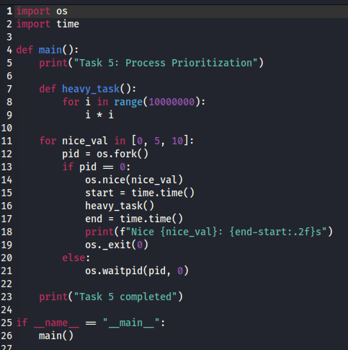

Output-

