Lab: Measuring and Analyzing the Running Time of Algorithms in C++
Analysis of Algorithms — Experimental Studies, Primitive Operations, Big-O

1. Experimental Method
The programs were compiled with g++ using -O0, as recommended by the lab. The timed sections contain only the operation being measured, while input generation and output are outside the timed region where practical. The measurements below are from one execution environment, so exact times can change on another computer. The main purpose is to compare how the measurements grow as n increases.

2. Set 1 Results

Exercise 1 — Array Sum
n | Time (µs)
1000 | 1.00
5000 | 5.00
10000 | 10.00
50000 | 54.00
100000 | 170.40
Reflection: When n increases, the measured time generally increases almost proportionally. This matches O(n), because the loop visits every array element once.

Exercise 2 — Linear Search
n | Best (µs) | Average (µs) | Worst (µs)
1000 | 0.00 | 0.00 | 1.00
5000 | 0.00 | 2.20 | 5.00
10000 | 0.00 | 5.00 | 10.00
50000 | 0.00 | 25.00 | 88.80
100000 | 0.00 | 50.00 | 104.40
Reflection: The worst case matches O(n) because the algorithm may check every element before returning -1. The best case stays nearly constant because the key is the first element, so only one comparison is needed.

Exercise 3 — Bubble Sort
n | Sum time (µs) | Bubble sort time (µs)
1000 | 1.00 | 1412.67
5000 | 5.00 | 31040.67
10000 | 11.33 | 122304.00
20000 | 21.67 | 506704.67
30000 | 32.67 | 1340465.00
Reflection: Increasing n by 10 times is expected to increase quadratic work by about 100 times. The measurements show a strong super-linear increase, which is consistent with O(n²).

Exercise 4 — Static vs Dynamic Array
n | Static fill (µs) | Dynamic fill (µs) | Dynamic bytes
1000 | 5.40 | 5.20 | 4000
5000 | 28.80 | 29.00 | 20000
10000 | 57.80 | 61.60 | 40000
50000 | 351.80 | 306.20 | 200000
100000 | 651.00 | 657.00 | 400000
Reflection: The timing difference is small and changes between input sizes. The important practical difference is flexibility: a dynamic array can be allocated for a size known at runtime, while the static array has a fixed compile-time capacity.

Exercise 5 — std::vector
n | push_back only (µs) | reserve + push_back (µs)
1000 | 28.60 | 22.60
5000 | 140.00 | 130.40
10000 | 246.00 | 236.00
50000 | 1233.60 | 1202.80
100000 | 2443.60 | 2385.80
capacity_jumps: 1 2 4 8 16 32 64 128 256 512 1024 2048 4096 8192 16384 32768 65536 131072 | None | None
Capacity jumps observed: 1, 2, 4, 8, 16, 32, 64, 128, 256, 512, 1024, 2048, 4096, 8192, 16384, 32768, 65536, 131072.
Reflection: reserve(n) usually reduces the cost because the vector does not need to repeatedly allocate a larger buffer and move existing elements. The capacity growth pattern explains amortized O(1): most push_back operations are cheap, while occasional growth operations are expensive, but the expensive operations are spread over many insertions.
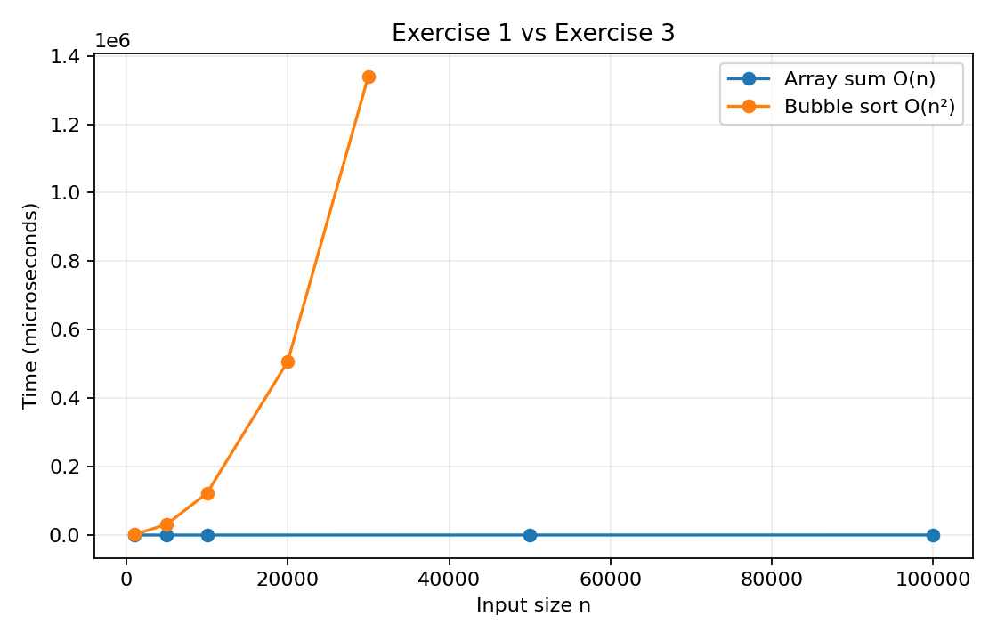
Figure 1. Measured running time for array sum and bubble sort.

3. Set 2 Challenge Results

Challenge 1 — Bubble Sort vs std::sort
n | Bubble sort (ms) | std::sort (ms) | Ratio
1000 | 1.127 | 0.160 | 7.061
5000 | 26.703 | 1.012 | 26.382
10000 | 116.460 | 3.492 | 33.347
20000 | 459.341 | 5.049 | 90.980
30000 | 1098.104 | 8.330 | 131.822
50000 | 3149.091 | 12.180 | 258.556
100000 | 16003.875 | 29.374 | 544.828
Reflection: The gap becomes very large as n grows. The ratio increases strongly because bubble sort grows as O(n²), while std::sort has O(n log n) average-case behavior. At n = 100,000 in this run, bubble sort took 16003.875 ms while std::sort took 29.374 ms.
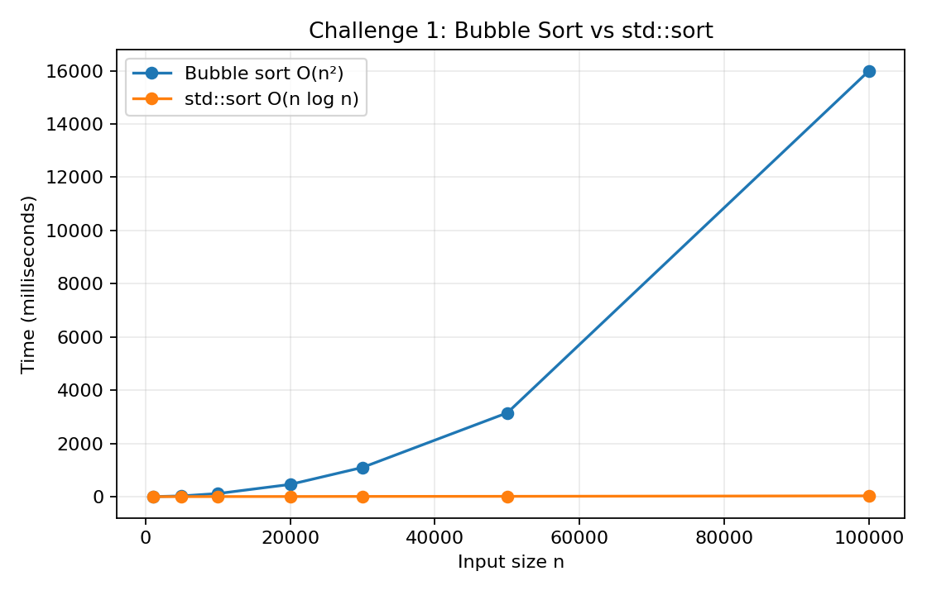
Figure 2. Measured running time for Challenge 1.

Challenge 2 — Matrix Multiplication
n | Multiply time (ms) | Approx. bytes
50 | 1.088 | 30000
100 | 9.365 | 120000
200 | 75.665 | 480000
400 | 570.473 | 1920000
Reflection: When n doubles, the cubic model predicts about 8 times as much work. The measured times increase strongly with n and are consistent with O(n³). The memory calculation grows with n² because three n × n integer matrices are stored.

Challenge 3 — Recursive vs Iterative Fibonacci
Recursive n | Recursive time (µs)
20 | 34
25 | 378
30 | 4999
35 | 53513
Iterative n | Iterative time (µs)
1000 | 1
100000 | 110
1000000 | 1433
Reflection: The recursive implementation repeatedly solves the same smaller Fibonacci problems, so its number of calls grows exponentially. The iterative version uses one loop, so its running time grows linearly with n. This is why the iterative version remains practical at much larger input sizes.

Challenge 4 — Array, Vector, and Linked List
n | Structure | Insert (µs) | Search (µs) | Bytes/element | Total bytes
1000 | vector | 49 | 6 | 4 | 4096
1000 | array | 3 | 3 | 4 | 4000
1000 | linked_list | 19 | 1 | 16 | 16000
5000 | vector | 83 | 21 | 4 | 32768
5000 | array | 9 | 9 | 4 | 20000
5000 | linked_list | 71 | 7 | 16 | 80000
10000 | vector | 209 | 41 | 4 | 65536
10000 | array | 62 | 19 | 4 | 40000
10000 | linked_list | 164 | 14 | 16 | 160000
50000 | vector | 855 | 224 | 4 | 262144
50000 | array | 224 | 140 | 4 | 200000
50000 | linked_list | 952 | 121 | 16 | 800000
100000 | vector | 1861 | 523 | 4 | 524288
100000 | array | 617 | 268 | 4 | 400000
100000 | linked_list | 2801 | 147 | 16 | 1600000
Reflection: In this experiment the raw array generally had the smallest insertion and search times, while the linked list used the most memory per element because each node stores both an integer and a pointer. The vector uses extra capacity, so its allocated memory can be larger than n × sizeof(int). The linked list search is still linear because nodes must be visited one by one.

4. Connection to Big-O Growth Rates
The experiments show why the growth-rate class matters when the input becomes large. Array sum and linear search grow roughly linearly, while bubble sort grows much faster because its work is quadratic. Matrix multiplication shows cubic growth, so doubling n can increase the work by about eight times. The recursive Fibonacci program grows exponentially and becomes slow even for relatively small n, while the iterative version is linear. The comparison between bubble sort and std::sort also shows why an O(n log n) algorithm can become much faster than an O(n²) algorithm for large inputs.

5. Files Included
- exercise1_array_sum.cpp
- exercise2_linear_search.cpp
- exercise3_bubble_sort.cpp
- exercise4_static_dynamic_array.cpp
- exercise5_vector_reserve.cpp
- challenge1_bubble_vs_std_sort.cpp
- challenge2_matrix_multiplication.cpp
- challenge3_fibonacci.cpp
- challenge4_array_vector_linked_list.cpp
The CSV files contain the raw measured output from the programs. The source files contain no comments, as requested.

