

**Voice Control For Android 8.0**

**Porting Guide**

Version 1.0.1

2018-09-06

**Content**

1 System Architecture 3

2 Porting Requirement 4

3 Audio HAL Porting 5

4 Audio Policy Porting 7

5 Bluetooth Connection 11

5.1 Bluetooth Parameter 11

5.2 Update bluetooth connection parameter for Android O 13

6 Version Information 15

7 Contact Information 16

# System Architecture

The audio interface called by the voice recognition assistant is general audio interface of Android, which is used audio recorder here:

HID Driver

stub Audio Hal

HAL

Kernel

Audio Flinger

Framework

Audio Policy

/dev/hidraw

Audio 2.0 Interface

HIDL

Audio HIDL Service

Due to Android O modification, it is unable to custom the audio HAL and audio device, the stub HAL library is applied to instead.

When using voice assistant, audiorecorder call the stub audio HAL library audiorecorder, voice data is read directly from the HIDRAW node by audio HAL interface.

The audio porting should pass CTS and VTS for Android O.

# Porting Requirement

Before porting, the android source code and compiler environmental of set-top box platforms should be supported , and access to root permissions. The audio system architecture is included the following parts:

a. Audio HAL

b. Audio Policy

According to the audio system, audio Hal are in the user space layer, the compiled files are directly pushed into the box; audio policy in the firmware layer and need to to modify the source code and recompile, then the corresponding library is pushed into the set-top box.

Before start the porting, android debug-tool box must be prepared. This porting guide is used for android 8.0+(8.1). First open a terminal and connect the device, use the command ‘adb root’ to enter root mode, and use the command ‘adb remount’ to remount the box and access to push and pull files with device. As shown as following, it means success.

# Audio HAL Porting

When completing installation of virtual sound card driver, it needs to add a corresponding audio Hal to achieve the specific functions of the virtual sound card. When the new audio Hal is active, the audio input channel source will become the remote. This voice data is flowing through android general audio channel right now.

Enter the command line in the terminal:

adb push ‘PATH’/audio.stub.default.so /vendor/lib/hw

Push the corresponding audio HAL library ‘audio.stub.default.so’ into the path: /vendor/lib/hw and then reboot the box to act this library:

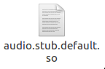

When calling the voice library, it need to modify the permissions of the hidraw node, otherwise it will be shown: permission denied. To achieve the permission, the device system file ueventd.rc should be modified.

Add the line in file ueventd.rc

/dev/hidraw* 0666 root root

If it wants to active this audio hal library, first should set property for the device. Add the following line in the boot file ‘init.rc’:

setprop audio.in.device.sklrm 1

Or add in the property file ‘default.prop’:

audio.in.device.sklrm = 1

And then recompile the system code to generate a new boot image file: boot.img. Push this image file into the set-top box and restart to take active.

If it is required to check the log message, please type the command:

logcat -s audio_hw_sklrm

In Android O, it could have the problem of permissions, the log of audio HAL Lib is liking:

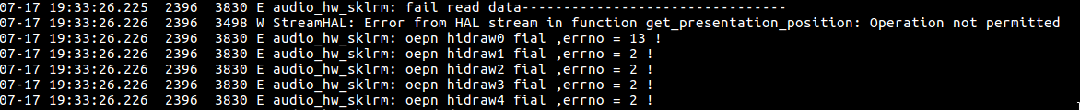

This is because the security mechanism of Linux kernel, SeLinux.

For testing, the SeLinux could be closed.Use the command in terminal for STB root direction:

setenforce 0

* Vendor also needs the following libraries support:

libmedia.so libmediadrm.so libmediametrics.so libmediautils.so libmemunreachable.so libaudiomanager.so libaudioclient.so libcamera_client.so libicuuc.so libicui18n.so libsonivox.so

All of the above should be pushed into /vendor/lib.

# Audio Policy Porting

After completing porting of audio driver and audio Hal, it is necessary to modify audio policy to enforce the stub Hal library active.

In Android 8.0+ version, the whole audio policy service is located at:

/frameworks/av/services/audiopolicy

When using the audio channel, inputgetInput () function is called to select the input audio channel. It will also call the getDeviceForInputSource () access to the source of the input device, which is located at:

/frameworks/av/services/audiopolicy/enginedefault/src/Engine.cpp

Add the code to get property when the remote source using:

char value[PROPERTY_VALUE_MAX];

int prop_rm;

property_get("audio.in.device.sklrm", value, NULL);

prop_rm = atoi(value);

if(prop_rm)

device=AUDIO_DEVICE_IN_BACK_MIC;

Add the code like the following figure：

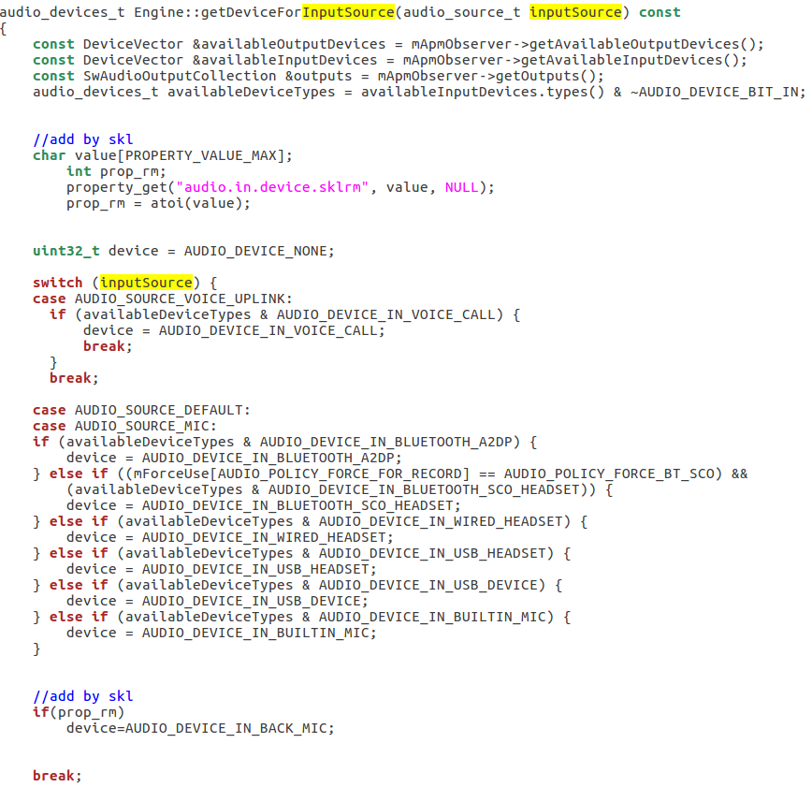

And then recompile the system code and generate following new audio policy libraries：

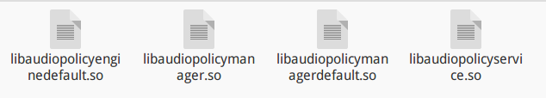

The new compiled library should be pushed into the path ‘/system/lib’ (if system is 64 bit, path is ‘/system/lib64’) by entrying the command in the terminal:

adb push PATH/libaudiopolicyenginedefault.so /system/lib

adb push PATH/libaudiopolicymanager.so /system/lib

adb push PATH/libaudiopolicymangerdefault.so /system/lib

adb push PATH/libaudiopolicyservice.so /system/lib

In addition, the audio policy configuration file should be modified. These relative files are generally located in the /device/ ‘VENDOR’ .

In Android 8.0+, there are two kinds of audio policy configuration files. First, check the board Makefile, whether defines USE_CONFIGURABLE_AUDIO_POLICY or USE_XML_AUDIO_POLICY_CONF.

Set USE_CONFIGURABLE_AUDIO_POLICY as 1

Now audio policy use audio_policy.conf file to configure the module information. At this time, add the stub module information and save it:

stub {

inputs {

stub {

sampling_rates 16000

channel_masks AUDIO_CHANNEL_IN_MONO

formats AUDIO_FORMAT_PCM_16_BIT

devices AUDIO_DEVICE_IN_BACK_MIC

}

}

}

And then push the updated ‘audio_policy.conf’ into the path ‘/system/etc’, type the command in the terminal:

adb push ‘PATH’/audio_policy.conf /vendor/etc

2. Set USE_XML_AUDIO_POLICY_CONF as 1

This time, the audio policy read audio_policy_configuration.xml to make configuration:

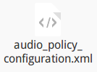

First, add the following code into this file:

<!-- STUB Audio HAL -->

<xi:include href="stub_audio_policy_configuration.xml"/>

Now the stub module configuration xml file is able to be called by main module xml file. Then push the stub xml file into the path ‘/vendor/etc’.

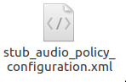

Use the command in the terminal:

adb push ‘PATH’/stub_audio_policy_configuration.xml /vendor/etc

adb push ‘PATH’/audio_policy_configuration.xml /vendor/etc

If both two definitions are set as 1, do two ways edition at same time.

After finishing all the above steps, restart the set-top box, and audio system porting is completed.

# Bluetooth Connection

## Bluetooth Parameter

To work the voice function, It is necessary to edit the bluetooth LE parameters .The path is：

/system/bt/stack/include/btm_ble_api_types.h

The main parameters are max and min interval, slave latency and timeout.

The recommend values are as following：

#define BTM_BLE_CONN_INT_MIN 0x0006

#define BTM_BLE_CONN_INT_MIN_DEF 6

#define BTM_BLE_CONN_INT_MAX_DEF 6

#define BTM_BLE_CONN_SLAVE_LATENCY_DEF 10

#define BTM_BLE_CONN_TIMEOUT_DEF 100

#define BTM_BLE_CONN_TIMEOUT_MIN_DEF 10

#define BTM_BLE_CONN_INT_MIN_LIMIT 0x0006

The file after editing is like:

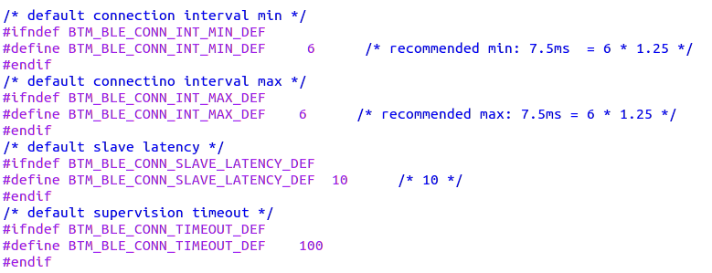

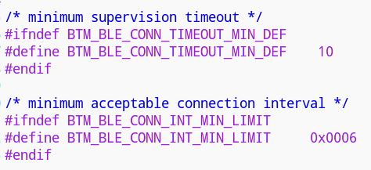

And then recompile the system code and generate following new bluetooth library：

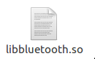

The new compiled library should be pushed into the path ‘/system/lib/’ by typing the command in the terminal:

adb push PATH/libbluetooth.so /system/lib/

## Update bluetooth connection parameter for Android O

Android 8.0 updates the bluetooth protocol stack. After the connection of the remote control is initially updated, the main opportunity automatically updates the connection parameters of the remote control at irregular intervals, making the connection parameters of the remote control at a slow value, resulting in the slow transmission speed of bluetooth. At this point, the voice function can not be used normally.

The following is required if you want the Voice normal operation normally:

* Update the remote firmware to version 8.0.
* Modify the BLE connection in the bluetooth protocol stack L2CAP.

The source code for the BLE connection in L2CAP is located:

/system/bt/stack/l2cap/l2c_ble.cc.

After the bluetooth device connects to the host, in the function

void L2CA_AdjustConnectionIntervals(uint16_t* min_interval, uint16_t* max_interval,uint16_t floor_interval),The host to perform the submit suggested connection parameters again. Comment out the section that executes the function,The modifies are shown in the figure:

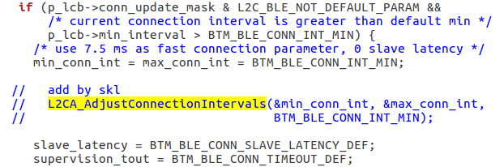

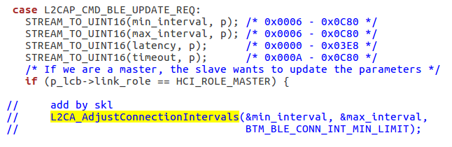

And then recompile the system code and generate following new bluetooth library：



The new compiled library should be pushed into the path ‘/system/lib/’ by typing the command in the terminal:

adb push PATH/libbluetooth.so /system/lib/

# Version Information

|  |  |  |  |
| --- | --- | --- | --- |
| **Ver.** | **Data** | **Writer** | **Description** |
| 1.0.0 | 2018-08-07 | George | First Version； |
| 1.0.1 | 2018-09-06 | George | Fix part error； |

# Contact Information

Shanghai Shockley Electronics Tech. Corp. LTD

Web：http://www.shockley-elect.com

Tel：021-64327686

Contact：George

E-mail：[geo](mailto:wythe@shockley-elect.com)rge@shockley-elect.com