[](https://www.comsol.com/)

Home final

|  |  |
| --- | --- |
| Report date | Dec 7, 2021 11:28:01 PM |

Contents

1. Global Definitions

1.1. Parameters

2. Component 1

2.1. Definitions

2.2. Geometry 1

2.3. Materials

2.4. Laminar Flow

2.5. Transport of Diluted Species

2.6. Mesh 1

3. Study 1

3.1. Stationary

3.2. Stationary 2

3.3. Time Dependent

3.4. Solver Configurations

4. Results

4.1. Datasets

4.2. Plot Groups

1. Global Definitions

|  |  |
| --- | --- |
| Date | Dec 1, 2021 5:36:01 AM |

Global settings

|  |  |
| --- | --- |
| Name | Home final.mph |
| Path | C:\Users\Shika\Desktop\Courses\3-1\Project\Comsol\home_final.mph |
| Version | COMSOL Multiphysics 5.6 (Build: 280) |
| Unit system | SI |

Used products

|  |
| --- |
| COMSOL Multiphysics |
| CAD Import Module |
| LiveLink™ for PTC® Creo® Parametric™ |
| Microfluidics Module |

Computer information

|  |  |
| --- | --- |
| CPU | Intel64 Family 6 Model 142 Stepping 12, 4 cores |
| Operating system | Windows 10 |

* 1. Parameters

Parameters 1

| **Name** | **Expression** | **Value** | **Description** |
| --- | --- | --- | --- |
| uL | 1 [mm/s] | 0.001 m/s | Left Inlet Velocity |
| cL | 1 [mol/m^3] | 1 mol/m³ | Left Inlet Concentration |
| D | 1e-11 [m^2/s] | 1E−11 m²/s | Diffusion Constant |
| t | 0 [s] | 0 s | Start time |
| uR | 5 [mm/s] | 0.005 m/s | Right Inlet Velocity |
| cR | 10 [mol/m^3] | 10 mol/m³ | Right Inlet Concentration |

1. Component 1

|  |  |
| --- | --- |
| Date | Dec 1, 2021 1:05:58 AM |

Settings

| **Description** | **Value** |
| --- | --- |
| Unit system | Same as global system (SI) |
| Geometry shape function | Automatic |

Spatial frame coordinates

| **First** | **Second** | **Third** |
| --- | --- | --- |
| x | y | z |

Material frame coordinates

| **First** | **Second** | **Third** |
| --- | --- | --- |
| X | Y | Z |

Geometry frame coordinates

| **First** | **Second** | **Third** |
| --- | --- | --- |
| Xg | Yg | Zg |

Mesh frame coordinates

| **First** | **Second** | **Third** |
| --- | --- | --- |
| Xm | Ym | Zm |

* 1. Definitions
     1. Coordinate Systems

#### Boundary System 1

|  |  |
| --- | --- |
| Coordinate system type | Boundary system |
| Tag | sys1 |

Coordinate names

| **First** | **Second** | **Third** |
| --- | --- | --- |
| t1 | t2 | n |

* 1. Geometry 1

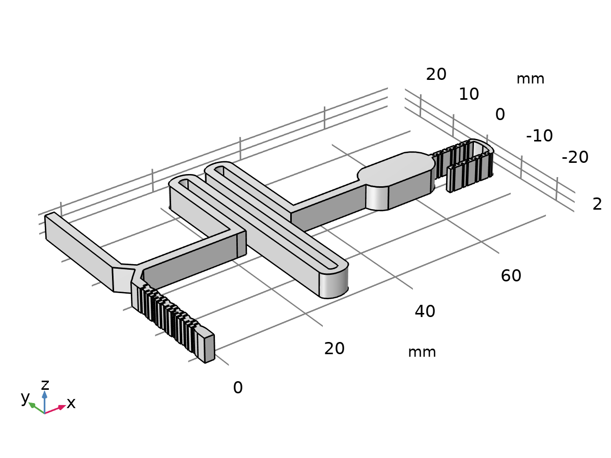

Geometry 1

Units

|  |  |
| --- | --- |
| Length unit | mm |
| Angular unit | deg |

Geometry statistics

| **Description** | **Value** |
| --- | --- |
| Space dimension | 3 |
| Number of domains | 1 |
| Number of boundaries | 269 |
| Number of edges | 801 |
| Number of vertices | 534 |

* + 1. LiveLink for PTC Creo Parametric 1 (cad1)

Settings

| **Description** | **Value** |
| --- | --- |
| Synchronize with | Specified document |
| Document | C:\Users\Shika\Desktop\Courses\3 - 1\Project\Creo\HOME_F.prt |
| Instance | GENERIC |
| Simplified representation | Master Rep |

* 1. Materials
     1. Material 1

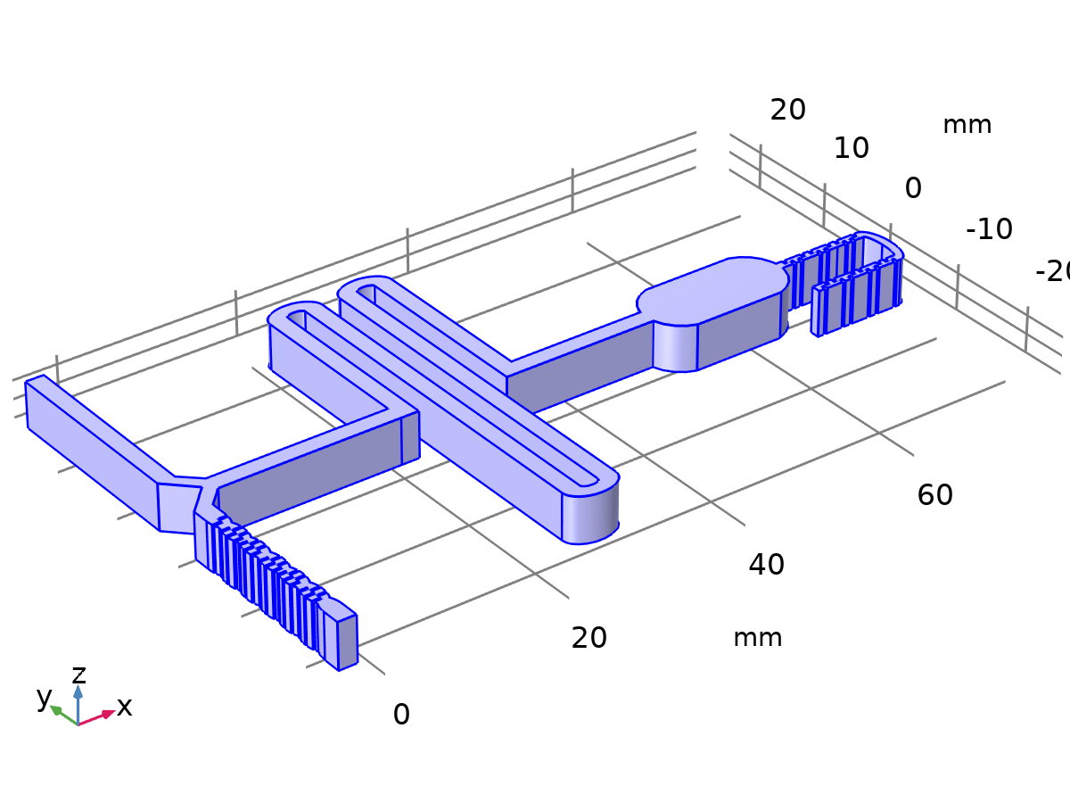

Material 1

Selection

|  |  |
| --- | --- |
| Geometric entity level | Domain |
| Selection | Geometry geom1: Dimension 3: All domains |

Material parameters

| **Name** | **Value** | **Unit** |
| --- | --- | --- |
| Density | 1005 | kg/m³ |
| Dynamic viscosity | 0.00109 | Pa·s |

Basic

| **Description** | **Value** |
| --- | --- |
| Density | 1005 |
| density_symmetry | 0 |
| Dynamic viscosity | 0.00109 |
| dynamicviscosity_symmetry | 0 |

* 1. Laminar Flow

Used products

|  |
| --- |
| COMSOL Multiphysics |
| Microfluidics Module |



Laminar Flow

Selection

|  |  |
| --- | --- |
| Geometric entity level | Domain |
| Selection | Geometry geom1: Dimension 3: All domains |

Equations





* + 1. Interface Settings

#### Discretization

Settings

| **Description** | **Value** |
| --- | --- |
| Discretization of fluids | P2 + P1 |

#### Physical Model

Settings

| **Description** | **Value** |
| --- | --- |
| Neglect inertial term (Stokes flow) | Off |
| Compressibility | Incompressible flow |
| Enable porous media domains | Off |
| Include gravity | Off |
| Reference temperature | User defined |
| Reference temperature | 293.15[K] |
| Reference pressure level | 1[atm] |

#### Turbulence

Settings

| **Description** | **Value** |
| --- | --- |
| Turbulence model type | None |

* + 1. Variables

| **Name** | **Expression** | **Unit** | **Description** | **Selection** | **Details** |
| --- | --- | --- | --- | --- | --- |
| spf.Tref | model.input.Tref | K | Reference temperature | Global | Meta |
| spf.dz | 1 | m | Thickness | Domain 1 |  |
| spf.pref | 1[atm] | Pa | Reference pressure level | Domain 1 |  |
| spf.pA | p+spf.pref | Pa | Absolute pressure | Domain 1 |  |
| spf.hasWF | 0 |  | Help variable | Boundaries 1–269 |  |
| spf.dt_CFL | 1/max(spf.maxop(sqrt(emetric_spatial(u-d(x,TIME),v-d(y,TIME),w-d(z,TIME)))),eps) | s | Time step, CFL=1 | Global |  |
| spf.Qvd_tot | spf.intop(spf.Qvd) | W | Total viscous dissipation | Global |  |
| spf.K_stressx | spf.K_stress_tensorxx*spf.nxmesh+spf.K_stress_tensorxy*spf.nymesh+spf.K_stress_tensorxz*spf.nzmesh | N/m² | Viscous force, exterior boundaries, x component | Boundaries 1–269 |  |
| spf.K_stressy | spf.K_stress_tensoryx*spf.nxmesh+spf.K_stress_tensoryy*spf.nymesh+spf.K_stress_tensoryz*spf.nzmesh | N/m² | Viscous force, exterior boundaries, y component | Boundaries 1–269 |  |
| spf.K_stressz | spf.K_stress_tensorzx*spf.nxmesh+spf.K_stress_tensorzy*spf.nymesh+spf.K_stress_tensorzz*spf.nzmesh | N/m² | Viscous force, exterior boundaries, z component | Boundaries 1–269 |  |
| spf.T_stressx | spf.T_stress_tensorxx*spf.nxmesh+spf.T_stress_tensorxy*spf.nymesh+spf.T_stress_tensorxz*spf.nzmesh | N/m² | Total traction, exterior boundaries, x component | Boundaries 1–269 |  |
| spf.T_stressy | spf.T_stress_tensoryx*spf.nxmesh+spf.T_stress_tensoryy*spf.nymesh+spf.T_stress_tensoryz*spf.nzmesh | N/m² | Total traction, exterior boundaries, y component | Boundaries 1–269 |  |
| spf.T_stressz | spf.T_stress_tensorzx*spf.nxmesh+spf.T_stress_tensorzy*spf.nymesh+spf.T_stress_tensorzz*spf.nzmesh | N/m² | Total traction, exterior boundaries, z component | Boundaries 1–269 |  |
| spf.K_stress_dx | down(spf.K_stress_tensorxx)*spf.dnxmesh+down(spf.K_stress_tensorxy)*spf.dnymesh+down(spf.K_stress_tensorxz)*spf.dnzmesh | N/m² | Viscous force, interior boundaries, downside, x component | Boundaries 1–269 |  |
| spf.K_stress_dy | down(spf.K_stress_tensoryx)*spf.dnxmesh+down(spf.K_stress_tensoryy)*spf.dnymesh+down(spf.K_stress_tensoryz)*spf.dnzmesh | N/m² | Viscous force, interior boundaries, downside, y component | Boundaries 1–269 |  |
| spf.K_stress_dz | down(spf.K_stress_tensorzx)*spf.dnxmesh+down(spf.K_stress_tensorzy)*spf.dnymesh+down(spf.K_stress_tensorzz)*spf.dnzmesh | N/m² | Viscous force, interior boundaries, downside, z component | Boundaries 1–269 |  |
| spf.T_stress_dx | down(spf.T_stress_tensorxx)*spf.dnxmesh+down(spf.T_stress_tensorxy)*spf.dnymesh+down(spf.T_stress_tensorxz)*spf.dnzmesh | N/m² | Total traction, interior boundaries, downside, x component | Boundaries 1–269 |  |
| spf.T_stress_dy | down(spf.T_stress_tensoryx)*spf.dnxmesh+down(spf.T_stress_tensoryy)*spf.dnymesh+down(spf.T_stress_tensoryz)*spf.dnzmesh | N/m² | Total traction, interior boundaries, downside, y component | Boundaries 1–269 |  |
| spf.T_stress_dz | down(spf.T_stress_tensorzx)*spf.dnxmesh+down(spf.T_stress_tensorzy)*spf.dnymesh+down(spf.T_stress_tensorzz)*spf.dnzmesh | N/m² | Total traction, interior boundaries, downside, z component | Boundaries 1–269 |  |
| spf.usePseudoTimeStepping | 0 | 1 | Help variable | Global | + operation |
| spf.localCFLvalue | 1.3^min(niterCMP,9)+if(niterCMP>=25,9*1.3^min(-25+niterCMP,9),0)+if(niterCMP>=45,90*1.3^min(-45+niterCMP,9),0) |  | Local CFL number | Domain 1 |  |
| spf.locCFL | CFLCMP | 1 | Local CFL number | Domain 1 |  |
| spf.geometryLengthScale | 0.0012749999999999999 | m | Geometry length scale | Domain 1 |  |
| spf.time_step_inv | max(sqrt(emetric_spatial(u,v,w)*2^if(gmg_level<2,0,-1+gmg_level)^2),spf.nu/spf.geometryLengthScale^2) | Hz | Inverse time step | Domain 1 |  |
| spf.tsti | nojac(spf.time_step_inv/spf.locCFL) | 1/s | Help variable | Domain 1 |  |
| spf.nx | dnx | 1 | Normal vector, x component | Boundaries 1–269 |  |
| spf.ny | dny | 1 | Normal vector, y component | Boundaries 1–269 |  |
| spf.nz | dnz | 1 | Normal vector, z component | Boundaries 1–269 |  |
| spf.nxmesh | dnxmesh | 1 | Normal vector, x component | Boundaries 1–269 |  |
| spf.nymesh | dnymesh | 1 | Normal vector, y component | Boundaries 1–269 |  |
| spf.nzmesh | dnzmesh | 1 | Normal vector, z component | Boundaries 1–269 |  |

* + 1. Fluid Properties 1



Fluid Properties 1

Selection

|  |  |
| --- | --- |
| Geometric entity level | Domain |
| Selection | Geometry geom1: Dimension 3: All domains |

Equations

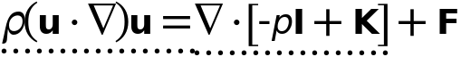



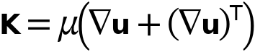

#### Fluid Properties

Settings

| **Description** | **Value** |
| --- | --- |
| Density | From material |
|  | Newtonian |
| Dynamic viscosity | From material |

#### Model Input

Settings

| **Description** | **Value** |
| --- | --- |
| Temperature | Common model input |

Used products

|  |
| --- |
| COMSOL Multiphysics |

Properties from material

| **Property** | **Material** | **Property group** |
| --- | --- | --- |
| Density | Material 1 | Basic |
| Dynamic viscosity | Material 1 | Basic |

#### Variables

| **Name** | **Expression** | **Unit** | **Description** | **Selection** | **Details** |
| --- | --- | --- | --- | --- | --- |
| spf.nu | spf.mu/spf.rho | m²/s | Kinematic viscosity | Domain 1 |  |
| spf.mu | material.mu | Pa·s | Dynamic viscosity | Domain 1 | Meta |
| spf.rho | subst(material.rho,spf.fp1.minput_temperature,spf.Trho,spf.fp1.minput_pressure,spf.prho) | kg/m³ | Density | Domain 1 | Meta |
| spf.Trho | spf.Tref | K | Temperature for density evaluation | Domain 1 |  |
| spf.prho | spf.pref | Pa | Pressure for the evaluation of density | Domain 1 |  |
| spf.rhoref | subst(material.rho,spf.fp1.minput_temperature,spf.Tref,spf.fp1.minput_pressure,spf.pref) | kg/m³ | Reference density | Domain 1 | Meta |
| spf.mumat | material.mu | Pa·s | Dynamic viscosity | Domain 1 | Meta |
| spf.srijxx | ux | 1/s | Strain rate tensor, xx component | Domain 1 |  |
| spf.srijyx | 0.5*(vx+uy) | 1/s | Strain rate tensor, yx component | Domain 1 |  |
| spf.srijzx | 0.5*(wx+uz) | 1/s | Strain rate tensor, zx component | Domain 1 |  |
| spf.srijxy | 0.5*(uy+vx) | 1/s | Strain rate tensor, xy component | Domain 1 |  |
| spf.srijyy | vy | 1/s | Strain rate tensor, yy component | Domain 1 |  |
| spf.srijzy | 0.5*(wy+vz) | 1/s | Strain rate tensor, zy component | Domain 1 |  |
| spf.srijxz | 0.5*(uz+wx) | 1/s | Strain rate tensor, xz component | Domain 1 |  |
| spf.srijyz | 0.5*(vz+wy) | 1/s | Strain rate tensor, yz component | Domain 1 |  |
| spf.srijzz | wz | 1/s | Strain rate tensor, zz component | Domain 1 |  |
| spf.rrijxx | 0 | 1/s | Rotation rate tensor, xx component | Domain 1 |  |
| spf.rrijyx | 0.5*(vx-uy) | 1/s | Rotation rate tensor, yx component | Domain 1 |  |
| spf.rrijzx | 0.5*(wx-uz) | 1/s | Rotation rate tensor, zx component | Domain 1 |  |
| spf.rrijxy | 0.5*(uy-vx) | 1/s | Rotation rate tensor, xy component | Domain 1 |  |
| spf.rrijyy | 0 | 1/s | Rotation rate tensor, yy component | Domain 1 |  |
| spf.rrijzy | 0.5*(wy-vz) | 1/s | Rotation rate tensor, zy component | Domain 1 |  |
| spf.rrijxz | 0.5*(uz-wx) | 1/s | Rotation rate tensor, xz component | Domain 1 |  |
| spf.rrijyz | 0.5*(vz-wy) | 1/s | Rotation rate tensor, yz component | Domain 1 |  |
| spf.rrijzz | 0 | 1/s | Rotation rate tensor, zz component | Domain 1 |  |
| spf.sr | sqrt(2*spf.srijxx^2+2*spf.srijxy^2+2*spf.srijxz^2+2*spf.srijyx^2+2*spf.srijyy^2+2*spf.srijyz^2+2*spf.srijzx^2+2*spf.srijzy^2+2*spf.srijzz^2+eps) | 1/s | Shear rate | Domain 1 |  |
| spf.rr | sqrt(2*spf.rrijxx^2+2*spf.rrijxy^2+2*spf.rrijxz^2+2*spf.rrijyx^2+2*spf.rrijyy^2+2*spf.rrijyz^2+2*spf.rrijzx^2+2*spf.rrijzy^2+2*spf.rrijzz^2+eps) | 1/s | Rotation rate | Domain 1 |  |
| spf.divu | ux+vy+wz | 1/s | Divergence of velocity field | Domain 1 |  |
| spf.Fx | 0 | N/m³ | Volume force, x component | Domain 1 | + operation |
| spf.Fy | 0 | N/m³ | Volume force, y component | Domain 1 | + operation |
| spf.Fz | 0 | N/m³ | Volume force, z component | Domain 1 | + operation |
| spf.U | sqrt(u^2+v^2+w^2) | m/s | Velocity magnitude | Domain 1 |  |
| spf.vorticityx | wy-vz | 1/s | Vorticity field, x component | Domain 1 |  |
| spf.vorticityy | -wx+uz | 1/s | Vorticity field, y component | Domain 1 |  |
| spf.vorticityz | vx-uy | 1/s | Vorticity field, z component | Domain 1 |  |
| spf.vort_magn | sqrt(spf.vorticityx^2+spf.vorticityy^2+spf.vorticityz^2) | 1/s | Vorticity magnitude | Domain 1 |  |
| spf.cellRe | 0.25*spf.rho*sqrt(emetric_spatial(u-d(x,TIME),v-d(y,TIME),w-d(z,TIME))/emetric2_spatial)/spf.mu | 1 | Cell Reynolds number | Domain 1 |  |
| spf.betaT | 0 | 1/Pa | Isothermal compressibility coefficient | Domain 1 |  |
| spf.Qm | 0 | kg/(m³·s) | Source term | Domain 1 | + operation |
| spf.Fgtotx | 0 | N/m³ | Gravity force, x component | Domain 1 | + operation |
| spf.Fgtoty | 0 | N/m³ | Gravity force, y component | Domain 1 | + operation |
| spf.Fgtotz | 0 | N/m³ | Gravity force, z component | Domain 1 | + operation |
| spf.mu_eff | spf.mu+spf.muT | Pa·s | Dynamic viscosity | Domain 1 |  |
| spf.muT | 0 | Pa·s | Turbulent dynamic viscosity | Domain 1 |  |
| spf.T_stress_tensorxx | spf.K_stress_tensorxx-p | N/m² | Total stress tensor, xx component | Domain 1 | + operation |
| spf.T_stress_tensoryx | spf.K_stress_tensoryx | N/m² | Total stress tensor, yx component | Domain 1 | + operation |
| spf.T_stress_tensorzx | spf.K_stress_tensorzx | N/m² | Total stress tensor, zx component | Domain 1 | + operation |
| spf.T_stress_tensorxy | spf.K_stress_tensorxy | N/m² | Total stress tensor, xy component | Domain 1 | + operation |
| spf.T_stress_tensoryy | spf.K_stress_tensoryy-p | N/m² | Total stress tensor, yy component | Domain 1 | + operation |
| spf.T_stress_tensorzy | spf.K_stress_tensorzy | N/m² | Total stress tensor, zy component | Domain 1 | + operation |
| spf.T_stress_tensorxz | spf.K_stress_tensorxz | N/m² | Total stress tensor, xz component | Domain 1 | + operation |
| spf.T_stress_tensoryz | spf.K_stress_tensoryz | N/m² | Total stress tensor, yz component | Domain 1 | + operation |
| spf.T_stress_tensorzz | spf.K_stress_tensorzz-p | N/m² | Total stress tensor, zz component | Domain 1 | + operation |
| spf.K_stress_tensorxx | 2*spf.mu_eff*ux | N/m² | Viscous stress tensor, xx component | Domain 1 | + operation |
| spf.K_stress_tensoryx | spf.mu_eff*(vx+uy) | N/m² | Viscous stress tensor, yx component | Domain 1 | + operation |
| spf.K_stress_tensorzx | spf.mu_eff*(wx+uz) | N/m² | Viscous stress tensor, zx component | Domain 1 | + operation |
| spf.K_stress_tensorxy | spf.mu_eff*(uy+vx) | N/m² | Viscous stress tensor, xy component | Domain 1 | + operation |
| spf.K_stress_tensoryy | 2*spf.mu_eff*vy | N/m² | Viscous stress tensor, yy component | Domain 1 | + operation |
| spf.K_stress_tensorzy | spf.mu_eff*(wy+vz) | N/m² | Viscous stress tensor, zy component | Domain 1 | + operation |
| spf.K_stress_tensorxz | spf.mu_eff*(uz+wx) | N/m² | Viscous stress tensor, xz component | Domain 1 | + operation |
| spf.K_stress_tensoryz | spf.mu_eff*(vz+wy) | N/m² | Viscous stress tensor, yz component | Domain 1 | + operation |
| spf.K_stress_tensorzz | 2*spf.mu_eff*wz | N/m² | Viscous stress tensor, zz component | Domain 1 | + operation |
| spf.K_stress_tensor_testxx | 2*spf.mu_eff*test(ux) | N/m² | Viscous stress tensor test, xx component | Domain 1 | + operation |
| spf.K_stress_tensor_testyx | spf.mu_eff*(test(vx)+test(uy)) | N/m² | Viscous stress tensor test, yx component | Domain 1 | + operation |
| spf.K_stress_tensor_testzx | spf.mu_eff*(test(wx)+test(uz)) | N/m² | Viscous stress tensor test, zx component | Domain 1 | + operation |
| spf.K_stress_tensor_testxy | spf.mu_eff*(test(uy)+test(vx)) | N/m² | Viscous stress tensor test, xy component | Domain 1 | + operation |
| spf.K_stress_tensor_testyy | 2*spf.mu_eff*test(vy) | N/m² | Viscous stress tensor test, yy component | Domain 1 | + operation |
| spf.K_stress_tensor_testzy | spf.mu_eff*(test(wy)+test(vz)) | N/m² | Viscous stress tensor test, zy component | Domain 1 | + operation |
| spf.K_stress_tensor_testxz | spf.mu_eff*(test(uz)+test(wx)) | N/m² | Viscous stress tensor test, xz component | Domain 1 | + operation |
| spf.K_stress_tensor_testyz | spf.mu_eff*(test(vz)+test(wy)) | N/m² | Viscous stress tensor test, yz component | Domain 1 | + operation |
| spf.K_stress_tensor_testzz | 2*spf.mu_eff*test(wz) | N/m² | Viscous stress tensor test, zz component | Domain 1 | + operation |
| spf.upwind_helpx | u-d(x,TIME) | m/s | Upwind term, x component | Domain 1 | + operation |
| spf.upwind_helpy | v-d(y,TIME) | m/s | Upwind term, y component | Domain 1 | + operation |
| spf.upwind_helpz | w-d(z,TIME) | m/s | Upwind term, z component | Domain 1 | + operation |
| spf.tau_vdxx | 2*spf.mu*spf.srijxx | Pa | Viscous stress tensor, xx component | Domain 1 | + operation |
| spf.tau_vdyx | 2*spf.mu*spf.srijyx | Pa | Viscous stress tensor, yx component | Domain 1 | + operation |
| spf.tau_vdzx | 2*spf.mu*spf.srijzx | Pa | Viscous stress tensor, zx component | Domain 1 | + operation |
| spf.tau_vdxy | 2*spf.mu*spf.srijxy | Pa | Viscous stress tensor, xy component | Domain 1 | + operation |
| spf.tau_vdyy | 2*spf.mu*spf.srijyy | Pa | Viscous stress tensor, yy component | Domain 1 | + operation |
| spf.tau_vdzy | 2*spf.mu*spf.srijzy | Pa | Viscous stress tensor, zy component | Domain 1 | + operation |
| spf.tau_vdxz | 2*spf.mu*spf.srijxz | Pa | Viscous stress tensor, xz component | Domain 1 | + operation |
| spf.tau_vdyz | 2*spf.mu*spf.srijyz | Pa | Viscous stress tensor, yz component | Domain 1 | + operation |
| spf.tau_vdzz | 2*spf.mu*spf.srijzz | Pa | Viscous stress tensor, zz component | Domain 1 | + operation |
| spf.Qvd | spf.tau_vdxx*ux+spf.tau_vdxy*uy+spf.tau_vdxz*uz+spf.tau_vdyx*vx+spf.tau_vdyy*vy+spf.tau_vdyz*vz+spf.tau_vdzx*wx+spf.tau_vdzy*wy+spf.tau_vdzz*wz | W/m³ | Viscous dissipation | Domain 1 | + operation |
| spf.epsilon_p | 1 | 1 | Porosity | Domain 1 |  |
| spf.Fst_tensorxx | 0 | N/m² | Surface tension force, xx component | Domain 1 | + operation |
| spf.Fst_tensoryx | 0 | N/m² | Surface tension force, yx component | Domain 1 | + operation |
| spf.Fst_tensorzx | 0 | N/m² | Surface tension force, zx component | Domain 1 | + operation |
| spf.Fst_tensorxy | 0 | N/m² | Surface tension force, xy component | Domain 1 | + operation |
| spf.Fst_tensoryy | 0 | N/m² | Surface tension force, yy component | Domain 1 | + operation |
| spf.Fst_tensorzy | 0 | N/m² | Surface tension force, zy component | Domain 1 | + operation |
| spf.Fst_tensorxz | 0 | N/m² | Surface tension force, xz component | Domain 1 | + operation |
| spf.Fst_tensoryz | 0 | N/m² | Surface tension force, yz component | Domain 1 | + operation |
| spf.Fst_tensorzz | 0 | N/m² | Surface tension force, zz component | Domain 1 | + operation |
| spf.continuityEquation | spf.rho*spf.divu | kg/(m³·s) | Continuity equation | Domain 1 |  |
| spf.contCoeff | spf.rho | kg/m³ | Help variable | Domain 1 |  |
| spf.res_u | px+spf.rho*u*ux+spf.rho*v*uy+spf.rho*w*uz-(d(2*ux,x)+d(uy+vx,y)+d(uz+wx,z))*spf.mu-spf.Fx | N/m³ | Equation residual | Domain 1 |  |
| spf.res_v | spf.rho*u*vx+py+spf.rho*v*vy+spf.rho*w*vz-(d(vx+uy,x)+d(2*vy,y)+d(vz+wy,z))*spf.mu-spf.Fy | N/m³ | Equation residual | Domain 1 |  |
| spf.res_w | spf.rho*u*wx+spf.rho*v*wy+pz+spf.rho*w*wz-(d(wx+uz,x)+d(wy+vz,y)+d(2*wz,z))*spf.mu-spf.Fz | N/m³ | Equation residual | Domain 1 |  |
| spf.res_p | spf.rho*spf.divu | kg/(m³·s) | Pressure equation residual | Domain 1 |  |

#### Shape functions

| **Name** | **Shape function** | **Unit** | **Description** | **Shape frame** | **Selection** |
| --- | --- | --- | --- | --- | --- |
| u | Lagrange (Quadratic) | m/s | Velocity field, x component | Spatial | Domain 1 |
| v | Lagrange (Quadratic) | m/s | Velocity field, y component | Spatial | Domain 1 |
| w | Lagrange (Quadratic) | m/s | Velocity field, z component | Spatial | Domain 1 |
| p | Lagrange (Linear) | Pa | Pressure | Spatial | Domain 1 |

#### Weak Expressions

| **Weak expression** | **Integration order** | **Integration frame** | **Selection** |
| --- | --- | --- | --- |
| (p-spf.K_stress_tensorxx)*test(ux)-spf.K_stress_tensorxy*test(uy)-spf.K_stress_tensorxz*test(uz)-spf.K_stress_tensoryx*test(vx)+(p-spf.K_stress_tensoryy)*test(vy)-spf.K_stress_tensoryz*test(vz)-spf.K_stress_tensorzx*test(wx)-spf.K_stress_tensorzy*test(wy)+(p-spf.K_stress_tensorzz)*test(wz) | 4 | Spatial | Domain 1 |
| spf.Fx*test(u)+spf.Fy*test(v)+spf.Fz*test(w) | 4 | Spatial | Domain 1 |
| spf.rho*(-(d(u,x)*u+d(u,y)*v+d(u,z)*w)*test(u)-(d(v,x)*u+d(v,y)*v+d(v,z)*w)*test(v)-(d(w,x)*u+d(w,y)*v+d(w,z)*w)*test(w)) | 4 | Spatial | Domain 1 |
| -spf.continuityEquation*test(p) | 4 | Spatial | Domain 1 |
| spf.streamlinens | 4 | Spatial | Domain 1 |
| spf.crosswindns | 4 | Spatial | Domain 1 |
| (spf.usePseudoTimeStepping>0)*spf.rho*spf.tsti*(-(u-nojac(u))*test(u)-(v-nojac(v))*test(v)-(w-nojac(w))*test(w)) | 4 | Spatial | Domain 1 |

* + 1. Initial Values 1



Initial Values 1

Selection

|  |  |
| --- | --- |
| Geometric entity level | Domain |
| Selection | Geometry geom1: Dimension 3: All domains |

#### Initial Values

Settings

| **Description** | **Value** |
| --- | --- |
| Velocity field, x component | 0 |
| Velocity field, y component | 0 |
| Velocity field, z component | 0 |
| Pressure | 0 |

#### Coordinate System Selection

Settings

| **Description** | **Value** |
| --- | --- |
| Coordinate system | Global coordinate system |

Used products

|  |
| --- |
| COMSOL Multiphysics |

#### Variables

| **Name** | **Expression** | **Unit** | **Description** | **Selection** |
| --- | --- | --- | --- | --- |
| spf.u_initx | 0 | m/s | Velocity field, x component | Domain 1 |
| spf.u_inity | 0 | m/s | Velocity field, y component | Domain 1 |
| spf.u_initz | 0 | m/s | Velocity field, z component | Domain 1 |
| spf.p_init | 0 | Pa | Pressure | Domain 1 |

* + 1. Wall 1

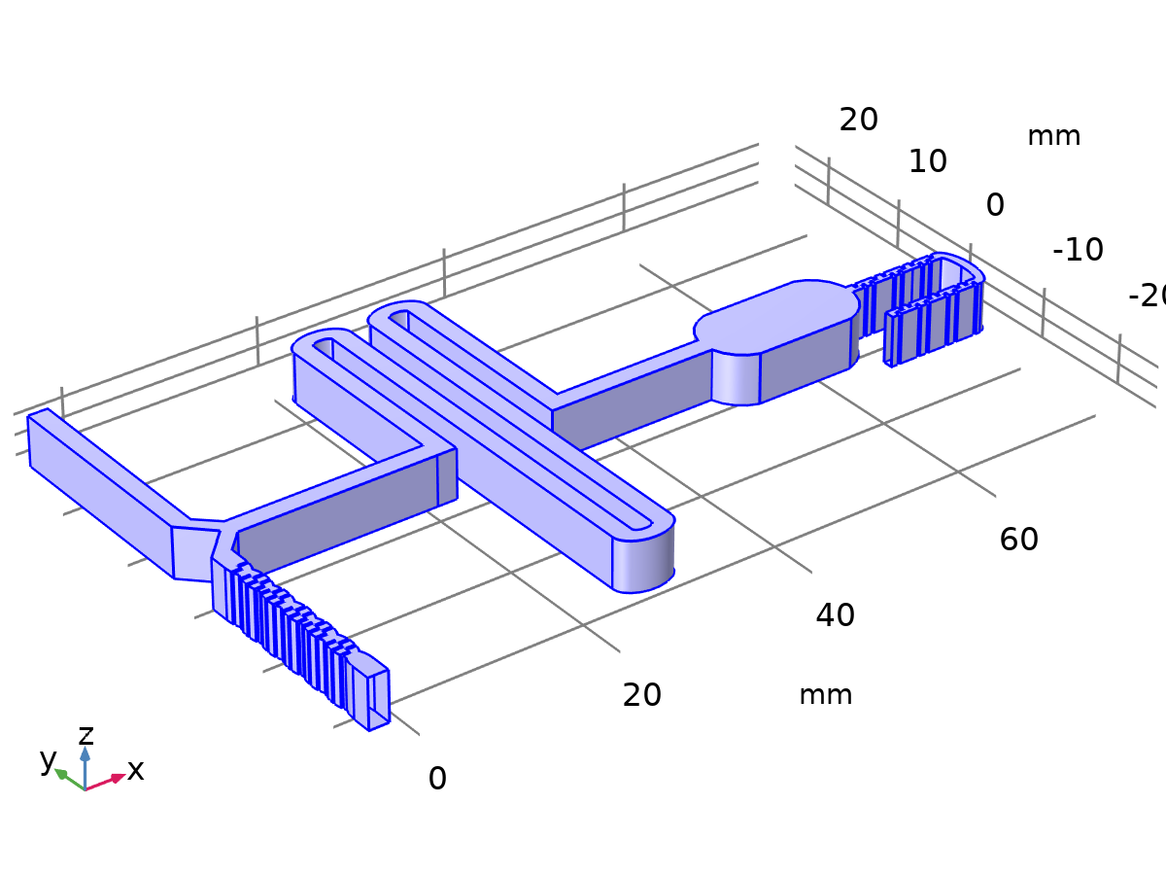

Wall 1

Selection

|  |  |
| --- | --- |
| Geometric entity level | Boundary |
| Selection | Geometry geom1: Dimension 2: All boundaries |

Equations



#### Boundary Condition

Settings

| **Description** | **Value** |
| --- | --- |
| Wall condition | No slip |

#### Wall Movement

Settings

| **Description** | **Value** |
| --- | --- |
| Translational velocity | Automatic from frame |
| Sliding wall | Off |

Used products

|  |
| --- |
| COMSOL Multiphysics |

#### Variables

| **Name** | **Expression** | **Unit** | **Description** | **Selection** | **Details** |
| --- | --- | --- | --- | --- | --- |
| spf.ubndx | spf.utrx+spf.usx | m/s | Velocity at boundary, x component | Boundaries 1, 3–20, 22–163, 165–269 |  |
| spf.ubndy | spf.utry+spf.usy | m/s | Velocity at boundary, y component | Boundaries 1, 3–20, 22–163, 165–269 |  |
| spf.ubndz | spf.utrz+spf.usz | m/s | Velocity at boundary, z component | Boundaries 1, 3–20, 22–163, 165–269 |  |
| spf.usx | 0 | m/s | Velocity of sliding wall, x component | Boundaries 1, 3–20, 22–163, 165–269 |  |
| spf.usy | 0 | m/s | Velocity of sliding wall, y component | Boundaries 1, 3–20, 22–163, 165–269 |  |
| spf.usz | 0 | m/s | Velocity of sliding wall, z component | Boundaries 1, 3–20, 22–163, 165–269 |  |
| spf.utrx | 0 | m/s | Velocity of moving wall, x component | Boundaries 1, 3–20, 22–163, 165–269 |  |
| spf.utry | 0 | m/s | Velocity of moving wall, y component | Boundaries 1, 3–20, 22–163, 165–269 |  |
| spf.utrz | 0 | m/s | Velocity of moving wall, z component | Boundaries 1, 3–20, 22–163, 165–269 |  |
| spf.uLeakagex | 0 | m/s | Leakage velocity, x component | Boundaries 1, 3–20, 22–163, 165–269 | + operation |
| spf.uLeakagey | 0 | m/s | Leakage velocity, y component | Boundaries 1, 3–20, 22–163, 165–269 | + operation |
| spf.uLeakagez | 0 | m/s | Leakage velocity, z component | Boundaries 1, 3–20, 22–163, 165–269 | + operation |
| spf.noSlipWall | 1 | 1 | Help variable | Boundaries 1, 3–20, 22–163, 165–269 |  |

#### Constraints

| **Constraint** | **Constraint force** | **Shape function** | **Selection** | **Details** |
| --- | --- | --- | --- | --- |
| -u+spf.ubndx+spf.uLeakagex | test(-u) | Lagrange (Quadratic) | Boundaries 1, 3–20, 22–163, 165–269 | Elemental |
| -v+spf.ubndy+spf.uLeakagey | test(-v) | Lagrange (Quadratic) | Boundaries 1, 3–20, 22–163, 165–269 | Elemental |
| -w+spf.ubndz+spf.uLeakagez | test(-w) | Lagrange (Quadratic) | Boundaries 1, 3–20, 22–163, 165–269 | Elemental |

* + 1. Inlet 1

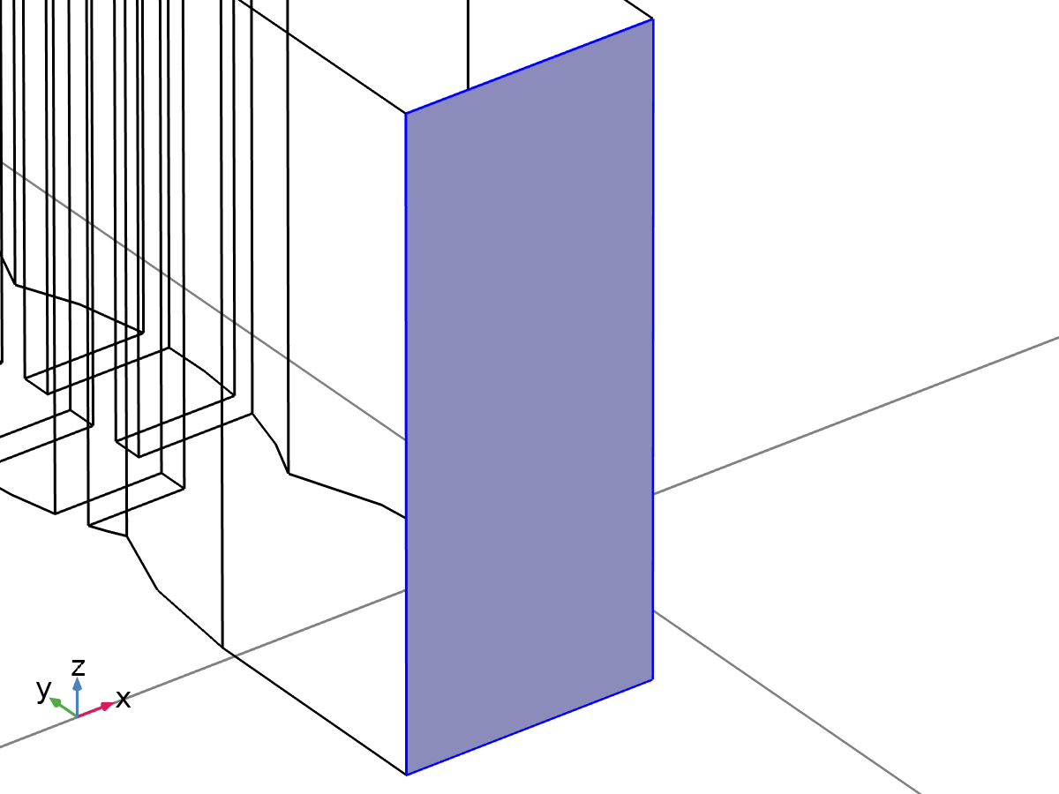

Inlet 1

Selection

|  |  |
| --- | --- |
| Geometric entity level | Boundary |
| Selection | Geometry geom1: Dimension 2: Boundary 2 |

Equations





#### Boundary Condition

Settings

| **Description** | **Value** |
| --- | --- |
| Boundary condition | Fully developed flow |
| Apply condition on each disjoint selection separately | On |

#### Fully Developed Flow

Settings

| **Description** | **Value** |
| --- | --- |
| Fully developed flow option | Average velocity |
| Average velocity | uL |

#### Variables

| **Name** | **Expression** | **Unit** | **Description** | **Selection** |
| --- | --- | --- | --- | --- |
| spf.nu | spf.mu/spf.rho | m²/s | Kinematic viscosity | Boundary 2 |
| spf.KStressn_avx | spf.K_stress_tensorxx*spf.nxmesh+spf.K_stress_tensorxy*spf.nymesh+spf.K_stress_tensorxz*spf.nzmesh | N/m² | Average viscous stress, x component | Boundary 2 |
| spf.KStressn_avy | spf.K_stress_tensoryx*spf.nxmesh+spf.K_stress_tensoryy*spf.nymesh+spf.K_stress_tensoryz*spf.nzmesh | N/m² | Average viscous stress, y component | Boundary 2 |
| spf.KStressn_avz | spf.K_stress_tensorzx*spf.nxmesh+spf.K_stress_tensorzy*spf.nymesh+spf.K_stress_tensorzz*spf.nzmesh | N/m² | Average viscous stress, z component | Boundary 2 |
| spf.KStressTestn_avx | spf.K_stress_tensor_testxx*spf.nxmesh+spf.K_stress_tensor_testxy*spf.nymesh+spf.K_stress_tensor_testxz*spf.nzmesh | N/m² | Average viscous stress, x component | Boundary 2 |
| spf.KStressTestn_avy | spf.K_stress_tensor_testyx*spf.nxmesh+spf.K_stress_tensor_testyy*spf.nymesh+spf.K_stress_tensor_testyz*spf.nzmesh | N/m² | Average viscous stress, y component | Boundary 2 |
| spf.KStressTestn_avz | spf.K_stress_tensor_testzx*spf.nxmesh+spf.K_stress_tensor_testzy*spf.nymesh+spf.K_stress_tensor_testzz*spf.nzmesh | N/m² | Average viscous stress, z component | Boundary 2 |
| spf.ujumpx | spf.ut_herex-spf.ut_therex | m/s | Velocity jump, x component | Boundary 2 |
| spf.ujumpy | spf.ut_herey-spf.ut_therey | m/s | Velocity jump, y component | Boundary 2 |
| spf.ujumpz | spf.ut_herez-spf.ut_therez | m/s | Velocity jump, z component | Boundary 2 |
| spf.meshVol | meshvol_spatial | m² |  | Boundary 2 |
| spf.meshVolInt | down(meshvol_spatial) | m³ | Volume of interior mesh element | Boundary 2 |
| spf.c_here | 96*nojac(down((spf.mu+spf.muT)/spf.epsilon_p))*spf.meshVol/spf.meshVolInt | Pa·s/m | Intermediate variable | Boundary 2 |
| spf.sigma_dg_ns | 4*spf.c_here | Pa·s/m |  | Boundary 2 |
| spf.un_here | u*nojac(spf.nxmesh)+v*nojac(spf.nymesh)+w*nojac(spf.nzmesh) | m/s | Intermediate variable | Boundary 2 |
| spf.ut_herex | u-spf.un_here*nojac(spf.nxmesh) | m/s | Intermediate variable, x component | Boundary 2 |
| spf.ut_herey | v-spf.un_here*nojac(spf.nymesh) | m/s | Intermediate variable, y component | Boundary 2 |
| spf.ut_herez | w-spf.un_here*nojac(spf.nzmesh) | m/s | Intermediate variable, z component | Boundary 2 |
| spf.un_there | 0 | m/s | Intermediate variable | Boundary 2 |
| spf.ut_therex | -spf.un_there*nojac(spf.nxmesh) | m/s | Intermediate variable, x component | Boundary 2 |
| spf.ut_therey | -spf.un_there*nojac(spf.nymesh) | m/s | Intermediate variable, y component | Boundary 2 |
| spf.ut_therez | -spf.un_there*nojac(spf.nzmesh) | m/s | Intermediate variable, z component | Boundary 2 |
| spf.unTestx | (test(u)*spf.nxmesh+test(v)*spf.nymesh+test(w)*spf.nzmesh)*spf.nxmesh | m/s |  | Boundary 2 |
| spf.unTesty | (test(u)*spf.nxmesh+test(v)*spf.nymesh+test(w)*spf.nzmesh)*spf.nymesh | m/s |  | Boundary 2 |
| spf.unTestz | (test(u)*spf.nxmesh+test(v)*spf.nymesh+test(w)*spf.nzmesh)*spf.nzmesh | m/s |  | Boundary 2 |
| spf.d | 1 |  | Length | Boundary 2 |
| spf.inl1.Uavfdf | uL | m/s | Average velocity | Global |
| spf.inl1.dz | spf.dz | m | Channel thickness | Boundary 2 |
| spf.inl1.pHydroCompensation | 0 | Pa | Hydrostatic pressure | Global |
| spf.inl1.L | 10*sqrt(spf.inl1.intop(1)) | m | Entrance length | Global |
| spf.inl1.volumeFlowRate | spf.inl1.intop(u*spf.nxmesh+v*spf.nymesh+w*spf.nzmesh) | m³/s | Outward volume flow rate across feature selection | Global |
| spf.inl1.massFlowRate | spf.inl1.intop(spf.rho*(u*spf.nxmesh+v*spf.nymesh+w*spf.nzmesh)) | kg/s | Outward mass flow rate across feature selection | Global |
| spf.inl1.pAverage | spf.inl1.aveop(p) | Pa | Pressure average over feature selection | Global |
| spf.inl1.Vinlfdf | -spf.inl1.volumeFlowRate | m³/s | Boundary integral of velocity | Global |
| spf.inl1.Area | spf.inl1.intop(spf.d) | m² | Boundary area | Global |

#### Shape functions

| **Name** | **Shape function** | **Unit** | **Description** | **Shape frame** | **Selection** |
| --- | --- | --- | --- | --- | --- |
| spf.inl1.Pinlfdf | ODE | Pa | Help ode variable for fully developed flow |  | Global |

#### Weak Expressions

| **Weak expression** | **Integration order** | **Integration frame** | **Selection** |
| --- | --- | --- | --- |
| spf.KStressn_avx*test(spf.ut_herex)+spf.KStressn_avy*test(spf.ut_herey)+spf.KStressn_avz*test(spf.ut_herez)+spf.KStressTestn_avx*spf.ujumpx+spf.KStressTestn_avy*spf.ujumpy+spf.KStressTestn_avz*spf.ujumpz-spf.sigma_dg_ns*spf.ujumpx*test(spf.ut_herex)-spf.sigma_dg_ns*spf.ujumpy*test(spf.ut_herey)-spf.sigma_dg_ns*spf.ujumpz*test(spf.ut_herez) | 4 | Spatial | Boundary 2 |
| ((-2*spf.mu_eff*uTx/spf.epsilon_p+p)*dtang(spf.unTestx,x)-spf.mu_eff*(uTy+vTx)*dtang(spf.unTesty,x)/spf.epsilon_p-spf.mu_eff*(uTz+wTx)*dtang(spf.unTestz,x)/spf.epsilon_p-spf.mu_eff*(uTy+vTx)*dtang(spf.unTestx,y)/spf.epsilon_p+(-2*spf.mu_eff*vTy/spf.epsilon_p+p)*dtang(spf.unTesty,y)-spf.mu_eff*(vTz+wTy)*dtang(spf.unTestz,y)/spf.epsilon_p-spf.mu_eff*(uTz+wTx)*dtang(spf.unTestx,z)/spf.epsilon_p-spf.mu_eff*(vTz+wTy)*dtang(spf.unTesty,z)/spf.epsilon_p+(-2*spf.mu_eff*wTz/spf.epsilon_p+p)*dtang(spf.unTestz,z))*spf.inl1.L-(spf.nxmesh*test(u)+spf.nymesh*test(v)+spf.nzmesh*test(w))*spf.inl1.Pinlfdf | 4 | Spatial | Boundary 2 |
| (spf.inl1.Vinlfdf-spf.inl1.Area*spf.inl1.Uavfdf)*test(spf.inl1.Pinlfdf) | 4 |  | Global |

#### Constraints

| **Constraint** | **Constraint force** | **Shape function** | **Selection** | **Details** |
| --- | --- | --- | --- | --- |
| -u+spf.ubndx | test(-u) | Lagrange (Quadratic) | Edges 1, 3, 5, 395 | Elemental |
| -v+spf.ubndy | test(-v) | Lagrange (Quadratic) | Edges 1, 3, 5, 395 | Elemental |
| -w+spf.ubndz | test(-w) | Lagrange (Quadratic) | Edges 1, 3, 5, 395 | Elemental |

* + 1. Inlet 2

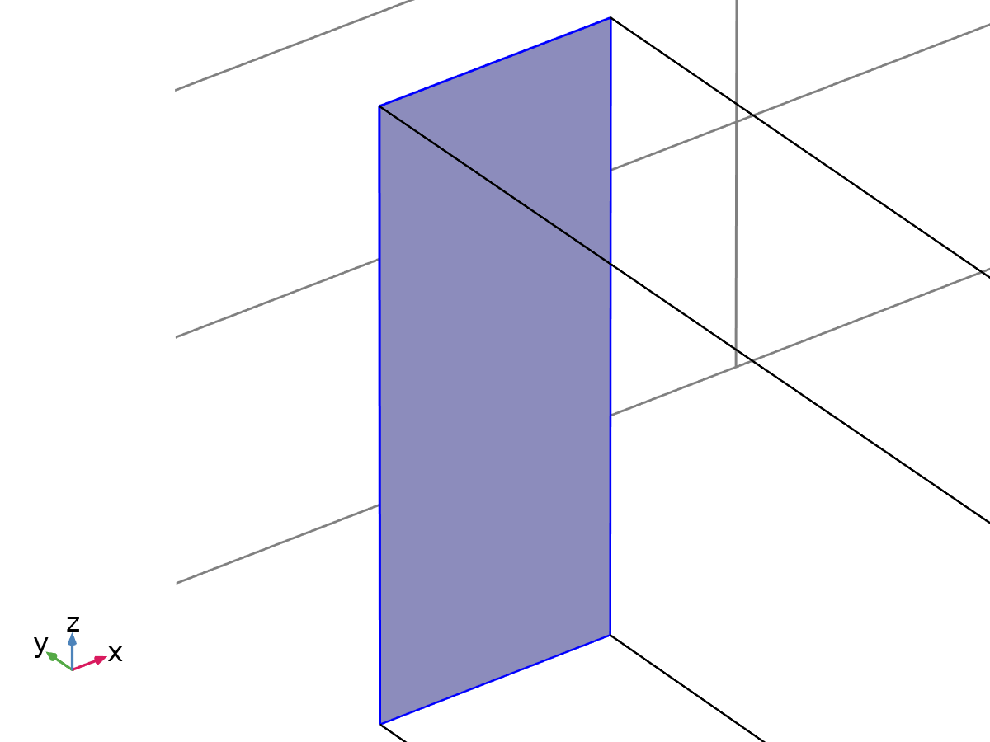

Inlet 2

Selection

|  |  |
| --- | --- |
| Geometric entity level | Boundary |
| Selection | Geometry geom1: Dimension 2: Boundary 21 |

Equations





#### Boundary Condition

Settings

| **Description** | **Value** |
| --- | --- |
| Boundary condition | Fully developed flow |
| Apply condition on each disjoint selection separately | On |

#### Fully Developed Flow

Settings

| **Description** | **Value** |
| --- | --- |
| Fully developed flow option | Average velocity |
| Average velocity | uR |

#### Variables

| **Name** | **Expression** | **Unit** | **Description** | **Selection** |
| --- | --- | --- | --- | --- |
| spf.nu | spf.mu/spf.rho | m²/s | Kinematic viscosity | Boundary 21 |
| spf.KStressn_avx | spf.K_stress_tensorxx*spf.nxmesh+spf.K_stress_tensorxy*spf.nymesh+spf.K_stress_tensorxz*spf.nzmesh | N/m² | Average viscous stress, x component | Boundary 21 |
| spf.KStressn_avy | spf.K_stress_tensoryx*spf.nxmesh+spf.K_stress_tensoryy*spf.nymesh+spf.K_stress_tensoryz*spf.nzmesh | N/m² | Average viscous stress, y component | Boundary 21 |
| spf.KStressn_avz | spf.K_stress_tensorzx*spf.nxmesh+spf.K_stress_tensorzy*spf.nymesh+spf.K_stress_tensorzz*spf.nzmesh | N/m² | Average viscous stress, z component | Boundary 21 |
| spf.KStressTestn_avx | spf.K_stress_tensor_testxx*spf.nxmesh+spf.K_stress_tensor_testxy*spf.nymesh+spf.K_stress_tensor_testxz*spf.nzmesh | N/m² | Average viscous stress, x component | Boundary 21 |
| spf.KStressTestn_avy | spf.K_stress_tensor_testyx*spf.nxmesh+spf.K_stress_tensor_testyy*spf.nymesh+spf.K_stress_tensor_testyz*spf.nzmesh | N/m² | Average viscous stress, y component | Boundary 21 |
| spf.KStressTestn_avz | spf.K_stress_tensor_testzx*spf.nxmesh+spf.K_stress_tensor_testzy*spf.nymesh+spf.K_stress_tensor_testzz*spf.nzmesh | N/m² | Average viscous stress, z component | Boundary 21 |
| spf.ujumpx | spf.ut_herex-spf.ut_therex | m/s | Velocity jump, x component | Boundary 21 |
| spf.ujumpy | spf.ut_herey-spf.ut_therey | m/s | Velocity jump, y component | Boundary 21 |
| spf.ujumpz | spf.ut_herez-spf.ut_therez | m/s | Velocity jump, z component | Boundary 21 |
| spf.meshVol | meshvol_spatial | m² |  | Boundary 21 |
| spf.meshVolInt | down(meshvol_spatial) | m³ | Volume of interior mesh element | Boundary 21 |
| spf.c_here | 96*nojac(down((spf.mu+spf.muT)/spf.epsilon_p))*spf.meshVol/spf.meshVolInt | Pa·s/m | Intermediate variable | Boundary 21 |
| spf.sigma_dg_ns | 4*spf.c_here | Pa·s/m |  | Boundary 21 |
| spf.un_here | u*nojac(spf.nxmesh)+v*nojac(spf.nymesh)+w*nojac(spf.nzmesh) | m/s | Intermediate variable | Boundary 21 |
| spf.ut_herex | u-spf.un_here*nojac(spf.nxmesh) | m/s | Intermediate variable, x component | Boundary 21 |
| spf.ut_herey | v-spf.un_here*nojac(spf.nymesh) | m/s | Intermediate variable, y component | Boundary 21 |
| spf.ut_herez | w-spf.un_here*nojac(spf.nzmesh) | m/s | Intermediate variable, z component | Boundary 21 |
| spf.un_there | 0 | m/s | Intermediate variable | Boundary 21 |
| spf.ut_therex | -spf.un_there*nojac(spf.nxmesh) | m/s | Intermediate variable, x component | Boundary 21 |
| spf.ut_therey | -spf.un_there*nojac(spf.nymesh) | m/s | Intermediate variable, y component | Boundary 21 |
| spf.ut_therez | -spf.un_there*nojac(spf.nzmesh) | m/s | Intermediate variable, z component | Boundary 21 |
| spf.unTestx | (test(u)*spf.nxmesh+test(v)*spf.nymesh+test(w)*spf.nzmesh)*spf.nxmesh | m/s |  | Boundary 21 |
| spf.unTesty | (test(u)*spf.nxmesh+test(v)*spf.nymesh+test(w)*spf.nzmesh)*spf.nymesh | m/s |  | Boundary 21 |
| spf.unTestz | (test(u)*spf.nxmesh+test(v)*spf.nymesh+test(w)*spf.nzmesh)*spf.nzmesh | m/s |  | Boundary 21 |
| spf.d | 1 |  | Length | Boundary 21 |
| spf.inl2.Uavfdf | uR | m/s | Average velocity | Global |
| spf.inl2.dz | spf.dz | m | Channel thickness | Boundary 21 |
| spf.inl2.pHydroCompensation | 0 | Pa | Hydrostatic pressure | Global |
| spf.inl2.L | 10*sqrt(spf.inl2.intop(1)) | m | Entrance length | Global |
| spf.inl2.volumeFlowRate | spf.inl2.intop(u*spf.nxmesh+v*spf.nymesh+w*spf.nzmesh) | m³/s | Outward volume flow rate across feature selection | Global |
| spf.inl2.massFlowRate | spf.inl2.intop(spf.rho*(u*spf.nxmesh+v*spf.nymesh+w*spf.nzmesh)) | kg/s | Outward mass flow rate across feature selection | Global |
| spf.inl2.pAverage | spf.inl2.aveop(p) | Pa | Pressure average over feature selection | Global |
| spf.inl2.Vinlfdf | -spf.inl2.volumeFlowRate | m³/s | Boundary integral of velocity | Global |
| spf.inl2.Area | spf.inl2.intop(spf.d) | m² | Boundary area | Global |

#### Shape functions

| **Name** | **Shape function** | **Unit** | **Description** | **Shape frame** | **Selection** |
| --- | --- | --- | --- | --- | --- |
| spf.inl2.Pinlfdf | ODE | Pa | Help ode variable for fully developed flow |  | Global |

#### Weak Expressions

| **Weak expression** | **Integration order** | **Integration frame** | **Selection** |
| --- | --- | --- | --- |
| spf.KStressn_avx*test(spf.ut_herex)+spf.KStressn_avy*test(spf.ut_herey)+spf.KStressn_avz*test(spf.ut_herez)+spf.KStressTestn_avx*spf.ujumpx+spf.KStressTestn_avy*spf.ujumpy+spf.KStressTestn_avz*spf.ujumpz-spf.sigma_dg_ns*spf.ujumpx*test(spf.ut_herex)-spf.sigma_dg_ns*spf.ujumpy*test(spf.ut_herey)-spf.sigma_dg_ns*spf.ujumpz*test(spf.ut_herez) | 4 | Spatial | Boundary 21 |
| ((-2*spf.mu_eff*uTx/spf.epsilon_p+p)*dtang(spf.unTestx,x)-spf.mu_eff*(uTy+vTx)*dtang(spf.unTesty,x)/spf.epsilon_p-spf.mu_eff*(uTz+wTx)*dtang(spf.unTestz,x)/spf.epsilon_p-spf.mu_eff*(uTy+vTx)*dtang(spf.unTestx,y)/spf.epsilon_p+(-2*spf.mu_eff*vTy/spf.epsilon_p+p)*dtang(spf.unTesty,y)-spf.mu_eff*(vTz+wTy)*dtang(spf.unTestz,y)/spf.epsilon_p-spf.mu_eff*(uTz+wTx)*dtang(spf.unTestx,z)/spf.epsilon_p-spf.mu_eff*(vTz+wTy)*dtang(spf.unTesty,z)/spf.epsilon_p+(-2*spf.mu_eff*wTz/spf.epsilon_p+p)*dtang(spf.unTestz,z))*spf.inl2.L-(spf.nxmesh*test(u)+spf.nymesh*test(v)+spf.nzmesh*test(w))*spf.inl2.Pinlfdf | 4 | Spatial | Boundary 21 |
| (spf.inl2.Vinlfdf-spf.inl2.Area*spf.inl2.Uavfdf)*test(spf.inl2.Pinlfdf) | 4 |  | Global |

#### Constraints

| **Constraint** | **Constraint force** | **Shape function** | **Selection** | **Details** |
| --- | --- | --- | --- | --- |
| -u+spf.ubndx | test(-u) | Lagrange (Quadratic) | Edges 47–49, 400 | Elemental |
| -v+spf.ubndy | test(-v) | Lagrange (Quadratic) | Edges 47–49, 400 | Elemental |
| -w+spf.ubndz | test(-w) | Lagrange (Quadratic) | Edges 47–49, 400 | Elemental |

* + 1. Outlet 1

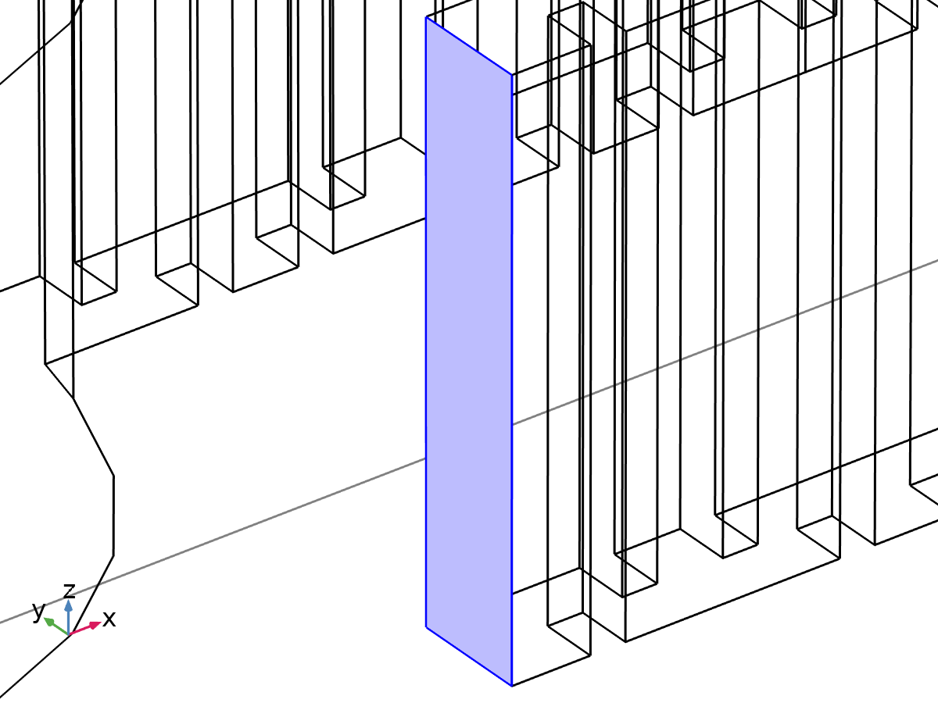

Outlet 1

Selection

|  |  |
| --- | --- |
| Geometric entity level | Boundary |
| Selection | Geometry geom1: Dimension 2: Boundary 164 |

Equations





#### Boundary Condition

Settings

| **Description** | **Value** |
| --- | --- |
| Boundary condition | Pressure |

#### Pressure Conditions

Settings

| **Description** | **Value** |
| --- | --- |
| Pressure | Static |
| Pressure | 0 |
| Normal flow | Off |
| Suppress backflow | On |

Used products

|  |
| --- |
| COMSOL Multiphysics |

#### Variables

| **Name** | **Expression** | **Unit** | **Description** | **Selection** |
| --- | --- | --- | --- | --- |
| spf.meshVol | meshvol_spatial | m² |  | Boundary 164 |
| spf.meshVolInt | down(meshvol_spatial) | m³ | Volume of interior mesh element | Boundary 164 |
| spf.c_here | 384/spf.epsilon_p | Pa·s/m | Intermediate variable | Boundary 164 |
| spf.rhoFace | down(spf.rho) | kg/m³ | Density face value | Boundary 164 |
| spf.umxTnFace | spf.upwind_helpx*spf.nxmesh+spf.upwind_helpy*spf.nymesh+spf.upwind_helpz*spf.nzmesh | m/s | Relative velocity on face | Boundary 164 |
| spf.upwind_ns | spf.backflowPenaltyConv*spf.uNormal | W/m² | Upwind term | Boundary 164 |
| spf.p0 | 0 | Pa | Pressure | Boundary 164 |
| spf.out1.Uav | 0 | m/s | Average velocity | Global |
| spf.out1.p0avfdf | 0 | Pa | Average pressure | Global |
| spf.out1.dz | spf.dz | m | Channel thickness | Boundary 164 |
| spf.out1.Mflow | spf.out1.massFlowRate | kg/s | Mass flow | Global |
| spf.f0 | spf.p0+spf.uNormal*(spf.backflowPenaltyDiff-spf.backflowPenaltyConv)*(spf.uNormal<0) | N/m² | Normal stress | Boundary 164 |
| spf.uNormal | u*nojac(spf.nxmesh)+v*nojac(spf.nymesh)+w*nojac(spf.nzmesh) | m/s | Normal velocity | Boundary 164 |
| spf.backflowPenaltyDiff | spf.c_here*min((down(spf.mu)+spf.muT)*spf.meshVol/spf.meshVolInt,down(spf.rho)*abs(spf.uNormal)/down(spf.epsilon_p)) | kg²/(m⁴·s²) | Backflow penalty parameter, diffusive contribution | Boundary 164 |
| spf.backflowPenaltyConv | spf.rhoFace*spf.umxTnFace/spf.epsilon_p^2 | kg/(m²·s) | Backflow penalty parameter, convective contribution | Boundary 164 |
| spf.out1.volumeFlowRate | spf.out1.intop(u*spf.nxmesh+v*spf.nymesh+w*spf.nzmesh) | m³/s | Outward volume flow rate across feature selection | Global |
| spf.out1.massFlowRate | spf.out1.intop(spf.rho*(u*spf.nxmesh+v*spf.nymesh+w*spf.nzmesh)) | kg/s | Outward mass flow rate across feature selection | Global |
| spf.out1.pAverage | spf.out1.aveop(p) | Pa | Pressure average over feature selection | Global |

#### Weak Expressions

| **Weak expression** | **Integration order** | **Integration frame** | **Selection** |
| --- | --- | --- | --- |
| -spf.f0*(test(u)*spf.nxmesh+test(v)*spf.nymesh+test(w)*spf.nzmesh) | 4 | Spatial | Boundary 164 |

* 1. Transport of Diluted Species

Used products

|  |
| --- |
| COMSOL Multiphysics |



Transport of Diluted Species

Selection

|  |  |
| --- | --- |
| Geometric entity level | Domain |
| Selection | Geometry geom1: Dimension 3: All domains |

Equations





* + 1. Interface Settings

#### Discretization

Settings

| **Description** | **Value** |
| --- | --- |
| Concentration | Quadratic |

#### Transport Mechanisms

Settings

| **Description** | **Value** |
| --- | --- |
| Convection | On |
| Migration in electric field | Off |
| Mass transfer in porous media | Off |

* + 1. Variables

| **Name** | **Expression** | **Unit** | **Description** | **Selection** | **Details** |
| --- | --- | --- | --- | --- | --- |
| tds.R_c | 0 | mol/(m³·s) | Total rate expression | Domain 1 | + operation |
| tds.cP_c | 0 | mol/kg | Concentration species absorbed to the solid | Domain 1 | + operation |
| tds.cP_c | 0 | mol/kg | Concentration species absorbed to the solid | Boundaries 1–269 | + operation |
| tds.KP_c | 0 | m³/kg | Adsorption isotherm, first concentration derivative | Domain 1 | + operation |
| tds.KP_c | 0 | m³/kg | Adsorption isotherm, first concentration derivative | Boundaries 1–269 | + operation |
| tds.poro | 1 | 1 | Porosity | Domain 1 |  |
| tds.theta_g | 0 | 1 | Gas volume fraction | Domain 1 |  |
| tds.theta | tds.poro | 1 | Mobile fluid volume fraction | Domain 1 |  |
| tds.nx | dnx | 1 | Normal vector, x component | Boundaries 1–269 |  |
| tds.ny | dny | 1 | Normal vector, y component | Boundaries 1–269 |  |
| tds.nz | dnz | 1 | Normal vector, z component | Boundaries 1–269 |  |
| tds.nxmesh | dnxmesh | 1 | Normal vector (mesh), x component | Boundaries 1–269 |  |
| tds.nymesh | dnymesh | 1 | Normal vector (mesh), y component | Boundaries 1–269 |  |
| tds.nzmesh | dnzmesh | 1 | Normal vector (mesh), z component | Boundaries 1–269 |  |
| tds.nxc | root.nxc/tds.ncLen | 1 | Normal vector, x component | Boundaries 1–269 |  |
| tds.nyc | root.nyc/tds.ncLen | 1 | Normal vector, y component | Boundaries 1–269 |  |
| tds.nzc | root.nzc/tds.ncLen | 1 | Normal vector, z component | Boundaries 1–269 |  |
| tds.ncLen | sqrt(root.nxc^2+root.nyc^2+root.nzc^2+eps) | 1 | Help variable | Boundaries 1–269 |  |
| tds.cbf_c | 0 | mol/(m²·s) | Convective boundary flux | Boundaries 1–269 |  |
| tds.u | 0 | m/s | Velocity field, x component | Domain 1 |  |
| tds.v | 0 | m/s | Velocity field, y component | Domain 1 |  |
| tds.w | 0 | m/s | Velocity field, z component | Domain 1 |  |

* + 1. Transport Properties 1



Transport Properties 1

Selection

|  |  |
| --- | --- |
| Geometric entity level | Domain |
| Selection | Geometry geom1: Dimension 3: All domains |

Equations





#### Convection

Settings

| **Description** | **Value** |
| --- | --- |
| Velocity field | Velocity field (spf) |

#### Diffusion

Settings

| **Description** | **Value** |
| --- | --- |
| Source | Material |
| Material | None |
| Diffusion coefficient | User defined |
| Diffusion coefficient | {{D, 0, 0}, {0, D, 0}, {0, 0, D}} |

#### Coordinate System Selection

Settings

| **Description** | **Value** |
| --- | --- |
| Coordinate system | Global coordinate system |

#### Model Input

Settings

| **Description** | **Value** |
| --- | --- |
| Temperature | Common model input |

#### Variables

| **Name** | **Expression** | **Unit** | **Description** | **Selection** | **Details** |
| --- | --- | --- | --- | --- | --- |
| domflux.cx | tds.dflux_cx | mol/(m²·s) | Domain flux, x component | Domain 1 |  |
| domflux.cy | tds.dflux_cy | mol/(m²·s) | Domain flux, y component | Domain 1 |  |
| domflux.cz | tds.dflux_cz | mol/(m²·s) | Domain flux, z component | Domain 1 |  |
| tds.ndflux_c | tds.bndFlux_c | mol/(m²·s) | Normal diffusive flux | Boundaries 1–269 |  |
| tds.ncflux_c | tds.cflux_cx*tds.nxc+tds.cflux_cy*tds.nyc+tds.cflux_cz*tds.nzc | mol/(m²·s) | Normal convective flux | Boundaries 1–269 |  |
| tds.ntflux_c | tds.bndFlux_c+tds.cflux_cx*tds.nxc+tds.cflux_cy*tds.nyc+tds.cflux_cz*tds.nzc | mol/(m²·s) | Normal total flux | Boundaries 1–269 |  |
| tds.u | model.input.u1 | m/s | Velocity field, x component | Domain 1 | Meta |
| tds.v | model.input.u2 | m/s | Velocity field, y component | Domain 1 | Meta |
| tds.w | model.input.u3 | m/s | Velocity field, z component | Domain 1 | Meta |
| tds.bndFlux_c | -dflux_spatial(c) | mol/(m²·s) | Boundary flux | Boundaries 1–269 |  |
| tds.D_cxx | D | m²/s | Diffusion coefficient, xx component | Domain 1 |  |
| tds.D_cyx | 0 | m²/s | Diffusion coefficient, yx component | Domain 1 |  |
| tds.D_czx | 0 | m²/s | Diffusion coefficient, zx component | Domain 1 |  |
| tds.D_cxy | 0 | m²/s | Diffusion coefficient, xy component | Domain 1 |  |
| tds.D_cyy | D | m²/s | Diffusion coefficient, yy component | Domain 1 |  |
| tds.D_czy | 0 | m²/s | Diffusion coefficient, zy component | Domain 1 |  |
| tds.D_cxz | 0 | m²/s | Diffusion coefficient, xz component | Domain 1 |  |
| tds.D_cyz | 0 | m²/s | Diffusion coefficient, yz component | Domain 1 |  |
| tds.D_czz | D | m²/s | Diffusion coefficient, zz component | Domain 1 |  |
| tds.Dav_c | (tds.D_cxx+tds.D_cyy+tds.D_czz)/3 | m²/s | Average diffusion coefficient | Domain 1 |  |
| tds.tflux_cx | tds.dflux_cx+tds.cflux_cx | mol/(m²·s) | Total flux, x component | Domain 1 | + operation |
| tds.tflux_cy | tds.dflux_cy+tds.cflux_cy | mol/(m²·s) | Total flux, y component | Domain 1 | + operation |
| tds.tflux_cz | tds.dflux_cz+tds.cflux_cz | mol/(m²·s) | Total flux, z component | Domain 1 | + operation |
| tds.dfluxMag_c | sqrt(tds.dflux_cx^2+tds.dflux_cy^2+tds.dflux_cz^2) | mol/(m²·s) | Diffusive flux magnitude | Domain 1 |  |
| tds.tfluxMag_c | sqrt(tds.tflux_cx^2+tds.tflux_cy^2+tds.tflux_cz^2) | mol/(m²·s) | Total flux magnitude | Domain 1 |  |
| tds.dpflux_cx | 0 | mol/(m²·s) | Dispersive flux, x component | Domain 1 |  |
| tds.dpflux_cy | 0 | mol/(m²·s) | Dispersive flux, y component | Domain 1 |  |
| tds.dpflux_cz | 0 | mol/(m²·s) | Dispersive flux, z component | Domain 1 |  |
| tds.dflux_cx | -tds.D_cxx*cx-tds.D_cxy*cy-tds.D_cxz*cz | mol/(m²·s) | Diffusive flux, x component | Domain 1 |  |
| tds.dflux_cy | -tds.D_cyx*cx-tds.D_cyy*cy-tds.D_cyz*cz | mol/(m²·s) | Diffusive flux, y component | Domain 1 |  |
| tds.dflux_cz | -tds.D_czx*cx-tds.D_czy*cy-tds.D_czz*cz | mol/(m²·s) | Diffusive flux, z component | Domain 1 |  |
| tds.grad_cx | cx | mol/m⁴ | Concentration gradient, x component | Domain 1 |  |
| tds.grad_cy | cy | mol/m⁴ | Concentration gradient, y component | Domain 1 |  |
| tds.grad_cz | cz | mol/m⁴ | Concentration gradient, z component | Domain 1 |  |
| tds.cflux_cx | c*tds.u | mol/(m²·s) | Convective flux, x component | Domain 1 |  |
| tds.cflux_cy | c*tds.v | mol/(m²·s) | Convective flux, y component | Domain 1 |  |
| tds.cflux_cz | c*tds.w | mol/(m²·s) | Convective flux, z component | Domain 1 |  |
| tds.cfluxMag_c | sqrt(tds.cflux_cx^2+tds.cflux_cy^2+tds.cflux_cz^2) | mol/(m²·s) | Convective flux magnitude | Domain 1 |  |
| tds.Res_c | -tds.D_cxx*cxx-tds.D_cxy*cxy-tds.D_cxz*cxz-tds.D_cyx*cyx-tds.D_cyy*cyy-tds.D_cyz*cyz-tds.D_czx*czx-tds.D_czy*czy-tds.D_czz*czz+tds.u*cx+tds.v*cy+tds.w*cz-tds.R_c | mol/(m³·s) | Equation residual | Domain 1 |  |

#### Shape functions

| **Name** | **Shape function** | **Unit** | **Description** | **Shape frame** | **Selection** |
| --- | --- | --- | --- | --- | --- |
| c | Lagrange (Quadratic) | mol/m³ | Concentration | Spatial | Domain 1 |

* + 1. No Flux 1



No Flux 1

Selection

|  |  |
| --- | --- |
| Geometric entity level | Boundary |
| Selection | Geometry geom1: Dimension 2: All boundaries |

Equations



#### Convection

Settings

| **Description** | **Value** |
| --- | --- |
| Include | Off |

* + 1. Initial Values 1



Initial Values 1

Selection

|  |  |
| --- | --- |
| Geometric entity level | Domain |
| Selection | Geometry geom1: Dimension 3: All domains |

#### Initial Values

Settings

| **Description** | **Value** |
| --- | --- |
| Concentration | 0 |

* + 1. Concentration 1



Concentration 1

Selection

|  |  |
| --- | --- |
| Geometric entity level | Boundary |
| Selection | Geometry geom1: Dimension 2: Boundary 2 |

Equations



#### Concentration

Settings

| **Description** | **Value** |
| --- | --- |
| Species c | On |
| Concentration | cL |

#### Variables

| **Name** | **Expression** | **Unit** | **Description** | **Selection** |
| --- | --- | --- | --- | --- |
| tds.c0_c | cL | mol/m³ | Concentration | Boundary 2 |

* + 1. Concentration 2



Concentration 2

Selection

|  |  |
| --- | --- |
| Geometric entity level | Boundary |
| Selection | Geometry geom1: Dimension 2: Boundary 21 |

Equations



#### Concentration

Settings

| **Description** | **Value** |
| --- | --- |
| Species c | On |
| Concentration | cR |

#### Variables

| **Name** | **Expression** | **Unit** | **Description** | **Selection** |
| --- | --- | --- | --- | --- |
| tds.c0_c | cR | mol/m³ | Concentration | Boundary 21 |

* + 1. Outflow 1



Outflow 1

Selection

|  |  |
| --- | --- |
| Geometric entity level | Boundary |
| Selection | Geometry geom1: Dimension 2: Boundary 164 |

Equations



#### Variables

| **Name** | **Expression** | **Unit** | **Description** | **Selection** |
| --- | --- | --- | --- | --- |
| tds.out1.c0_avg_c | tds.out1.int(c*(tds.u*tds.nx+tds.v*tds.ny+tds.w*tds.nz))/tds.out1.int(tds.u*tds.nx+tds.v*tds.ny+tds.w*tds.nz) | mol/m³ | Concentration | Global |

* 1. Mesh 1

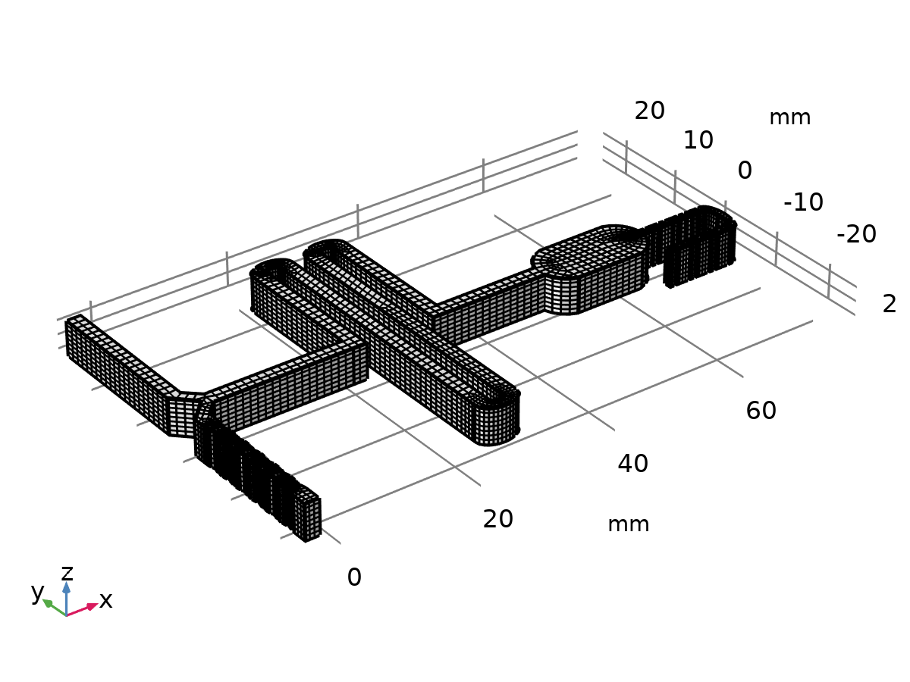

Mesh 1

Mesh statistics

| **Description** | **Value** |
| --- | --- |
| Minimum element quality | 0.02018 |
| Average element quality | 0.6627 |
| Prism | 96 |
| Hexahedron | 9592 |
| Triangle | 24 |
| Quad | 9886 |
| Edge element | 4008 |
| Vertex element | 534 |

* + 1. Size (size)

Settings

| **Description** | **Value** |
| --- | --- |
| Calibrate for | Fluid dynamics |
| Maximum element size | 1.07 |
| Minimum element size | 0.319 |
| Curvature factor | 0.6 |
| Resolution of narrow regions | 0.7 |
| Maximum element growth rate | 1.15 |

* + 1. Swept 1 (swe1)

Selection

|  |  |
| --- | --- |
| Geometric entity level | Domain |
| Selection | Remaining |

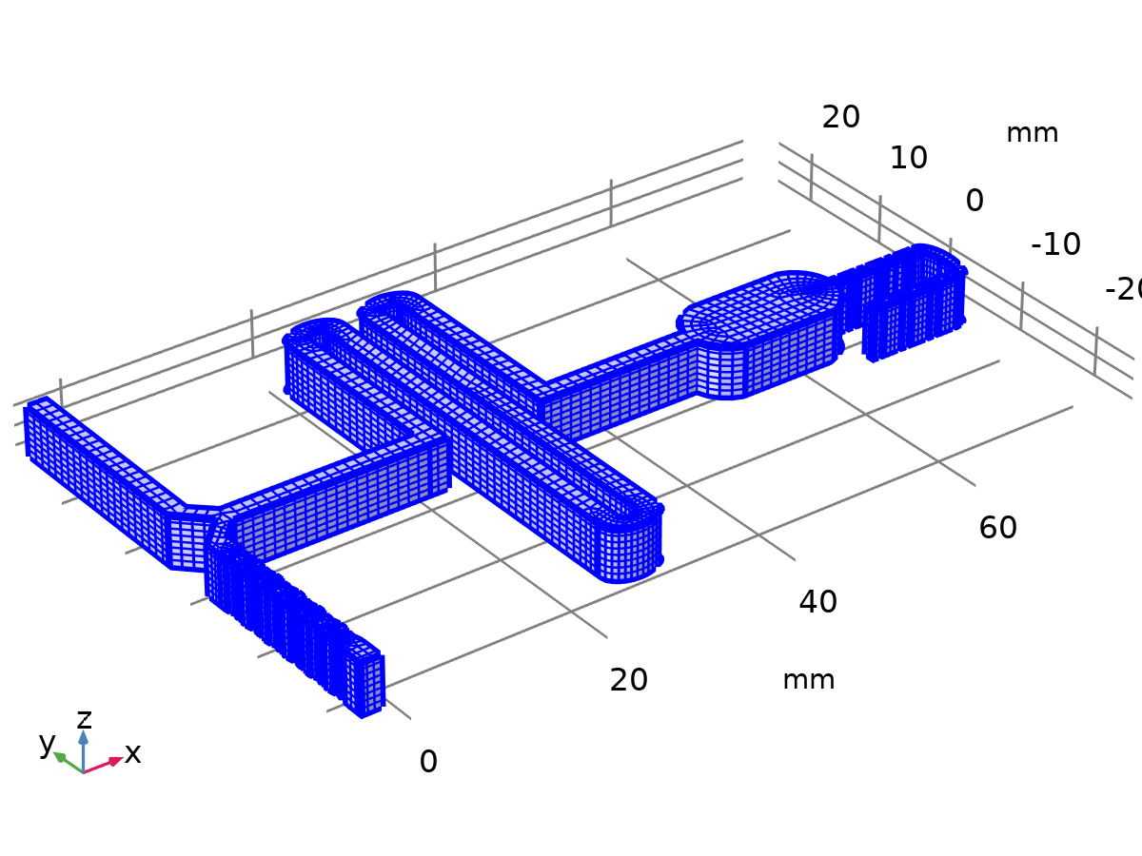

Swept 1

#### Distribution 1 (dis1)

Selection

|  |  |
| --- | --- |
| Geometric entity level | Domain |
| Selection | Geometry geom1: Dimension 3: All domains |



Distribution 1

Settings

| **Description** | **Value** |
| --- | --- |
| Number of elements | 8 |

1. Study 1

Computation information

|  |  |
| --- | --- |
| Computation time | 3 h 14 min 17 s |

* 1. Stationary

Study settings

| **Description** | **Value** |
| --- | --- |
| Include geometric nonlinearity | Off |

Physics and variables selection

| **Physics interface** | **Discretization** |
| --- | --- |
| Laminar Flow (spf) | physics |

Mesh selection

| **Geometry** | **Mesh** |
| --- | --- |
| Geometry 1 (geom1) | mesh1 |

* 1. Stationary 2

Study settings

| **Description** | **Value** |
| --- | --- |
| Include geometric nonlinearity | Off |

Values of dependent variables

| **Description** | **Value** |
| --- | --- |
| Settings | User controlled |
| Method | Solution |
| Study | Study 1 |

Study extensions

| **Description** | **Value** |
| --- | --- |
| Auxiliary sweep | On |
| Sweep type | Specified combinations |

Parameters

| **Parameter name** | **Parameter value list** | **Parameter unit** |
| --- | --- | --- |
| D (Diffusion Constant) | 1e-10 5e-11 1e-11 | m^2/s |

Physics and variables selection

| **Physics interface** | **Discretization** |
| --- | --- |
| Transport of Diluted Species (tds) | physics |

Mesh selection

| **Geometry** | **Mesh** |
| --- | --- |
| Geometry 1 (geom1) | mesh1 |

* + 1. Study extensions

Study extensions

| **Description** | **Value** |
| --- | --- |
| Auxiliary sweep | On |
| Sweep type | Specified combinations |

Parameters

| **Parameter name** | **Parameter value list** | **Parameter unit** |
| --- | --- | --- |
| D (Diffusion Constant) | 1e-10 5e-11 1e-11 | m^2/s |

* 1. Time Dependent

| **Times** | **Unit** |
| --- | --- |
| range(0,0.2,3) | s |

Study settings

| **Description** | **Value** |
| --- | --- |
| Include geometric nonlinearity | Off |

Study settings

| **Description** | **Value** |
| --- | --- |
| Output times | {0, 0.2, 0.4, 0.6000000000000001, 0.8, 1, 1.2000000000000002, 1.4000000000000001, 1.6, 1.8, 2, 2.2, 2.4000000000000004, 2.6, 2.8000000000000003, 3} |

Physics and variables selection

| **Physics interface** | **Discretization** |
| --- | --- |
| Laminar Flow (spf) | physics |
| Transport of Diluted Species (tds) | physics |

Mesh selection

| **Geometry** | **Mesh** |
| --- | --- |
| Geometry 1 (geom1) | mesh1 |

* 1. Solver Configurations
     1. Solution 1

#### Compile Equations: Stationary (st1)

Study and step

| **Description** | **Value** |
| --- | --- |
| Use study | Study 1 |
| Use study step | Stationary |

Log

<---- Compile Equations: Stationary in Study 1/Solution 1 (sol1) ---------------

Started at Dec 1, 2021 1:27:09 AM.

Geometry shape function: Linear Lagrange

Running on Intel64 Family 6 Model 142 Stepping 12, GenuineIntel.

Using 1 socket with 4 cores in total on LAPTOP-QEU20CEA.

Available memory: 8.08 GB.

Time: 2 s.

Physical memory: 1.28 GB

Virtual memory: 1.93 GB

Ended at Dec 1, 2021 1:27:11 AM.

----- Compile Equations: Stationary in Study 1/Solution 1 (sol1) -------------->

#### Dependent Variables 1 (v1)

General

| **Description** | **Value** |
| --- | --- |
| Defined by study step | Stationary |

Initial value calculation constants

| **Constant name** | **Initial value source** |
| --- | --- |
| timestep | 0.003[s] |

Log

<---- Dependent Variables 1 in Study 1/Solution 1 (sol1) -----------------------

Started at Dec 1, 2021 1:27:11 AM.

Solution time: 0 s.

Physical memory: 1.3 GB

Virtual memory: 1.95 GB

Ended at Dec 1, 2021 1:27:12 AM.

----- Dependent Variables 1 in Study 1/Solution 1 (sol1) ---------------------->

##### Concentration (comp1.c) (comp1_c)

General

| **Description** | **Value** |
| --- | --- |
| Field components | comp1.c |
| Internal variables | {comp1.uflux.c, comp1.dflux.c} |
| Solve for this field | Off |

##### Pressure (comp1.p) (comp1_p)

General

| **Description** | **Value** |
| --- | --- |
| Field components | comp1.p |

##### Velocity field (comp1.u) (comp1_u)

General

| **Description** | **Value** |
| --- | --- |
| Field components | {comp1.u, comp1.v, comp1.w} |
| Internal variables | comp1.spf.isFluidHasBeenSolved |

##### Help ode variable for fully developed flow (comp1.spf.inl1.Pinlfdf) (comp1_spf_inl1_Pinlfdf)

General

| **Description** | **Value** |
| --- | --- |
| State components | comp1.spf.inl1.Pinlfdf |

##### Help ode variable for fully developed flow (comp1.spf.inl2.Pinlfdf) (comp1_spf_inl2_Pinlfdf)

General

| **Description** | **Value** |
| --- | --- |
| State components | comp1.spf.inl2.Pinlfdf |

#### Stationary Solver 1 (s1)

General

| **Description** | **Value** |
| --- | --- |
| Defined by study step | Stationary |

Log

<---- Stationary Solver 1 in Study 1/Solution 1 (sol1) -------------------------

Started at Dec 1, 2021 1:27:13 AM.

Nonlinear solver

Number of degrees of freedom solved for: 308675 (plus 1 internal DOFs).

Nonsymmetric matrix found.

Scales for dependent variables:

Pressure (comp1.p): 0.11

Velocity field (comp1.u): 0.11

Help ode variable for fully developed flow (comp1.spf.inl1.Pinlfdf): 1

Help ode variable for fully developed flow (comp1.spf.inl2.Pinlfdf): 0.71

Orthonormal null-space function used.

Iter      SolEst      ResEst     Damping    Stepsize #Res #Jac #Sol LinIt   LinErr   LinRes

   1          85     7.9e+05   0.0100000          86    2    1    2     6    0.093       24

   2         7.1     5.3e+03   0.1000000         7.9    3    2    5    21   0.0031      8.2

   3       0.051     4.8e+04   1.0000000        0.77    4    3    8    47    0.076      0.3

   4      0.0087       6e+03   1.0000000       0.049    5    4   11    53    0.005        -

   5      0.0033     5.7e+03   1.0000000       0.016    7    5   14    62   0.0013        -

   6       0.023     5.8e+03   0.1000000       0.025    8    6   17    71   0.0084        -

   7     0.00043       5e+02   1.0000000       0.022   10    7   20    77   0.0067        -

Solution time: 2049 s. (34 minutes, 9 seconds)

Physical memory: 3.83 GB

Virtual memory: 5.18 GB

Ended at Dec 1, 2021 2:01:22 AM.

----- Stationary Solver 1 in Study 1/Solution 1 (sol1) ------------------------>

##### Advanced (aDef)

Assembly settings

| **Description** | **Value** |
| --- | --- |
| Reuse sparsity pattern | On |

##### Fully Coupled 1 (fc1)

General

| **Description** | **Value** |
| --- | --- |
| Linear solver | AMG, fluid flow variables (spf) |

Method and termination

| **Description** | **Value** |
| --- | --- |
| Initial damping factor | 0.01 |
| Maximum number of iterations | 100 |

##### AMG, fluid flow variables (spf) (i1)

General

| **Description** | **Value** |
| --- | --- |
| Nonlinear-based error norm | On |
| Maximum number of iterations | 1000 |

Error

| **Description** | **Value** |
| --- | --- |
| Factor in error estimate | 20 |

###### Multigrid 1 (mg1)

General

| **Description** | **Value** |
| --- | --- |
| Solver | Smoothed aggregation AMG |
| Maximum number of DOFs at coarsest level | 80000 |
| Strength of connections | 0.02 |
| Construct prolongators componentwise | On |
| Prolongator smoothing | Off |

Presmoother (pr)

Vanka 1 (va1)

Main

| **Description** | **Value** |
| --- | --- |
| Sweep type | SSOR |
| Number of iterations | 0 |
| Variables | {Help ode variable for fully developed flow (comp1.spf.inl1.Pinlfdf), Help ode variable for fully developed flow (comp1.spf.inl2.Pinlfdf), Pressure (comp1.p)} |

Secondary

| **Description** | **Value** |
| --- | --- |
| Relaxation factor | 0.5 |

Postsmoother (po)

Vanka 1 (va1)

Main

| **Description** | **Value** |
| --- | --- |
| Sweep type | SSOR |
| Number of iterations | 1 |
| Variables | {Help ode variable for fully developed flow (comp1.spf.inl1.Pinlfdf), Help ode variable for fully developed flow (comp1.spf.inl2.Pinlfdf), Pressure (comp1.p)} |

Secondary

| **Description** | **Value** |
| --- | --- |
| Number of secondary iterations | 2 |
| Relaxation factor | 0.5 |

Coarse Solver (cs)

Direct 1 (d1)

General

| **Description** | **Value** |
| --- | --- |
| Solver | PARDISO |
| Pivoting perturbation | 1.0E-13 |

#### Solution Store 1 (su1)

General

| **Description** | **Value** |
| --- | --- |
| Solution | Solution Store 1 |

#### Compile Equations: Stationary 2 (st2)

Study and step

| **Description** | **Value** |
| --- | --- |
| Use study | Study 1 |
| Use study step | Stationary 2 |

Log

<---- Compile Equations: Stationary 2 in Study 1/Solution 1 (sol1) -------------

Started at Dec 1, 2021 2:01:22 AM.

Geometry shape function: Linear Lagrange

Time: 4 s.

Physical memory: 1.52 GB

Virtual memory: 2.15 GB

Ended at Dec 1, 2021 2:01:26 AM.

----- Compile Equations: Stationary 2 in Study 1/Solution 1 (sol1) ------------>

#### Dependent Variables 2 (v2)

General

| **Description** | **Value** |
| --- | --- |
| Defined by study step | Stationary 2 |

Initial values of variables solved for

| **Description** | **Value** |
| --- | --- |
| Method | Solution |
| Solution | Solution 1 |

Values of variables not solved for

| **Description** | **Value** |
| --- | --- |
| Method | Solution |
| Solution | Solution 1 |

Initial value calculation constants

| **Constant name** | **Initial value source** |
| --- | --- |
| D | 1e-10[m^2/s] 5e-11[m^2/s] 1e-11[m^2/s] |
| timestep | 0.003[s] |

Log

<---- Dependent Variables 2 in Study 1/Solution 1 (sol1) -----------------------

Started at Dec 1, 2021 2:01:28 AM.

Initial values of variables solved for: Solution 1 (sol1).

Values of variables not solved for: Solution 1 (sol1).

Solution time: 0 s.

Physical memory: 1.55 GB

Virtual memory: 2.15 GB

Ended at Dec 1, 2021 2:01:28 AM.

----- Dependent Variables 2 in Study 1/Solution 1 (sol1) ---------------------->

##### Concentration (comp1.c) (comp1_c)

General

| **Description** | **Value** |
| --- | --- |
| Field components | comp1.c |
| Internal variables | {comp1.uflux.c, comp1.dflux.c, comp1.tds.dt2Inv_c} |

##### Pressure (comp1.p) (comp1_p)

General

| **Description** | **Value** |
| --- | --- |
| Field components | comp1.p |
| Solve for this field | Off |

##### Velocity field (comp1.u) (comp1_u)

General

| **Description** | **Value** |
| --- | --- |
| Field components | {comp1.u, comp1.v, comp1.w} |
| Internal variables | {comp1.spf.isFluidHasBeenSolved, comp1.spf.dt2Inv_u} |
| Solve for this field | Off |

##### Help ode variable for fully developed flow (comp1.spf.inl1.Pinlfdf) (comp1_spf_inl1_Pinlfdf)

General

| **Description** | **Value** |
| --- | --- |
| State components | comp1.spf.inl1.Pinlfdf |
| Solve for this state | Off |

##### Help ode variable for fully developed flow (comp1.spf.inl2.Pinlfdf) (comp1_spf_inl2_Pinlfdf)

General

| **Description** | **Value** |
| --- | --- |
| State components | comp1.spf.inl2.Pinlfdf |
| Solve for this state | Off |

#### Stationary Solver 2 (s2)

General

| **Description** | **Value** |
| --- | --- |
| Defined by study step | Stationary 2 |

Results while solving

| **Description** | **Value** |
| --- | --- |
| Probes | None |

Log

<---- Stationary Solver 2 in Study 1/Solution 1 (sol1) -------------------------

Started at Dec 1, 2021 2:01:29 AM.

Continuation solver

Nonlinear solver

Number of degrees of freedom solved for: 97869 (plus 47877 internal DOFs).

Continuation parameter D = 1e-10.

Nonsymmetric matrix found.

Scales for dependent variables:

Concentration (comp1.c): 1

Orthonormal null-space function used.

Iter      SolEst      ResEst     Damping    Stepsize #Res #Jac #Sol LinIt   LinErr   LinRes

   1          58     3.8e+02   0.0100000          58    2    1    2   200      2.6   0.0033

   2          21     9.8e+03   0.0313351          21    3    2    4   229     0.12  0.00024

   3           2     2.9e+04   0.3133508         2.8    4    3    6   259     0.11  0.00023

   4        0.11     5.2e+04   1.0000000        0.66    5    4    9   336     0.12   0.0012

   5       0.077     4.5e+04   1.0000000       0.064    6    5   12   390     0.12        -

   6       0.063     4.3e+04   0.3431282       0.058    8    6   16   425     0.11        -

   7       0.059     4.2e+04   0.3404948       0.054   10    7   20   454      0.1        -

   8       0.056     4.1e+04   0.3391104       0.052   12    8   24   481     0.12        -

   9       0.055     4.1e+04   0.3374030        0.05   14    9   28   507     0.12        -

  10       0.053       4e+04   0.3350904       0.049   16   10   32   532     0.12        -

  11       0.051       4e+04   0.3326843       0.047   18   11   36   557     0.11        -

  12        0.05     3.9e+04   0.3313443       0.045   20   12   40   582      0.1        -

  13       0.048     3.9e+04   0.3311122       0.044   22   13   44   607    0.093        -

  14       0.047     3.9e+04   0.3329709       0.043   24   14   48   630     0.12        -

  15       0.046     3.8e+04   0.3329855       0.042   26   15   52   653     0.11        -

  16       0.046     3.8e+04   0.3332086       0.042   28   16   56   676      0.1        -

  17       0.045     3.7e+04   0.3334980       0.041   30   17   60   698     0.12        -

  18       0.044     3.7e+04   0.3335643       0.041   32   18   64   720     0.11        -

  19       0.044     3.6e+04   0.3339869        0.04   34   19   68   742      0.1        -

  20       0.043     3.6e+04   0.3380158        0.04   36   20   72   761     0.12        -

  21       0.042     3.6e+04   0.3400585       0.039   38   21   76   780     0.11        -

  22       0.041     3.5e+04   0.3407578       0.038   40   22   80   799     0.11        -

  23        0.04     3.5e+04   0.3419232       0.037   42   23   84   818    0.099        -

  24       0.039     3.5e+04   0.3429752       0.036   44   24   88   837    0.094        -

  25       0.038     3.5e+04   0.3436387       0.035   46   25   92   854     0.12        -

  26       0.037     3.4e+04   0.3447814       0.035   48   26   96   872     0.12        -

  27       0.036     3.4e+04   0.3490802       0.034   50   27  100   889     0.12        -

  28       0.036     3.4e+04   0.3504959       0.033   52   28  104   907    0.091        -

  29       0.034     3.4e+04   0.3539232       0.032   54   29  108   922    0.091        -

  30       0.033     3.4e+04   0.3573826       0.031   56   30  112   937    0.089        -

  31       0.032     3.4e+04   0.3616620        0.03   58   31  116   951    0.085        -

  32       0.031     3.4e+04   0.3643985       0.028   60   32  120   965     0.08        -

  33        0.03     3.4e+04   1.0000000       0.023   61   33  123   975    0.097        -

  34       0.025     3.3e+04   1.0000000        0.02   62   34  126   986    0.088        -

  35       0.019     3.1e+04   1.0000000       0.018   63   35  129   995    0.083        -

  36       0.013     2.8e+04   1.0000000       0.014   64   36  132  1003    0.085        -

  37      0.0097     2.4e+04   1.0000000       0.011   65   37  135  1011    0.096        -

  38       0.007       2e+04   1.0000000      0.0084   66   38  138  1025    0.081        -

  39      0.0048     1.6e+04   1.0000000      0.0066   67   39  141  1041     0.07        -

  40      0.0029     1.2e+04   1.0000000      0.0045   68   40  144  1057     0.12        -

  41      0.0018     8.6e+03   1.0000000      0.0029   69   41  147  1069    0.083        -

  42      0.0011     6.3e+03   1.0000000       0.002   70   42  150  1082    0.071        -

  43     0.00065     6.1e+03   1.0000000      0.0013   72   43  153  1093    0.068        -

Continuation parameter D = 5e-11.

Iter      SolEst      ResEst     Damping    Stepsize #Res #Jac #Sol LinIt   LinErr   LinRes

   1     0.00091     3.7e+03   1.0000000      0.0011   77   44  157  1348     0.12   0.0013

Continuation parameter D = 1e-11.

Iter      SolEst      ResEst     Damping    Stepsize #Res #Jac #Sol LinIt   LinErr   LinRes

   1     0.00089     4.7e+03   1.0000000     0.00092   82   45  161  1566     0.11   0.0012

Solution time: 802 s. (13 minutes, 22 seconds)

Physical memory: 2.47 GB

Virtual memory: 3.06 GB

Ended at Dec 1, 2021 2:14:50 AM.

----- Stationary Solver 2 in Study 1/Solution 1 (sol1) ------------------------>

##### Advanced (aDef)

Assembly settings

| **Description** | **Value** |
| --- | --- |
| Reuse sparsity pattern | On |

##### Parametric 1 (p1)

General

| **Description** | **Value** |
| --- | --- |
| Defined by study step | Stationary 2 |

Parameters

| **Parameter name** | **Parameter value list** | **Parameter unit** |
| --- | --- | --- |
| D | 1e-10 5e-11 1e-11 | m^2/s |

##### Fully Coupled 1 (fc1)

General

| **Description** | **Value** |
| --- | --- |
| Linear solver | AMG, concentrations (tds) |

Method and termination

| **Description** | **Value** |
| --- | --- |
| Initial damping factor | 0.01 |
| Minimum damping factor | 1.0E-6 |
| Maximum number of iterations | 50 |

##### AMG, concentrations (tds) (i1)

General

| **Description** | **Value** |
| --- | --- |
| Nonlinear-based error norm | On |
| Maximum number of iterations | 1000 |

###### Multigrid 1 (mg1)

General

| **Description** | **Value** |
| --- | --- |
| Solver | Smoothed aggregation AMG |
| Maximum number of DOFs at coarsest level | 50000 |
| Construct prolongators componentwise | On |
| Prolongator smoothing | Off |

Presmoother (pr)

SOR Line 1 (sl1)

Main

| **Description** | **Value** |
| --- | --- |
| Sweep type | SSOR |
| Number of iterations | 1 |
| Relaxation factor | 0.7 |

Secondary

| **Description** | **Value** |
| --- | --- |
| Relaxation factor | 0.5 |

Postsmoother (po)

SOR Line 1 (sl1)

Main

| **Description** | **Value** |
| --- | --- |
| Sweep type | SSOR |
| Number of iterations | 1 |
| Relaxation factor | 0.7 |

Secondary

| **Description** | **Value** |
| --- | --- |
| Relaxation factor | 0.5 |

Coarse Solver (cs)

Direct 1 (d1)

General

| **Description** | **Value** |
| --- | --- |
| Solver | PARDISO |
| Pivoting perturbation | 1.0E-13 |

#### Solution Store 2 (su2)

General

| **Description** | **Value** |
| --- | --- |
| Solution | Solution Store 2 |

#### Compile Equations: Time Dependent (st3)

Study and step

| **Description** | **Value** |
| --- | --- |
| Use study | Study 1 |
| Use study step | Time Dependent |

Log

<---- Compile Equations: Time Dependent in Study 1/Solution 1 (sol1) -----------

Started at Dec 1, 2021 2:14:50 AM.

Geometry shape function: Linear Lagrange

Time: 4 s.

Physical memory: 1.48 GB

Virtual memory: 2.21 GB

Ended at Dec 1, 2021 2:14:54 AM.

----- Compile Equations: Time Dependent in Study 1/Solution 1 (sol1) ---------->

#### Dependent Variables 3 (v3)

General

| **Description** | **Value** |
| --- | --- |
| Defined by study step | Time Dependent |

Initial values of variables solved for

| **Description** | **Value** |
| --- | --- |
| Method | Solution |
| Solution | Solution 1 |

Residual scaling

| **Description** | **Value** |
| --- | --- |
| Method | Manual |

Values of variables not solved for

| **Description** | **Value** |
| --- | --- |
| Method | Solution |
| Solution | Solution 1 |

Initial value calculation constants

| **Constant name** | **Initial value source** |
| --- | --- |
| t | range(0,0.2,3) |
| timestep | 0.003[s] |

Log

<---- Dependent Variables 3 in Study 1/Solution 1 (sol1) -----------------------

Started at Dec 1, 2021 2:15:01 AM.

Initial values of variables solved for: Solution 1 (sol1), Solution Store 2 (sol3), D=1E-11 m^2/s [Automatic].

Values of variables not solved for: Solution 1 (sol1), D=1E-11 [Automatic].

Solution time: 12 s.

Physical memory: 1.56 GB

Virtual memory: 2.27 GB

Ended at Dec 1, 2021 2:15:13 AM.

----- Dependent Variables 3 in Study 1/Solution 1 (sol1) ---------------------->

##### Concentration (comp1.c) (comp1_c)

General

| **Description** | **Value** |
| --- | --- |
| Field components | comp1.c |
| Internal variables | {comp1.uflux.c, comp1.dflux.c, comp1.tds.dt2Inv_c} |

##### Pressure (comp1.p) (comp1_p)

General

| **Description** | **Value** |
| --- | --- |
| Field components | comp1.p |

##### Velocity field (comp1.u) (comp1_u)

General

| **Description** | **Value** |
| --- | --- |
| Field components | {comp1.u, comp1.v, comp1.w} |
| Internal variables | {comp1.spf.isFluidHasBeenSolved, comp1.spf.dt2Inv_u} |

##### Help ode variable for fully developed flow (comp1.spf.inl1.Pinlfdf) (comp1_spf_inl1_Pinlfdf)

General

| **Description** | **Value** |
| --- | --- |
| State components | comp1.spf.inl1.Pinlfdf |

##### Help ode variable for fully developed flow (comp1.spf.inl2.Pinlfdf) (comp1_spf_inl2_Pinlfdf)

General

| **Description** | **Value** |
| --- | --- |
| State components | comp1.spf.inl2.Pinlfdf |

#### Time-Dependent Solver 1 (t1)

General

| **Description** | **Value** |
| --- | --- |
| Defined by study step | Time Dependent |
| Output times | {0, 0.2, 0.4, 0.6000000000000001, 0.8, 1, 1.2000000000000002, 1.4000000000000001, 1.6, 1.8, 2, 2.2, 2.4000000000000004, 2.6, 2.8000000000000003, 3} |
| Relative tolerance | 0.005 |

Absolute tolerance

| **Description** | **Value** |
| --- | --- |
| Tolerance method | Manual |
| Absolute tolerance | 5.0E-5 |

Field tolerance method

| **Field** | **Value** |
| --- | --- |
| Concentration (comp1.c) | Use_global |
| Pressure (comp1.p) | Scaled |
| Velocity field (comp1.u) | Use_global |
| Help ode variable for fully developed flow (comp1.spf.inl1.Pinlfdf) | Use_global |
| Help ode variable for fully developed flow (comp1.spf.inl2.Pinlfdf) | Use_global |

Field tolerance factor

| **Field** | **Value** |
| --- | --- |
| Concentration (comp1.c) | 0.1 |
| Pressure (comp1.p) | 1 |
| Velocity field (comp1.u) | 0.1 |
| Help ode variable for fully developed flow (comp1.spf.inl1.Pinlfdf) | 0.1 |
| Help ode variable for fully developed flow (comp1.spf.inl2.Pinlfdf) | 0.1 |

Time stepping

| **Description** | **Value** |
| --- | --- |
| Maximum BDF order | 2 |
| Nonlinear controller | On |
| Fraction of initial step for Backward Euler | 0.01 |
| Error estimation | Exclude algebraic |

Log

<---- Time-Dependent Solver 1 in Study 1/Solution 1 (sol1) ---------------------

Started at Dec 1, 2021 2:15:13 AM.

Time-dependent solver (BDF)

Number of degrees of freedom solved for: 406544 (plus 67254 internal DOFs).

Nonsymmetric matrix found.

Scales for dependent variables:

Pressure (comp1.p): 8.9

Velocity field (comp1.u): 7.5

Help ode variable for fully developed flow (comp1.spf.inl1.Pinlfdf): 73

Help ode variable for fully developed flow (comp1.spf.inl2.Pinlfdf): 52

Orthonormal null-space function used.

Nonsymmetric matrix found.

Scales for dependent variables:

Concentration (comp1.c): 10

Orthonormal null-space function used.

Nonsymmetric matrix found.

Step        Time    Stepsize      Res  Jac  Sol Order Tfail NLfail LinIt   LinErr   LinRes

   0           0           - out   16    6   16                  0

                   Group #1:        8    3    8                      134    0.002   0.0006

                   Group #2:        8    3    8                       58   0.0017  1.5e-06

   1       0.003       0.003       24    8   24     1     0      0

                   Group #1:       12    4   12                      150   0.0009        -

                   Group #2:       12    4   12                       71   0.0019        -

   2       0.006       0.003       32   10   32     1     0      0

                   Group #1:       16    5   16                      161  0.00048        -

                   Group #2:       16    5   16                       83   0.0016        -

   3   0.0098495   0.0038495       54   14   54     1     1      0

                   Group #1:       27    7   27                      184  0.00029        -

                   Group #2:       27    7   27                      115   0.0016        -

   4    0.013699   0.0038495       64   16   64     1     1      0

                   Group #1:       32    8   32                      194  0.00011        -

                   Group #2:       32    8   32                      129  0.00094        -

   5    0.017548   0.0038495       66   18   66     1     1      0

                   Group #1:       33    9   33                      201    0.002        -

                   Group #2:       33    9   33                      135   0.0016        -

   6    0.025247    0.007699       74   20   74     1     1      0

                   Group #1:       37   10   37                      209  6.2e-05        -

                   Group #2:       37   10   37                      147    0.001        -

   7    0.032946    0.007699       76   22   76     1     1      0

                   Group #1:       38   11   38                      214   0.0014        -

                   Group #2:       38   11   38                      153  0.00087        -

   8    0.048344    0.015398       80   24   80     1     1      0

                   Group #1:       40   12   40                      220  0.00043        -

                   Group #2:       40   12   40                      162   0.0003        -

   9    0.063742    0.015398       84   26   84     1     1      0

                   Group #1:       42   13   42                      229  6.7e-05        -

                   Group #2:       42   13   42                      170   0.0015        -

  10    0.094538    0.030796       94   28   94     1     1      0

                   Group #1:       47   14   47                      239  7.6e-06        -

                   Group #2:       47   14   47                      187   0.0011        -

  11     0.12533    0.030796       96   30   96     1     1      0

                   Group #1:       48   15   48                      247   0.0016        -

                   Group #2:       48   15   48                      196   0.0011        -

  12     0.18693    0.061592      100   32  100     1     1      0

                   Group #1:       50   16   50                      256    3e-05        -

                   Group #2:       50   16   50                      210  0.00091        -

   -         0.2           - out

  13     0.24852    0.061592      104   34  104     1     1      0

                   Group #1:       52   17   52                      265  8.4e-06        -

                   Group #2:       52   17   52                      224  0.00074        -

  14      0.3717     0.12318      108   36  108     1     1      0

                   Group #1:       54   18   54                      276  8.9e-06        -

                   Group #2:       54   18   54                      242    0.001        -

   -         0.4           - out

  15     0.49489     0.12318      112   38  112     1     1      0

                   Group #1:       56   19   56                      288  3.8e-06        -

                   Group #2:       56   19   56                      261   0.0022        -

   -         0.6           - out

  16     0.74125     0.24637      118   40  118     1     1      0

                   Group #1:       59   20   59                      299    9e-06        -

                   Group #2:       59   20   59                      290   0.0021        -

   -         0.8           - out

  17     0.98762     0.24637      122   42  122     1     1      0

                   Group #1:       61   21   61                      316  6.5e-06        -

                   Group #2:       61   21   61                      316   0.0016        -

   -           1           - out

   -         1.2           - out

  18      1.2876         0.3      126   44  126     1     1      0

                   Group #1:       63   22   63                      329  2.1e-06        -

                   Group #2:       63   22   63                      345   0.0021        -

   -         1.4           - out

  19      1.5876         0.3      130   46  130     1     1      0

                   Group #1:       65   23   65                      344  2.3e-06        -

                   Group #2:       65   23   65                      372   0.0019        -

   -         1.6           - out

   -         1.8           - out

  20      1.8876         0.3      134   48  134     1     1      0

                   Group #1:       67   24   67                      357  2.4e-06        -

                   Group #2:       67   24   67                      403   0.0019        -

   -           2           - out

  21      2.1876         0.3      136   50  136     1     1      0

                   Group #1:       68   25   68                      367   0.0023        -

                   Group #2:       68   25   68                      428   0.0024        -

   -         2.2           - out

   -         2.4           - out

  22      2.4876         0.3      138   52  138     1     1      0

                   Group #1:       69   26   69                      380    0.002        -

                   Group #2:       69   26   69                      451   0.0024        -

   -         2.6           - out

  23      2.7876         0.3      146   54  146     1     1      0

                   Group #1:       73   27   73                      395  5.9e-07        -

                   Group #2:       73   27   73                      489   0.0019        -

   -         2.8           - out

   -           3           - out

  24      3.0876         0.3      150   56  150     1     1      0

                   Group #1:       75   28   75                      410  3.3e-07        -

                   Group #2:       75   28   75                      520   0.0017        -

Time-stepping completed.

Solution time: 8773 s. (2 hours, 26 minutes, 13 seconds)

Physical memory: 4.84 GB

Virtual memory: 6.35 GB

Ended at Dec 1, 2021 4:41:26 AM.

----- Time-Dependent Solver 1 in Study 1/Solution 1 (sol1) -------------------->

##### Advanced (aDef)

Assembly settings

| **Description** | **Value** |
| --- | --- |
| Reuse sparsity pattern | On |

##### Segregated 1 (se1)

General

| **Description** | **Value** |
| --- | --- |
| Tolerance factor | 0.5 |
| Stabilization and acceleration | Anderson acceleration |
| Dimension of iteration space | 5 |
| Mixing parameter | 0.9 |
| Iteration delay | 1 |

###### Velocity u, Pressure p (ss1)

General

| **Description** | **Value** |
| --- | --- |
| Variables | {Velocity field (comp1.u), Pressure (comp1.p), Help ode variable for fully developed flow (comp1.spf.inl1.Pinlfdf), Help ode variable for fully developed flow (comp1.spf.inl2.Pinlfdf)} |
| Linear solver | AMG, fluid flow variables (spf) |

Method and termination

| **Description** | **Value** |
| --- | --- |
| Damping factor | 0.8 |
| Jacobian update | Once per time step |

###### Concentration c (ss2)

General

| **Description** | **Value** |
| --- | --- |
| Variables | Concentration (comp1.c) |
| Linear solver | AMG, concentrations (tds) |

Method and termination

| **Description** | **Value** |
| --- | --- |
| Damping factor | 0.8 |
| Jacobian update | Once per time step |

##### AMG, fluid flow variables (spf) (i1)

General

| **Description** | **Value** |
| --- | --- |
| Maximum number of iterations | 100 |

Error

| **Description** | **Value** |
| --- | --- |
| Factor in error estimate | 20 |

###### Multigrid 1 (mg1)

General

| **Description** | **Value** |
| --- | --- |
| Solver | Smoothed aggregation AMG |
| Maximum number of DOFs at coarsest level | 80000 |
| Strength of connections | 0.02 |
| Construct prolongators componentwise | On |
| Prolongator smoothing | Off |

Presmoother (pr)

Vanka 1 (va1)

Main

| **Description** | **Value** |
| --- | --- |
| Sweep type | SSOR |
| Number of iterations | 0 |
| Variables | {Help ode variable for fully developed flow (comp1.spf.inl1.Pinlfdf), Help ode variable for fully developed flow (comp1.spf.inl2.Pinlfdf), Pressure (comp1.p)} |

Secondary

| **Description** | **Value** |
| --- | --- |
| Relaxation factor | 0.5 |

Postsmoother (po)

Vanka 1 (va1)

Main

| **Description** | **Value** |
| --- | --- |
| Sweep type | SSOR |
| Number of iterations | 1 |
| Variables | {Help ode variable for fully developed flow (comp1.spf.inl1.Pinlfdf), Help ode variable for fully developed flow (comp1.spf.inl2.Pinlfdf), Pressure (comp1.p)} |

Secondary

| **Description** | **Value** |
| --- | --- |
| Number of secondary iterations | 2 |
| Relaxation factor | 0.5 |

Coarse Solver (cs)

Direct 1 (d1)

General

| **Description** | **Value** |
| --- | --- |
| Solver | PARDISO |
| Pivoting perturbation | 1.0E-13 |

##### AMG, concentrations (tds) (i2)

General

| **Description** | **Value** |
| --- | --- |
| Maximum number of iterations | 50 |

###### Multigrid 1 (mg1)

General

| **Description** | **Value** |
| --- | --- |
| Solver | Smoothed aggregation AMG |
| Maximum number of DOFs at coarsest level | 50000 |
| Construct prolongators componentwise | On |
| Prolongator smoothing | Off |

Presmoother (pr)

SOR Line 1 (sl1)

Main

| **Description** | **Value** |
| --- | --- |
| Sweep type | SSOR |
| Number of iterations | 1 |
| Relaxation factor | 0.7 |

Secondary

| **Description** | **Value** |
| --- | --- |
| Relaxation factor | 0.5 |

Postsmoother (po)

SOR Line 1 (sl1)

Main

| **Description** | **Value** |
| --- | --- |
| Sweep type | SSOR |
| Number of iterations | 1 |
| Relaxation factor | 0.7 |

Secondary

| **Description** | **Value** |
| --- | --- |
| Relaxation factor | 0.5 |

Coarse Solver (cs)

Direct 1 (d1)

General

| **Description** | **Value** |
| --- | --- |
| Solver | PARDISO |
| Pivoting perturbation | 1.0E-13 |

1. Results
   1. Datasets
      1. Study 1/Solution 1

Solution

| **Description** | **Value** |
| --- | --- |
| Solution | Solution 1 |
| Component | Component 1 (comp1) |

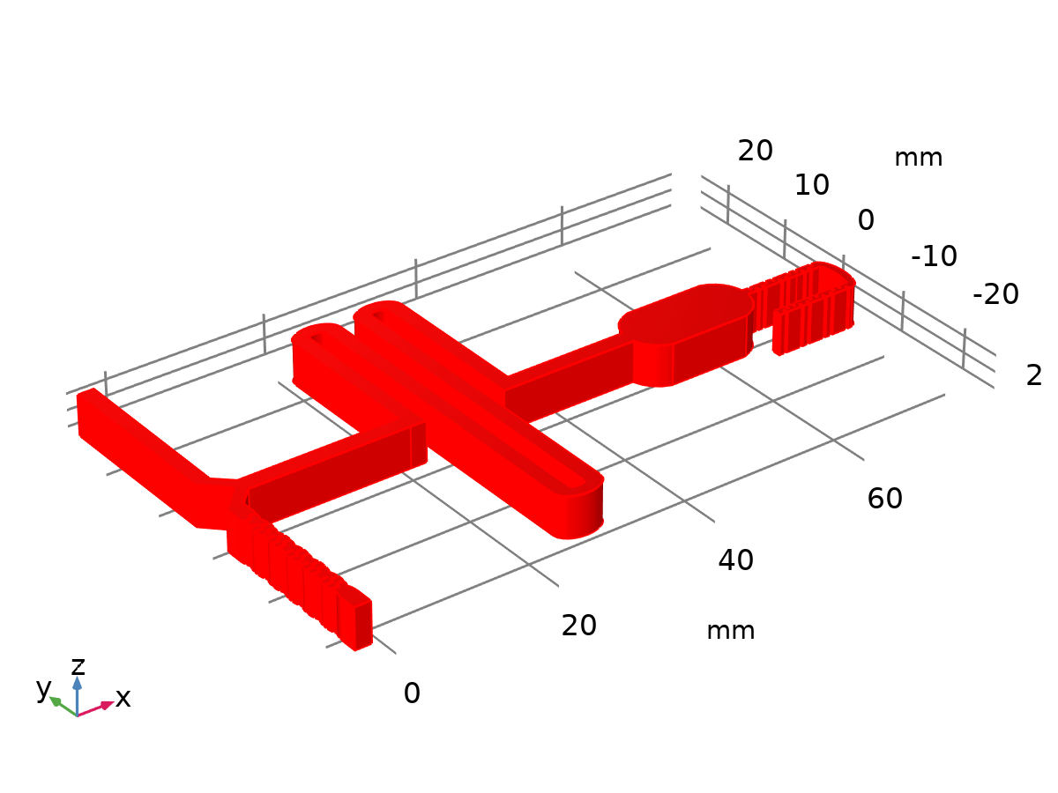

Dataset: Study 1/Solution 1

* + 1. Study 1/Solution Store 1

Solution

| **Description** | **Value** |
| --- | --- |
| Solution | Solution Store 1 |
| Component | Component 1 (comp1) |



Dataset: Study 1/Solution Store 1

* + 1. Study 1/Solution Store 2

Solution

| **Description** | **Value** |
| --- | --- |
| Solution | Solution Store 2 |
| Component | Component 1 (comp1) |



Dataset: Study 1/Solution Store 2

* 1. Plot Groups
     1. Concentration, Surface (tds)

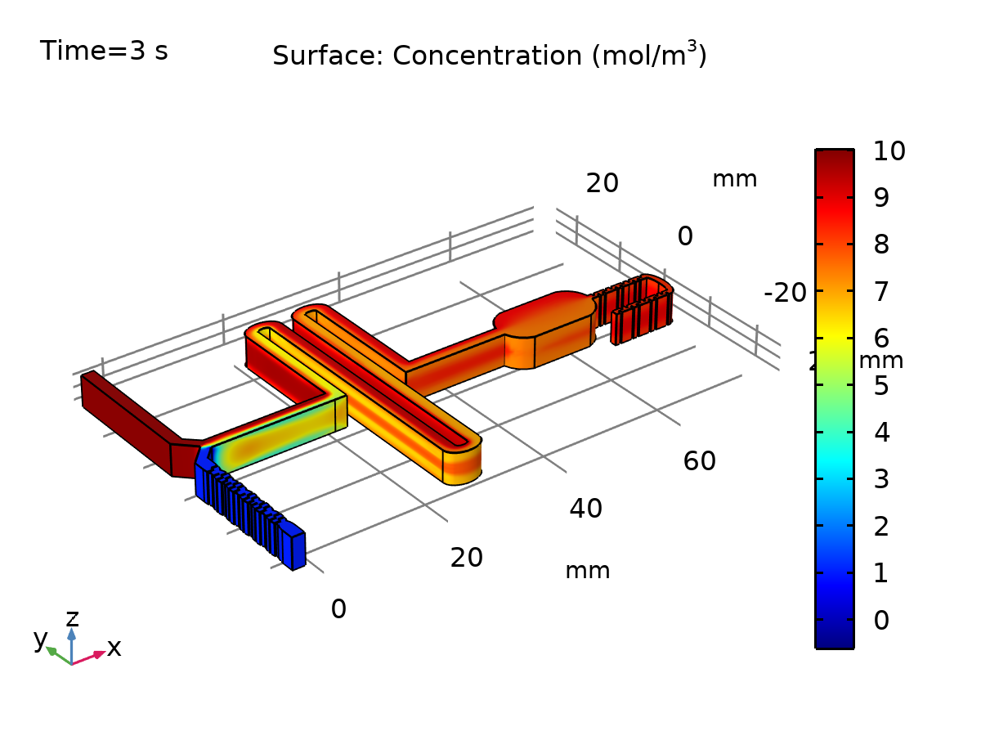

Surface: Concentration (mol/m3)

* + 1. Velocity (spf)

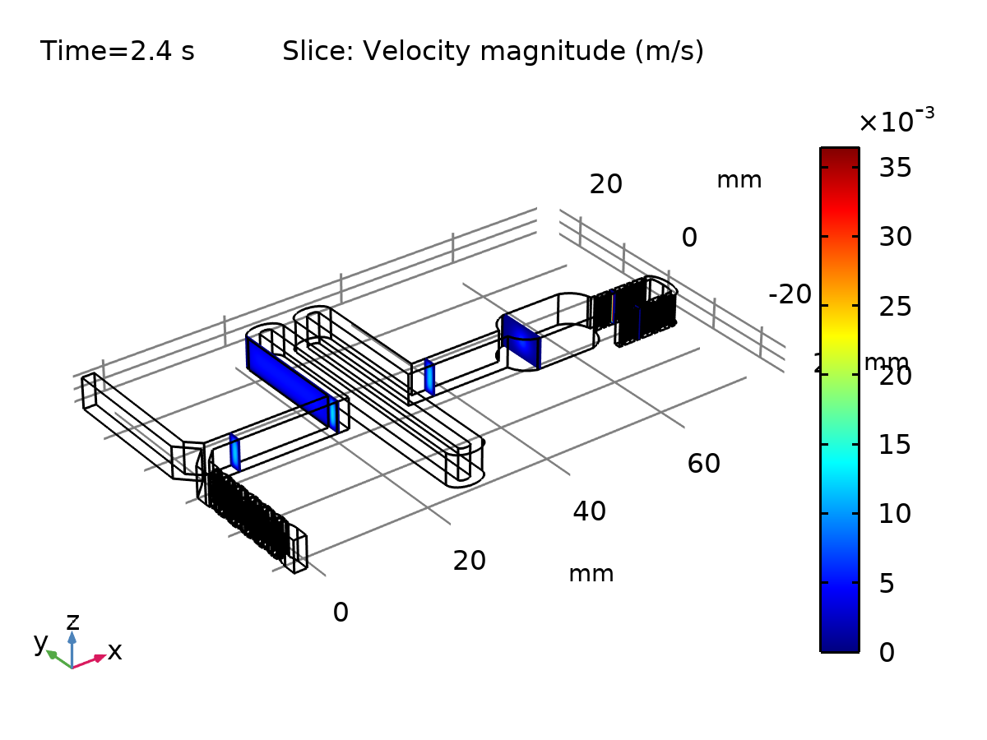

Slice: Velocity magnitude (m/s)

* + 1. Pressure (spf)

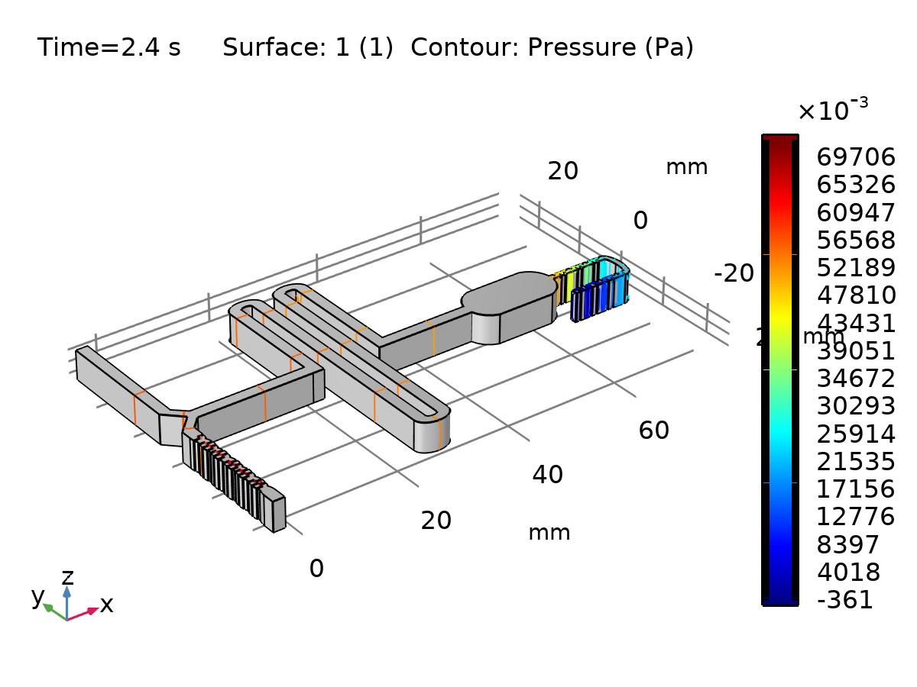

Surface: 1 (1) Contour: Pressure (Pa)

* + 1. Velocity 3D

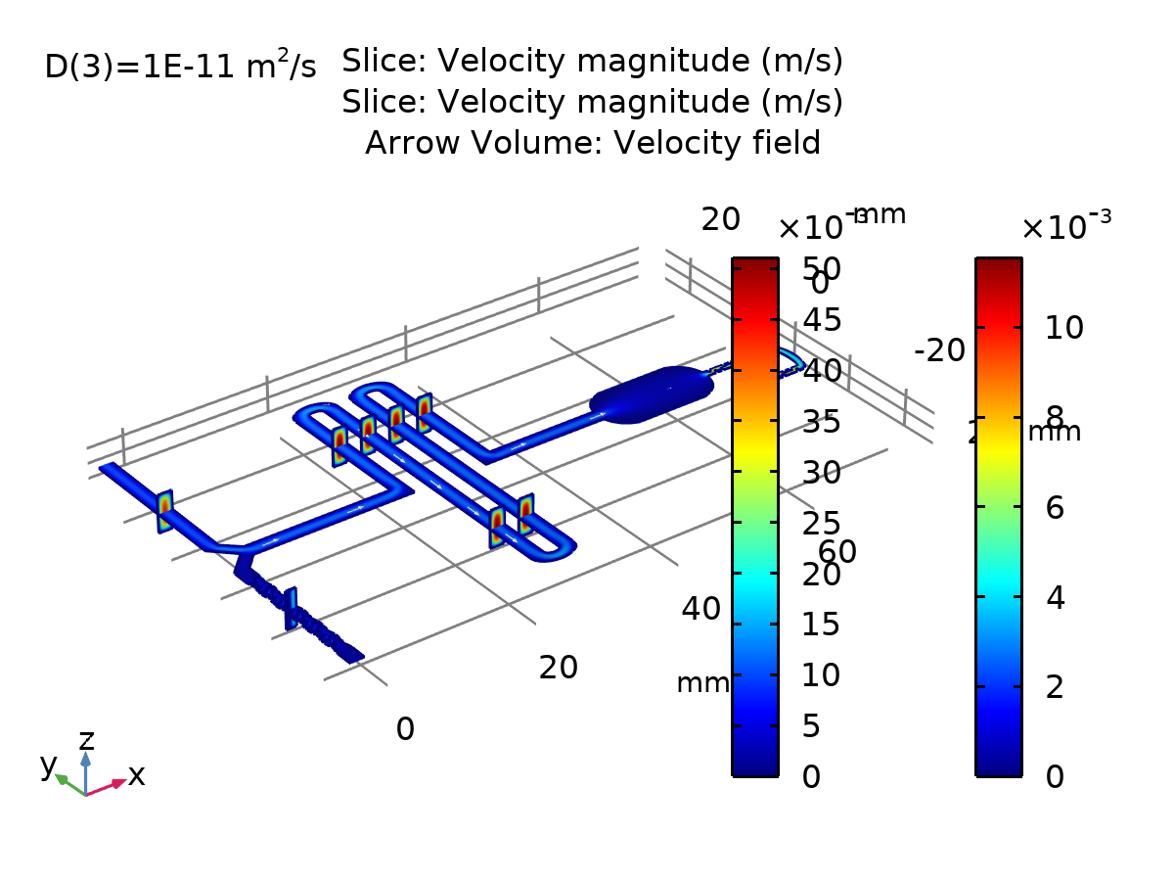

Slice: Velocity magnitude (m/s) Slice: Velocity magnitude (m/s) Arrow Volume: Velocity field

* + 1. Concentration, Streamline (tds)

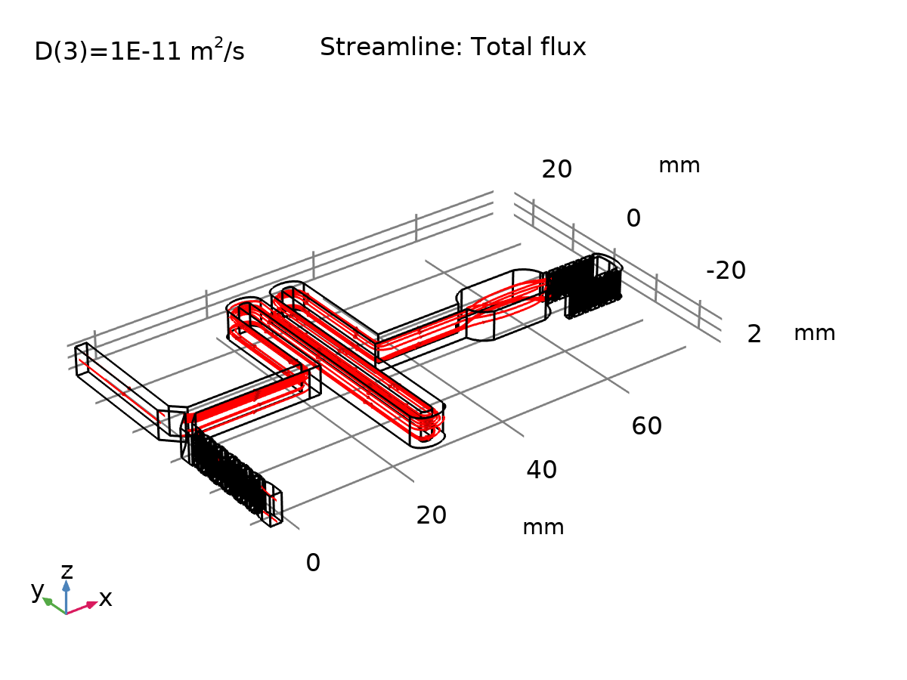

Streamline: Total flux

* + 1. Pressure 3D

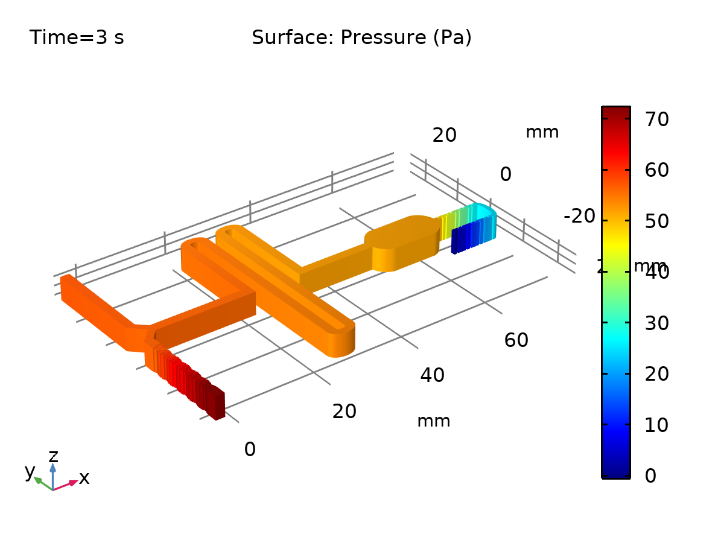

Surface: Pressure (Pa)

* + 1. Concentration 3D

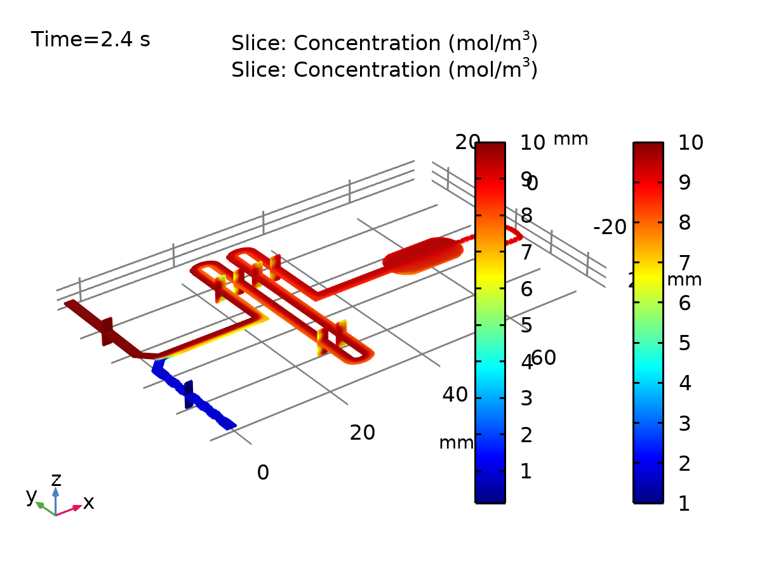

Slice: Concentration (mol/m3) Slice: Concentration (mol/m3)