20176342 Song min joon

1. What is the difference between rdt 2.1 and rdt 3.0? What is the advantage of using rdt 3.0?
2. Switch/Hub has a Network Layer. ( O / X )
3. In client side, using UDP Protocol to send message need ‘bind’ process in communication between server and client. ( O / X )

Answer

1. There is an assumption that rdt 2.1 has no packet loss. There is an assumption that rdt 3.0 has a provisional packet loss. Therefore, in rdt 3.0, a timeout timer is created to enable response to packet loss.
2. Answer is ‘X’.

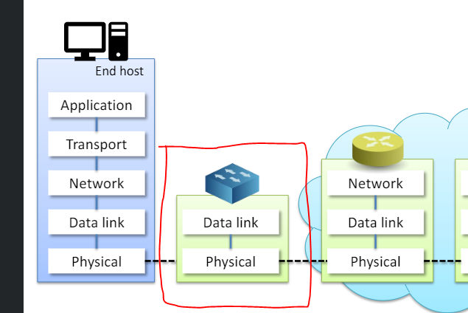

As shown in the picture above, the switch/hub does not involve the network layer.

So the answer is X.

1. Answer is ‘X’, The server needs a 'bind' process to receive the message, but the client can skip the process and send 'datagram' to the server's ip, port.