A) If weight <= 50.0 | Ask for distance | No output yet
A) If weight > 50.0 | Error: close | End program
B) If weight <= 50.0 && milesTraveled < 0.0 | Error: close | End program
B) If weight <= 50.0 && milesTraveled > 0.0 | Check for miles > 0 | No output yet
C) if weight <= 50.0 && milesTraveled > 0.0 && weight <= 10.0 | Proceed to calculation, subtract 2 from standard charge | No output yet
C) if weight <= 50.0 && milesTraveled > 0.0 && weight > 10.0 | Proceed to calculation | No output yet
If milesTraveled / 500 != int | Add 1, then use in shipping calculation | Output shipping calculation
If milesTraveled / 500 = int | Use in shipping calculation | Output shipping calculation
/** Global Courier Services Shipping Manifest Helper
*
* A program developed in COP-1000C for a pretend company to
* determine the price of goods shipped based on weight
* and travel distance.
*
* @author: Shyanne
* @ver: 0.1
* @date: 9/26/21
*/

//import
#include <stdio.h>
#include <stdlib.h>

//main method
main() {

//initilize variables for later use
double weight;
double milesTraveled;
double shippingCharge;

//UI intro prompt
printf("GLOBAL COURIER SERVICES: SHIPPING MANIFEST\n");
printf("=+=+=+=+=+=+=+=+=+=+=+=+=+=+=+=+=+=+=+=+=+=\n");

printf("\nHello! I'm the shipping manifest helper!\n");

//ask for user input (weight)
printf("Please input the weight of the package that you would like to ship in lbs. (must not exceed 50 lbs.)\n");
scanf_s("%lf", &weight);

//if weight is greater than 50lbs, alert user and close.
if(weight > 50.0) {
printf("Sorry, your package exceeds the 50lbs weight maximum. Goodbye!\n");
//end program
system("pause");
}
//if weight is less than or equal to 0, alert user and close.
if(weight <= 0.0) {
printf("Sorry, your packages must have a weight higher than 0lbs. Goodbye!\n");
//end program
system("pause");
}
if (weight > 0.0 && weight <= 50.0) {
//ask for user input (milesTraveled)
printf("Great! Now input the distance this package will be traveling in miles.\n");
scanf_s("%lf", &milesTraveled);

//if milesTraveled is less than or equal to 0, alert user and close.
if(milesTraveled <= 0.0) {
printf("Sorry, this package has to travel more than 0 miles. Goodbye!\n");
//end program
system("pause");
}
if(milesTraveled > 0.0) {
//if weight is less than or equal to 10lbs, caluclate shipping price at reduced rate ($3.00)
if(weight <= 10.0) {
milesTraveled = milesTraveled / 500.0;
if (milesTraveled != (int)milesTraveled) {
milesTraveled = milesTraveled - (milesTraveled - (int)milesTraveled) + 1;
}
if (milesTraveled == (int)milesTraveled) {
milesTraveled = milesTraveled - (milesTraveled - (int)milesTraveled);
}
shippingCharge = milesTraveled * 3.00;
printf("Your shipping price will be %lf.\n", shippingCharge);
//end program
system("pause");
}

//if weight is less than or equal to 50lbs, calculate shipping price ($5.00)
if(weight > 10.0 && weight <= 50.0) {
milesTraveled = milesTraveled / 500.0;
if (milesTraveled != (int)milesTraveled) {
milesTraveled = milesTraveled - (milesTraveled - (int)milesTraveled) + 1;
}
if (milesTraveled == (int)milesTraveled) {
milesTraveled = milesTraveled - (milesTraveled - (int)milesTraveled);
}
shippingCharge = milesTraveled * 5.00;
printf("Your shipping price will be %lf.\n", shippingCharge);
//end program
system("pause");
}
}
}
}
TEST CASE 1:
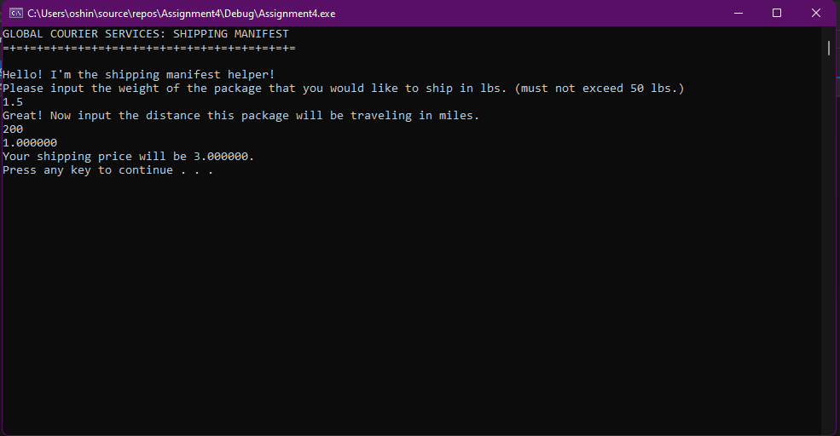
TEST CASE 2:
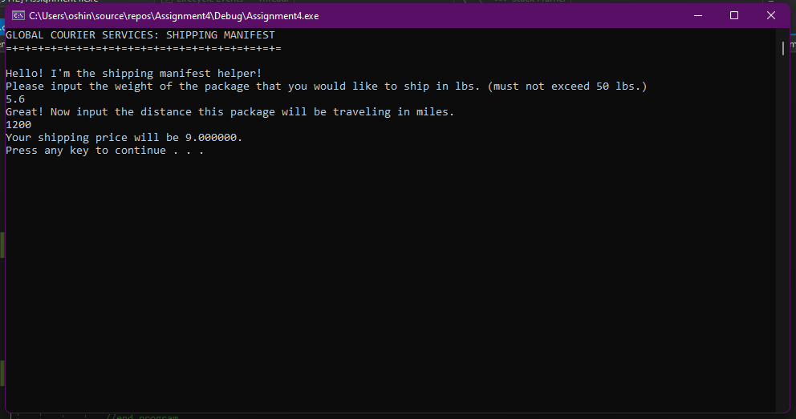
TEST CASE 3:
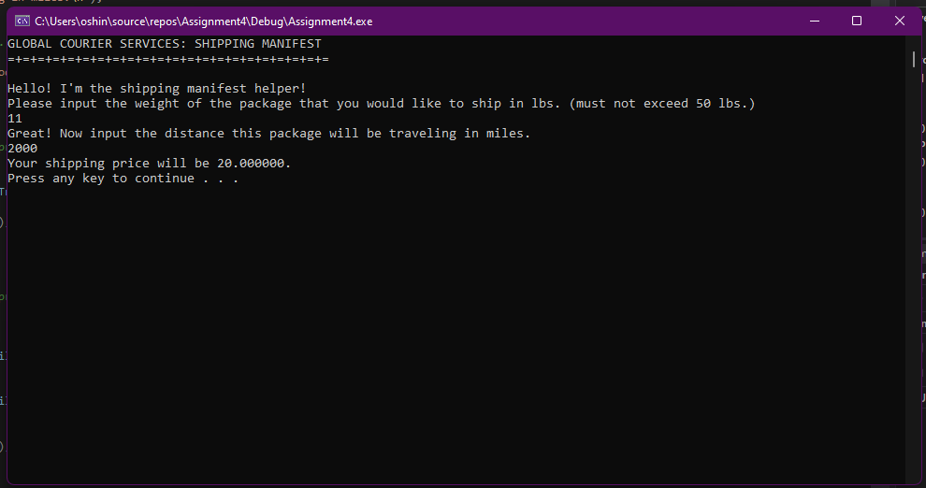
TEST CASE 4:
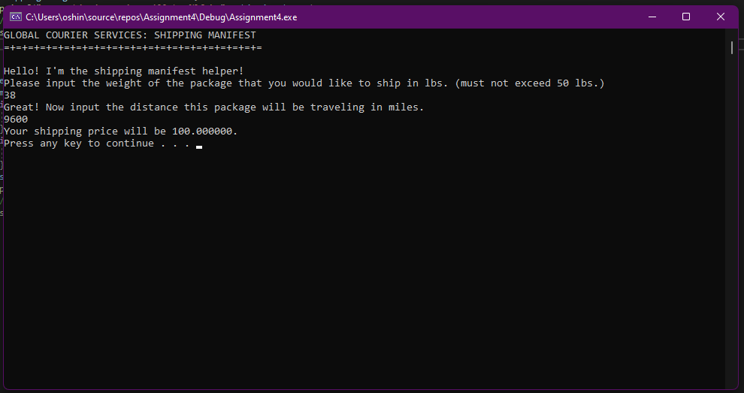
TEST CASE 5:
