Shyanne Bean
COP-1000C
Assignment #5

Part 1:
“I have watched both videos outlined in Part 1.”
Part 2:
I’m not doing this. I don’t understand what this guy wants from me and quite frankly I do not have the patience to find out. I took Calculus and am currently writing a logging program in java, so I feel qualified enough to not necessitate this part of the assignment.
Part 3:
You stated that I did not need to create an IPO via email correspondence.
/**
* Grades Statistics Analyzer
* A program to determine the percentage of passing grades out of a set of grades entered.
* @author: Shyanne
* @ver: 0.1
* @date: 10/01/21
*
*/

#include <stdio.h>
#include <stdlib.h>

main() {

//declare variables to be used
double grade;
int gradeCounter = 0;
int passingGradeCounter = 0;

//greet user
printf("Hello! Please input your grade values between 0 and 100. To finish, input -1.\n");

//scan for user input
scanf_s("%lf", &grade);

//while input is NOT equal to -1, calculate and scan again
while(grade != -1) {

//if input is greater than 100 OR less than 0, show error
if(grade > 100.0 || grade < 0.0) {
printf("Sorry, that isn't a valid grade input. Your input must be between 0 and 100. If you would like to finish, input -1.\n");
}

//if input is less than or equal to 100 AND is greater than or equal to 0, count grade
if(grade <= 100.0 && grade >= 0.0) {
//add 1 to gradeCounter
gradeCounter++;

//if input is greater than or equal to 70, add to passingGradeCounter
if(grade >= 70.0) {
//add 1 to passingGradeCounter
passingGradeCounter++;
}
}

scanf_s("%lf", &grade);
}

//present information
printf("Alright! Calculating statistics...\n");
printf("%i grades entered.\n", gradeCounter);

//calculate average
double percentage = ((double)passingGradeCounter / (double)gradeCounter) * 100.0;

//show user the percentage of passing grades
printf("%lf of total grades are passing.\n", percentage);

system("pause");
}

Part 3:
Values | Total Amount | Passing Amount | Standing Value
45 | 1 | 0 | 0/1
90 | 2 | 1 | ½
70 | 3 | 2 | 2/3
87 | 4 | 3 | ¾
123 |  |  | NA
100 | 5 | 4 | 4/5
-1 |  |  | EXIT LOOP

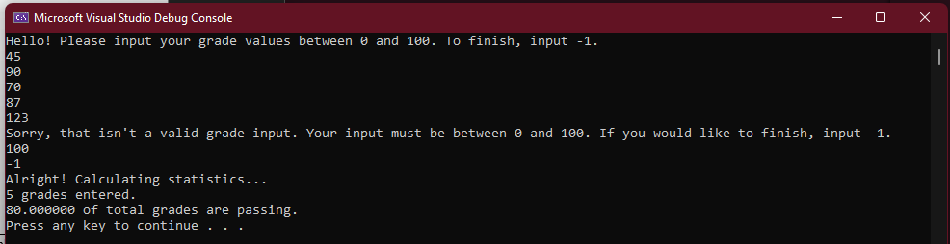

Values | Total Amount | Passing Amount | Standing Value
58 | 1 | 0 | 0/1
12 | 2 | 0 | 0/2
100 | 3 | 1 | 1/3
98 | 4 | 2 | 2/4
75 | 5 | 3 | 3/5
-2 |  |  | NA
-1 |  |  | EXIT LOOP

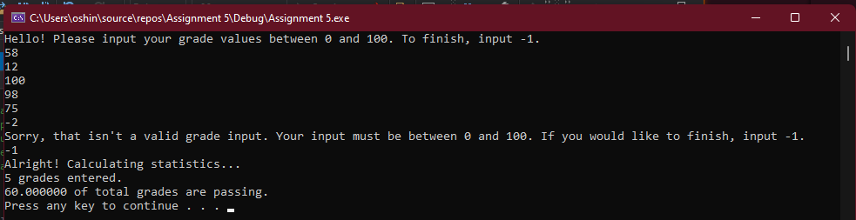
Values | Total Amount | Passing Amount | Standing Value
98 | 1 | 1 | 1/1
100 | 2 | 2 | 2/2
110 |  |  | NA
102 |  |  | NA
99 | 3 | 3 | 3/3
69 | 4 | 3 | 3/4
-1 |  |  | EXIT LOOP

