Shyanne Bean
COP-1000C
Assignment #6
Part I: I have completed the practice exercises outlined in Part 1.
Part II: I have completed the problems outlined in Part 2.
Part III:
/** While loops that do number things
* This program runs loops to list all the numbers associated with those loops.
* @author: Shyanne
* @ver: 0.1
* COP-1000C
*/

#include <stdio.h>
#include <stdlib.h>

main() {

int selection;
printf("Hi there! Select a loop you'd like to run with 1, 2, 3, or 4.\n");
scanf_s("%i", &selection);

while (selection < 1 || selection > 4) {
printf("Sorry, that's not a valid response. Please respond with 1, 2, 3, or 4.");
scanf_s("%i", &selection);
}

//loop 1
if (selection == 1) {
int loopCounter = 0;
printf("You've selected loop 1.\n");
printf("This will show all multiples of 5 that are greater than 0 and less than 60.\n\n");
while (loopCounter >= 0 && loopCounter < 60) {
if (loopCounter % 5 == 0) {
printf("%i\n", loopCounter);
}
loopCounter++;
}
}

//loop 2
if (selection == 2) {
int loopCounter = 0;
printf("You've selected loop 2.\n");
printf("This will show all numbers that are divisible by 2 AND 7, and are less than 200.\n\n");
while (loopCounter >= 0 && loopCounter <= 200) {
if ((loopCounter % 2 == 0) && (loopCounter % 7 == 0)) {
printf("%i\n", loopCounter);
}
loopCounter++;
}
}

//loop 3
if (selection == 3) {
int loopCounter = 100;
int loopVar = 0;
printf("You've selected loop 3.\n");
printf("This will show the sum of all multiples of 8 between 100 and 500.\n\n");
while (loopCounter >= 100 && loopCounter <= 500) {
if (loopCounter % 8 == 0) {
loopVar += loopCounter;
}
loopCounter++;
}

printf("%i\n", loopVar);
}

//loop 4
if (selection == 4) {
int loopCounter = 20;
int loopVar = 0;
printf("You've selected loop 4.\n");
printf("This will show the sum of all odd numbers between 20 and 100.\n\n");
while (loopCounter >= 20 && loopCounter <= 200) {
if (loopCounter % 2 == 1) {
loopVar += loopCounter;
}
loopCounter++;
}

printf("%i\n", loopVar);
}
system("pause");
}

Loop 1
- Create a loop that will output all the multiples of 5 that are greater than zero and
less than 60 (do not include 60).
5, 10, 15, 20, 25, 30, 35, 40, 45, 50, 55
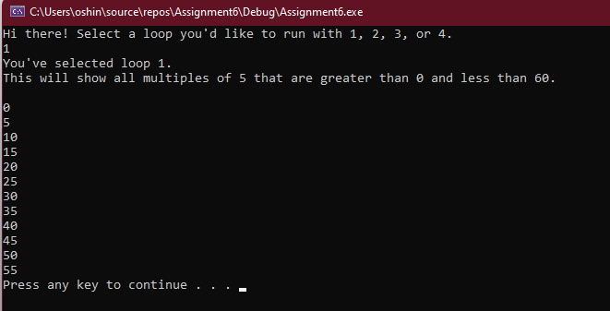

Loop 2:
- Create a loop that will output all the numbers less than 200 that are evenly
divisible by both 2 and 7.
14 28 …
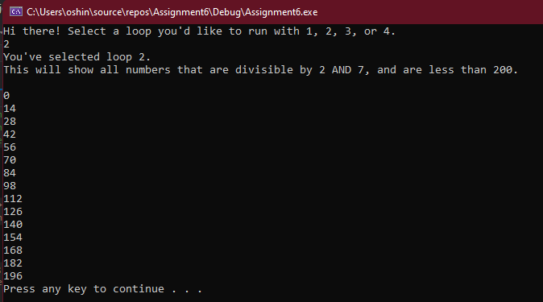

Loop 3:
- Create a loop that will calculate the sum of the multiples of 8 that are between 100
and 500. Output the sum only.
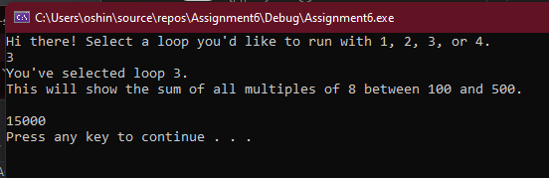

Loop 4:
- Create a loop that will output the sum of all odd numbers between 20 and 100.
