- No
- Test Cases

Test case | lowest | highest | counter | average
1, 6, 4.3, 7, -4 | 1 | 7 | 4 | 4.575
12, 3, 6.2, 77, -3,5 | 3 | 77 | 4 | 24.55
4, 66, 72.3, 5.2, -6, 8 | 4 | 72.3 | 5 | 31.1

/**
* Assignment #7
* Working with numbers provided by the user to generate stats
* @author: Shyanne
* @ver: 0.1
*/

#include <stdio.h>
#include <stdlib.h>

main() {

int counter = 0;
double highest = 0.0;
double lowest = 0.0;
double sum = 0.0;
double input;

double average;

printf("Hello there!\n");
printf("Please input some numbers when prompted (must be greater than zero).\n");
printf("To finish, type in -1.\n");

scanf_s("%lf", &input);

//if input != -1, run loops
while (input != -1.0) {

//if input <= 0, ask for input again
while (input <= 0.0 && input != -1.0) {

printf("Sorry, your input must be greater than zero. Try again.\n");
scanf_s("%lf", &input);
}

//if input > 0, run stats and ask for input again
while (input > 0.0) {
counter++;

//setting the comparison table
if (counter == 1) {
highest = input;
lowest = input;
}

//compare for lowest value
if (input < lowest) {
lowest = input;
}

//compare for highest value
if (input > highest) {
highest = input;
}

//add inputs
sum += input;
scanf_s("%lf", &input);
}
}

printf("Lowest Number: %lf\n", lowest);
printf("Highest Number: %lf\n", highest);
printf("Numbers submitted: %i\n", counter);
printf("Average of all numbers: %lf\n", (sum / (double)counter));

system("pause");

}

Screenshots
Case #1
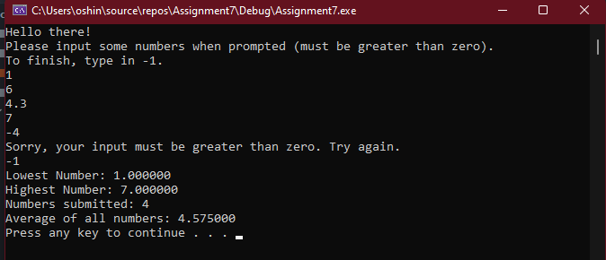

Case #2
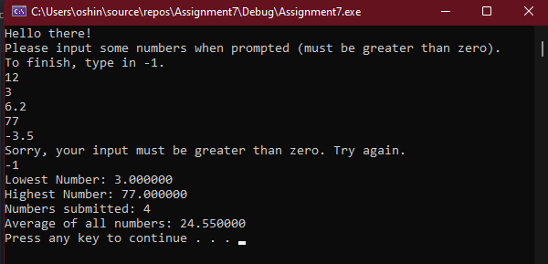

Case #3
