Abandoned Object Detection
&
Implementation of Low Pass, Laplacian, High
pass, Band pass and Bandstop filters
using MatLab



DEPARTMENT OF COMPUTER SCIENCE AND ENGINEERING
AHSANULLAH UNIVERSITY OF SCIENCE AND TECHNOLOGY
DHAKA, BANGLADESH
AUGUST 2017

Submitted By
Fahim Shariar Shoumik
13.02.04.027
XX
XX
XX
XX
XX
XX
Section : A1

Abandoned Object Detection

Abstract— The objective of this assignment is to Design a Matlab Simulink model which will identify objects which are abandoned in public areas.
Keywords— abandon; object-detection; simulink;

Introduction
Abandoned objects in public areas concern authorities since they might pose a security risk. Algorithms, such as the one used in this example, can be used to assist security officers monitoring live surveillance video by directing their attention to a potential area of interest.

Problem Statement

To detect an object we need a BlobAnalysis System to identify objects and track them. Implements this system must be done following these steps:

• Extract a region of interest (ROI), thus eliminating video areas that are unlikely to contain abandoned objects.
• Perform video segmentation using background subtraction.
• Calculate object statistics using the blob analysis System object.
• Track objects based on their area and centroid statistics.
• Visualize the results.

Implementation

We used Simulink Toolbox found in Matlab to Implement the System . During the System Implementation we have used many build in modules found in Simulink. A video is used as an imput for the System and the final output is also shown in a separate window with ROI and the detected abandoned object in a green rectangle .
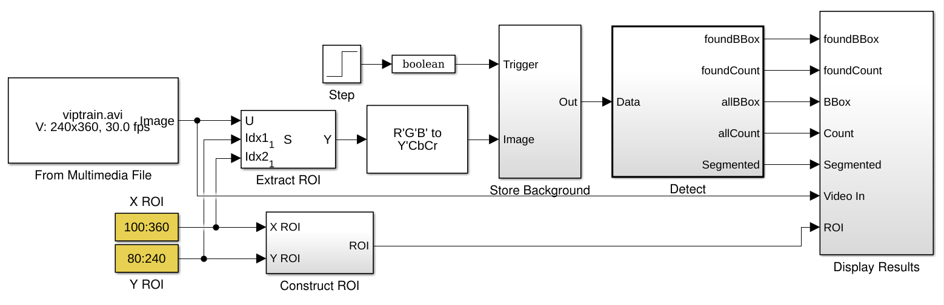
Figure 1: Abandon Object Detection ( Simulink )

Store Background Subsystem

We have used the first frame of the video as the background. To improve accuracy, the example uses both intensity and color information for the background subtraction operation. During this operation, Cb and Cr color channels are stored in a complex array.
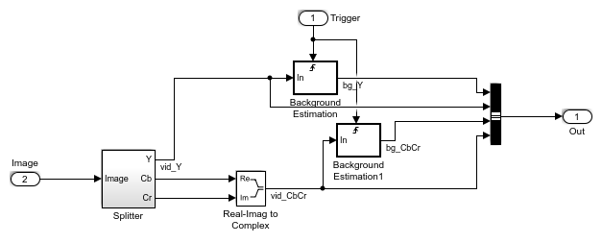

Figure 2: Store Background Model

Detect Subsystem
The Detect subsystem contains the main algorithm. Inside this subsystem, the Luminance Segmentation and Color Segmentation subsystems perform background subtraction using the intensity and color data. The example combines these two segmentation results using a binary OR operator. The Blob Analysis block computes statistics of the objects present in the scene.

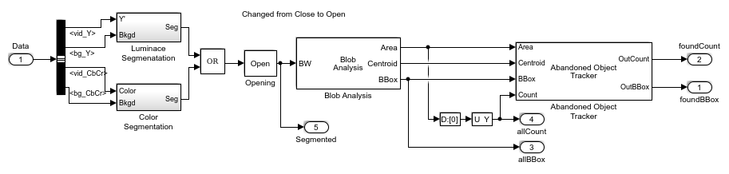
Figure 3: Subsystem of Blob Analysis

Abandoned Object Tracker subsystem, shown below, uses the object statistics to determine which objects are stationary. To view the contents of this subsystem
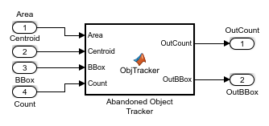

First we determined how many Number of frames that an object must remain stationary before an alarm is raised. Including the maximum number of frames that an abandoned object can be hidden before it is no longer tracked.

We have used a ColorSpaceConverter System object to convert the RGB image to Y'CbCr format. Then we have created an an Autothresholder System object to convert an intensity image to a binary image. After that we created a system objects to display results.

Video Processing
We have Selectd the region of interest from the original video, then stored the first video frame as the background , a after that we used a module to fill in small gaps in the detected objects.
We Performed blob analysis by calling the helper function that tracks the identified objects and it returns the bounding boxes and the number of the abandoned objects.
Finally we displayed the abandoned object detection results.

result analysis

The All Objects window marks the region of interest (ROI) with a yellow box and all detected objects with green boxes.
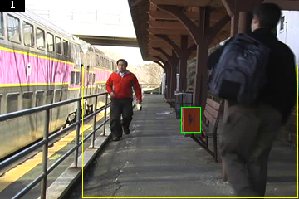

Figure 4: Detection of Abandon Object marked with green rectangle
The Threshold window shows the result of the background subtraction in the ROI.
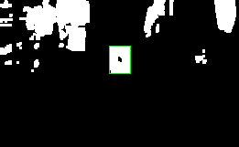

Figure 5: Threshold of ROI

The Abandoned Objects window highlights the abandoned objects with a red box.

Conclusion
Although our System is performing well but we need to improve this model by better thresholding algorithm and filtering with pre-processing .

