Abandoned Object Detection
&
Implementation of Low Pass, Laplacian, High
pass, Band pass and Bandstop filters
using MatLab



DEPARTMENT OF COMPUTER SCIENCE AND ENGINEERING
AHSANULLAH UNIVERSITY OF SCIENCE AND TECHNOLOGY
DHAKA, BANGLADESH
AUGUST 2017

Submitted By
Fahim Shariar Shoumik
13.02.04.027
XX
XX
XX
XX
XX
XX
Section : A1

Implementation of Low Pass, Laplacian, High
pass, Band pass and Bandstop filters
using Simulink

Abstract— The objective of this assignment is to Implementation of Low Pass, Laplacian, Highpass, Band pass and Bandstop filters using Simulink
Keywords— abandon; object-detection; simulink;

Introduction
Filters are an important steps in signal and image processing , Most widely used filters are Low Pass , High Pass , Band Pass , Band Stop , Laplacian , Median etc.

Problem Statement

Using build in Modules in Simulink show the usages and output of Low Pass , High Pass , Band Pass[1] , Band Stop[1] , Laplacian filters . We will take a signal as input and show the filtered signal as output at the end.

Implementation

Low Pass Filter

Here we have implemented a low pass filter that only allows lower frequency to pass which is less than 5 hz. The transfer function for this filter is ,
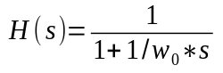

Here ,
wo = 2 * pi * frequency
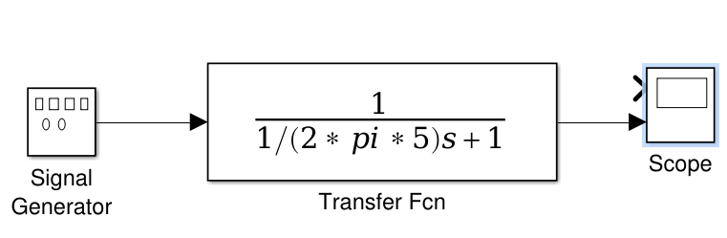

Figure 1: Low Pass Filter of 5 Hz

High Pass Filter
This high pass 100 hz filter that only allows higher frequency to pass . The transfer function for this filter is ,

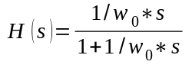
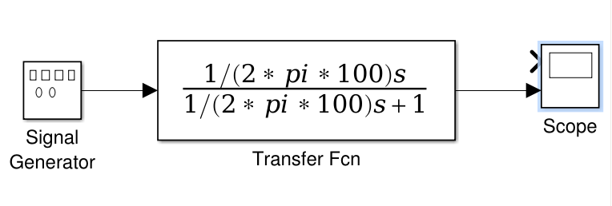

Figure 2: High Pass Filter of 100 Hz

Band Pass Filter
This band pass filter only allows frequency between 4000 Hz to 8000 Hz . The transfer function for this filter is , The transfer function for this filter is ,
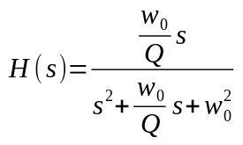

Here ,
wo = 2 * pi * frequency
Q = ( frequency / Higher frequency – Lower frequency )
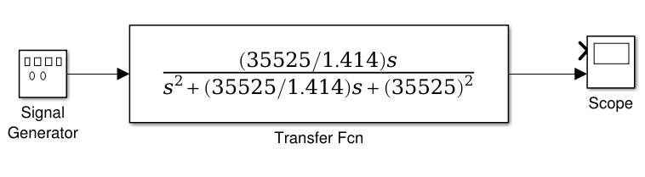

Figure 3: Band Pass Filter between 4000-8000 Hz

Band Stop Filter
This band pass filter only allows frequency between 4000 Hz to 8000 Hz . The transfer function for this filter is , The transfer function for this filter is ,
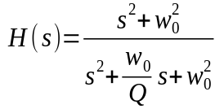

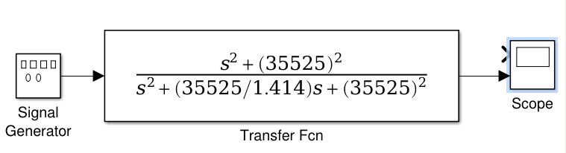
Figure 4: Band Stop Filter between 4000-8000 Hz

Laplacian Filter
The transfer function for Laplacian filter[2] is ,
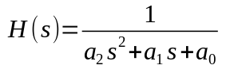

Here ,
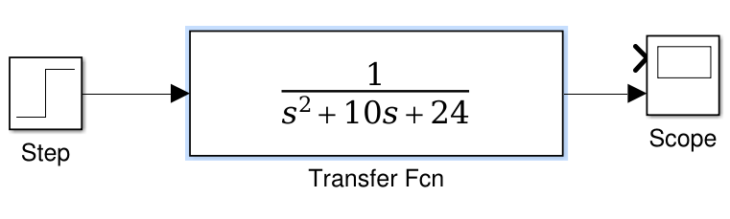
a[n] = second order differential equation coefficient

Figure 4: Laplacian Filter

result analysis

The Low Pass filter only passes lower frequency like 2-3 Hz and if higher frequency are given , 1000 Hz the filter drops the frequency , The High Pass filter passes Higher frequency greater than 100 Hz and drops all the lower frequency , Band Pass filter only passes frequency between 4000 Hz to 8000 Hz and the Band Reject filter does the oposit , The Laplacian filter detects the rapid changes in edge and shows the output in a scope .

Conclusion
Although our System is performing well but we need to improve this model by better transfer function . The band reject filter could be improved by reducing the parameter size .

reference
[1] http://slideplayer.com/slide/9589845/

[2] https://www.pdx.edu/nanogroup/sites/www.pdx.edu.nanogroup/files/NOTES_Transfer%20function%20Laplace%20Transormation%20Active%20filter_0.pdf

