**Amazon.com Inc.**

**FY2023 Financial Statements Analysis**

Seiji Hirano

Last Updated on 1/30/2025

Table of Contents

Report Overview & Background 4

Description 4

Methodology 4

Company Overview 4

Amazon.com, Inc. 4

Business 4

Wholesale Business Model 5

Subscription Services 5

AWS Services 6

Competition 7

Employees & Labor Relations 8

Property 8

Key Risk Factors Unique to Amazon.com. Inc. 8

Timeline of Amazon’s Biggest Acquisitions 9

Horizontal Analysis 11

Balance Sheet Chart 11

P/L Chart 11

Cash Flow Chart (left to right) 12

Historical Financial Ratios 12

Long-Term Debt (Most Recent Years) 13

Maturities of Long-Term Debt / Estimated Debt Service Requirements 13

Key Financial Insights 13

Final Notes 18

Capital Structure 18

Asset Composition 18

Revenue & Profitability 18

Liquidity & Solvency 18

Cash Flow 18

Supplemental Data 19

Amazon.com, Inc. 19

Net Sales by Reportable Segment 19

Historical Operating Expenses 19

Operating Income and Margin by Reportable Segment 19

Historical Balance Sheet with % of Total 20

Historical Balance Sheet with % Change 20

Historical P/L Statement 21

Historical Equity Statement 22

Historical Cash Flow Statement 23

DuPont Analysis (2023) 24

Amazon.com, Inc. 24

Financial Ratios Formula 25

Activity Ratios 25

Liquidity Ratios 26

Solvency Ratios 26

Profitability Ratios 27

Valuation Ratios 27

# Report Overview & Background

## Description

This report is designed to provide a detailed overview of Amazon.com Inc.

## Methodology

This report primarily relies on data from Amazon.com Inc.’s financial statements, as well as information from reliable online sources.

# Company Overview

## Amazon.com, Inc.

### Business

The company has organized its operations into three segments: North America, International, Amazon Web Services (AWS). In each segment, the company serves consumers, sellers, developers, enterprises, content creators, advertisers, and employees.

#### Consumers

The company serves consumers through its online and physical stores and focuses on selection, price, and convenience. The company also manufactures and sells electronic devices, including Kindle, Fire tablet, Fire TV, Echo, Ring, Blink, and eero, while also developing and producing media content. In addition, the company offers subscription services, such as Amazon Prime.

The company fulfills customer orders in a number of ways, including through: North America and International fulfillment networks that we operate; co-sourced and outsourced arrangements in certain countries; digital delivery; and through its physical stores.

#### Sellers

The company offers programs that enable sellers to grow their businesses, sell their products in its stores, and fulfill orders using its services. The company earns fixed fees, a percentage of sales, per-unit activity fees, interest, or some combination thereof, for its seller programs.

#### Developers and Enterprises

The company serves developers and enterprises of all sizes through AWS, which offers a broad set of on-demand technology services, including compute, storage, database, analytics, and machine learning, and other services.

#### Content Creators

The company offers programs that allow authors, independent publishers, musicians, filmmakers, Twitch streamers, skill and app developers, and others to publish and sell content.

#### Advertisers

The company provides advertising services to sellers, vendors, publishers, authors, and others, through programs such as sponsored ads, display, and video advertising.

### Wholesale Business Model

### Subscription Services

### AWS Services

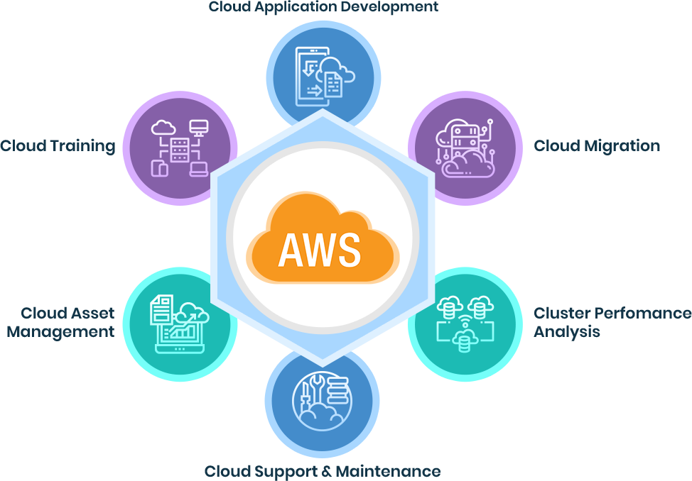

The company’s **primary source of revenue is the sale of a wide range of products and services to customers**. The products offered through its stores include merchandise and content the company purchased for resale and products offered by offered by third-party sellers as well as electronic devices manufactured and sold by the company. Generally, the company recognizes gross revenue from items it sells from its inventory as **product sales** and recognizes its net share of revenue of items sold by third-party sellers as **service sales**.

The company’s **financial focus is on long-term, sustainable growth in free cash flows**. Free cash flows are driven primarily by increasing operating income and efficiently managing accounts receivable, inventory, accounts payable, and cash capital expenditures.

The company seeks to **reduce its variable costs per unit and work to leverage its fixed costs**. The company’s variable costs include product and content costs, payment processing and related transaction costs, picking, packaging, and preparing orders for shipment, transportation, customer service support, costs necessary to run AWS, and a portion of its marketing costs. The company’s fixed costs include the costs necessary to build and run its technology infrastructure; to build, enhance, and add features to its online stores, web services, electronic devices, and digital offerings; and to build and optimize its fulfillment network. To decrease its variable costs on a per unit basis and enable the company to lower prices for customers, the company seeks to increase its direct sourcing, increase discounts from suppliers, and reduce defects in its processes, while minimizing unnecessary growth in fixed costs by improving process efficiencies and maintain a lean culture.

The company also seeks to **efficiently manage shareholder dilution while maintaining the flexibility to issue shares for strategic purposes**. The company utilizes restricted stock units as its primary vehicle for equity compensation because the company believes this compensation model aligns the long-term interests of its shareholders and employees. In measuring shareholder dilution, the company includes all vested and unvested stock awards outstanding, without regard to estimated forfeitures.

### Competition

The company’s current and potential competitors include:

* Physical, e-commerce, and omnichannel retailers, publishers, vendors, distributors, manufacturers, and producers of the products the company offers and sells to consumers and businesses (Walmart, Costco, Alibaba, etc.);
* Publishers, producers, and distributors of physical, digital, and interactive media of all types and all distribution channels (Sony Music, Spotify, Netflix, Microsoft Xbox, etc.);
* Web search engines, comparison shopping websites, social networks, web portals, and other online and app-based means of discovering, using, or acquiring goods and services, either directly or in collaboration with other retailers (Google, Bing, Facebook, TikTok, Pinterest, etc.);
* Companies that provide e-commerce services, including website development and hosting, omnichannel sales, inventory and supply chain management, advertising, fulfillment, customer service, and payment processing (Shopify, Salesforce, PayPal, etc.);
* Companies that provide fulfillment and logistics services for themselves or for third parties, whether online or offline (FedEx, UPS, DHL, Rakuten Super Logistics, etc.);
* Companies that provide information technology services or products, including on-premises or cloud-based infrastructure and other services (Microsoft Azure, Google Cloud, IBM Cloud, Oracle, Dell, etc.);
* Companies that sell grocery products online and in physical stores (Instacart, Kroger, etc.);
* Companies that provide advertising services, whether in digital or other formats (Google Ads, Facebook Ads, TikTok Ads, etc.).

The company believes that **the principal competitive factors in its retail businesses include selection, price, and convenience, including fast and reliable fulfillment.** Additional competitive factors for its seller and enterprise services include **the quality, speed, and reliability of its services and tools, as well as customers’ ability and willingness to change business practices**.

### Employees & Labor Relations

As of December 31, 2023, the company employed approximately 1,525,000 full-time and part-time employees. The company also use independent contractors and temporary personnel to supplement its workforce.

### Property

### Key Risk Factors Unique to Amazon.com. Inc.

* ***The Variability in the Company’s Retail Business Places Increased Strain on Its Operations***
  + Demand for its products and services can fluctuate significantly for many reasons, including as a result of seasonality, promotions, product launches, or unforeseeable events, such as in response to global economic conditions such as recessionary fears or rising inflation, natural or human-caused disasters (including public health crises) or extreme weather (including as a result of climate change), or geopolitical events. The company’s failure to stock or restock popular products in sufficient amounts such that it fails to meet customer demand could significantly affect its revenue and our future growth.
* ***International Operations Exposes the Company to a Number of Risks***
  + The company’s international activities are significant to its revenues and profits, and it plans to further expand internationally. In certain international market segments, the company has relatively little operating experience and may not benefit from any first-to-market advantages or otherwise succeed. It is costly to establish, develop, and maintain international operations and stores, and promote its brand internationally. The company’s international operations may not become profitable on a sustained basis.
* ***The Company Has Foreign Exchange Risk***
  + The results of operations of, and certain of its intercompany balances associated with, its international stores and product and service offerings are exposed to foreign exchange rate fluctuations. Due to these fluctuations, operating results may differ materially from expectations, and the company may record significant gains or losses on the remeasurement of intercompany balances. As the company has expanded its international operations, its exposure to exchange rate fluctuations has increased. The company also holds cash equivalents and/or marketable securities in foreign currencies. When the U.S. Dollar strengthens compared to these currencies, cash equivalents, and marketable securities balances, when translated, may be materially less than expected and vice versa.

### Timeline of Amazon’s Biggest Acquisitions

[*Source: FE International*](https://feinternational.com/blog/timeline-of-amazons-biggest-acquisitions/)

#### 1998: IMDb – Moving Beyond Books ($55 Million)

Amazon bought the leading website for movie fans and critics, IMDb, to expand beyond just selling books. Amazon simply added a link to buy the DVD on each movie’s profile, so IMDb’s movie fans are just one click away from purchasing DVDs with Amazon. This acquisition laid the groundwork for Amazon Prime Video with IMD’s metadata serving as the backbone for curating, recommending, and cataloging their eventual streaming services.

#### 2004: Joyo – Expanding to China ($75 Million)

Joyo, well-established e-commerce business with a strong brand and logistical network, was the perfect target for Amazon to break into the China market. However, Amazon eventually withdrew from the Chinese market due to intense competition, from Alibaba and JD.com, and complex legal challenges.

#### 2009: Zappos – More than Shoes ($1.2 Billion)

Amazon was struggling to get a foothold in the fashion and footwear market with challenges like sizing, style, and returns. Zappos was a market leader in the category, and the acquisition also brought Amazon Zappos’ expertise in customer service. The influence of Zappos can still be seen in Amazon’s operations today, like its hassle-free returns.

#### 2012: Kiva Systems – Smarter Warehouses ($775 Million)

With more customers buying products online, Amazon needed to deliver more packages more efficiently, including streamlining fulfillment centers. By acquiring Kiva Systems, Amazon gained exclusive access to the technology. In 2024, there are 750,000 robots across its operations, matching nearly half of its human workforce. This acquisition was critical to Amazon delivering on its promises of two-day Prime shipping and, later, same-day shipping.

#### 2014: Twitch – Live Streaming and Gaming ($970 Million)

Amazon did not have a social media platform like Google or Facebook. Livestreaming in gaming was exploding in popularity. Acquiring Twitch gave Amazon access to a young, tech-savvy audience and a rapidly growing market. Amazon integrated Twitch into its ecosystem by offering Prime members exclusive perks and connecting Twitch’s users to its suite of products. Today, Twitch is central to Amazon’s digital entertainment strategy, driving advertising revenue and solidifying Amazon’s position in the gaming industry.

#### 2017: Whole Foods – Physical Retail and Digital Groceries ($13.7 Billion)

This was Amazon’s biggest move into brick-and-mortar retail. Whole Foods brought Amazon access to a nationwide network of physical stores, providing a foundation to merge online and offline shopping. Amazon quickly integrated Whole Foods into its ecosystem by offering Prime-exclusive discounts and launching its delivery service, Amazon Fresh. The acquisition allowed Amazon to leverage its logistics network and cater to the growing demand for fresh, organic produce delivered straight to customers’ doors.

#### 2018: Ring – Smart Homes Get Smarter ($1 Billion)

With Ring, Amazon gained a strong foothold in home security, complementing its Alexa-powered Echo devices. The acquisition further builds out Amazon’s ecosystem of connected devices and increases its presence in the IoT market.

#### 2018: PillPack – An Online Pharmacy ($753 Million)

This acquisition gave Amazon pharmacy licenses in all 50 U.S. states. PilPack is an online pharmacy known for pre-sorting and delivering medication. PillPack’s streamlined prescription management aligned perfectly with Amazon’s logistics expertise, forming the foundation for Amazon Pharmacy launched in 2020. PillPack is central to Amazon’s healthcare strategy, offering convenient medication delivery and price transparency, and helping Amazon expand into the growing online pharmacy market.

#### 2019: Eero – Strengthening Smart Home Connectivity ($97 Million)

Everyone has a room in their house without Wi-Fi and that’s a big problem for smart devices. Eero’s mesh Wi-Fi technology eliminates dead zones and creates reliable internet coverage throughout an entire home. By acquiring Eero, Amazon both solved this issue and expanded its presence in the hardware space – aligning with its mission to provide seamless connectivity for its growing suite of IoT devices, including Alexa-enabled Echo products and Ring security systems.

#### 2020: Zoox – Driving Autonomous Vehicle ($1.2 Billion)

Zook’s mission is to develop fully autonomous, zero-emissions vehicles. The acquisition offers Amazon potential in two key areas: improving last-mile delivery logistics and establishing a foothold in the ride-hailing market. Zoox’s autonomous vehicle technology could revolutionize package delivery by introducing driverless delivery vehicles, reducing costs, and increasing efficiency.

#### 2022: MGM Studios – Doubling Down on Media ($8.5 Billion)

By picking up MGM, Amazon Prime scooped up over 4,000 films and 17,000 TV episodes, including iconic franchises like *James Bond* and *Rocky*. The acquisition brought Amazon a massive library of intellectual property (IP) to fuel original content production needed to compete against streaming rivals like Netflix and Disney+.

#### 2023: One Medical – Expanding into Primary Care ($3.9 Billion)

One Medical is a membership-based primary care provider – combining in-person care with telehealth services. This acquisition marked a major step in Amazon’s healthcare strategy, giving the company access to One Medical’s network of over 200 clinics and a digital health platform designed to streamline patient care. The move highlights Amazon’s ambition to disrupt the healthcare industry, positioning it to offer folistic, tech-driven healthcare solutions.

Amazon’s each purchase shows an expansion into a new region, product, or niche. It’s all unified under a clear vision for the company – into areas that align with what Amazon is now known for: e-commerce, smart homes, operations, digital media, healthcare, and now AI.

# Horizontal Analysis

### Balance Sheet Chart

### P/L Chart

### Cash Flow Chart (left to right)

### Historical Financial Ratios



### Long-Term Debt (Most Recent Years)

(In Millions)

### Maturities of Long-Term Debt / Estimated Debt Service Requirements

### Key Financial Insights

Refer to the Supplemental Data section for additional details on Amazon’s Balance Sheet, Income Statement, Equity Statement, and Cash Flow Statement to better understand the insights discussed below.

* (BL/Ratio) ***The company’s capital structure has been well balanced with current liabilities, non-current liabilities, and equity with around 30%-40% for each.***
  + The company’s current liabilities primarily consist of accounts payable (16.1% of total liabilities/equity in 2023) and accrued expenses (12.3%).
    - This suggests a reliance on short-term financing to manage day-to-day operations and obligations. This is typical for a retail or e-commerce business like Amazon, where the company deals with many suppliers and incurs operational expenses.
    - A high level of current liabilities also indicates Amazon’s significant purchasing power and negotiation leverage with suppliers.
  + The company’s non-current liabilities primarily consist of long-term lease liabilities (14.6%) and long-term debt (11.0%).
    - Lease liabilities reflect the company’s substantial commitment to long-term leases for warehouses, data centers, and office, and physical store facilities as well as server and networking equipment, aircraft, and vehicles.
    - The company appears to rely on debt financing to some extent but does not overburden itself with excessive leverage. The company’s historical interest coverage ratio indicates its ability to generate enough EBIT to easily cover interest payments (except for 2022, where the company had negative interest coverage ratio).
  + The company’s equity primarily consists of retained earnings (21.5%) and additional paid-in capital (18.8%), partially offset by treasury stock (-1.5%) and accumulated other comprehensive loss (-0.6%).
    - The significant amount of retained earnings suggests that the company reinvests its profit back into the business rather than distributing them as dividends (Ending Retained Earnings = Beginning Retained Earnings + Net Income – Dividends Paid).
    - Its additional paid-in capital reflects investor confidence and the capital raised from equity issuances.
* (BL) ***About 70% of its assets are non-current assets*.**
  + The company’s non-current assets primarily consist of PP&E (38.7% of its total assets in 2023), operating leases (13.7%), and other assets (10.6%).
    - The company’s property includes buildings and land that the company owns, along with property it has acquired under build-to-suit lease arrangements when the company has control over the building during the construction period and finance lease arrangements.
    - The company’s equipment includes assets such as servers and networking equipment, heavy equipment, and other fulfillment equipment.
    - As mentioned earlier, the company has long-term leases for warehouses, data centers, and office, and physical store facilities as well as server and networking equipment, aircraft, and vehicles.
      * Prior to 2018, only finance leases were recorded on the balance sheet. However, there was a major change in lease accounting in 2018 and lessees are now required to recognize most operating leases on their balance sheets as a right-of-use (ROU) asset and a lease liability. The update aims to provide investors and stakeholders with a clearer picture of a company’s lease obligations and their financial impacts. This is why leases account for a significant portion of balance sheet for both assets and liabilities.
* (PL) ***The company’s business scale is significant ($600 billion in sales revenue), but its profitability is low due to high COGS % and OpEx %***.
  + The North America segment primarily consists of amounts earned from retail sales of consumer products (including from sellers) and advertising and subscription services through North America-focused online and physical stores. This segment includes export sales from these online stores.
  + The International segment primarily consists of amounts earned from retail sales of consumer products (including from sellers) and advertising and subscription services through internationally focused online stores. This segment includes export sales from these internationally focused online stores (including export sales from these online stores to customers in the U.S., Mexico, and Canada), but excludes export sales from its North America-focused online stores.
  + The AWS segment consists of amounts earned from global sales of compute, storage, database, and other services for start-ups, enterprises, government agencies, and academic institutions.
  + The chart below shows that the North America segment typically accounts for the largest portion of the company’s net sales, followed by the International and AWS segments. However, operating margin tells a very different story: the AWS segment has a much higher margin while the North America and International segments have very low margins. This is likely due to the nature of retail and tech business models. Retail businesses rely on a high-volume-low-margin strategy due to a cost-plus pricing model, whereas tech businesses typically enjoy higher margins as they offer services and solutions that are scalable, often with lower incremental costs. This allows them to generate significant profits once initial development and infrastructure costs are covered.

* + The company’s operating expenses provide additional insights. Its retail-related expenses (cost of sales and fulfillment) typically account for about 75%-80% of its total operating expenses, whereas its tech-related expenses (technology and infrastructure) account for much less, around 12%-16%.



* (PL) ***The company had income from non-operating activities in 2021***.
  + Included in other income, net in 2021 is a marketable equity securities gain from its equity investment in Rivian Automotive, Inc., an electric vehicle startup. When Rivian went public in November 2021, its stock surged, significantly increasing the value of Amazon’s investment.
* (PL) ***The company had negative net income in 2022***.
  + The company’s operating income decreased by 50.8% in 2022, compared to the prior year, primarily due to increased fulfillment and shipping costs, due in part to increases in investments in its fulfillment network, transportation costs, and wage rates and incentives, increased technology and content costs, and growth in certain operating expenses, partially offset by increased unit sales, including sales by third-party sellers, and advertising sales. Changes in foreign currency exchange rates positively impacted the North America operation but negatively affected the International operation.
  + The company also reported a significant other loss in 2022, which contributed to a negative EBIT and EBT. The loss was primarily due to a sharp decline in Rivian Automotive, Inc.’s stock price as shown below. Although this loss was partially offset by an income tax benefit, but the company still ended the year with a negative net income of $2.7 billion.

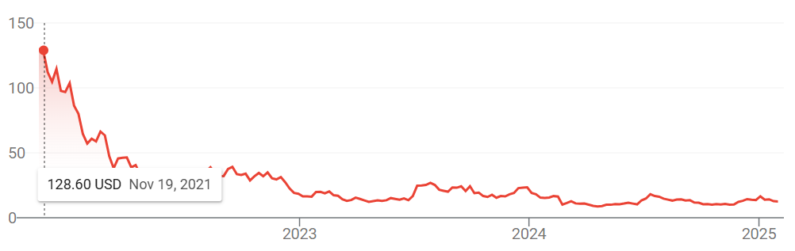

* (PL) ***The company’s interest burden appears to be very low***.
  + The company’s historical interest coverage ratio (5 years average of 11.27) indicates a strong ability to generate sufficient cash flow from operating activities to cover interest payment. However, the company had a negative interest coverage ratio in 2022, driven by negative EBIT, primarily due to losses from its equity investment in Rivian Automotive, Inc. Nevertheless, the company’s operating income was sufficient to cover its interest payments for 2022, so this is not a major concern.
* (CF) ***The company had positive cash flows from financing activities in 2021 and 2022***.
  + Positive cash flows from financing activities in 2021 and 2022 were primarily driven by proceeds from short-term debt and long-term debt, partially offset by share repurchases and repayments of debt, finance leases, and financing obligations.
  + The company does not provide further details on the positive cash flows from financing activities in 2021 and 2022. However, the positive cash flow in 2021 appears to be due to the company financing investments by taking on debt what operating cash flows could not. In 2022, it seems that the company raised financing to cover losses from equity investment in Rivian Automotive, Inc. and to increase its EOP cash balances.
* (CF) ***The company generates so much cash from operating activities that it has increased EOP cash balances even after spending on investing and financing activities***.
  + The company’s strong and consistent cash flow from its core business operations provides financial flexibility, reduces reliance on external financing, supports growth opportunities, and enhances resilience. As the company scales its operations, its cash needs will increase, and it appears to have successfully managed this so far.
* (Debt) ***The company appears to have very favorable debt terms with longer maturities***.
  + The company’s interest rates are relatively low, ranging from 0.45% to 5.20%, with long maturities. This indicates strong creditworthiness and financial stability. These favorable terms help the company lower financial risk, reduce overall borrowing costs, and allocate cash flow toward growth initiatives rather than short-term debt payments.

# Final Notes

## Capital Structure

* Balanced mix of current liabilities, non-current liabilities, and equity.
* Current liabilities mainly include accounts payable and accrued expenses, reflecting strong purchasing power and supplier leverage.
* Non-current liabilities consist of long-term leases and long-term debt, supporting infrastructure investments.
* Retained earnings and additional paid-in capital indicate reinvestment and investor confidence.

## Asset Composition

* 70% of assets are non-current, mainly PP&E and operating leases.
* Investments in warehouses, data centers, fulfillment, and transportation assets support long-term growth.

## Revenue & Profitability

* High revenue but low margins due to high COGS and OpEx.
* The AWS segment drives profitability, whereas retail operations have lower margins.

## Liquidity & Solvency

* Strong operating cash flow ensures liquidity and reduces reliance on external financing.
* Interest coverage ratio indicates the ability to meet debt obligations, though 2022 showed temporary weakness due to Rivian losses.
* Favorable debt terms with low interest rates and long maturities.

## Cash Flow

* Strong operating cash flow allows reinvestment and financial flexibility.

# Supplemental Data

## Amazon.com, Inc.

### Net Sales by Reportable Segment

(In Millions)





### Historical Operating Expenses

(In Millions)



### Operating Income and Margin by Reportable Segment

(In Millions)



### Historical Balance Sheet with % of Total



### Historical Balance Sheet with % Change



Historical P/L Statement



### Historical Equity Statement

(In Millions)

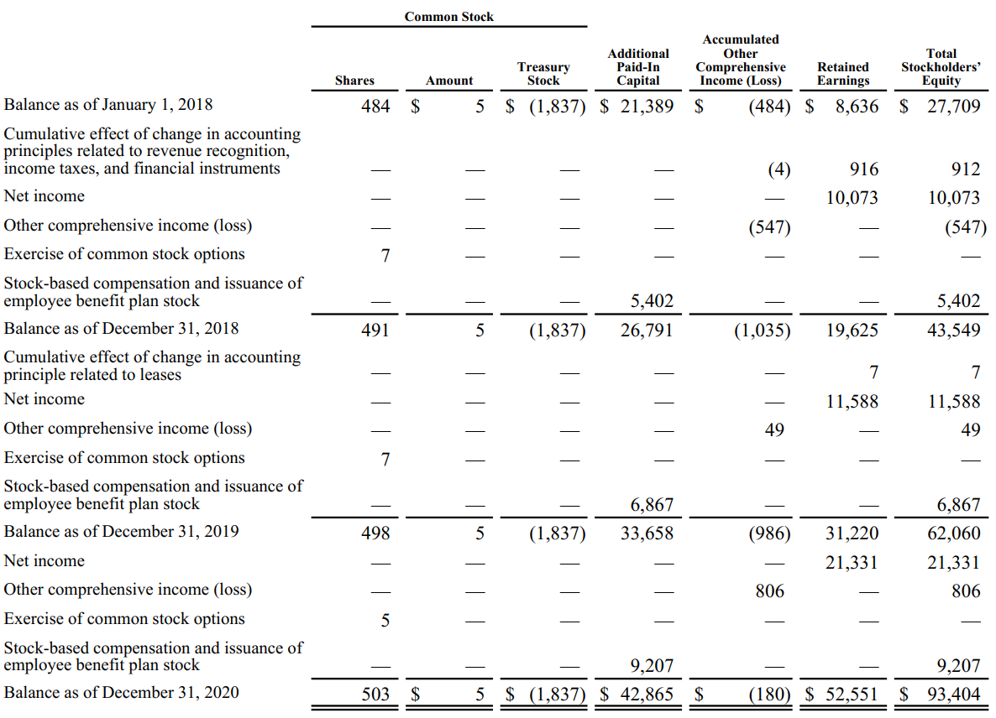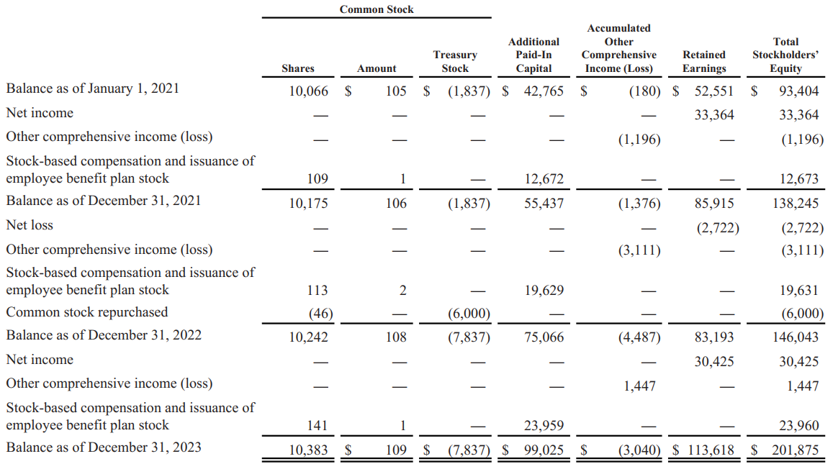

### Historical Cash Flow Statement



## DuPont Analysis (2023)

DuPont Analysis is a financial performance framework that helps break down a company’s ROE into 6 key components. This analysis provides insights into the drivers of a company’s financial performance, helping stakeholders understand how each factor contributes to the overall return.

### Amazon.com, Inc.



## Financial Ratios Formula

### Activity Ratios

#### Receivables Turnover

Meaning: The efficiency of a company in collecting its receivables  
Formula: Revenue / Average Receivables

#### DSO

Meaning: The average number of days a company takes to collect its receivables from clients  
Formula: 365 / Receivables Turnover

#### Inventory Turnover

Meaning: The efficiency of a company in terms of inventory management  
Formula: COGS / Average Inventory

#### DIO

Meaning: The average inventory processing period  
Formula: 365 / Inventory Turnover

#### Payables Turnover

Meaning: The efficiency of a company in allowing its credit to suppliers  
Formula: Purchases / Average Payables

#### DPO

Meaning: The average number of days a company takes to pay its suppliers  
Formula: 365 / Payables Turnover

#### Cash Conversion Cycle

Meaning: The number of days a company takes to convert its investments in inventory and other resources into cash flows from sales

Formula: DSO + DIO - DPO

#### Fixed Assets Turnover

Meaning: The efficiency of a company in utilizing its fixed assets to generate revenue  
Formula: Revenue / Average Fixed Assets

#### Working Capital Turnover

Meaning: The efficiency of a company in managing its working capital (current assets – current liabilities)  
Formula: Revenue / Average Working Capital

#### Total Assets Turnover

Meaning: The efficiency of a company in utilizing its total assets to generate revenue  
Formula: Revenue / Average Total Assets

#### Equity Turnover

Meaning: The efficiency of a company in utilizing equity to generate revenue  
Formula: Revenue / Average Total Equity

### Liquidity Ratios

#### Current Ratio

Meaning: The ability of a company to meet current liabilities (with total current assets)  
Formula: Current Assets / Current Liabilities

#### Quick Ratio

Meaning: The ability of a company to meet current liabilities (with total current assets, excluding inventory and prepaid expenses)

Formula: (Total Current Assets – Inventory – Prepaid Expenses) / Current Liabilities

#### Cash Ratio

Meaning: The ability of a company to meet current liabilities (with cash only)  
Formula: Cash / Current Liabilities

#### Defensive Interval

Meaning: The number of days a company can cover its average daily expenses with the use of current liquid assets only

Formula: (Total Current Assets – Inventory – Prepaid Expenses) / Average Daily Expenditure

### Solvency Ratios

#### Debt-to-Equity

Meaning: Debt as a percentage of total equity  
Formula: Total Debt / Total Equity

#### Debt-to-Capital

Meaning: Debt as a percentage of total capital  
Formula: Total Debt / (Total Debt + Total Equity)

#### Debt-to-Assets

Meaning: Debt as a percentage of total assets  
Formula: Total Debt / Total Assets

#### Financial Leverage

Meaning: An indicator of a company’s debt financing usage  
Formula: Average Total Assets / Average Total Equity

#### Interest Coverage

Meaning: The ability of a company to cover its interest expenses  
Formula: EBIT (Operating Income) / Interest Payments

### Profitability Ratios

#### Gross Profit Margin

Meaning: Gross profitability as a percentage of total revenue  
Formula: (Revenue – COGS) / Revenue

#### Operating Profit Margin

Meaning: Operating profitability (before interest and tax) as a percentage of total revenue  
Formula: Operating Income (EBIT) / Revenue

#### Pre-Tax Profit Margin

Meaning: Operating profitability (before tax) as a percentage of total revenue  
Formula: EBT / Revenue

#### Net Profit Margin

Meaning: Net profitability as a percentage of total revenue  
Formula: Net Income / Revenue

#### ROA (Return on Assets)

Meaning: Net profitability (excluding interest and tax) as a percentage of total invested funds  
Formula: Net Income / Average Total Assets

#### Operating ROA

Meaning: Net profitability (including interest and tax) as a percentage of total invested funds  
Formula: Operating Income (EBIT) / Average Total Assets

#### ROC (Return on Total Capital)

Meaning: Operating profitability as a percentage of total capital  
Formula: Operating Income (EBIT) / Average Total Capital

#### ROE (Return on Equity)

Meaning: Net profitability as a percentage of total equity  
Formula: Net Income / Average Equity

### Valuation Ratios

#### EPS (Earnings Per Share)

Meaning: Income earned per 1 common share outstanding

Data is obtained from each company’s financial statement.

PE Ratio  
Meaning: The price that investors are willing to pay per $1 of earnings

Data is obtained from Macrotrends.