**eBay Inc.**

**FY2023 Financial Statements Analysis**

Seiji Hirano

Last Updated on 1/29/2025

Table of Contents

Report Overview & Background 4

Description 4

Methodology 4

Company Overview 4

eBay Inc. 4

Business 4

Competition 4

Employees & Labor Relations 5

Property 5

Key Risk Factors Unique to eBay Inc. 5

Acquisitions History 5

Horizontal Analysis 7

Balance Sheet Chart 7

P/L Chart 7

Cash Flow Chart (left to right) 8

Historical Financial Ratios 8

Long-Term Debt (Most Recent Years) 9

Maturities of Long-Term Debt / Estimated Debt Service Requirements 9

KPIs 9

Key Financial Insights 10

Final Notes 15

Capital Structure 15

Revenue & Profitability 15

Liquidity & Solvency 15

Cash Flow 15

Supplemental Data 16

eBay Inc. 16

Other KPIs 16

Historical Operating Expenses 16

Historical Balance Sheet 16

Historical P/L Statement 17

Historical Equity Statement 17

Historical Cash Flow Statement 18

DuPont Analysis (2023) 19

eBay Inc. 19

Financial Ratios Formula 20

Activity Ratios 20

Liquidity Ratios 20

Solvency Ratios 21

Profitability Ratios 22

Valuation Ratios 22

# Report Overview & Background

## Description

This report is designed to provide a detailed overview of the XXX industry.

## Methodology

This report solely relies on data from each company’s financial statements.

# Company Overview

## eBay Inc.

### Business

eBay is a global commerce leader that connects people and builds communities to create economic opportunity for all. The company’s technology empowers millions of buyers and sellers in more than 190 markets around the world, providing everyone the opportunity to grow and thrive. Its Marketplace platforms, including online marketplace located at [www.ebay.com](http://www.ebay.com) and its localized counterparts, off-platform businesses in Japan and the United States, and suite of mobile apps, together, create one of the world's largest marketplaces for discovering great value and unique selection. In 2023, eBay enabled more than $73 billion of gross merchandise volume.

eBay’s online marketplace platform follows a **consumer-to-consumer model** but also allows online retailers to use it as a secondary sales channel. eBay was the first online marketplace to utilize an auction system where the highest bidder wins an item. Many sellers also offer a “Buy It Now” function, allowing users to bypass the auction and purchase items immediately. eBay does not own inventory; it simply acts as a mediator between buyers and sellers.

The company generates revenue primarily through fees collected on paid sales, product listing, and advertising.

#### Transaction Fees

eBay earns a commission on every sale made by sellers on the platform. This commission is earned in the form of the Final Value Fee and is gauged as a percentage of the total amount of the sale.

#### Advertising

eBay allows sellers to advertise their products on its online marketplace platform in trade for money.

#### Listing Fees

eBay enables every type of seller to list certain amount of products on its online marketplace platform free of cost. Once the limit is exhausted, the company charges a listing fee for each listing (limits can increase based on seller performance).

### Competition

eBay’s users can list, sell, buy, and pay for similar items through a variety of competing online, mobile and offline channels. These include, but are not limited to, retailers, distributors, liquidators, import and export companies, auctioneers, catalog and mail-order companies, directories, search engines, commerce participants (consumer-to-consumer, business-to-consumer, and business-to-business), shopping channels and networks. Additional competition from other online, mobile and offline channels as its product offerings continue to broaden into new categories of items and new commerce formats. In the United States, these include, but are not limited to, Amazon, Facebook, Instagram, Google, TikTok, Walmart, Target, Best Buy, Macy’s, Etsy, Shopify, Wayfair, Temu, Shein, and Rakuten, among others.

The company believes the principal competitive factors in the basis of price, product selection and services, and global scale.

### Employees & Labor Relations

As of December 31, 2023, the company employed approximately 12,300 people globally. Approximately 7,500 of them were in the United States.

### 

### Property

eBay owns and leases various properties in the United States and 23 other countries around the world. The company uses the properties for executive and administrative offices, data centers, product development offices and customer service offices. The following table presents the aggregate square footage of its owned and leased properties as of December 31, 2023 (in millions):

### Key Risk Factors Unique to eBay Inc.

***The company is exposed to fluctuations in foreign currency exchange rates, which could negatively impact its financial results***

Since the company generates approximately half of its revenues outside the United States but report its financial results in U.S. dollars, its financial results are impacted by fluctuations in foreign currency exchange rates, or foreign exchange rates.

***Substantial and increasingly intense competition worldwide in ecommerce may harm its business***

The company must attract both buyers and sellers to use its platforms. Consumers have more and more alternatives, and merchants have more channels to reach consumers. The company expects competition to continue to intensify. The barriers to entry into these channels can be low, and businesses can easily launch online sites or mobile platforms and applications at nominal cost by using commercially available software or partnering with any of a number of successful ecommerce, search, advertising or social companies. As the company responds to changes in the competitive environment, it may, from time to time, make pricing, service, policy or marketing decisions or acquisitions that may be controversial with and lead to dissatisfaction among sellers or buyers, which could reduce activity on its platform and harm its reputation and profitability.

### Acquisitions History

eBay’s past acquisitions include PayPal (online payment service), Skype Technologies (voice-over-IP service), StubHub (online ticket marketplace), GSI Commerce (e-commerce services), Motors.co.uk (online car marketplace), Terapeak (e-commerce data analytics), Sneaker Con (sneaker authentication service), TCGPlayer (trading card marketplace), Of these, the company still retains ownership of Terapeak, Sneaker Con, and TCGPlayer as of December 31, 2023.

It appears that the company’s acquisitions primarily aim to 1) enhance payment & transaction capabilities, 2) expand into new market segments, 3) boost logistics & operations, 4) improve trust & authentication, and 5) leveraging data & analytics.

# Horizontal Analysis

### Balance Sheet Chart

### P/L Chart

### Cash Flow Chart (left to right)

### Historical Financial Ratios



### Long-Term Debt (Most Recent Years)

### Maturities of Long-Term Debt / Estimated Debt Service Requirements

### KPIs

Gross Merchandise Volume (GMV) and take rate are significant factors that the company believes affect its net revenues.

**GMV** consists of the total value of all paid transactions between users on its platforms during the applicable period inclusive of shipping fees and taxes. Despite GMV’s divergence from revenue, the company still believes that GMV provides a useful measure of the overall volume of paid transactions that flow through its platforms in a given period.

**Take rate** is defined as net revenues divided by GMV and represents net revenue as a percentage of overall volume on its platforms. The company believes that take rate provides a useful measure of its ability to monetize volume through marketplace services on its platforms in a given period. The company uses take rate to identify key revenue drivers on its marketplace.



Net revenues increased primarily due to the investment in focus categories and a higher take rate driven by the expansion of promoted listings and payment services and the launch of eBay International Shipping. The increase in net revenues was partially offset by a reduction in traffic in most markets resulting from geopolitical events, inflationary pressure, foreign exchange rate volatility, elevated interest rates and lower consumer confidence. Net revenues continued to outpace GMV in 2023 due to the benefit of a higher take rate.

As of December 31, 2023, the company derives a majority of GMV from the following product categories: parts & accessories, collectibles, fashion, electronics, and home & garden.

### Key Financial Insights

*Refer to the Supplemental Data section for additional details on eBay’s Balance Sheet, Income Statement, Equity Statement, and Cash Flow Statement to better understand the insights discussed below.*

(BL) ***The company had a significant decrease in total assets (or liabilities and equity) in 2022.***

A decline of approximately $6 billion in total assets in 2022 was primarily driven by a decrease in eBay’s equity investment in Adevinta and a decrease in short-term investments.

In June 2021, the company completed the sale of its Classifieds business to Adevinta, an online classifieds group, in exchange for $2.5 billion in cash and a 44% equity stake in Adevinta, equivalent to approximately 540 million shares, valued at $10.8 billion. eBay chose the fair value option, meaning they tracked the investment based on Adevinta’s stock price and exchange rate.

eBay later sold 135 million shares to Permira for $2.3 billion, which reduced eBay’s ownership from 44% to 33%. Adevinta’s stock price declined, causing eBay to record $3.07 billion in unrealized losses in 2021 and $2.69 billion in 2022. By December 31, 2021, the fair value of the investment was $5.4 billion. By December 2022, eBay moved its Adevinta investment from non-current assets to current assets because it planned to sell more shares after its contractual holding period ended in October 2023. As a result, fluctuations in eBay’s balance sheet was driven partially by stock price changes, sales of shares, and reclassification from non-current to current assets related to Adevinta.

According to eBay’s annual report, its short-term investments primarily include restricted cash, corporate debt securities, and government and agency securities. The majority are corporate debt securities, generally considered low-risk based on their credit ratings from the major rating agencies. The value of eBay’s available-for-sale corporate debt securities declined from $4.2 billion to $2.4 billion.

(BL) ***About one-third of the company’s assets were non-current assets in 2021, but it has been around 50% in 2022 and 2023.***

This change is primarily attributed to eBay’s equity investment in Adevinta, as described above.

(BL) ***About one-third of the company’s assets obtained through equity financing (37%, 25%, and 30% in 2021, 2022, 2023, respectively).***

eBay’s equity primarily consists of retained earnings and additional paid-in capital, largely offset by treasury stock at cost. Since equity is mainly derived from retained earnings and paid-in capital, it appears that eBay has historically grown without excessive reliance on debt.

The presence of significant treasury stock indicates that eBay has spent substantial capital repurchasing its own shares, reducing reported equity. While this can boost EPS, it also reduces book value.

(PL) ***The company had other Income, instead of expense, in 2021 and 2023.***

The significant other income in 2021 was primarily due to income from discontinued operations, while the increase in 2023 was primarily attributed to a rise in gains from equity investments and warrant.

In June 2021, eBay completed the transfer of its Classifieds business to Adevinta. In November 2021, the company also completed the sale of 80.01% of the outstanding equity interests of eBay Korea to Emart. The company has classified the results of its eBay Korea and Classifieds businesses as discontinued operations and are included under other income. The flowing table presents financial results from discontinued operations, net of income taxes (in millions).

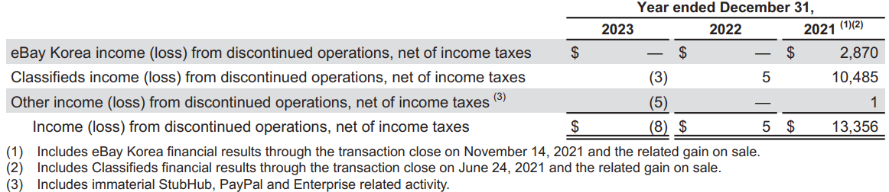

Gain (loss) on equity investments and warrant, net primarily consists of gains and losses related to various equity investments, including eBay’s stakes in Adevinta, KakaoBank (a South Korean financial institution specializing in mobile banking services and financial technology), and Gmarket (a South Korean e-commerce platform). It also includes gains and losses due to changes in fair value of the warrant received from Adyen (a Dutch online payment company). The following table presents gain (loss) on equity investments and warrant, net (in millions, except percentages).

(PL) ***The company had negative net income in 2022.***

This was primarily due to losses on equity investments and warrant, net in 2022. As shown in the last chart, the increase in total losses on equity investments and warrant, net in 2022 compared to 2021 was primarily driven by a $158 million and $621 million increase in realized and unrealized losses, respectively, recorded related to the change in fair value of its equity investment in KakaoBank, a $584 million increase in the loss recorded related to the change in fair value of the Adyen warrant, and a $291 million increase in the loss recorded related to the change in fair value of its equity investment in Gmarket, partially offset by a $377 million decrease in the unrealized loss recorded related to the change in fair value of its equity investment in Adevinta.

These total losses, along with interest and other, net, income tax benefit (provision), and income from discontinued operations, net of income taxes, exceeded the company’s operating income, resulting in a negative net income in 2022.

(PL) ***It appears that the company usually has more operating expenses than COGS.***

COGS represents costs associated with customer support, site operations and payment processing. Significant components of these costs primarily consist of employee compensation (including stock-based compensation), contractor costs, facilities costs, depreciation of equipment and amortization expense, bank transaction fees, credit card interchange and assessment fees, authentication costs, shipping costs and digital services tax.

Operating expenses primarily consist of sales and marketing, product development, general and administrative, provision for transaction loses, amortization of acquired intangible assets.

Sales and marketing expenses primarily consist of advertising and marketing program costs (both online and offline), employee compensation (including stock-based compensation), certain user coupons and rewards, contractor costs, facilities costs and depreciation on equipment. Online marketing expenses represent traffic acquisition costs in various channels such as paid search, affiliates marketing and display advertising. Offline advertising primarily includes brand campaigns and buyer/seller communications.

Product development expenses primarily consist of employee compensation (including stock-based compensation), contractor costs, facilities costs and depreciation on equipment. Product development expenses are net of required capitalization of major platform and other product development efforts, including the development and maintenance of its technology platform. Its top technology priorities include the implementation of its strategic plan including payment intermediation capabilities, improved seller tools and buyer experiences.

General and administrative expenses primarily consist of employee compensation (including stock-based compensation), contractor costs, facilities costs, depreciation of equipment, legal expenses, restructuring, insurance premiums and professional fees.

Provision for transaction losses primarily consists of transaction loss expense associated with its buyer protection programs, losses from its managed payments services, fraud and bad debt expense associated with its accounts receivable balance.

The following tables present COGS and operating expenses:

eBay’s low COGS and high operating expenses reflect its tech-driven marketplace model rather than a traditional retail business. The company invests heavily in marketing, technology, and risk management to keep the platform competitive, leading to higher operating expenses relative to COGS.

(CF) ***The company’s cash flow activities have been following the same pattern over the last three years (+ operating cash flows, + investing cash flows, - financing cash flows).***

eBay’s steady positive cash flows from operating activities indicate strong operational performance.

The positive cash flows from investing activities in 2021 were primarily due to net cash provided by discontinued investing activities, while in 2022 and 2023, they were primarily driven by maturities and sales of investments. The company has been actively purchasing and selling investments, with proceeds and purchases both exceeding $10 billion. The largely offsetting effects of purchases of investments and maturities and sale of investments results from the management of its investments. As its immediate cash needs change, purchase and sale activity will fluctuate.

The company’s primary financing activities include repurchases of common stock, repayment of debt, and payments for dividends. Its stock repurchase programs are intended to programmatically offset the impact of dilution from its equity compensation programs and, subject to market conditions and other factors, to make opportunistic and programmatic repurchases of its common stock to reduce its outstanding share count.

Final Notes

## Capital Structure

* Balanced mix of current and non-current assets.
* Current assets mainly include cash and cash equivalents, short-term investments, and equity investments with readily determinable fair values, reflecting the company’s active investment strategy.
* Non-current assets are primarily composed of goodwill and deferred tax assets, indicating the company’s strategy to grow through acquisitions.
* About 30% of total assets are financed through equity, consisting primarily of significant retained earnings and paid-in capital, which suggest reinvestment and investor confidence, largely offset by treasury stock at cost.

## Revenue & Profitability

* High profitability due to its tech-based business model, with an operating profit margin around 25%.
* The company’s net profit margin fluctuates due to its active equity and other investments.

## Liquidity & Solvency

* Strong free cash flow and working capital.

## Cash Flow

* Steady cash flows from operating activities
* Very active in investing activities including equity investments, corporate debt securities, commercial paper and government and agency securities.
* Primary financing activities involve share repurchases to offset the impact of dilution from its equity compensation programs and reduce its outstanding share count and debt repayments.

# Supplemental Data

## eBay Inc.

### Other KPIs

(In Millions)



### Historical Operating Expenses

(In Millions)



### Historical Balance Sheet



Historical P/L Statement



### Historical Equity Statement

(In Millions)

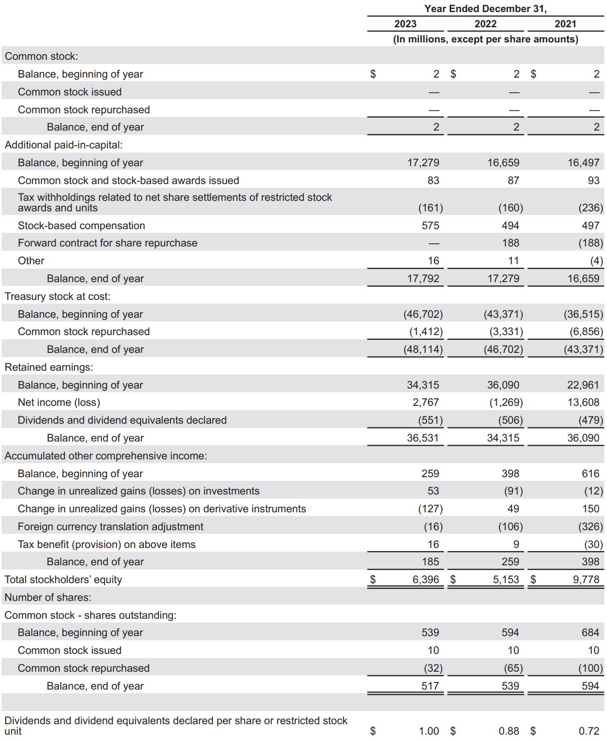

### Historical Cash Flow Statement



## DuPont Analysis (2023)

DuPont Analysis is a financial performance framework that helps break down a company’s ROE into 6 key components. This analysis provides insights into the drivers of a company’s financial performance, helping stakeholders understand how each factor contributes to the overall return.

### eBay Inc.



## Financial Ratios Formula

### Activity Ratios

#### Receivables Turnover

Meaning: The efficiency of a company in collecting its receivables  
Formula: Revenue / Average Receivables

#### DSO

Meaning: The average number of days a company takes to collect its receivables from clients  
Formula: 365 / Receivables Turnover

#### Inventory Turnover

Meaning: The efficiency of a company in terms of inventory management  
Formula: COGS / Average Inventory

#### DIO

Meaning: The average inventory processing period  
Formula: 365 / Inventory Turnover

#### Payables Turnover

Meaning: The efficiency of a company in allowing its credit to suppliers  
Formula: Purchases / Average Payables

#### DPO

Meaning: The average number of days a company takes to pay its suppliers  
Formula: 365 / Payables Turnover

#### Cash Conversion Cycle

Meaning: The number of days a company takes to convert its investments in inventory and other resources into cash flows from sales

Formula: DSO + DIO - DPO

#### Fixed Assets Turnover

Meaning: The efficiency of a company in utilizing its fixed assets to generate revenue  
Formula: Revenue / Average Fixed Assets

#### Working Capital Turnover

Meaning: The efficiency of a company in managing its working capital (current assets – current liabilities)  
Formula: Revenue / Average Working Capital

#### Total Assets Turnover

Meaning: The efficiency of a company in utilizing its total assets to generate revenue  
Formula: Revenue / Average Total Assets

#### Equity Turnover

Meaning: The efficiency of a company in utilizing equity to generate revenue  
Formula: Revenue / Average Total Equity

### Liquidity Ratios

#### Current Ratio

Meaning: The ability of a company to meet current liabilities (with total current assets)  
Formula: Current Assets / Current Liabilities

#### Quick Ratio

Meaning: The ability of a company to meet current liabilities (with total current assets, excluding inventory and prepaid expenses)

Formula: (Total Current Assets – Inventory – Prepaid Expenses) / Current Liabilities

#### Cash Ratio

Meaning: The ability of a company to meet current liabilities (with cash only)  
Formula: Cash / Current Liabilities

#### Defensive Interval

Meaning: The number of days a company can cover its average daily expenses with the use of current liquid assets only

Formula: (Total Current Assets – Inventory – Prepaid Expenses) / Average Daily Expenditure

### Solvency Ratios

#### Debt-to-Equity

Meaning: Debt as a percentage of total equity  
Formula: Total Debt / Total Equity

#### Debt-to-Capital

Meaning: Debt as a percentage of total capital  
Formula: Total Debt / (Total Debt + Total Equity)

#### Debt-to-Assets

Meaning: Debt as a percentage of total assets  
Formula: Total Debt / Total Assets

#### Financial Leverage

Meaning: An indicator of a company’s debt financing usage  
Formula: Average Total Assets / Average Total Equity

#### Interest Coverage

Meaning: The ability of a company to cover its interest expenses  
Formula: EBIT (Operating Income) / Interest Payments

### Profitability Ratios

#### Gross Profit Margin

Meaning: Gross profitability as a percentage of total revenue  
Formula: (Revenue – COGS) / Revenue

#### Operating Profit Margin

Meaning: Operating profitability (before interest and tax) as a percentage of total revenue  
Formula: Operating Income (EBIT) / Revenue

#### Pre-Tax Profit Margin

Meaning: Operating profitability (before tax) as a percentage of total revenue  
Formula: EBT / Revenue

#### Net Profit Margin

Meaning: Net profitability as a percentage of total revenue  
Formula: Net Income / Revenue

#### ROA (Return on Assets)

Meaning: Net profitability (excluding interest and tax) as a percentage of total invested funds  
Formula: Net Income / Average Total Assets

#### Operating ROA

Meaning: Net profitability (including interest and tax) as a percentage of total invested funds  
Formula: Operating Income (EBIT) / Average Total Assets

#### ROC (Return on Total Capital)

Meaning: Operating profitability as a percentage of total capital  
Formula: Operating Income (EBIT) / Average Total Capital

#### ROE (Return on Equity)

Meaning: Net profitability as a percentage of total equity  
Formula: Net Income / Average Equity

### Valuation Ratios

#### EPS (Earnings Per Share)

Meaning: Income earned per 1 common share outstanding

Data is obtained from each company’s financial statement.

PE Ratio  
Meaning: The price that investors are willing to pay per $1 of earnings

Data is obtained from Macrotrends.

Dividend Payout Ratio (DPR)  
Meaning: The measure of dividends paid out to shareholders relative to the company’s net income

Formula: Dividends Paid to Common Shareholders / Net Income

Dividend Yield  
Meaning: The ratio that shows how much a company pays out in dividends each year relative to its stock price

Formula: Dividends Paid to Common Shareholders / Net Income