15 МНОГОПОЛЬЗОВАТЕЛЬСКОЕ ПРИЛОЖЕНИЕ
Задание.
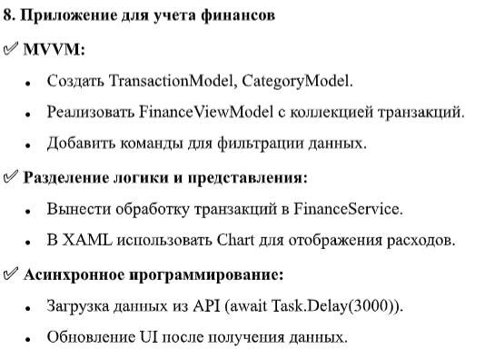
Листинг программы:
using System;
using System.Collections.ObjectModel;
using System.ComponentModel;
using System.Runtime.CompilerServices;
using System.Threading.Tasks;
using System.Windows.Input;
namespace FinanceApp
{
public class FinanceViewModel : INotifyPropertyChanged
{
private readonly FinanceService _financeService;
private bool _isLoading;
public ObservableCollection<Transaction> Transactions { get; set; } = new ObservableCollection<Transaction>();
public ObservableCollection<CategoryModel> Stats { get; set; } = new ObservableCollection<CategoryModel>();
public bool IsLoading
{
get => _isLoading;
set
{
_isLoading = value;
OnPropertyChanged();

public ICommand LoadDataCommand { get; }
public FinanceViewModel()
{
_financeService = new FinanceService();
LoadDataCommand = new RelayCommand(async _ => await LoadDataAsync());
_ = LoadDataAsync();
}
public async Task LoadDataAsync()
{
if (IsLoading) return;
try
{
IsLoading = true;
var data = await _financeService.GetTransactionsFromApiAsync();
Transactions.Clear();
foreach (var t in data) Transactions.Add(t);
var statistics = _financeService.CalculateStatistics(Transactions);
Stats.Clear();
foreach (var s in statistics) Stats.Add(s);
}
catch (Exception ex)
{
System.Diagnostics.Debug.WriteLine($"Ошибка: {ex.Message}");
}
finally
{
IsLoading = false;
}
}
public event PropertyChangedEventHandler PropertyChanged;
protected void OnPropertyChanged([CallerMemberName] string name = null) =>
PropertyChanged?.Invoke(this, new PropertyChangedEventArgs(name));
}
}
Анализ результатов:
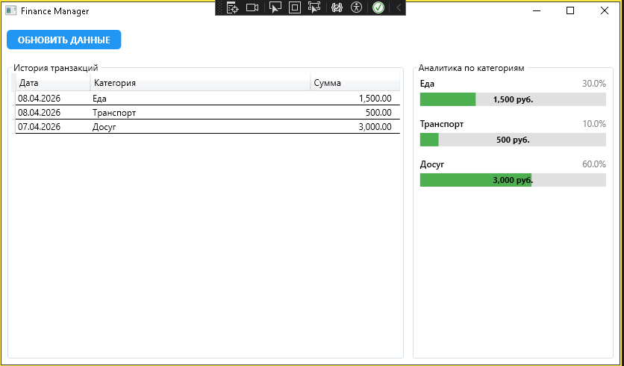
Рисунок 15.1 – Результат работы программы

