34 РАЗВЕРТЫВАНИЕ WINDOWS-ПРИЛОЖЕНИЯ
Задание. Возьмите за основы проект Windows Forms и создайте установочный файл Setup.msi изучив Теоретический материал.
Листинг программы:
<?xml version="1.0" encoding="utf-8"?>
<Package
xmlns="http://schemas.microsoft.com/appx/manifest/foundation/windows10"
xmlns:uap="http://schemas.microsoft.com/appx/manifest/uap/windows10"
xmlns:mp="http://schemas.microsoft.com/appx/2014/phone/manifest"
xmlns:rescap="http://schemas.microsoft.com/appx/manifest/foundation/windows10/restrictedcapabilities"
IgnorableNamespaces="uap rescap">
<Identity Name="maui-package-name-placeholder" Publisher="CN=User Name" Version="0.0.0.0" />
<mp:PhoneIdentity PhoneProductId="FCFAE379-CB9D-4258-BFC5-9620E99D9DD1" PhonePublisherId="00000000-0000-0000-0000-000000000000"/>
<Properties>
<DisplayName>Maui Setup App</DisplayName>
<PublisherDisplayName>MyCompany</PublisherDisplayName>
<Logo>Assets\Logo.png</Logo>
</Properties>
<Dependencies>
<TargetDeviceFamily Name="Windows.Universal" MinVersion="10.0.17763.0" MaxVersionTested="10.0.19041.0" />
<TargetDeviceFamily Name="Windows.Desktop" MinVersion="10.0.17763.0" MaxVersionTested="10.0.19041.0" />
</Dependencies>
<Resources>
<Resource Language="x-generate" />
</Resources>
<Applications>
<Application Id="App" Executable="$targetnametoken$.exe" EntryPoint="$targetentrypoint$">
<uap:VisualElements
DisplayName="$placeholder$"
Description="$placeholder$"
Square150x150Logo="$placeholder$.png"
Square44x44Logo="$placeholder$.png"
BackgroundColor="transparent">

<uap:DefaultTile Square71x71Logo="$placeholder$.png"
Wide310x150Logo="$placeholder$.png" Square310x310Logo="$placeholder$.png" />
<uap:SplashScreen Image="$placeholder$.png" />
</uap:VisualElements>
</Application>
</Applications>
<Capabilities>
<rescap:Capability Name="runFullTrust" />
</Capabilities>
</Package>

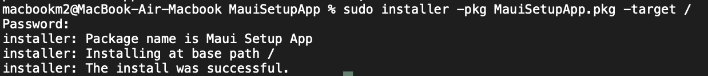
Рисунок 34.1 – Результат работы

