17 РАБОТА С ГРАФИКОЙ.АНИМАЦИЯ
Задание. 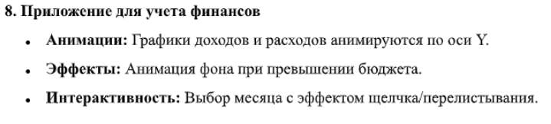
Листинг программы:
using System;
using System.Windows;
using System.Windows.Media;
using System.Windows.Media.Animation;
namespace FinanceApp
{
public partial class MainWindow : Window
{
private string[] months = {
"Январь", "Февраль", "Март", "Апрель", "Май", "Июнь",
"Июль", "Август", "Сентябрь", "Октябрь", "Ноябрь", "Декабрь"
};
private double[,] data = {
{ 150, 80 }, { 120, 170 }, { 210, 110 }, { 90, 150 },
{ 180, 170 }, { 220, 190 }, { 250, 240 }, { 200, 240 },
{ 150, 180 }, { 170, 150 }, { 140, 190 }, { 240, 230 }
};
private int currentIndex = 0;
public MainWindow()
{
InitializeComponent();
this.Loaded += (s, e) => UpdateUI();
}
private void NextMonth_Click(object sender, RoutedEventArgs e)
{
currentIndex = (currentIndex + 1) % months.Length;
AnimateFlip(1);
}
private void PrevMonth_Click(object sender, RoutedEventArgs e)

{
currentIndex = (currentIndex - 1 + months.Length) % months.Length;
AnimateFlip(-1);
}
private void AnimateFlip(int direction)
{
DoubleAnimation slideOut = new DoubleAnimation
{
To = direction * -50,
Duration = TimeSpan.FromMilliseconds(150)
};
slideOut.Completed += (s, e) =>
{
UpdateUI();
MonthTextTransform.X = direction * 50;
DoubleAnimation slideIn = new DoubleAnimation
{
To = 0,
Duration = TimeSpan.FromMilliseconds(150)
};
MonthTextTransform.BeginAnimation(TranslateTransform.XProperty, slideIn);
};
MonthTextTransform.BeginAnimation(TranslateTransform.XProperty, slideOut);
}
private void UpdateUI()
{
MonthLabel.Text = months[currentIndex];
double income = data[currentIndex, 0];
double expense = data[currentIndex, 1];
AnimateBar(IncomeBar, income);
AnimateBar(ExpenseBar, expense);
CheckBudgetStatus(income, expense);
}
private void AnimateBar(System.Windows.Shapes.Rectangle bar, double newHeight)
{
DoubleAnimation anim = new DoubleAnimation
{
From = bar.Height,
To = newHeight,
Duration = TimeSpan.FromSeconds(0.6),
EasingFunction = new QuarticEase { EasingMode = EasingMode.EaseOut }
};
bar.BeginAnimation(HeightProperty, anim);
bar.Height = newHeight;
}

private void CheckBudgetStatus(double income, double expense)
{
Color targetColor = (expense > income) ? Color.FromRgb(255, 230, 230) : Colors.White;
ColorAnimation backgroundAnim = new ColorAnimation
{
To = targetColor,
Duration = TimeSpan.FromSeconds(0.5)
};
if (MainGrid.Background is SolidColorBrush brush)
{
if (brush.IsFrozen)
MainGrid.Background = new SolidColorBrush(brush.Color);
MainGrid.Background.BeginAnimation(SolidColorBrush.ColorProperty, backgroundAnim);
}
else
{
MainGrid.Background = new SolidColorBrush(Colors.White);
MainGrid.Background.BeginAnimation(SolidColorBrush.ColorProperty, backgroundAnim);
}
}
}
}
Анализ результатов:
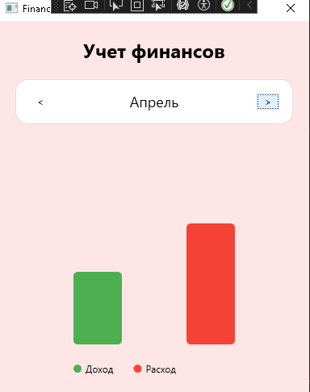

Рисунок 17.1 – Результат работы программы

