Contents

1. Watermark Removal 1

1.1 Visible Watermark Extraction 2

1.2 Original Image Recovery 2

2 Experiments 3

2.1 Transparency 3

2.2 Watermark Visibility 3

2.3 Robustness 4

2.4 Security 5

# 1. Watermark Removal

In the watermark removal phase, we first extract the visible watermark, and then remove it and recover the original BTC compressed image. the main steps are listed below.

1. Extract encrypted watermark signal *Wei* from BTC codes of the watermarked image using the following equation.

(1)

1. Get the visible watermark by decrypting the encrypted watermark with the secret key.
2. Produce the estimated mean image and compute the visual perception factor *vpf* using the same methods as the watermark embedding process. Note that the same mean image and visual perception factor can be obtained during both the watermark embedding phase and the watermark removal process since it is computed based on non-watermark pixels.
3. Remove the visible watermark (see Algorithm 5) and obtain a recovered BTC-compressed image (see Algorithm 6). The watermark removal approach can be written as

(2)

(3)

where t ∈ { , }

## 1.1 Visible Watermark Extraction

Given the user secret key, the proposed scheme can extract the visible watermark from the watermarked image. The detailed strategy is illustrated in Algorithm 5.

Algorithm 1:Visible watermark extraction

Input: , secret key *key1*

Initialization: *y*0 = *key*1, *μ* = 0.3618

for *i* = 1: *m* × *n* do

Extract the watermark bit *We* by using (1).

If *Wei*==0

Apply operation (*xh*, *xl*, *bp)* = (*xl*, *xh*, *)* and recover the watermarked image with the visible watermark *Iv* from the watermarked image .

end if

end for

Generate a binary sequence *R*.

Decrypted watermark signal *We* and obtain the visible watermark *W* by applying XOR operation to *We* and *R*.

Output: visible watermark *W* and the watermarked image with the visible watermark *Iv*

## 1.2 Original Image Recoveryо

Algorithm 2:Original image recovery

Input: *Iv*, *W*

Initialization: λ*w* = 50

According to the watermarked image *Iv* and the visible watermark *W*, generate the estimated mean image by using Algorithm 1. The same visual perception factor *vpf* is computed by Algorithm 2 since the same bit-planes can be obtained.

for *i* = 1: *m* × *n* do

Remove the visible watermark and recover the original BTC-compressed image by using 3)

end for

Output: Recovered BTC-compressed image *IBTC*

The same mean image can be generated based on the watermarked image with the visible watermark *Iv* and visible watermark by employing the total variation image restoration method. Then the same visual perception factor can be obtained since the bit-planes remain unchanged before and after watermark embedding. Therefore, the original BTC-compressed image can be recovered as depicted in Algorithm 6.

# 2 Experiments

In this section, the TVB-RVW scheme is evaluated by a series of experiments on several aspects such as the visual quality of the watermarked image, watermark visibility, robustness, and security. These experiments are conducted on some 512×512×8bits test images which range from fairly smooth images to highly textured ones. The visible watermark is a binary image with the size of 128×128 as shown in Fig. 1(a). Fig. 1(b-d) shows some BTC test images. In the experiments, the parameter λ*w* is set to 50.

* “Lena”;
* “Jet”;
* “Baboon”;

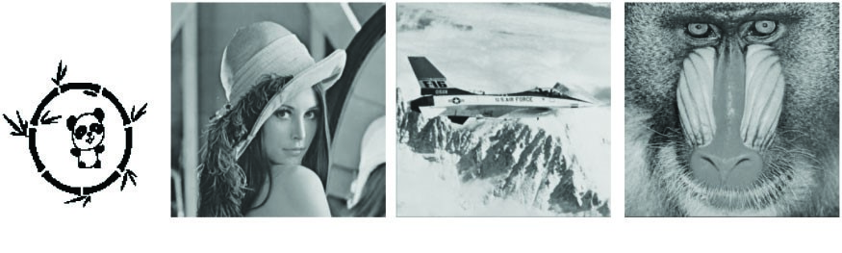

Figure 1Visible watermark and some test images

## 2.1 Transparency

Peak Signal to Noise Ratio (PSNR) values are adopted to evaluate the transparency of the BTC-compressed watermarked images produced by the TVB-RVW scheme. Fig. 2(a–c) illustrate the watermarked images for some BTC-compressed images, referred to as “Lena”, “jet”, “Baboon”, respectively. From Fig. 2, one can observe that the watermarked images have satisfactory visual quality, which preserves the visual perceptual content of original BTC-compressed images very well.

## 2.2 Watermark Visibility

Watermark visibility is one of the important attributions of visible watermarking techniques. Good watermark visibility means high contrast of the watermark content as well as the satisfactory visual quality of watermarked images. Simply, one can judge roughly the watermark visibility by observing watermark images produced by the TVB-RVW scheme as shown in Fig. 2. The visible watermark is translucent and adaptive to the content of host images with various texture types. Moreover, Fig. 3 illustrates the difference images of the original BTC-compressed images and corresponding watermarked images. To provide a good visual effect, the difference images are magnified by 10 times.

From Fig. 3, it can be noticed that the watermark strength is adaptive to the perceptual content of images.

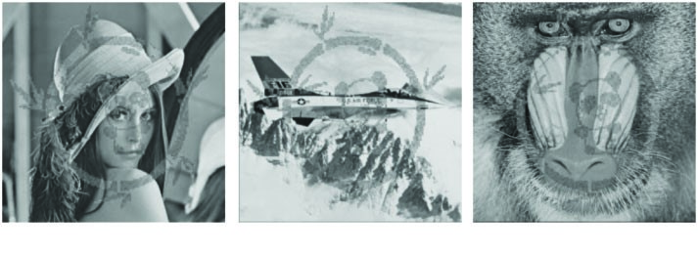

Figure 2Watermarked images



Figure 3 Difference images between original BTC-compressed images and watermarked images

## 2.3 Robustness

Fig. 4 illustratestheseattackedexperimentalresultsfortheLenaBTC-compressedimage. It can be observed that one can recognize the visible watermark clearly from the attacked watermarked images. According to the experiments, these above-mentioned signal processing attacks cannot completely delete the superimposed visible watermark. So, it can be concluded that the proposed TVB-RVW scheme is robust against common signal processing attacks.



Figure 4 Robustness against common signal processing attacks. histogram equalization, Laplacian sharpening, 5×5 median filtering.

## 2.4 Security

The PSNR values (dB) of recovery images are shown in Tab. 1. The average PSNR value for illegal removal and legal removal is 17.33 and 58.91dB, respectively. The PSNR values for illegal removal are much lower than those for legal removal. This shows that illegal removal results for different types of images have poor visual quality and unauthorized users cannot completely delete the visible watermark by illegal watermark removal.

Table 1 Visual quality of recovery images (dB)

|  |  |  |
| --- | --- | --- |
| Test images | Legal removal | Illegal removal |
| Lena | 58.92 | 18.34 |
| Jet | 58.79 | 15.67 |
| Baboon | 58.91 | 18.10 |
| Boat | 58.82 | 18.55 |
| Crowd | 59.23 | 16.07 |
| Couple | 58.89 | 17.82 |
| Goldhill | 58.86 | 17.51 |
| Peppers | 58.83 | 16.60 |