POWERTRAIN SYSTEM ANALYSIS
eBAJA Electric Vehicle Powertrain
Motor → Chain/Sprocket → Gearbox → Output Shaft → Tyre

Analytical calculations, MATLAB model results and engineering checks

1. Objective
The objective is to develop an analytical and MATLAB-based model of the vehicle powertrain to determine how motor current and motor speed are transformed through the chain drive, gearbox and output shaft into tyre torque, tyre speed, vehicle speed and tractive force. The analysis also checks motor power consistency and tyre-road traction limits.

Powertrain Configuration
Motor → 15T motor sprocket → 14T gearbox sprocket → 9:1 gearbox → output shaft → rear tyre/wheel
The output shaft is treated as a 1:1 speed connection. The vehicle is modeled as rear-wheel drive without a differential, using the stated drivetrain arrangement.

2. Complete Powertrain Input Sheet
Parameter | Symbol | Value | Unit | Source / basis
Rated motor power | P_motor,rated | 5 | kW | Motor datasheet
Peak motor power | P_motor,peak | 9 | kW | Motor datasheet; peak/short-duration
Rated motor torque | T_motor,rated | 15.5 | Nm | Motor datasheet
Maximum motor torque | T_motor,max | 90 | Nm | Motor datasheet
Rated motor speed | N_motor,rated | 4200 | RPM | Motor datasheet
Maximum motor speed | N_motor,max | 4300 | RPM | Upper end of stated 4100–4300 RPM range
Rated current | I_cont | 80 | A | Motor datasheet
Maximum current | I_max | 180 | A | Motor datasheet
Torque constant | K_t | 0.19375 | Nm/A | Derived from 15.5 Nm / 80 A; modeling assumption
Motor efficiency | η_motor | 97 | % | Motor datasheet
Motor-side sprocket | Z_motor | 15 | teeth | Given drivetrain data
Gearbox-side sprocket | Z_GB | 14 | teeth | Given drivetrain data
Chain reduction | R_chain | 0.9333 | ratio | Calculated
Gearbox reduction | R_GB | 9.00 | ratio | Given drivetrain data
Total reduction | R_total | 8.4000 | ratio | Calculated
Overall mechanical efficiency | η_mech | 77.5 | % | Assumed midpoint of 75–80%
Output shaft ratio | R_shaft | 1.00 | ratio | Assumed direct 1:1 shaft
Tyre rolling radius | R_tyre | 0.3048 | m | 24 in diameter / 2
Vehicle mass incl. driver | M | 320 | kg | Given vehicle data
Driven-wheel load fraction | W_d fraction | 55 | % | Engineering assumption
Coefficient of friction | μ | 0.70 | — | Engineering assumption

3. Analytical Calculation Sheet

3.1 Chain Reduction
R_chain = Z_GB / Z_motor
R_chain = 14 / 15 = 0.9333
Since the gearbox-side sprocket has fewer teeth than the motor-side sprocket, the chain stage is a slight overdrive (speed increase and torque decrease), not a reduction.

3.2 Total Reduction
R_total = R_chain × R_GB
R_total = 0.9333 × 9 = 8.4000:1

3.3 Gearbox Input and Tyre Speed
N_GB,in = N_motor / R_chain
At 4300 RPM: N_GB,in = 4300 / 0.9333 = 4607.14 RPM
N_tyre = N_motor / R_total
At 4300 RPM: N_tyre = 4300 / 8.4000 = 511.90 RPM

3.4 Motor Torque from Current
For the linear region, T_motor = K_t × I
K_t = 15.5 / 80 = 0.19375 Nm/A
Because the same linear constant cannot simultaneously reproduce 15.5 Nm at 80 A and 90 Nm at 180 A, the MATLAB model uses a two-segment torque-current approximation: linear to 80 A, followed by linear interpolation from 15.5 Nm at 80 A to 90 Nm at 180 A. This is an engineering modeling assumption rather than a manufacturer torque-current map.

3.5 Tyre Torque
T_tyre = T_motor × R_chain × R_GB × η_mech
At peak motor torque: T_tyre,max = 90 × 0.9333 × 9 × 0.775 = 585.90 Nm

3.6 Vehicle Speed
V = (N_tyre × 2πR_tyre / 60) × 3.6
At maximum motor speed: V_max,theoretical = 58.82 km/h

3.7 Tractive Force
F_tractive = T_tyre / R_tyre
At peak tyre torque: F_tractive,max = 585.90 / 0.3048 = 1922.24 N

3.8 Traction Limit
W_d = 0.55 × M × g
W_d = 0.55 × 320 × 9.81 = 1726.56 N
F_traction,max = μ × W_d
F_traction,max = 0.70 × 1726.56 = 1208.59 N
T_traction,max = F_traction,max × R_tyre
T_traction,max = 1208.59 × 0.3048 = 368.38 Nm

3.9 Power Consistency
P = T × ω, where ω = 2πN/60
Using the 5 kW continuous/rated power limit, the calculated constant-torque break speed is N_break = 3080.4 RPM, corresponding to approximately 42.14 km/h.
Above this speed, the MATLAB model reduces motor torque approximately as T = P/ω so that continuous motor power remains at 5 kW. The resulting current falls from approximately 80 A at the break point to about 57.3 A at 4300 RPM.

4. Final Results
Result | Value | Unit
Maximum motor torque | 90.00 | Nm
Maximum motor speed | 4300 | RPM
Motor maximum current | 180 | A
Motor sprocket teeth | 15 | teeth
Gearbox input sprocket teeth | 14 | teeth
Chain ratio | 0.9333 | ratio
Gearbox reduction ratio | 9.00 | ratio
Total reduction ratio | 8.4000 | ratio
Overall mechanical efficiency | 77.5 | %
Output shaft ratio | 1.00 | ratio
Maximum tyre torque (peak) | 585.90 | Nm
Maximum tyre RPM | 511.90 | RPM
Maximum theoretical vehicle speed | 58.82 | km/h
Maximum tractive force from peak tyre torque | 1922.24 | N
Traction-limited tyre torque | 368.38 | Nm
Continuous motor power used for main speed model | 5.00 | kW

5. Operating Limits and Engineering Interpretation
- The 5 kW rated power is used as the continuous operating basis of the speed/torque model.
- The 9 kW motor rating is treated only as peak/short-duration capability and is not assumed to be continuously sustainable.
- The 180 A current is the modeled maximum current limit.
- The theoretical top speed is approximately 58.82 km/h at 4300 motor RPM and assumes no road load, aerodynamic drag or additional speed-dependent losses.
- The peak calculated tyre torque (585.90 Nm) exceeds the estimated traction-limited tyre torque (368.38 Nm). Therefore, under the stated μ and driven-wheel-load assumptions, peak launch torque is traction-limited rather than fully usable at the tyre.
- The actual vehicle speed under load can be lower than the theoretical value because of rolling resistance, aerodynamic drag, terrain, battery/controller limits, tyre slip and other losses.

6. MATLAB Model / Simulation
The MATLAB model contains editable motor, transmission, tyre and vehicle parameters and generates the required performance datasets. The model sweeps motor current and motor speed and calculates motor torque, tyre torque, tyre RPM, vehicle speed, tractive force, motor power and motor current.
The MATLAB script used for the analysis should be submitted with this report as a separate .m file.

Modeling assumptions implemented
- Chain + gearbox + output shaft mechanical efficiency = 77.5% overall.
- Output shaft speed ratio = 1:1.
- Tyre rolling radius = 0.3048 m.
- Vehicle mass including driver = 320 kg.
- Driven-wheel normal load = 55% of total vehicle weight.
- Coefficient of friction μ = 0.7.
- Torque-current model uses the derived Kt = 0.19375 Nm/A in the linear region and a two-segment approximation to the peak torque point.
- 5 kW is the continuous/rated power limit for the main torque-speed model.

7. Mandatory MATLAB Plots
Insert the generated MATLAB plots below/in the following order. The plots are not embedded in this document so that the final report can use the user's preferred plot formatting and resolution.
Graph 1: Motor Torque vs Motor Current
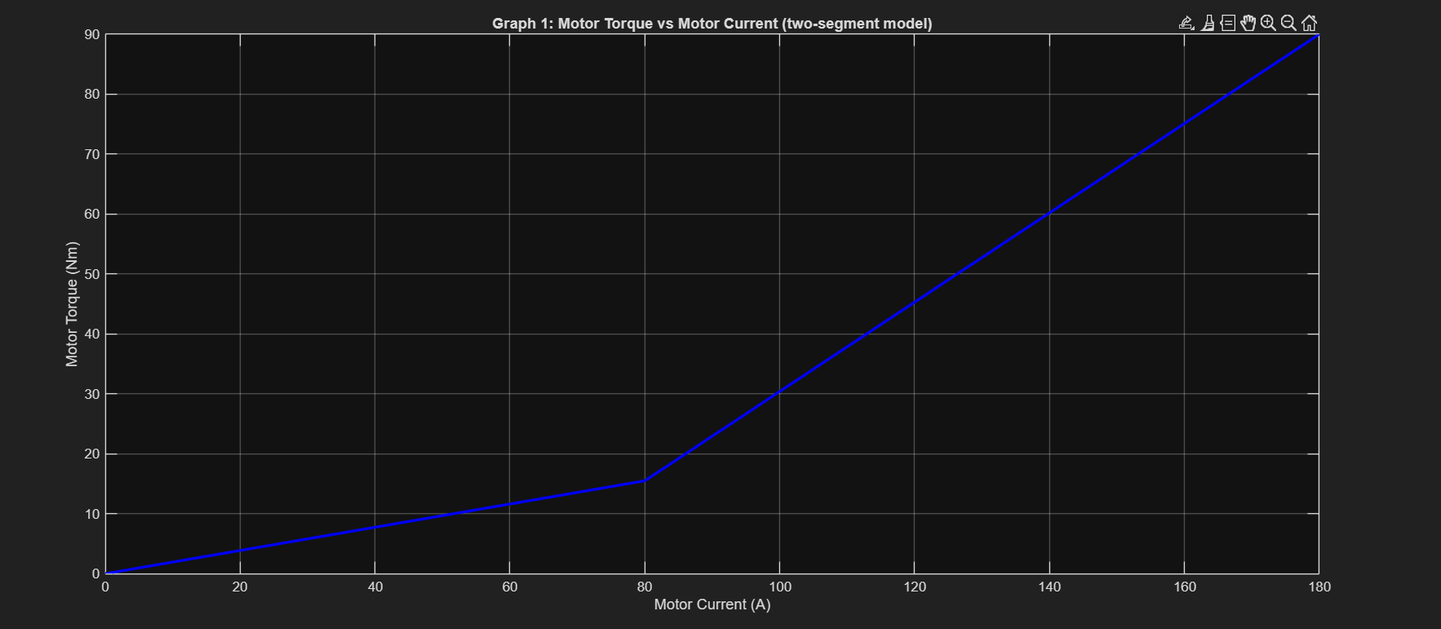

Graph 2: Tyre Torque vs Motor Current
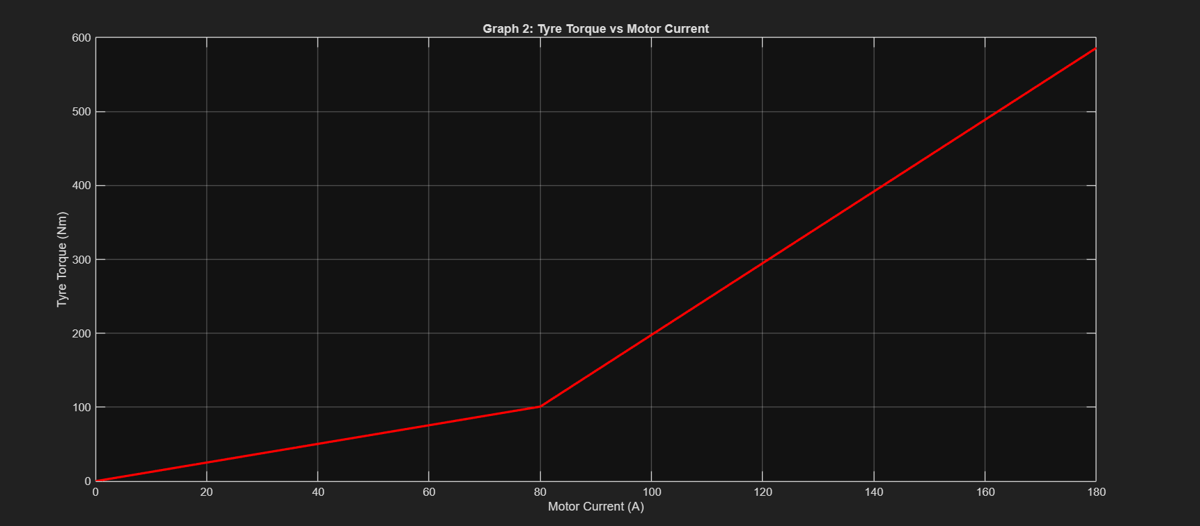

Graph 3: Motor Speed vs Tyre Speed
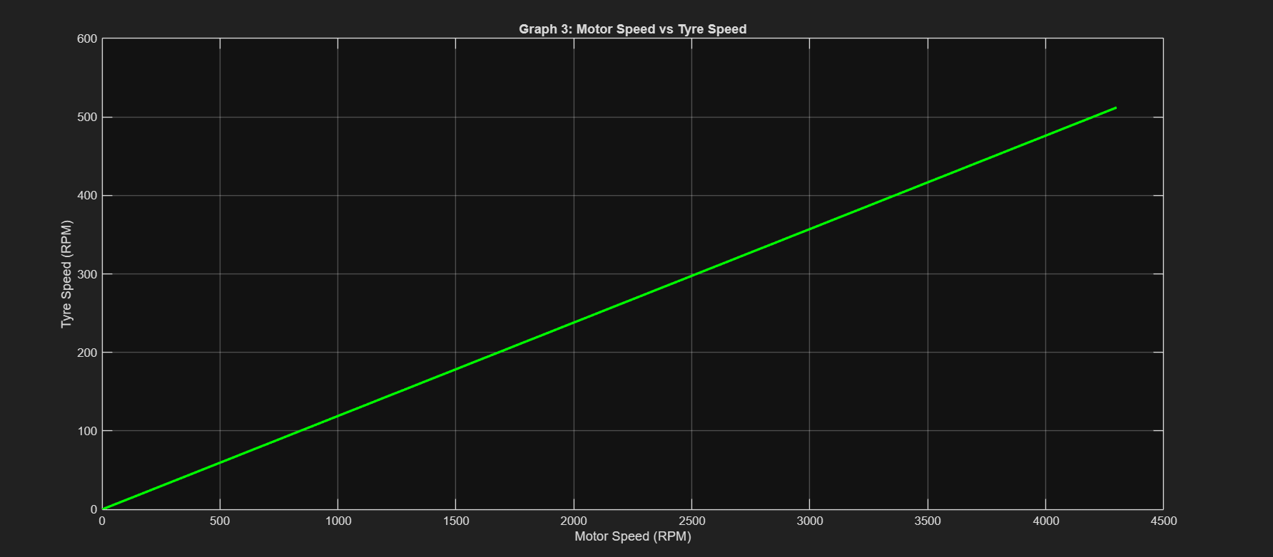

Graph 4: Motor Speed vs Vehicle Speed
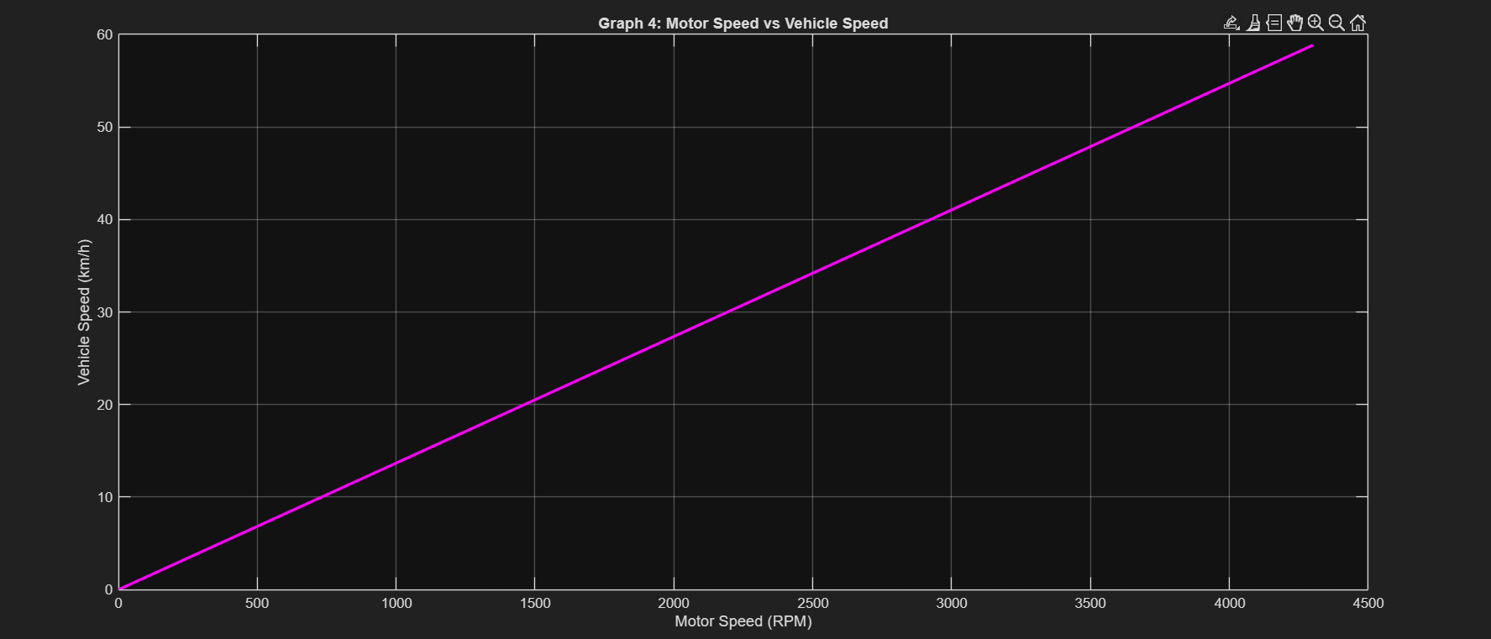
Graph 5: Tyre Torque vs Vehicle Speed
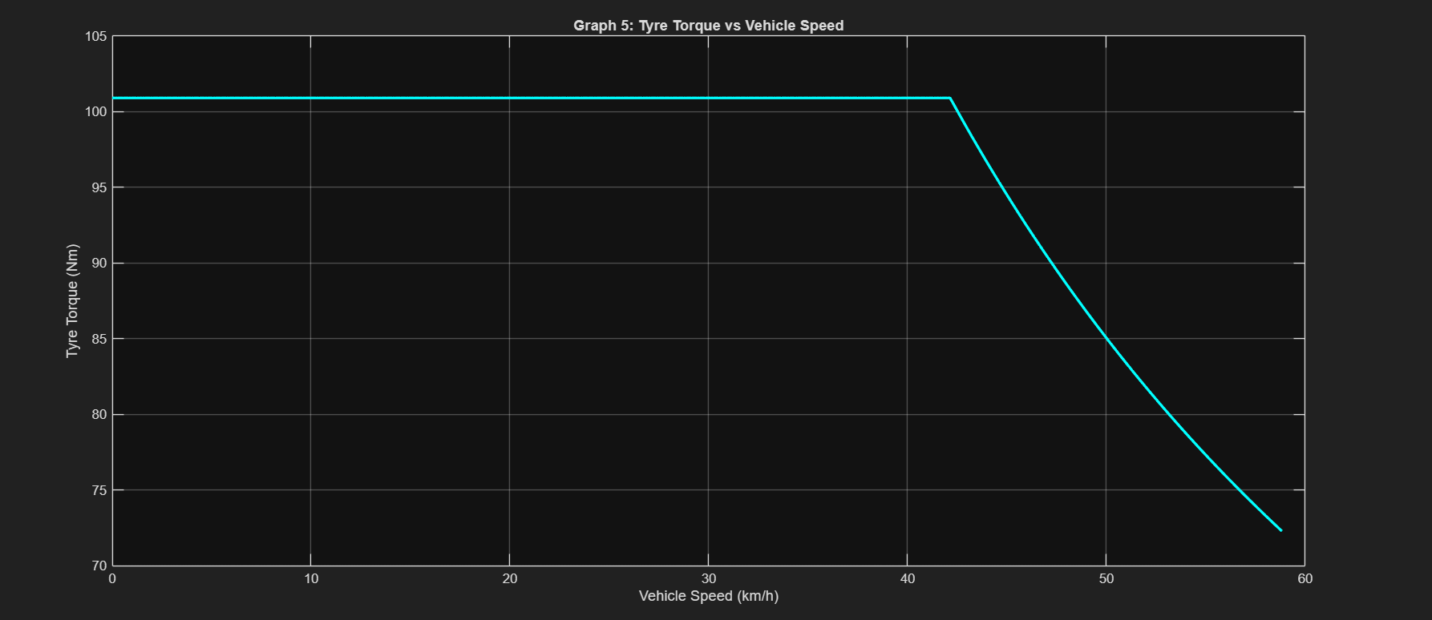
Graph 6: Motor Power vs Motor Speed
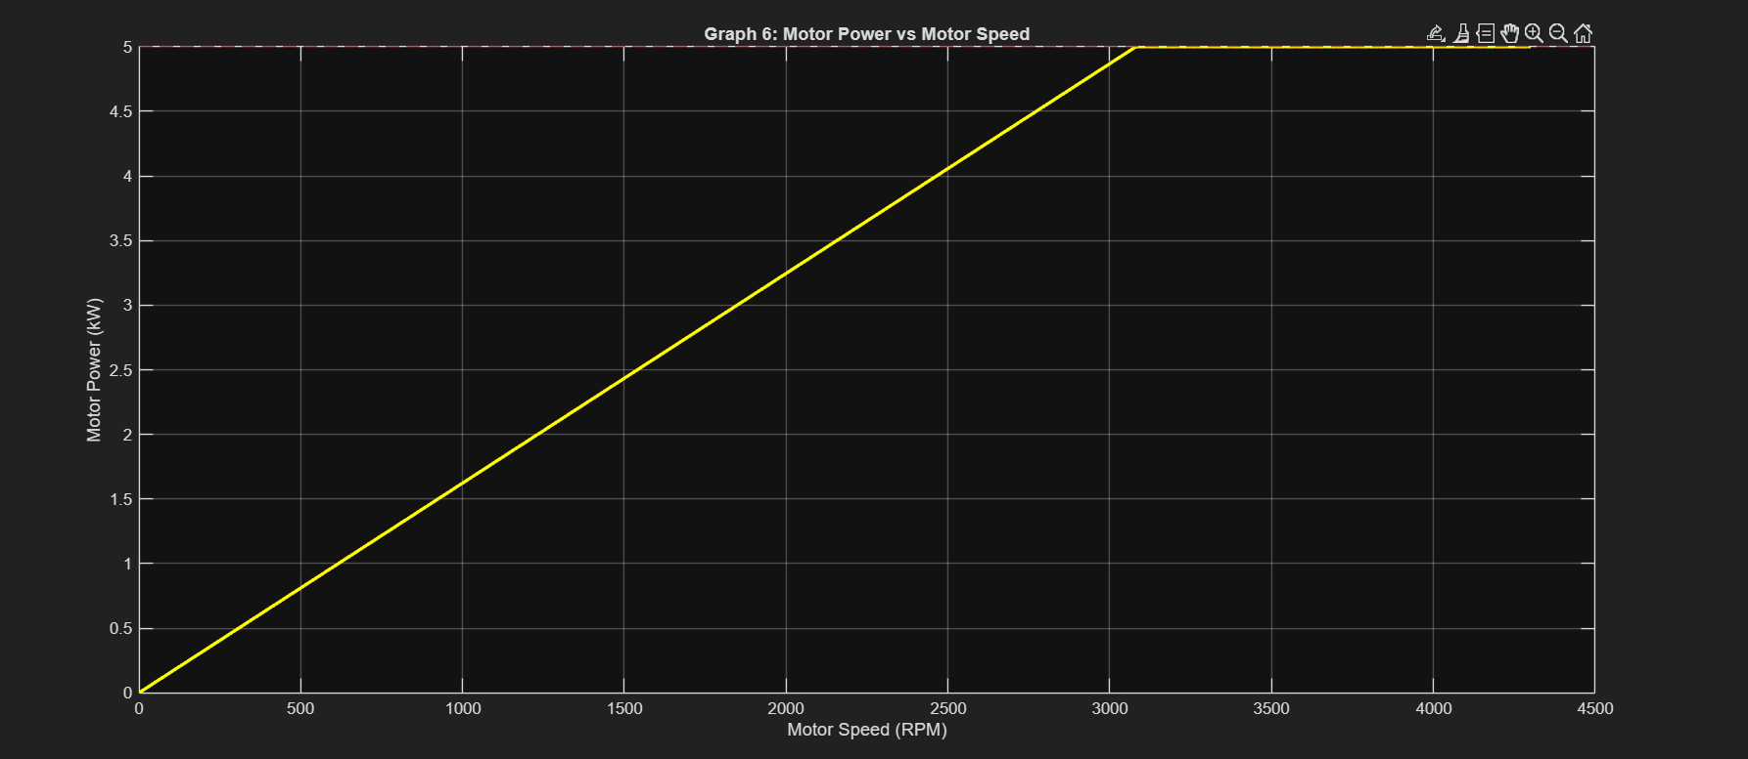
Graph 7: Tractive Force vs Vehicle Speed
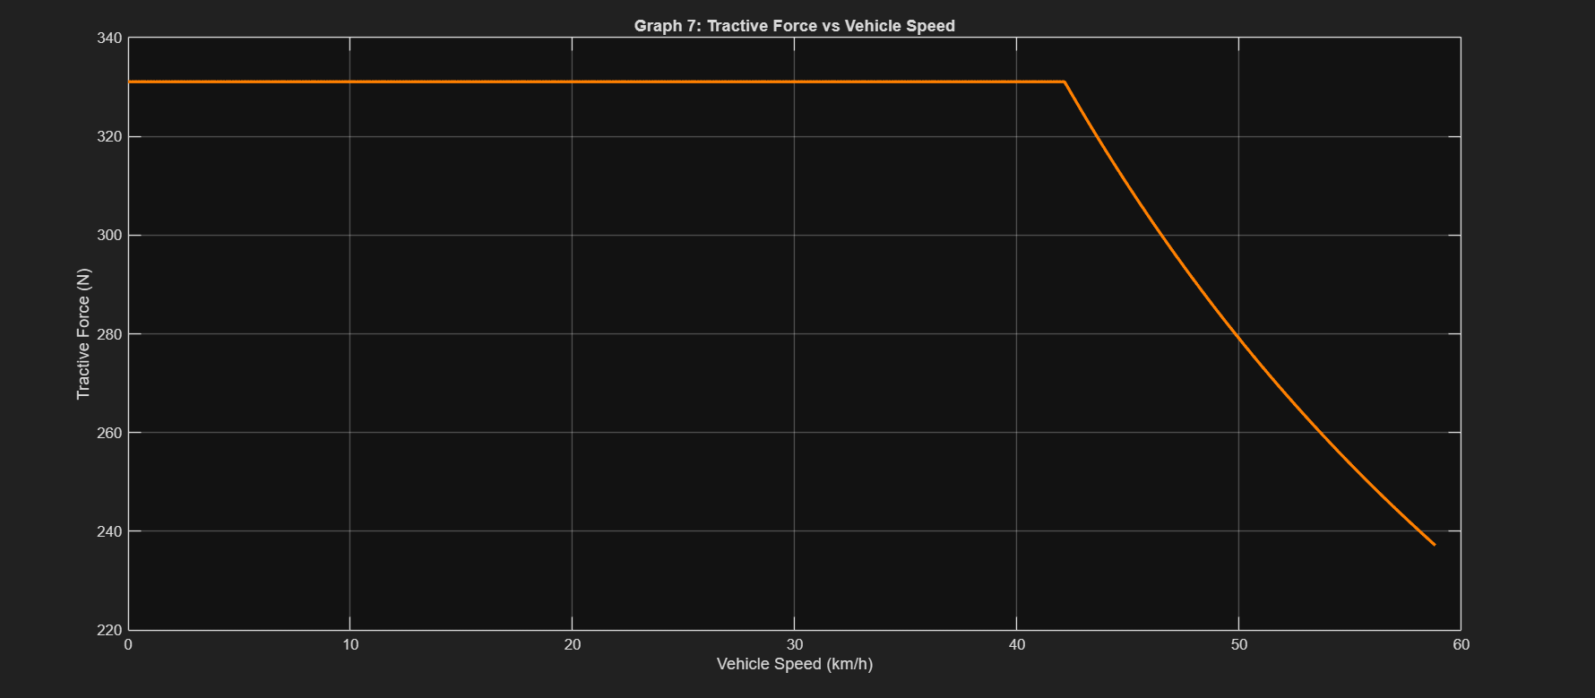

Graph 8: Motor Current vs Vehicle Speed
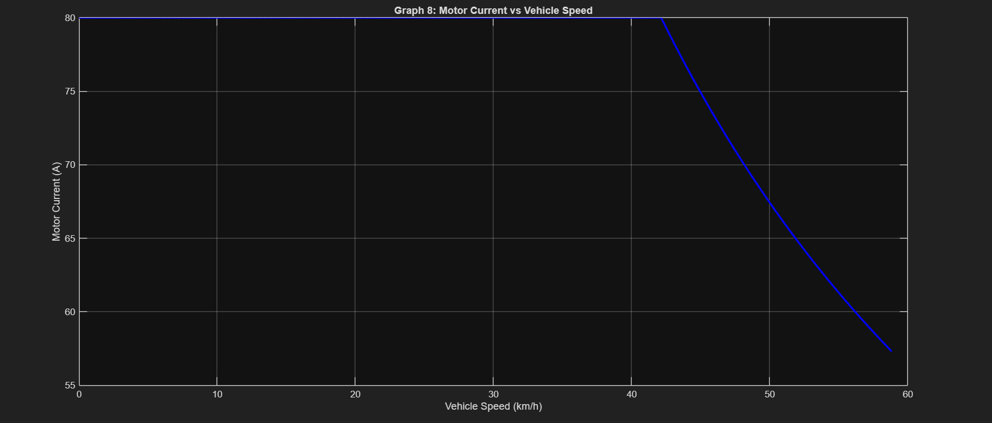

8. Additional Combined MATLAB Plots
The following combined plots may be included after the mandatory plots as supplementary visualization:

Combined Figure 1: Motor Speed, Tyre Speed and Vehicle Speed
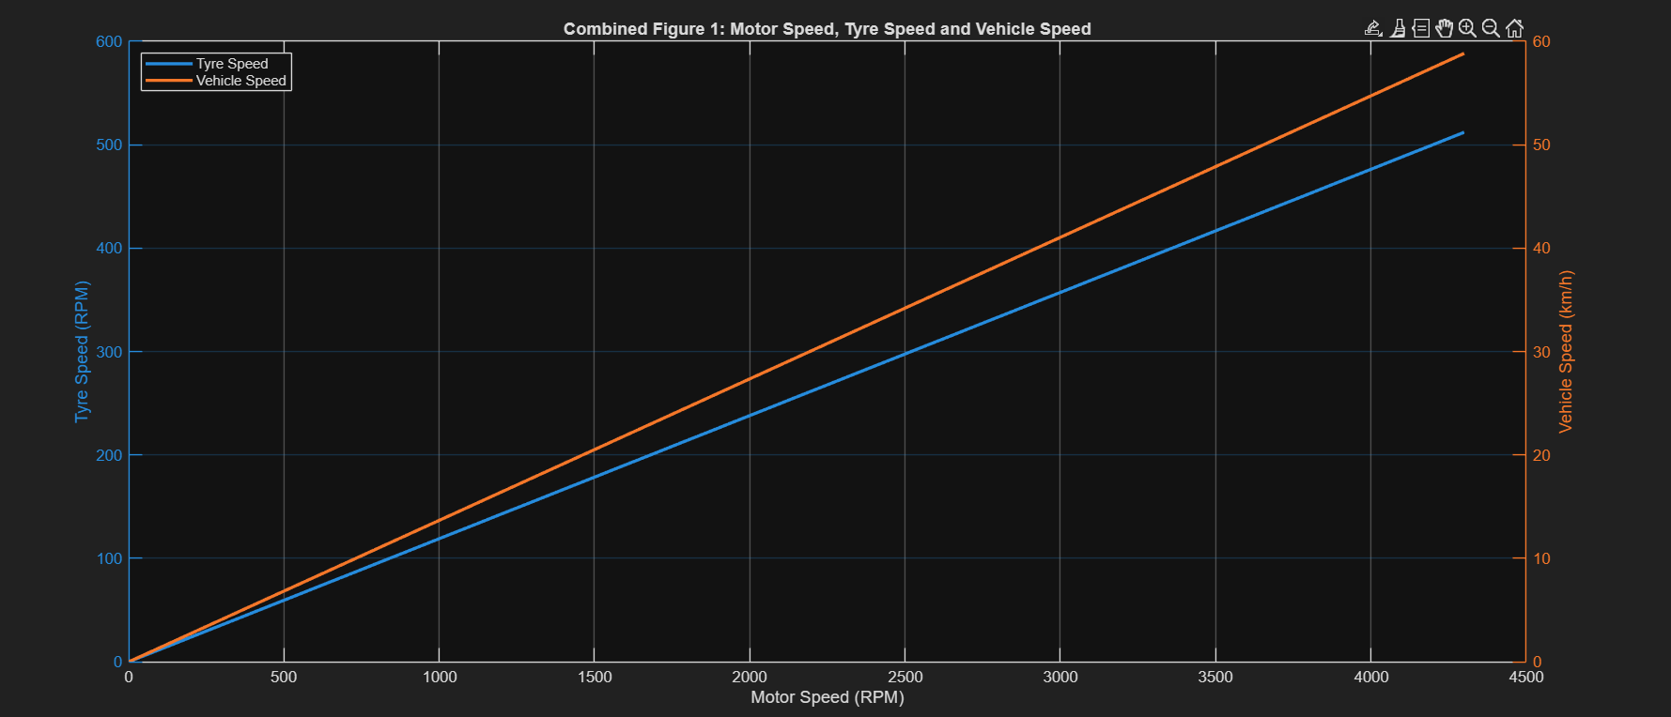

Combined Figure 2: Tyre Torque and Tractive Force
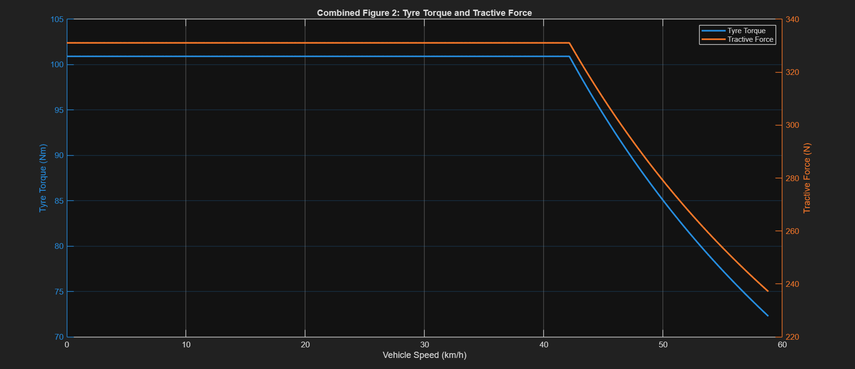

Combined Figure 3: Motor Current and Motor Power
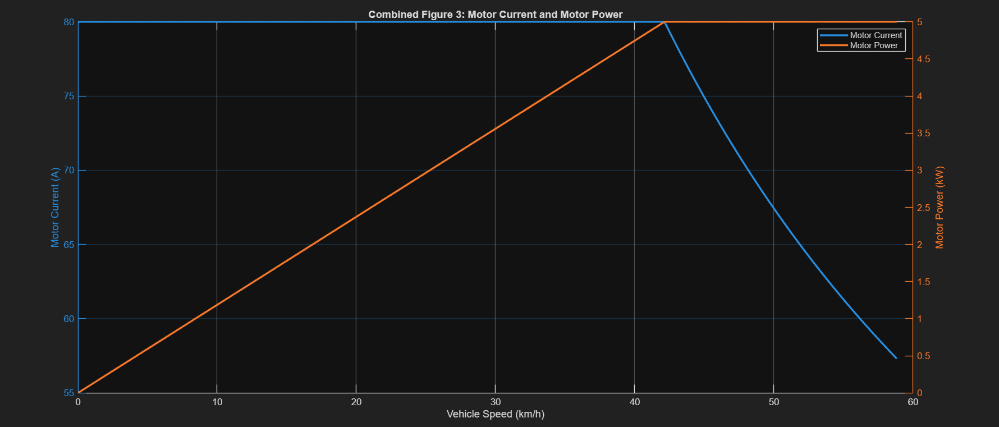

9. Final Deliverables Checklist
No. | Required deliverable | Status
1 | Complete powertrain input sheet with manufacturer references or clearly stated assumptions. | Included
2 | Hand calculations / analytical calculation sheet for chain, gearbox, shaft and tyre stages. | Included
3 | MATLAB code or Simulink model with editable parameters. | MATLAB model prepared separately
4 | All mandatory graphs with correct units, labels, legends and operating limits. | Plots to be pasted in Section 7
5 | Gear-ratio comparison table for at least three candidate configurations. | Omitted from this report per current analysis scope
6 | Traction-limit and power-consistency checks. | Included
7 | Final recommendation of chain + gearbox ratio with engineering justification. | Current drivetrain documented; formal ratio comparison omitted per scope
8 | One-page summary of maximum tyre torque, theoretical top speed and key operating constraints. | Included below

10. One-Page Summary
The analyzed eBAJA powertrain consists of a 5 kW rated electric traction motor driving a 15-tooth sprocket, a 14-tooth gearbox sprocket, a 9:1 gearbox, a direct 1:1 output shaft and the rear tyre/wheel. The chain ratio is 0.9333, giving a total drivetrain ratio of 8.4000:1.
The motor has a rated torque of 15.5 Nm, peak torque of 90 Nm, rated current of 80 A, maximum current of 180 A and maximum modeled speed of 4300 RPM. The overall mechanical efficiency is assumed to be 77.5%.
At peak motor torque, the calculated tyre torque is approximately 585.9 Nm. However, using a 55% driven-wheel load and μ = 0.7, the estimated traction-limited tyre torque is only 368.4 Nm. This indicates that the peak drivetrain torque can exceed the available tyre-road traction under the stated assumptions.
Using the 4300 RPM motor speed limit, the calculated maximum tyre speed is 511.9 RPM and the maximum theoretical vehicle speed is 58.82 km/h. This is a theoretical unloaded value; actual speed will depend on vehicle resistance, terrain, controller limits, battery condition, tyre slip and other losses.
For the continuous operating model, 5 kW is used as the main motor power limit. The torque-speed model holds 15.5 Nm up to approximately 3080 RPM (42.1 km/h), after which torque decreases approximately inversely with speed to maintain 5 kW. The 9 kW rating is therefore treated as peak/short-duration capability.
Overall, the modeled drivetrain provides substantial launch torque, but peak torque utilization is expected to be traction-limited under the selected assumptions. The calculated top speed should be treated as a theoretical upper bound rather than a guaranteed loaded vehicle speed.

11. Assumptions to Declare
Assumption | Value / statement
Chain efficiency | Included within 77.5% overall mechanical efficiency assumption.
Gearbox efficiency | Included within 77.5% overall mechanical efficiency assumption.
Output shaft efficiency | Included within 77.5% overall mechanical efficiency assumption; shaft ratio = 1:1.
Tyre rolling radius | 0.3048 m, based on 24-inch tyre diameter.
Coefficient of friction | μ = 0.7, engineering assumption.
Driven-wheel normal load | 55% of total vehicle weight, engineering assumption.
Motor torque-current model | Kt derived from rated point; two-segment approximation used to reach peak torque.
Motor/controller power limit | 5 kW continuous/rated basis; 9 kW treated as peak capability.
Other losses | Not explicitly modeled beyond the combined mechanical efficiency.

12. Conclusion
The MATLAB-based analytical model gives a peak calculated tyre torque of 585.90 Nm and a theoretical maximum vehicle speed of 58.82 km/h for the specified 15T/14T chain drive and 9:1 gearbox. The traction check gives a tyre torque limit of 368.38 Nm under the stated μ and driven-load assumptions, so peak drivetrain torque is above the available traction limit. The continuous performance model is based on the 5 kW rated motor power, while the 9 kW rating is treated as a short-duration peak capability.

