Please delete all the italic text before submission. It is here just for your reference.

Further: data set – DS, research question – RQ

The mark (x words) after each subchapter states the word count limit. This indicates the expected amount of information which you can exceed by 10% without losing the mark.

7COM1079-0901-2025 - Team Research and Development Project

Final report title: (the topic of your research.)

Group ID:

Dataset number:

Prepared by: Sayed Bin Harun 24131097
Mahmood Parvez 24153575
Abir Al Mahmud 24154288
Atik Shahariar Patwary-24000204

University of Hertfordshire
Hatfield, 2025

Table of Contents add page numbers from here

- Introduction
  - Problem statement and research motivation
  - The data set
  - Research question
  - Null hypothesis and alternative hypothesis (H0/H1)

- Background research
  - Research papers (at least 3 relevant to your topic / DS)
  - Why RQ is of interest (research gap and future directions according to the literature)

- Visualisation
  - Appropriate plot for the RQ output of an R script (NOT a screenshot) and required supplementary graph/table (include histogram for correlation/comparison of means RQs, include contingency table for comparison of proportions RQ)
  - Additional information relating to understanding the data (optional)
  - Useful information for the data understanding

- Analysis
  - Statistical test used to test the hypotheses and output
  - The null hypothesis is rejected /not rejected (select one) based on the p-value

- Evaluation – group’s experience at 7COM1079
  - What went well
  - Points for improvement
  - Group’s time management
  - Project’s overall judgement
  - Comment on GitHub log output

- Conclusions
  - Results explained.
  - Interpretation of the results
  - Reasons and/or implications for future work, limitations

- Reference list
Harvard (author, date) format.
- Appendices
- R code used for analysis and visualisation.
- GitHub log output.

1. Introduction

  - Problem statement and research motivation (100 words)

The trends of COVID-19 positivity are important to understand the impact of the responses to the problem on the health of the population and anticipate the dynamics of the outbreaks. In Ohio, there are daily testing statistics of confirmatory and presumptive laboratories, which reveal information about the level of infections and the accuracy of the tests. The research question is whether there is a statistically significant difference in the incidence of positive COVID-19 outcomes over time in terms of combined lab positivity rates. Previous studies indicate that positivity rates are delicate indicators of the effectiveness of the transmission and testing strategies in the community (CDC, 2022). With the help of this dataset, we will evaluate the temporal patterns and use this information to make future plans on how to respond to the pandemic.
Referral: CDC (2022) COVID-19 Testing Overview.

  - The data set (75 words)
DS101 is a dataset of the number of daily COVID-19 tests in Ohio, both confirmatory and presumptive. The most important variables would be the total tests, total positives, and percent positives per type of lab, combined variables, and 7-day averages. The independent variable is the nominal variable, "Date" and the dependent variable is the measurement variable, Confirmatory and Presumptive Lab Percent Positive (Daily). This dataset allows studying the trends in positivity and comparing the results of the testing over time and types of labs.

  - Research question (50 words). State your RQ (50 words)
Do the mean incidence of positive outcomes of COVID-19 in Ohio change between the time period between December 21 and April 22, 2022, regarding combined confirmatory and presumptive lab percent positive rates? This question examines how the positivity trends vary over time using daily testing information.

  - Null hypothesis and alternative hypothesis (H0/H1) (100 words)
Null Hypothesis (H0): The means of the percent positive COVID-19 results are not different between the observed dates in Ohio; the daily changes are because of random fluctuation and do not reflect a significant change.
Alternative Hypothesis (H1): The means of percent positive COVID-19 results on the observed dates in Ohio differ significantly; the time effects indicate real changes in the rates of infection or the testing population, which depend on the capacity of the testing, accuracy of reporting, and the trends of community transmission.
Statistical tests to be used in testing these hypotheses will involve ANOVA or t-tests, depending on the distribution of the data and the grouping.

2. Background Research
2.1 Research Papers (200 words)
1. Kline et al. (2021) estimated the prevalence of COVID-19 antibody in Ohio in July 2020. In Bayesian model of low response rates and inaccurate testing, they estimated that the level of infection among adults was more than official reports but nowhere near herd immunity at 1.3%.
Why this matters to us: This illustrates real infections that are usually greater than those reported which support the importance of keeping a close eye on the daily testing trends.
2. Ganesh et al. (2022) followed COVID-19 in an Ohio school district between January and May 2021. Community positivity was less than 20 but schools remained under 2.5% with regular safety measures.
Why this matters to us: This emphasizes the variability of infection patterns over the place and time, which provides us with interest in temporal trends in positivity.
3. Turner et al. (2021) surveyed Ohio in July 2020. They found that infections were approximately 3.5 times more than those diagnosed pointing to underreporting within the initial stages of the pandemic.
Why this matters to us: This supports the fact that statistical analysis of daily changes in positivity over the course of time is necessary in the testing surveillance in Ohio.

2.2 Why RQ is of Interest (100 words)
Current Ohio only estimates prevalence at intervals, but none statistically assesses whether a combination of daily lab positivity is significantly different over extended intervals. This lapse restricts the understanding of the daily dynamics of the pandemic. We fill this gap by using statistical tests to determine whether there was any difference in average positivity between December 2021 and April 2022. To Know the transmission pattern, we are going to analyze some static estimates. Our study fills this methodological deficiency and enables government health experts to understand more about frequent testing results to monitor epidemics and make prompt decisions.
References for the Research Papers:
1. Estimating seroprevalence of SARS-CoV-2 in Ohio: A Bayesian multilevel poststratification approach with multiple diagnostic tests
Kline, D., Li, Z., Chu, Y., Clark, S.J. et al. (2021) ‘Estimating seroprevalence of SARS-CoV-2 in Ohio: A Bayesian multilevel poststratification approach with multiple diagnostic tests’, Proceedings of the National Academy of Sciences (PNAS), 118(21). Available at: https://www.pnas.org/doi/epdf/10.1073/pnas.2023947118 (Accessed: 25 June 2021).

2. Back to the Basics: A COVID-19 Surveillance Program Within a Local School District
Ganesh, P.R., May, R., Dandurand, M., Graham, J., Rose, J., Gullett, H., Covell, D. and Stange, K.C. (2022) ‘Back to the Basics: A COVID-19 Surveillance Program Within a Local School District’, Journal of School Health, 92(12), pp. 1170–1178. Available at: https://onlinelibrary.wiley.com/doi/epdf/10.1111/josh.13149 (Accessed: 23 February 2022).

3. Prevalence of current and past COVID-19 in Ohio adults
Turner, A.N., Kline, D., Norris, A., Phillips, W.G., Root, E., Wakefield, J., Li, Z., Lemeshow, S., Spahnie, M., Luff, A., Chu, Y., Francis, M.K., Gallo, M., Chakraborty, P., Lindstrom, M., Lozanski, G., Miller, W. and Clark, S. (2022) ‘Prevalence of current and past COVID-19 in Ohio adults’, Journal of Medical Virology. Available at: https://pmc.ncbi.nlm.nih.gov/articles/PMC9759827 (Accessed: 16 December 2021).

- Visualisation
  - Appropriate graphs for the RQ output of an R script (NOT a screenshot) (50 words)

Choice of the plot

The research question focuses on whether the mean daily COVID-19 positivity rate differs across years. A boxplot is the most appropriate choice because it effectively compares the distribution of a continuous variable (percent positive) across categorical groups (years). It highlights central tendency, spread, and outliers, which are essential for assessing differences in mean positivity between 2020, 2021, and 2022.

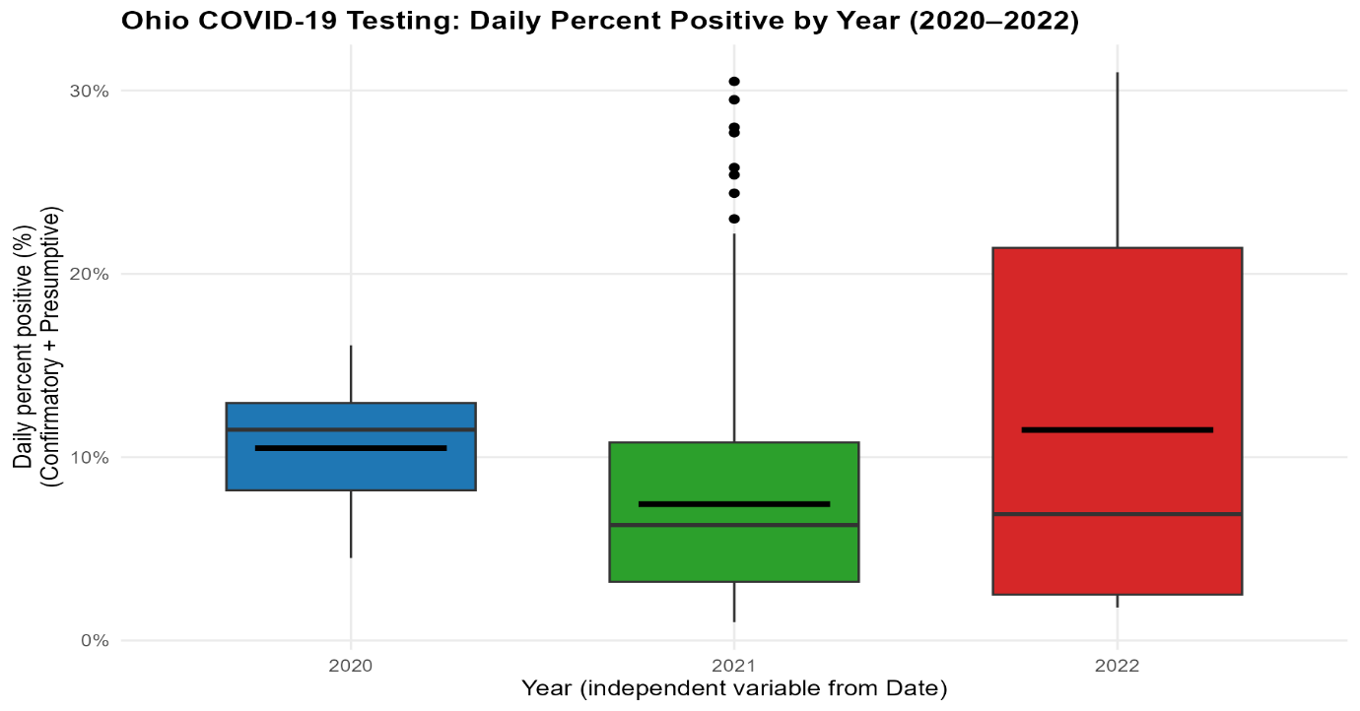
Main plot relevant to the RQ

The boxplot of Daily Percent Positive by Year clearly shows variation across the three years. The median positivity in 2022 is noticeably higher than in 2020 and 2021, with a wider interquartile range and several extreme values. In contrast, 2021 exhibits the lowest median and a relatively compact distribution, while 2020 falls in between. These patterns suggest potential differences in mean positivity rates, aligning with the research question.

Supplementary plot (Histogram)

The histogram of Daily Percent Positive (Combined) reveals a right-skewed distribution, with most daily positivity rates concentrated below 15%. A long tail extends toward higher values, indicating occasional spikes in positivity. The overlayed normal curve shows deviation from normality, suggesting that the data may not perfectly meet parametric assumptions. This insight is useful for deciding whether transformations or non-parametric tests might be necessary.

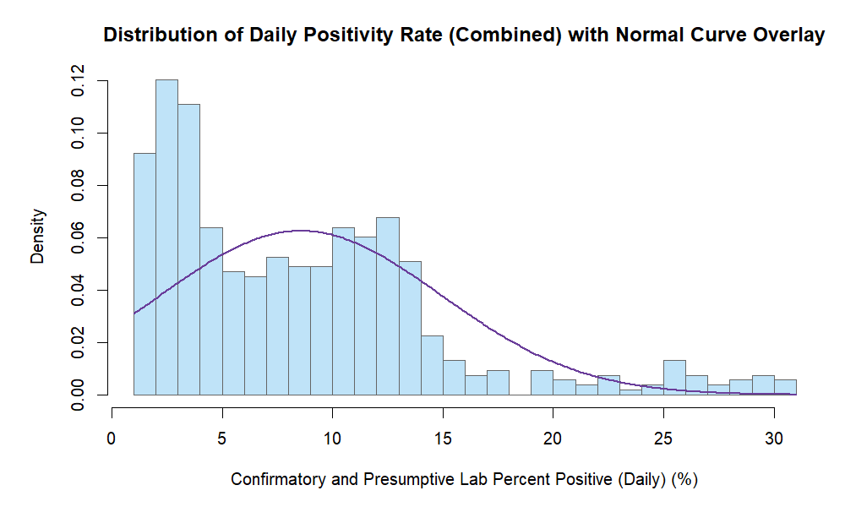

  - Useful information for the data understanding (50 words)

The boxplot indicates substantial variability in positivity rates across years, with 2022 showing the highest spread and median. The histogram confirms that most observations cluster at lower positivity levels, with a few extreme peaks. Together, these plots highlight temporal differences and distributional skewness, informing both hypothesis testing and interpretation.

- Explain the choice of the plot.
- Include your main plot relevant to the RQ type.
- Include histogram or contingency table (think what is suitable) in addition to the main plot.
- Anything on the plot from R is not counted towards word count limit (e.g. legend, axes titles, name).
- Make sure that the plot is from output of an R script (NOT a screenshot).
- Make sure that the plot has a caption or title, X and Y-axis labels with units where appropriate, and legend.
- Make sure the title or caption and axis labels are informative and written in English.

  - Additional information relating to understanding the data (optional) (50 words)
- Per plot: explain the purpose and insights.

  - Useful information for the data understanding (50 words)
- Summarise key observations from the plot.

- Analysis
  - Statistical test used to test the hypotheses and output (75 words)
- Explain the choice of the statistical test.
- Make sure the test is appropriate for the RQ and data.

  - The null hypothesis is rejected /not rejected based on the p-value (100 words) (interpret the results)

- Evaluation – group’s experience at 7COM1079
  - What went well (75 words)
Our team collaborated effectively by splitting duties based on personal strengths. Data cleaning, statistical analysis, and visualization were executed seamlessly, while GitHub used to file and code sharing. Regular discussions and weekly practical lab sessions allowed us to maintain progress and resolve challenges efficiently. The data was well-organized, and RStudio supported the replicable plots and statistical results. Overall, the collaborative environment fostered a free exchange of ideas, leading to a clear research question and a well-managed final report.

  - Points for improvement (75 words)
The initial planning stage required improvement. Our first research question was unclear until the instructor helped us refine it. We also struggled with R and GitHub early on, which caused delays. For future projects, we will focus more on background research, adaptation of Rstudio & github beforehand. Establishing stricter internal deadlines will improve time management, ensuring efficient work without last-minute pressure.

  - Group’s time management (50 words)
We organized our time well as a group by identifying clear milestones that were in line with the report template. Early priorities were given to the data cleaning and visualization, and later the statistical analysis and interpretation were given importance. Frequent updates of progress helped to keep tasks on schedule. Minor delays were experienced during the debugging of the R code, and deadlines were generally met.

  - Project’s overall judgement (50 words)
The project successfully met its objectives, delivering a clear analysis of COVID-19 positivity trends in Ohio using appropriate statistical methods. Visualizations and R-based outputs were accurate and informative. Despite minor delays in background research and debugging, the final report adhered to requirements and demonstrated strong teamwork and methodological rigor.

  - Note any changes to group since original allocation if applicable. Add new or amended GitHub Ids for new members (75 words, write only if applies to your group arrangements)
  - Comment on the GitHub log output (50 words)
The GitHub Commits are developed with the evolution of visualization to analysis. Such updates made version control and collaborative transparency Every Commit enhanced the quality and reproducibility of reports written using transparent R code and visualisation with important features.
Significant Commits:
- Commit Message: Implemented Boxplot for Visualization
Impact: Added a core visual comparing yearly positivity rate, supporting hypothesis testing and enhancing interpretability.
- Commit Message: Implemented Histogram for visualisation
Impact: Provided distribution insights, revealing skewness and guiding the choice of non-parametric statistical methods.
- Commit Message: Implemented the analysis
Impact: Integrated Kruskal–Wallis test and interpretation, completing the analytical framework and enabling evidence-based conclusions.

- Conclusions
  - Results explained (75 words)
The Kruskal-Wallis test indicated a very significant difference in the percentage positivity of COVID-19 daily in the years 2020, 2021, and 2022 (H = 37.333, p = 0.001). Boxplots showed the lowest median positivity in the year 2021, and the highest median and variability in 2022. The non-parametric approach was supported by the histograms that revealed a right-skewed distribution. These results show that the positivity rates differed significantly across the years representing the pandemic waves, testing strategies, and seasonal dynamics across years of data collection.

  - Interpretation of the results (75 words)
The significant difference in positivity rates across years indicates that COVID-19 trends were influenced by evolving public health measures, vaccination rollout, and pandemic waves. Lower median rates in 2021 suggest improved control, while higher variability in 2022 reflects early-year surges. These results confirm the hypothesis that positivity rates were not equal across years. However, interpretation must consider partial-year data for 2020 and 2022, limiting generalization and emphasizing the need for cautious conclusions and further research.

  - Reasons and/or implications for future work, limitations of your study (50 words)
This study is limited by partial-year data for 2020 and 2022, which may not fully represent annual trends. Future research could incorporate complete yearly data, vaccination rates, and policy changes. Expanding the dataset to other states or applying time-series models would provide deeper insights into positivity patterns and pandemic dynamics.

- Reference list (not included in the word count)
Harvard (author, date) format.

- Appendices
- R code used for analysis and visualisation (not included in the word count)
Analysis.R code with the appropriate statistics to test the hypotheses.
- No word count, but ensure the code is without redundant lines, well-commented and produces the correct output.
- Make sure it runs (look in Rscript.log for output from a statistical test)
- It should compute appropriate statistics to test the hypotheses
- GitHub log output.

