7COM1079-0901-2025 - Team Research and Development Project

Final report title: Differences in Mean Incidence of Positive COVID-19 Outcomes in Ohio from 2020 to 2022

Group ID: Group A-80

Dataset number: ds101

Prepared by: Sayed Bin Harun (Student ID - 24131097)
Atik Shahariar Patwary (Student ID - 24000204)
Mahmood Parvez (Student ID - 24153575)
Abir Al Mahmud (Student ID - 24154288)
Md Tanvir Ahmed (Student ID - 24160757)

University of Hertfordshire
Hatfield, 2025

Table of Contents

- Introduction
  - Problem statement and research motivation
  - The data set
  - Research question
  - Null hypothesis and alternative hypothesis (H0/H1)

- Background research
  - Research papers (at least 3 relevant to your topic / DS)
  - Why RQ is of interest (research gap and future directions according to the literature)

- Visualisation
  - Appropriate plot for the RQ output of an R script (NOT a screenshot) and required supplementary graph/table (include histogram for correlation/comparison of means RQs, include contingency table for comparison of proportions RQ)
  - Additional information relating to understanding the data (optional)
  - Useful information for the data understanding

- Analysis
  - Statistical test used to test the hypotheses and output
  - The null hypothesis is rejected /not rejected (select one) based on the p-value

- Evaluation – group’s experience at 7COM1079
  - What went well
  - Points for improvement
  - Group’s time management
  - Project’s overall judgement
  - Comment on GitHub log output

- Conclusions
  - Results explained.
  - Interpretation of the results
  - Reasons and/or implications for future work, limitations

- Reference list
Harvard (author, date) format.
- Appendices
- R code used for analysis and visualisation.
- GitHub log output.

1. Introduction

  - Problem statement and research motivation

Analysing positivity trends during COVID-19 is essential for evaluating transmission processes and providing an effective response to the population. Positivity rates are one of the main indicators of the severity of the outbreak and testing capacity (CDC, 2022). Although there are national-level studies, few studies take a closer look at changes at the state level. This paper addresses this gap by comparing daily testing data in Ohio from 2020-2022. We want to understand whether the alterations in the levels of positivity were actual or only by chance. These findings can help to create better health policies and prepare for future pandemics.

  - The data set

The dataset includes the daily COVID-19 test data of Ohio in 2020-2022 (confirmatory and presumptive laboratory test outcomes). Main variables are total tests, total positives and combined percent positivity rates besides 7-day averages. Date is the independent variable and Confirmatory and Presumptive Lab Percent Positive (Daily) is the dependent variable. Such an extensive dataset can be analysed to determine the temporal pattern of positivity rates, and statistics can be done to determine the difference between the years of pandemic.

  - Research question

“Is there a difference in the mean incidence of positive COVID-19 outcomes in Ohio during the period from 2020 to 2022?” This study examines whether combined confirmatory and presumptive laboratory percent positive rates vary significantly across these years

  - Null hypothesis and alternative hypothesis (H0/H1)

H0: There is no difference in the mean positivity rate among the years from 2020 to 2022 in Ohio. This assumes that any observed variation in positivity rates across years is due to random chance rather than actual temporal changes.

H1: There is a difference in the mean positivity rate among the years from 2020 to 2022 in Ohio. This suggests that changes in positivity rates reflect real differences in infection dynamics or testing strategies over time, indicating significant temporal effects rather than random fluctuations.

- Background research
  - Research papers

1.Kline et al. (2021) estimated the prevalence of COVID-19 antibody in Ohio in July 2020. In Bayesian model of low response rates and inaccurate testing, they estimated that the level of infection among adults was more than official reports but nowhere near herd immunity at 1.3%.

Why this matters to us: This illustrates real infections that are usually greater than those reported which support the importance of keeping a close eye on the daily testing trends.

2.Ganesh et al. (2022) followed COVID-19 in an Ohio school district between January and May 2021. Community positivity was less than 20 but schools remained under 2.5% with regular safety measures.

Why this matters to us: This emphasizes the variability of infection patterns over the place and time, which provides us with interest in temporal trends in positivity.

3.Turner et al. (2021) surveyed Ohio in July 2020. They found that infections were approximately 3.5 times more than those diagnosed pointing to underreporting within the initial stages of the pandemic.

Why this matters to us: This supports the fact that statistical analysis of daily changes in positivity over the course of time is necessary in the testing surveillance in Ohio.

  - Why RQ is of interest (research gap and future directions according to the literature)

Current Ohio only estimates prevalence at intervals, but none statistically assesses whether a combination of daily lab positivity is significantly different over extended intervals. This lapse restricts the understanding of the daily dynamics of the pandemic. We fill this gap by using statistical tests to determine whether there was any difference in average positivity between December 2021 and April 2022. To Know the transmission pattern, we are going to analyse some static estimates. Our study fills this methodological deficiency and enables government health experts to understand more about frequent testing results to monitor epidemics and make prompt decisions.

- Visualisation

  - Appropriate graphs for the RQ

The best type of plot for the research question would be a boxplot since it is used to compare the distribution of positivity across years. It emphasizes median, variability and outliers, which are necessary to evaluate the difference in positivity trend. Additionally, the histogram shows the overall distribution of positivity, indicating skewness and justifying the non-parametric test.

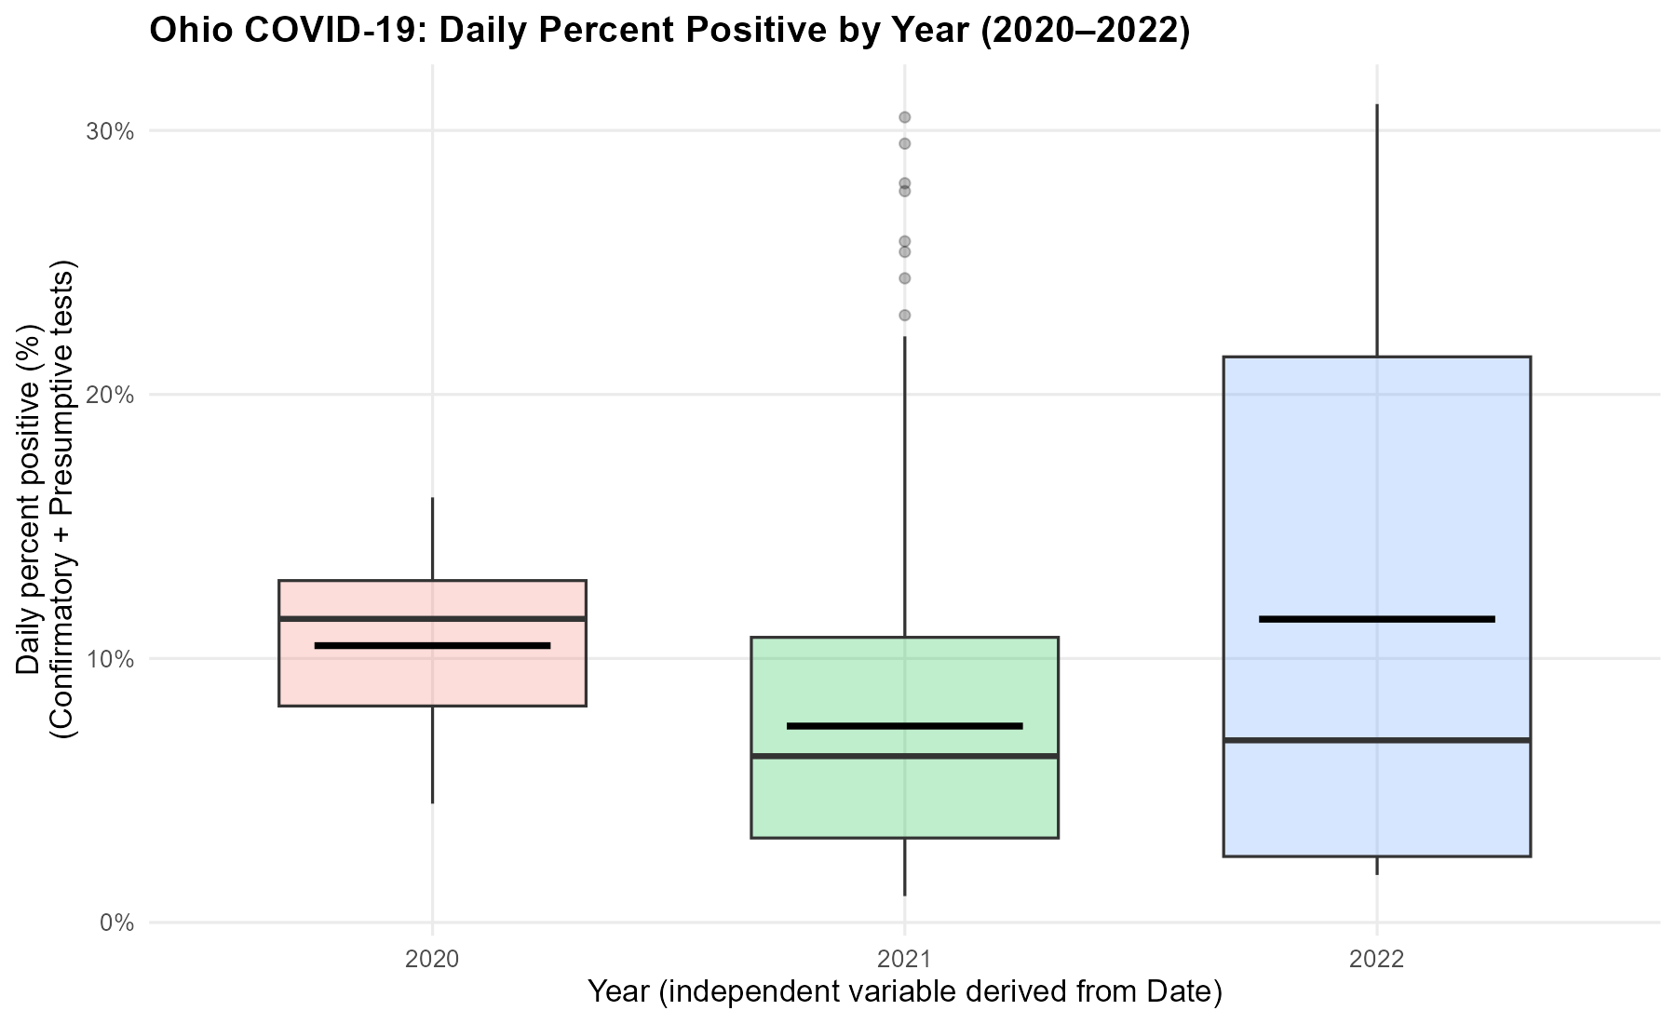
Figure 1: Boxplot of daily positivity by year (2020–2022)

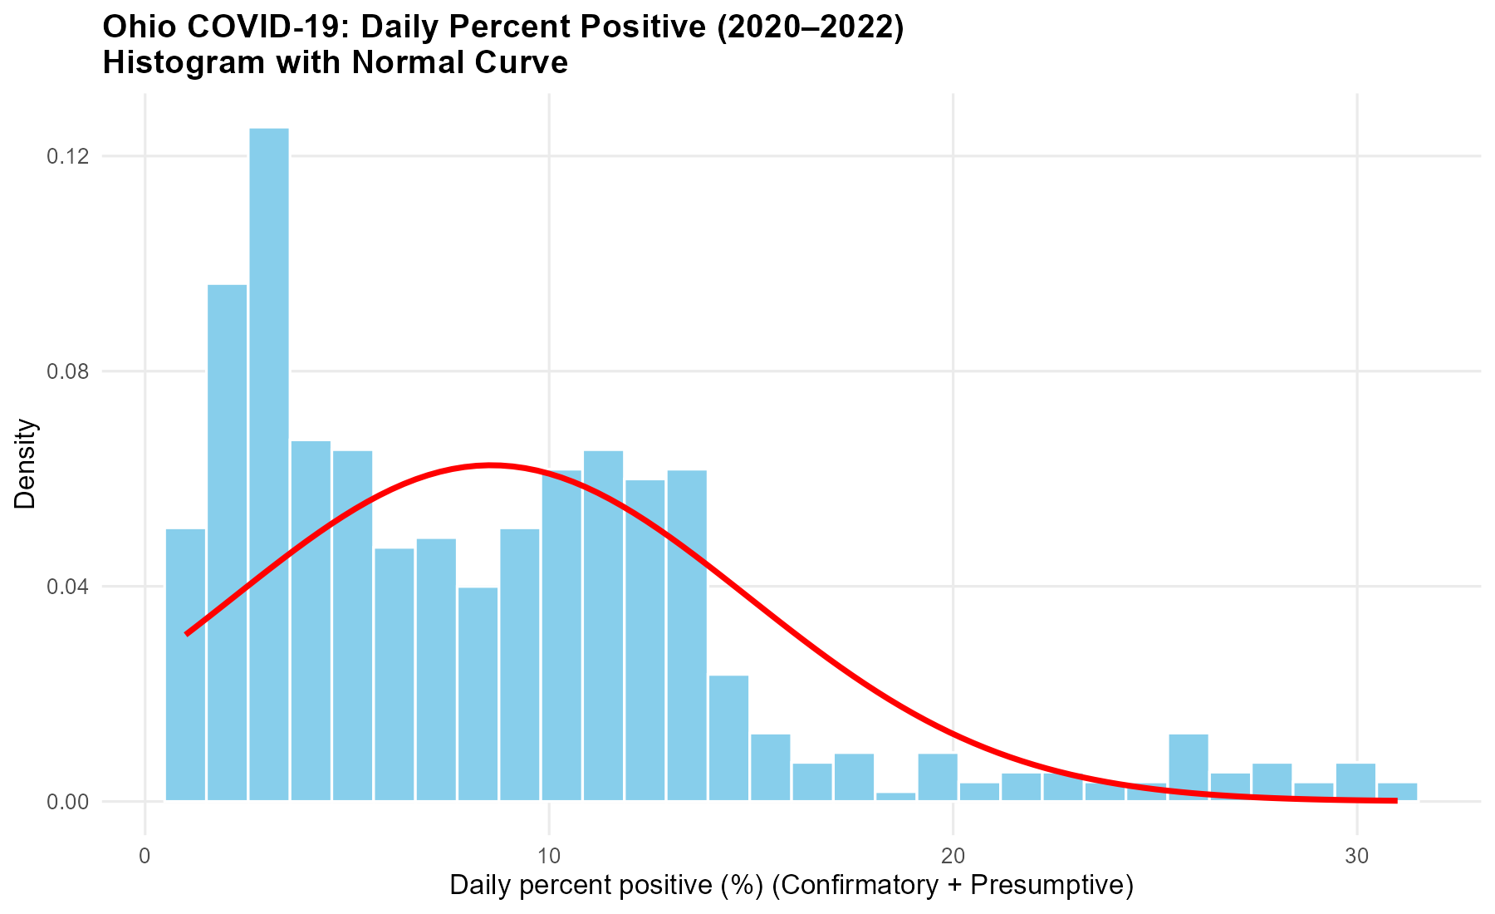
Figure 2: Histogram of daily positivity (2020–2022) showing skewed distribution.

  - Additional information relating to understanding the data (optional)

The boxplot shows the difference between years, with 2022 having the biggest spread and median positivity. This means that there was a rise or shift in testing. The histogram shows a right-skewed distribution, which means that most daily positivity rates were modest, although there were some fluctuations. All these insights affirm temporal differences and can be used to select an appropriate statistical test.

  - Useful information for the data understanding

The boxplot is used to demonstrate that there is a great variability across years, whereas the histogram validates skewness and outliers. These plots collectively point at differences in the time and distributions, which are used to test and interpret hypothesis.

- Analysis

  - Statistical test used to test the hypotheses and output

To find out whether the mean positivity rate was different in all the years from 2020 to 2022, we used the Kruskal Wallis rank sum test. This non-parametric approach was selected because the histogram revealed a right skewed distribution and the boxplot revealed unequal disperses of groups, which is non-conformity to ANOVA assumptions. Kruskal-Wallis is used to compare rank distributions of more than two groups without any normality.

R Code : kruskal.test(Percent ~ Year, data = df_dep)
Output:
Kruskal–Wallis chi-squared = 37.333, df = 2, p-value = 7.819e-09, indicating a
highly significant difference among the three years.

  - The null hypothesis is rejected /not rejected based on the p-value (interpret the results)

H₀: There is no difference in the mean positivity rate among 2020–2022.
H₁: There is a difference in the mean positivity rate among 2020–2022.

The Kruskal–Wallis test returned H = 37.333, df = 2, p = 7.819e-09, which is far below the 0.05 threshold for statistical significance. Hence, we do not accept H₀ and say that the difference in the daily percent positive in the three years is significant. This observation is in line with the boxplot where the median in 2021 is lower than 2020 and 2022.Interpretation should consider partial coverage and that positivity rates can vary with testing strategies and pandemic waves. The result supports that positivity rates were not equal across years.

- Evaluation – group’s experience at 7COM1079

  - What went well.

Our team collaborated by dividing duties based on personal strengths. There was an easy use of GitHub in sharing files and codes, and data cleaning, statistical analysis, and visualization were easily performed. Regular discussions and weekly practical laboratory sessions helped us to maintain our progress. The data were in a good order, and the reproducible plots and statistical results were supported by RStudio. Overall, the team-based environment promoted the free flow of ideas, leading to an accurate research topic and a properly structured final report.

  - Points for improvement.

The initial planning stage required improvement. Our instructor helped us to change the research question as its seemed confusing. GitHub and R were also problematic at the beginning and caused delays. For our future projects we take background research and adaptation with RStudio and GitHub as our primary focus. Tighter internal deadlines will improve time management and ensure that work is productive and not rushed.

  - Group’s time management.

We organized our time well as a group by identifying clear milestones that were in line with the report template. Early priorities were given to the data cleaning and visualization, and later the statistical analysis and interpretation were given importance. Frequent updates of progress helped to keep tasks on schedule. Minor delays were experienced during the debugging of the R code, and deadlines were generally met.

  - Project’s overall judgement.

Using appropriate statistical methods that gave a clear study of COVID-19 patterns of positivity in Ohio, the project was able to meet its objectives. The R-based findings and graphs were accurate and informative. The end report met the requirements and demonstrated outstanding cooperation and methodological rigor despite certain slight delays in background research and debug.

  - Comment on the GitHub log output

The GitHub Commits are developed with the evolution of visualization to analysis. Such updates made version control and collaborative transparency Every Commit enhanced the quality and reproducibility of reports written using transparent R code and visualisation with important features.

Significant Commits:
Commit Message: Implemented Boxplot for Visualization
Impact: Added a core visual comparing yearly positivity rate, supporting hypothesis testing and enhancing interpretability.
Commit Message: Implemented Histogram for visualisation
Impact: Provided distribution insights, revealing skewness and guiding the choice of non-parametric statistical methods.
Commit Message: Implemented the analysis
Impact: Integrated Kruskal–Walli’s test and interpretation, completing the analytical framework and enabling evidence-based conclusions.

- Conclusions

  - Results explained

The Kruskal-Wallis test indicated a very significant difference in the percentage positivity of COVID-19 daily in the years 2020, 2021, and 2022 (H = 37.333, p = 0.001). Boxplots showed the lowest median positivity in the year 2021, and the highest median and variability in 2022. The non-parametric approach was supported by the histograms that revealed a right-skewed distribution. These results show that the positivity rates differed significantly across the years representing the pandemic waves, testing strategies, and seasonal dynamics across years of data collection.

  - Interpretation of the results

The massive variation in the level of positivity shows COVID-19 was conditioned by the changing public health practices, the introduction of vaccines, and the pandemic waves. The median rate during 2021 can be better controlled, and the median rate during 2022 is more variable due to surges at the beginning of the year. These findings shows that the percentage of positivity was not the same every year. Partially released data of 2020 and 2022 should be considered in interpretation, as it restricts generalization and demands careful conclusions and additional research.

  - Reasons and/or implications for future work, limitations of your study

The shortcoming of this research is that partial-year 2020 and 2022 data are used, and they might not necessarily reflect the yearly trend. The studies of the same in future may include full annual data, immunization rates, and changes in policies. Generalizing the data to other states or using time-series models would give a better understanding of the dynamics of positivity and the pandemic.

- Reference list (not included in the word count)

National Centers for Immunization and Respiratory Diseases (U.S.) Division of Viral Diseases (2022) Overview of testing for SARS-CoV-2, the virus that causes COVID-19 [online]. Available at: https://stacks.cdc.gov/view/cdc/114419 (Accessed: 1 December 2025).

Kline, D., Li, Z., Chu, Y., Clark, S.J. et al. (2021) ‘Estimating seroprevalence of SARS-CoV-2 in Ohio: A Bayesian multilevel poststratification approach with multiple diagnostic tests’, Proceedings of the National Academy of Sciences, 118(21). Available at: https://www.pnas.org/doi/10.1073/pnas.2023947118 (Accessed: 5 December 2025).

Ganesh, P.R., May, R., Dandurand, M., Graham, J., Rose, J., Gullett, H., Covell, D. and Stange, K.C. (2022) ‘Back to the Basics: A COVID-19 Surveillance Program Within a Local School District’, Journal of School Health, 92(12), pp. 1170–1178. Available at: https://onlinelibrary.wiley.com/doi/epdf/10.1111/josh.13149 (Accessed: 5 December 2025).

Turner, A.N., Kline, D., Norris, A., Phillips, W.G., Root, E., Wakefield, J., Li, Z., Lemeshow, S., Spahnie, M., Luff, A., Chu, Y., Francis, M.K., Gallo, M., Chakraborty, P., Lindstrom, M., Lozanski, G., Miller, W. and Clark, S. (2022) ‘Prevalence of current and past COVID-19 in Ohio adults’, Journal of Medical Virology. Available at: https://pmc.ncbi.nlm.nih.gov/articles/PMC9759827 (Accessed: 5 December 2025).

- Appendices
- R code used for analysis and visualisation (not included in the word count)
Analysis.R code with the appropriate statistics to test the hypotheses.

# 1) Load tidyverse

library(tidyverse)

# 2) Read the CSV (mark common NA strings as missing)

df <- readr::read_csv(
"TestingDetails.csv",
na = c("N/A", "NA", "", " "),
show_col_types = FALSE
)

# 3) Set DV column name (short reference)

dv <- "Confirmatory and Presumptive Lab Percent Positive (Daily)"

# 4) Basic cleaning & preparation (tidyverse)
# - Parse Date
# - Drop rows with missing Date
# - Derive Year from Date
# - Coerce DV to numeric (non-numeric -> NA)

df <- df %>%
mutate(
Date = as.Date(Date, format = "%m/%d/%Y") # parse Date (mm/dd/yyyy)
) %>%
filter(!is.na(Date)) # drop rows where Date is NA
df <- df %>%
mutate(
Year = as.integer(format(Date, "%Y")), # derive Year (IV)
`Confirmatory and Presumptive Lab Percent Positive (Daily)` =
suppressWarnings(as.numeric(`Confirmatory and Presumptive Lab Percent Positive (Daily)`))
)

# 5) Build analysis frame for 2020–2022
# - Year as factor
# - Percent = DV * 100
# - Remove missing DV values

df_dep <- df %>%
filter(Year %in% c(2020, 2021, 2022)) %>%
transmute(
Year = factor(Year), # categorical x-axis
Percent = .data[[dv]] * 100 # DV in percent
) %>%
filter(!is.na(Percent)) # drop missing DV

# 6) BOXPLOT (ggplot2, tidyverse style)

p_box <- ggplot(df_dep, aes(x = Year, y = Percent, fill = Year)) +
geom_boxplot(width = 0.65, alpha = 0.25,
outlier.colour = "black", outlier.size = 1.6) +
stat_summary(fun = mean, geom = "crossbar",
width = 0.5, colour = "black", size = 0.5) +
scale_y_continuous(labels = function(x) paste0(x, "%")) +
labs(
title = "Ohio COVID-19: Daily Percent Positive by Year (2020–2022)",
x = "Year (independent variable derived from Date)",
y = "Daily percent positive (%)\n(Confirmatory + Presumptive tests)"
) +
theme_minimal(base_size = 12) +
theme(
plot.title = element_text(face = "bold"),
panel.grid.minor = element_blank(),
legend.position = "none" # legend not needed
)

# 7) Show and save the boxplot
print(p_box)

ggsave("boxplot_by_year_tidyverse.png", p_box, width = 9, height = 5.5, dpi = 200)

#=======================================================
#Histogram
#=======================================================
# 1) Load tidyverse
library(tidyverse)

# 2) Read the CSV (mark common NA strings as missing)
# - Same import as your preferred approach
df <- readr::read_csv(
"TestingDetails.csv",
na = c("N/A", "NA", "", " "),
show_col_types = FALSE
)

# 3) Set DV column name (short reference)
dv <- "Confirmatory and Presumptive Lab Percent Positive (Daily)"

# 4) Basic cleaning & preparation
# - Parse Date
# - Drop rows with missing Date
# - Derive Year from Date
# - Coerce DV to numeric (non-numeric -> NA)

df <- df %>%
mutate(
Date = as.Date(Date, format = "%m/%d/%Y")
) %>%
filter(!is.na(Date))
df <- df %>%
mutate(
Year = as.integer(format(Date, "%Y")),
`Confirmatory and Presumptive Lab Percent Positive (Daily)` =
suppressWarnings(as.numeric(`Confirmatory and Presumptive Lab Percent Positive (Daily)`))
)

# 5) Build DV-only frame (2020–2022)
# - Percent = DV * 100
# - Remove missing DV values
dv_df <- df %>%
filter(Year %in% c(2020, 2021, 2022)) %>%
transmute(Percent = .data[[dv]] * 100) %>%
filter(!is.na(Percent))

# 6) Compute mean & sd of DV (Percent) for normal overlay

dv_stats <- dv_df %>%
summarise(m = mean(Percent), sd = sd(Percent))

# 7) HISTOGRAM with normal curve overlay (density scale)

p_hist <- ggplot(dv_df, aes(x = Percent)) +
geom_histogram(aes(y = ..density..),
bins = 30, fill = "skyblue", color = "white") + # <-- skyblue bars
stat_function(fun = dnorm,
args = list(mean = dv_stats$m, sd = dv_stats$sd),
color = "red", linewidth = 1.2) +
labs(
title = "Ohio COVID-19: Daily Percent Positive (2020–2022)\nHistogram with Normal Curve",
x = "Daily percent positive (%) (Confirmatory + Presumptive)",
y = "Density"
) +
theme_minimal(base_size = 12) +
theme(
plot.title = element_text(face = "bold"),
panel.grid.minor = element_blank()
)

# 8) Show and save the histogram

print(p_hist)
ggsave("histogram_dv_with_normal_tidyverse.png", p_hist, width = 9, height = 5.5, dpi = 200)

#=======================================================
# Analysis: Kruskal–Wallis omnibus test (Percent ~ Year)
#=======================================================
kw_result <- kruskal.test(Percent ~ Year, data = df_dep)

# Show full test output
print(kw_result)

# Extract clean values for report
cat("\n=== Report values ===\n")
cat("Kruskal-Wallis chi-squared (H):", kw_result$statistic, "\n")
cat("Degrees of freedom (df):", kw_result$parameter, "\n")

- GitHub log output.

