SKU194872

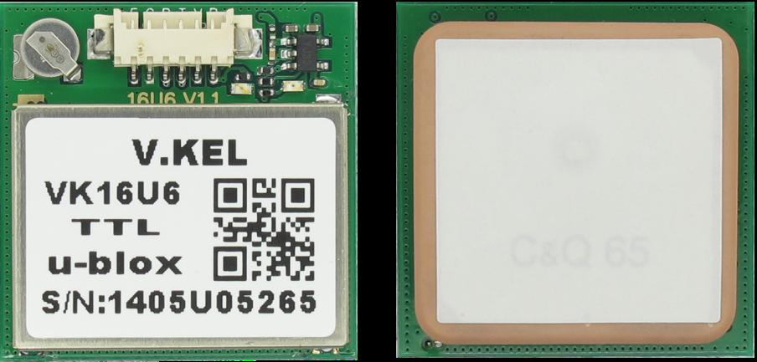

Feature:

Industry-standard 25 * 25 * 4MM high sensitivity GPS antenna
UART / TTL, 232, USB2.0 optional interface
KDS 0.5PPM using high-precision TCXO
Built-in RTC crystal and picofarads capacitance faster hot start
Built-in EEPROM, freedom rich configuration parameters
1-5Hz position update rate
Support AssistNow Online and AssistNow Offline A-GPS services, etc.
GPS, GALILEO, SBAS (WAAS, EGNOS, MSAS, GAGAN) Hybrid Engine

1.Product Description

C/A code,1.0 2 3 MHz Stream Receive band:L1[1575.42MHz]
Receive Channel:50 CH

Station-keeping

<2.5 m[Autonomous][5 0%] <2 m[SBAS]
Rate: <0.1 m/s Direction:.<0.5 Degrees
Timing Accuracy: 30 ns Reference coordinate system: WGS-84
The maximum altitude height: 50000 m The maximum speed: 500 m/s
Acceleration: <4g

Electrical properties:

Tracking sensitivity: - 162 DBM
Capture sensitivity: - 146 DBM
Cold start time: 32 s (AVG)
Warm start time: 32 s (AVG)
Warm start time: 1 s (AVG)
To capture time: 0.1 s (AVG)
Operating temperature: - 30 ℃ to + 80 ℃

Other Parameters:

Standard clock pulse: 0.25 Hz ~ 1 KHz
Position update rate: 1 H z ~ 5 H z (default 1Hz)
UART / TTL interface port [default]
USB port interface [optional]
RS232 port interface [optional]
AGPS [Network assisted inferior ephemeris data]: 3 s

1. Data rate: 9600 BPS (default) [optional: 1200240 0480 0192 00384 00576 00115 200230 400460 800921 00115]
2. The output statements: NMEA 0183 V3.0 (GGA, GSA, GSV, RMC, vacations, GLL) protocol data, can be arbitrary set match
3. The data refresh rate: 1 hz - 5 hz refresh rate
4. PPS indicator light: before positioning normally on or off; After positioning flashing
5. AGPS: support independent auxiliary positioning system
6. Can make control: supports external IO switch state trigger control module
7. The satellite quality control: rich set of satellite quality control and prevent the elegant software Settings
8. Application scenarios: from walking - car - static mode - portable mode - airborne model and 2 d & 3 d positioning user can be set free

Electrical properties of the interface: Wide voltage range: the main power supply is + 3.3 V ~ + 5V

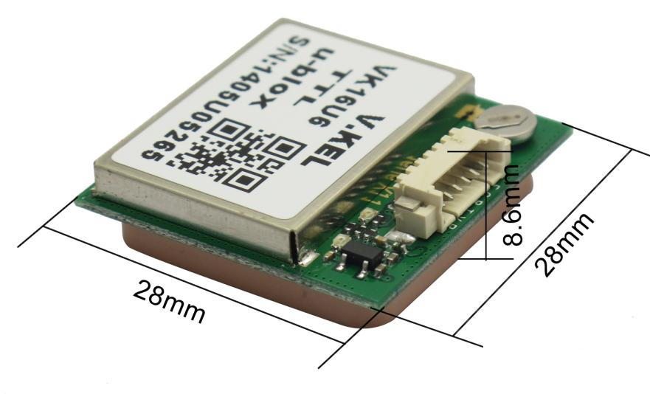

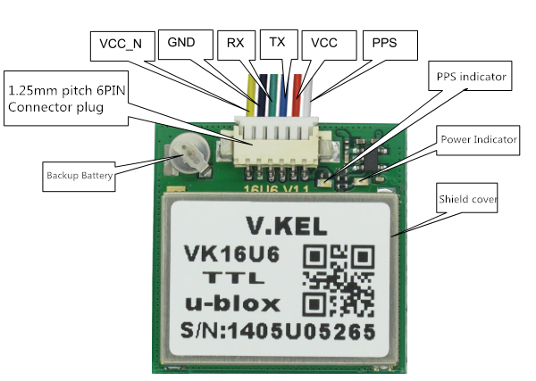

PIN foot function
PPS----Time standard pulse output
VCC-----System main power supply voltage is + 3.3V ~ + 5V, current consumption of about 55mA at work
TX----------UART interface, optional USB_DM and RS232_TXD
RX---------------UART interface, optional USB_DP and RS232_RXD
GND---all you know this :)
VCC_N----Power Enable, high / floating modules work, low module close

Normal operating conditions

Parameter | Min | Max | Unit | Standard
supply voltage | 3.3 | 5 | 5 | V
Working temperature | -40 | / | +80 | ℃
Working current |  | 40 | 60 | mA

Extreme operating conditions
Parameter | Min | Max | Unit | Standard
supply voltage | -0.3 | / | 5 | V
output voltage | -0.3 | / | 3.6 | V
Working temperature | -40 | / | 85 | ℃
Storage temperature | -55 | / | 100 | ℃
RTC Power qualified [RTC power supply module self, life time of about 2.5Hour]

Parameter | Min | Max | Unit | Standard
RTC supply voltage | 1.8 | 2.8 | 6 | V
Current consumption (operating) | / | 150 | / | uA
Current consumption (sleep) | / | 30 | / | uA

Digital interface level condition

Parameter | Min | Max | Unit | Standard
Input High | 2.0 | 2.8 | 3 | V
Input Low | / | / | 0.8 | V
Output High | 2.4 | 2.8 | 3 | V
Output Low | / | / | 0.4 | V

- NMEA0183 agreement

NMEA 0183 output
GGA: time, location, location type
GLL: latitude, longitude, UTC time
GSA: GPS receiver operating mode, the use of satellite positioning, DOP values
GSV: visible GPS satellite information, elevation, azimuth, signal to noise ratio (SNR)
RMC: time, date, location, velocity
VTG: ground speed information
MSS: signal strength, etc.
Note: The output of information related to the frequency and setup

Sample data:

$GPGGA,061831.000,2236.9152,N,11403.2422,E,2,07,1.1,144.0,M,-2.2,M,4.8,0000*60
$GPGSA,A,3,18,22,25,12,14,21,24,15,,,,,1.93,1.04,1.63*01
$GPGSV,3,1,11,12,40,089,45,14,37,314,46,15,10,078,44,18,77,096,43*72
$GPGSV,3,2,11,21,27,192,31,22,60,330,43,24,24,037,45,25,42,142,41*71
$GPGSV,3,3,11,31,21,230,27,42,51,128,37,50,46,122,39*4D
$GPRMC,061831.000,A,2236.9152,N,11403.2422,E,0.00,,130214,,,D*76
$GPVTG,309.62,T, ,M,0.13,N,0.2,K*6E

Make by vaa

