Instruction “How to start the game Tic Tac Toe”

- Click the link http://qatest.fora-soft.com:4234/
- Send your opponent the link that appears (or open it in the incognito version of your browser or in another browser)

Summary | the game continues despite the winning condition (diagonal)
Steps to reproduce | - Start the game  - Click on the left upper square of the game field  - Wait for your turn  - Click on the center square  - Wait for your turn  - Click on the right bottom square
Expected Result | You win
Actual Result | The game continues
Priority | S2 (Critical)
Environment | OS: Windows 10 64 bit  Browser: Opera version 68.0.3618.173
Attachments | 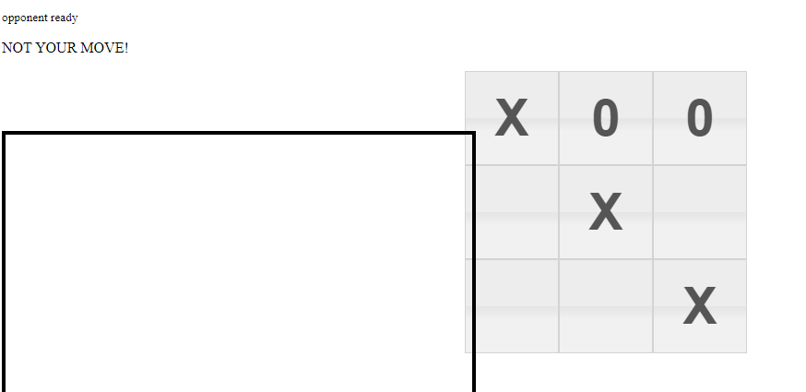

Summary | The player walks twice after clicking on the middle bottom square
Steps to reproduce | - Start the game  - Click on the middle bottom square of the game field  - Click on any other square
Expected Result | Nothing happens
Actual Result | The game allows you to walk a second time
Priority | S2 (Critical)
Environment | OS: Windows 10 64 bit  Browser: Opera version 68.0.3618.173
Attachments

Summary | Possible empty input in the text field
Steps to reproduce | - Start the game  - Enter space in the text field  - Press «Send» button
Expected Result | Nothing happens
Actual Result | You enter an empty line
Priority | S5 (Trivial)
Environment | OS: Windows 10 64 bit  Browser: Opera version 68.0.3618.173
Attachments | 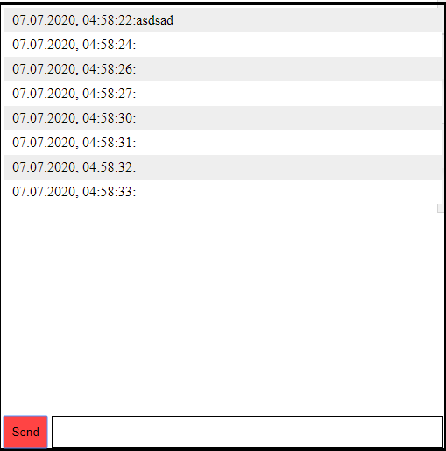

Summary | Pressing “Enter” key doesn’t sent text in the dialog field
Steps to reproduce | - Start the game  - Type any text in the text field  - Press “Enter” key on your keyboard
Expected Result | You sent text
Actual Result | Nothing happens
Priority | S4 (Minor)
Environment | OS: Windows 10 64 bit  Browser: Opera version 68.0.3618.173
Attachments

Summary | The dialog window closes some part of the game field
Steps to reproduce | - Start the game
Expected Result | The dialog window located next to the game field
Actual Result | The dialog window closes some part of the game field
Priority | S4 (Minor)
Environment | OS: Windows 10 64 bit  Browser: Opera version 68.0.3618.173
Attachments | 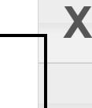

Summary | the time of sent messages is set one hour ahead
Steps to reproduce | - Start the game  - Type a text message  - Press “Send” button
Expected Result | The time of sent message is correct
Actual Result | the time of sent message is set one hour ahead
Priority | S4 (Minor))
Environment | OS: Windows 10 64 bit  Browser: Opera version 68.0.3618.173
Attachments
Summary | The player changes team after clicking on the middle bottom square
Steps to reproduce | - Start the game  - Click on the middle bottom square of the game field  - Click on any other square
Expected Result | Nothing happens
Actual Result | You walk with the opposite team
Priority | S2 (Critical)
Environment | OS: Windows 10 64 bit  Browser: Opera version 68.0.3618.173
Attachments
Summary | The messages of the same player is highlighted with different color
Steps to reproduce | - Start the game  - Type a message in the text field  - Press “Send”  - Type a new message  - Press “Send”
Expected Result | Messages are highlighted with the same color (grey or white)
Actual Result | Messages are highlighted differently
Priority | S4 (Minor)
Environment | OS: Windows 10 64 bit  Browser: Opera version 68.0.3618.173
Attachments

Summary | incorrect highlighting of long text lines
Steps to reproduce | - Start the game  - Type a long text line in the text field (>200 symbols)  - Press “Send” button
Expected Result | Line is fully highlighted with the grey color
Actual Result | 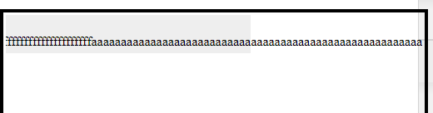
Priority | S5 (Trivial)
Environment | OS: Windows 10 64 bit  Browser: Opera version 68.0.3618.173
Attachments

Summary | the time of sent messages is set one hour ahead
Steps to reproduce | - Start the game  - Type a text message  - Press “Send” button
Expected Result | The time of sent message is correct
Actual Result | the time of sent message is set one hour ahead
Priority | S4 (Minor))
Environment | OS: Windows 10 64 bit  Browser: Opera version 68.0.3618.173
Attachments

