

**VBlox** 

In regards of completion of the research title of:

*The Effectiveness of Utilizing Vblox with Simulation Mechanics for Learning Basic Programming among Grade 12 STEMC Students in University of Cabuyao*

This capstone project was initiated in accordance with the ESTEMC Agenda of:

*Industry, Energy, and Emerging Technology*

This introduces the capstone project, VBlox.

The researchers aim to make a game-based basic programming course with a goal of teaching students basic programming skills with an in-depth application and hands-on. The game will immerse students by teaching programming in a game-like structure, which makes it fun and immersive. The researchers will test its effectiveness of such game-based learning to students and provide data accordingly.

The researchers aim to develop a game that immerses students while teaching them programming. It involves quests like lessons and materials which students can play, utilizing a block-based programming mechanic, students can code by placing blocks to attain a certain task or quest to progress. Additionally, students can test their code into a virtual robot which resides in a virtual environment. By this, students can build and personalize their own robots that interact with the environment, complete tasks, or quest which in the end might teach them basic programming knowledge.

**1. BRAND IDENTITY**

**1.1 LOGO**

Logo (Flat) Logo (3d Model)

**1.2 COLOR**

#00FFFF - Main Color (May vary according to themes. But this is the brand color.)

**1.3 TYPEFACE**

Lexend – For in-game texts.

Aptos Display – For documents.

**2. TECHNICAL**

**2.1 Game Engine**

**Godot Engine** - is a cross-platform, free and open-source game engine released under the permissive MIT license.

**2.2 Programming Language**

**GDScript** - is a high-level, object-oriented, imperative, and gradually typed programming language built for Godot. It uses an indentation-based syntax like languages like Python. Its goal is to be optimized for and tightly integrated with **Godot Engine**, allowing great flexibility for content creation and integration.

**2.3 Other software and websites used**

**BlockBench** - an open-source 3D modeling application where a creator can model, texture, and animate 3D block-based models for a variety of games.

**PiskelApp** – is a simple tool for Spriting and Pixel art.

**Github** – is a platform and cloud-based service for software development and version control using Git, allowing developers to store and manage their code.

**3. IDEA**

**3.1 CONCEPT**

The concept of this project is to teach students code in a fun and immersive way.

The problems or gaps which needs to be addressed are:

* **Immersive basic programming courses.**

For students to learn or grasp a material, they must be able to interact with it and see a dynamic result. In this way, students can retain what they have learned. Additionally, they can test what they have learned via putting it on a ***virtual buildable entity***and test if their code works!

Students and Teachers can work together to have a much more immersive and creative learning environment. The teachers can help students grasp the material by providing an immersive environment where students can unleash their creative prowess.

* **Fun and innovative approach.**

Student’s mental health is important while getting knowledge. The project aims to encourage students to have fun doing the game's concept of doing “quests” or tasks that involve programming.

The students can build their own ***virtual buildable entity***by putting ***interactables*** *together*, which they can test their code in. Furthermore, the game has “quests”-like structures or tasks, where you can build those entities, put your code in it and finish those tasks to progress!

Additionally, the concept of the game involves using a block-based coding approach, which guarantees that students will not be overwhelmed with the need of making sure that there are no typographical errors in the syntax. Which encourages them to have fun while learning basic programming!

With these concepts in mind, the project aims to provide an alternative in teaching basic programming principles.

**3.2 DESIGN**

With the concepts given in mind, the project will address it with the following design.

* **Block-based coding Mechanic**

To not overwhelm the students via the syntax and teaching it little by little, the project will employ a block-based coding mechanic. This is like putting little puzzle pieces together to have a working mechanic or logic.

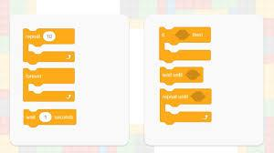 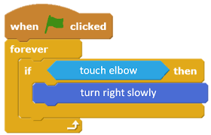

This will make the students learn coding easier and more fun because it is giving them an impression of putting puzzles together. Additionally, it will not overwhelm the students with the syntax that type-based coding provides.

The project will make a simple block-based coding platform which utilizes the student’s creative and logical prowess.

* **Simulation Mechanic**

To immerse students and provide a dynamic environment where they can unleash their creativity, simulation mechanics will be utilized. This will make a virtual environment where they can test their code.

The project will have ***“interactables”***which looklike building-blocks or Lego. The students will put those together to have a virtual robot or entity. They can put their code inside to move each part or have those parts work in unison to finish a particular quest or task the project provides to progress.

This will give the students a ground to test their ideas and unleash their creativity. They can also simulate kinds of robots or entities.

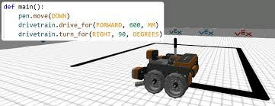 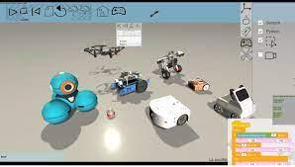

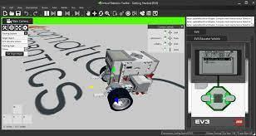 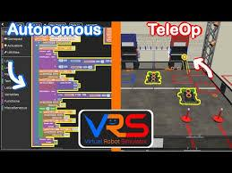

Note, the virtual environment will not be as accurate as industry-level simulators. The goal of the project is to make coding immersive and fun.

* **Quest-like tasks**

This project will employ quest-like tasks, so students have a sort of goal. It encourages students to learn basic programming skills.

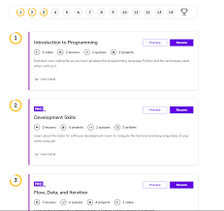 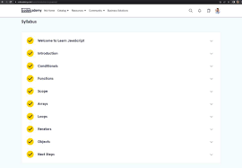

**4. RESEARCH AND DEVELOPMENT**

**4.1 Simulation Engine**

The simulation engine is the heart of the game. It houses the necessary scripts for the engine to work. The figure attached is how the simulation engine works.



In the figure, it shows how the current (December 2023) simulation engine works.

**What to discuss in the Simulation Engine?**