[TOUR BROCHURE]

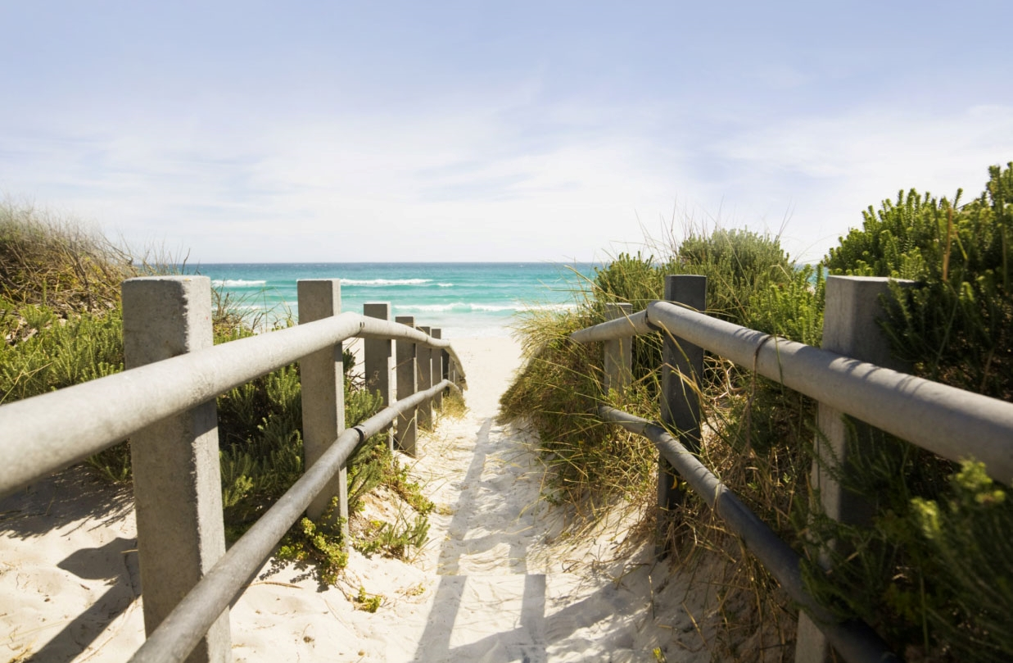

## [Puja Special offer booking in just fraction of seconds!]

|  |  |
| --- | --- |
| [It is special offer which will be only applicable for the packages booked within 15th of August. Das Tours and Travel Reserves all Rights for the tour Packages] | [Rs.20000/person] |

|  |  |  |
| --- | --- | --- |
|  |  |  |
| [Interior View] [This is our furnished office with a free Wi-Fi facility for offline booking of travel packages.] | [Outside View] [Magnificent view of the office from outside at Kolkata’s best location for better communication.] | [Friendship] [Trusted Partnership for more than 17 years.] |

# [DAS TOURS AND TRAVEL]

[India NO.1 Tours And Travel Agency]  |  [nm@gmail.com]  |  [WWW.DasTours&Travel.com]  |

 [2442-7638]