YAPP_router

Verification Plan Document

Shifra Lemberger
2025

DUT Overview
The YAPP router accepts data packets on a single input port, in_data, and routes the packets to one of three output channels: channel0, channel1 or channel2. The input and output ports have slightly different signal protocols. The router also has an HBUS host interface for programming registers.
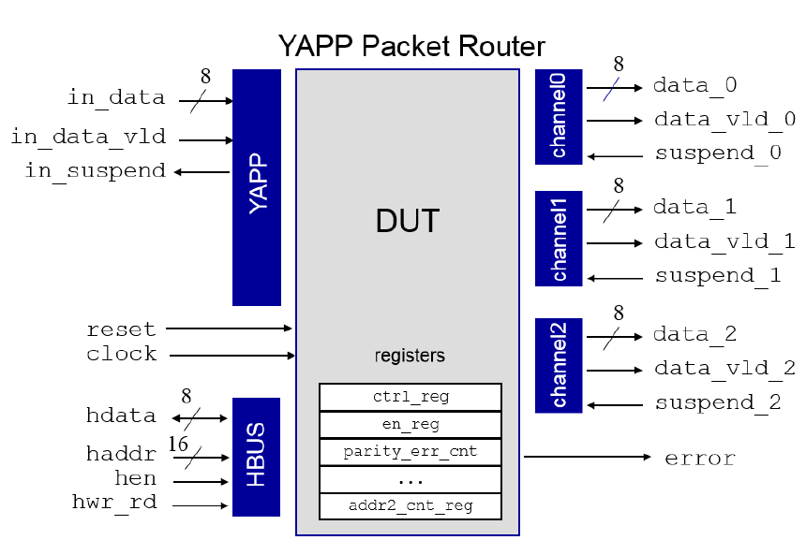

Clocks
The router is driven by a single system clock (clk).

Resets
Active-high reset signal.

More Declarations
The router has a data-path and a control-path of various registers such as enables counters and more.

Design Assumptions and Configuration

Assumptions
- Assume all input signals are active high and are to be driven on the falling edge of the clock.
- Assume all output signals are active high and are to be sampled on the falling edge of the clock.
- Assume each packet contains address, correct length,data and parity.
- Assume the packet payload is greater than 0.
- Assume that immediately after the valid input goes down, the parity goes out and the packet ends.
- Assume only one transaction (read or write) is active at a time, no overlapping operations.
- Assume The DUT releases the hdata bus after completing a read.

Configuration
The router has a set of registers that are written and read via the HBUS as follows: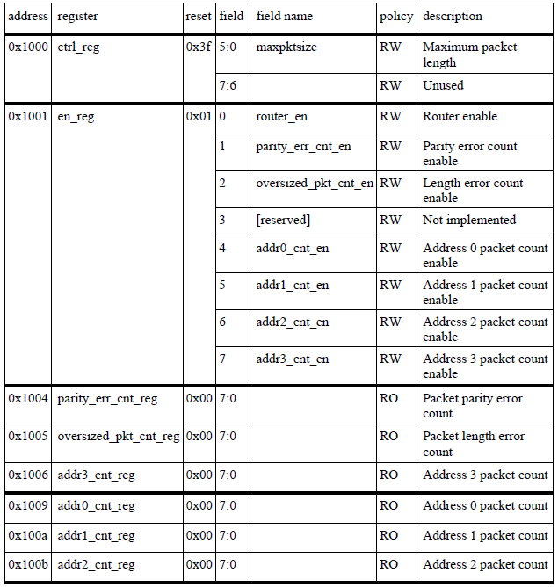
The router contains also two memory blocks as follows:
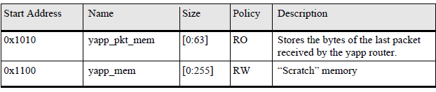

Features (Design expected behavior)
- The RTL shall be enabled only when router_en is active.
- The RTL shall get a packet only when in_data_vld is active.
- The RTL shall route the packet to the corresponding channel according to the received address only when his data_valid is active and his suspend is inactive.
- The RTL shall count the parity errors and the length error only when the corresponding enable register is active.
- The RTL shall count the packets per channel only when the corresponding enable register is active.
- The RTL shall drive one in the error output when at least one of the error counter registers is greater than zero.
- The RTL shall write to register according to the address received only when hwr_rd and hen are active.
This operation will take one clock cycle and after it hen will be driven to be zero.
- The RTL shall read from the register according to the address received only when hwr_rd is inactive and hen is active.
This operation will take two clock cycles and after it hen will be driven to be zero.
The data will be driven only in the second clock cycle.

Flows & Cases production (test cases)

Static configuration:
- Verify that no packets are routed when router_en is disabled.
- Verify routing to a single output channel.
- Verify correct packet length handling when maxpksize is statically configured.
- Verify error counters increment only when the respective enable bit is set, and remain unchanged otherwise.
- Verify packet counters per address operate only when enabled.
- Verify inactive channels remain idle and do not receive data.
- Verify correct FIFO operation under normal load conditions.
- Verify that packets smaller than maxpksize are transmitted correctly.
- Verify proper behavior when FIFOs are full (no data loss or corruption).
- Verify full reset behavior — all registers and counters return to default values.
- Verify that enabling or disabling one function does not affect unrelated features.

Run-time (on the fly) configuration:
- Verify valid signal deasserts immediately after the last data byte, and parity output is driven immediately.
- Verify output data remains consistent during suspend state.
- Verify error output asserts when:
- Address equals 3.
- Packet length exceeds current maxpksize.
- Parity error is detected.
- Verify modification of maxpksize during transmission affects only subsequent packets.
- Verify changing destination address during ongoing transmission behaves predictably.
- Verify router behavior when router_en is toggled during transmission.
- Verify counters remain accurate after real-time configuration changes.
- Verify proper handling of extended suspend durations and successful resume.
- Verify system response when FIFO overflow occurs mid-packet.

Bring-up stages:
- Apply and release reset; verify system initializes to stable state.
- Enable system clocks and confirm all outputs are idle before activation.
- Enable router_en and verify traffic flow starts correctly.
- Confirm DUT transmits only after full bring-up sequence (no premature activity).
- Verify all channels indicate “ready” before beginning test traffic.

Environment
Environment diagram:

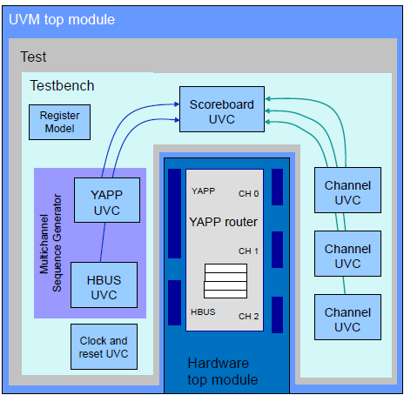

YAPP Agents
This agent should support driving data yapp packets to the DUT and monitoring the input and output packets that send and go out from the DUT.
The agent can be used as ACTIVE - drive data and samples signals.

I/F
The yapp interface connects yapp UVC to the input ports of the DUT.
The interface also includes 3 functions and tasks: reset_signals, collect_packets and send_to_dut.

Config - Agent Configuration
The yapp block focuses the main configuration to be used by the other environment blocks:
- Activation - agent will be active.
This configuration is defined per test.

Driver
This class is responsible for the data transmission to DUT, toggling the interface signals according to the interface specifications.
The driver is getting an appropriate item and flats it into a bit stream, meaning, all scenarios of errors and timing are being constructed in the item.

Monitor
The monitor samples the interface signals and expects the data to be transmitted correctly, following the interface type specifications.
The transmitted data is collected into a base item, to be internally (in the item) separated into packet structure fields, and checked from communication errors. The collected packet will be export to any upper verification layer.

HBUS Agent
This agent should support driving data hbus transactions to the DUT and monitoring the input and output transactions that send and go out from the DUT.
The agent can be used as ACTIVE - drive data and samples signals.
The agent supports multiple master and slave modes.

I/F
The hbus interface connects hbus UVC to the input ports of the DUT.
The interface also includes 5 functions and tasks: reset to master and to slave , collect_packet and send_to_dut to master and to slave.

Config - Agent Configuration
The hbus block focuses the main configuration to be used by the other environment blocks:
- Activation - agent will be active.
This configuration is defined per test.

Driver

Master Driver
This class is responsible for transferring data to the DUT, and turns off the interface signals according to the interface specifications.
The device driver receives an item with a read/write bit ,registers address, and IN/OUT data for reading or writing, and reads or writes according to the address received in the item.

Slave Driver
This class is responsible for transferring data to the DUT, and turns off the interface signals according to the interface specifications.
The device driver is responsible for updating and reading only the following registers: makpksize and router_en.

Monitor
The monitor samples the interface signals and expects the data to be transmitted correctly, following the interface type specifications.
The transmitted data is collected into a base item, to be internally (in the item) separated into packet structure fields, and checked from communication errors. The collected packet will be export to any upper verification layer.

CHANNEL Agent
This agent should support driving suspend to the DUT, and monitoring channel packets that send and go out from the DUT.
The agent can be used ACTIVE - drive suspend and sample signals.
The agent works in slave mode.

I/F
The channel interface connects channel UVC to the input/output ports of the DUT.
The interface also includes 2 tasks: send_response and collect_pkt.

Config - Agent Configuration
The channel block focuses the main configuration to be used by the other environment blocks:
- Activation - agent will be active.
This configuration is defined per test.

Driver
This class is responsible for transmitting suspend to the DUT, it turns suspend on and off according to random delays.

Monitor
The monitor samples the received packets and expects the data to be transmitted correctly.
The transmitted data is collected into a base item, which will be internally separated (within the item) into packet structure fields, and checked for communication errors. The collected packet will be output to any upper verification layer.

Reference Model
The reference model sends to the scoreboard only the legal packets:
Legal address, legal size and only when the router is enabled.
The reference model also saves the register’s values and checks them when there is a read transaction.

Checkers & Scoreboards
Each packet that enters the scoreboard from the reference model is pushed into a queue according to its address, and for each output packet from the DUT we compare it to the corresponding packet from the corresponding queue.
There are counters that count packages by their address and also count the number of matching packages and the number of mismatching packages per address.

Error Handling
There can be several types of errors ---
Error Types:
- Parity Error - Parity bit does not match expected value.
- Maxpksize Error - the length of the packet is greater than the register that declared in hbus.
- Address Error - sending to address 3.
Behavior:
The DUT drops the incorrect packet and turns on the error output.

Sequences

YAPP
- yapp_1_seq: Send one packet to a single output channel, The packet appears only on channel_1.
- yapp_012_seq:Send one packet to each channel in order excluding the illegal channel,The packet will only appear at the appropriate channel.
- yapp_111_seq: Send 3 packets to a single output channel, The packet appears only on channel_1.
- yapp_repeat_addr_seq: Send 2 packets to the same random channel, The packet will only appear at the appropriate channel.
- yapp _exhaustive_seq: Union of all the following sequences.
- yapp_rnd_seq: Send a random amount of packets.
- six_yapp_seq: do the previous seq with constraint (amount=6).

Hbus
- hbus_write_seq: Write with specified address and data, the register in the address will change to be the data.
- hbus_read_seq: Read with a specified address, the data will be the data at this address.
- hbus_set_yapp_regs_seq: Write specify to maxpksize and router_en, these registers will change to be the random values.
- hbus_get_yapp_regs_seq: Read specify to maxpksize and router_en,the data will be the data at these registers.
- hbus_small_packet_seq: Write to maxpksize - 20 (small packet) and to router_en - 1.
- hbus _set_default_regs_seq: Write to makpksize and to router_en their default values (63 and 1).
- hbus_read_max_pkt_seq: Read makpksize reg.
- hbus_read_enable_seq: Read router_en reg.
- hbus_set_get_regs_seq: execute 6-7-8 sequences (set to default and read).

Channel
- Channel_rx_resp_seq: send one random suspend.
- Channel_rx_long_resp_seq: send random suspend in forever loop- to each sent packet.

Multi-channel sequence
- Router_simple_mcseq: Do the following sequences:
  - hbus_small_packet_seq
  - hbus_read_max_pkt_seq
  - Twice yapp_012_seq
  - hbus _set_default_regs_seq
  - Hbus_read_max_pkt_seq
  - six_yapp_seq

Coverage
Cover all test cases----

YAPP
- Ensure all lengths of packets are sent into the router:
  - minimum(1)
  - maximum(63)
  - short(2-20)
  - medium(21-40)
  - large(41-62)
- Ensure all addresses received a packet, including the illegal address.
- Ensure all size packets were sent to all legal addresses with BAD_PARITY.

Hbus
- Ensure maxpksize reg and router_en reg and at least one of the registers have been called.
- Ensure there is at least one read and one write.
- Ensure that MAXPKSIZE and ROUTER_EN have been read and written, as well as at least one of the other registers.

Channel
- Ensure all lengths of packets are sent into the router:
  - minimum(1)
  - maximum(63)
  - short(2-20)
  - medium(21-40)
  - large(41-62)
- Ensure the two parity_type are received.

Post Verification Notes
Several notes which raised up during work:

Verification issues (Opens)

