 

Institute of Engineering Paschimanchal Campus

**Department of Electronics and Computer Engineering**

**SUBMITTED BY :**

* **SHIRISH BARAL**
* **SHIVA SHRESHA**
* **SHUBHAM THAPA**
* **SITTAL BHUSAL**

**SUBMITTED TO :**

**BALKRISHNA NEUPANE**

**DEPARTMENT OF ELECTRONICS AND COMPUTER ENGINEERING**

**Abstract**

This report describes the implementation of a Database Management System for airline reservation system . It is developed for Storing, Managing, and Updating the Data for the flight reservation system which becomes efficient for both passengers and the reservation company .

This report mainly includes the background and development process of the project. The main steps in the development process are identifying the Entities and the Relationship among them and presenting them in graphical form with an ER Diagram. It also includes some of the SQL queries used in the implementation of the MySQL Database.

This project is made for exploring the knowledge of students .

**Introduction**

A database management system (DBMS) refers to the technology for creating and managing databases.Basically DBMS is a software tool to organize (create, retrieve, update and manage) data in a database. The main aim of a DBMS is to supply a way to store up and retrieve database information that is both convenient and efficient. By data, we mean known facts that can be recorded and that have embedded meaning. Normally people use software such as Microsoft ACCESS, or EXCEL to store data in the form of a database .Database systems are meant to handle large collections of information. Management of data involves both defining structures for storage of information and providing mechanisms that can do the manipulation of those stored information. Moreover, the database system must ensure the safety of the information stored, despite system crashes or attempts at unauthorized access.

This project is to aim at the improvement of the **Flight Management System.** Frontend and backend are implemented using JavaScripts and MYSQL.

**Airline Reservation system**

IT ALL STARTED when “ In the early decades of commercial aviation, airline reservations relied on physical systems. These could be found in dedicated reservation centers. At such centralized facilities, employees would assign paper tickets to represent the sales of seats onboard their given airline's flights. However, as passenger numbers grew, alterations became necessary. So, the evolution of flight reservation started to begin . So, now we have several reservation systems that make computerized reservations/ online reservations and we are one of them .Modern reservation systems allow passengers to directly make their bookings on their chosen airline's website. They store information like schedules, booking class rules, and fares.All these records are kept in a database called (database management system ) and can be accessed or updated according to the needs of the airlines .

**PHYSICAL/MANUAL SYSTEM**

* Whenever any requisition comes to the Counter to issue a ticket the firstly the Ticket Capacity checks whether the required quantity of the ticket is present or not. If the required ticket is present then issue a ticket and update the reservation information and an entry is done to the Ticket Issue Register.
* The day-to-day entries are made manually into the book that has gotten all the relevant entries.
* Check the Ticket Quantity regularly whether any ticket is not in, if so then the Ticket Issue process is canceled. In the same way Ticket cancellation is followed. If Fare is increased or decreased then changes into Fare Book. If New Flight is introduced then entry on relevant book, that process applies to Flight-Schedule, Airbus, and Branch.

**PROBLEM STATEMENT**

There are many problems in existing systems like:

1. It becomes time consuming for the passengers to manually go to the ticket counter for reservations and also the works become very slow
2. There should be someone to keep track of records at each counter which increases the manpower
3. The cost and the complexity of the system increases
4. Similarly the system become less secure as the data might get lost because of pen and paper method
5. Also it requires more storage facilities and accuracy is also lost and time complexity increases
6. Records might get lost or be insufficient due to manual errors.
7. Maintaining and managing data is very costly and time consuming, because there are many documents that have to be maintained by each branch and copies have to be transferred to relative branches.
8. Transfer of information within the branches is costly and time consuming.

**PROPOSED SYSTEM**

The fight system proposed by us has addressed some of the major problems that could be faced by both passengers and the reservation company.

**Objectives**

Every project has its own objective to fulfill some certain criteria and requirements. Similar is the case of our project . Some major objective of our project are listed below:

* To develop the airline ticket booking system
* To understand the concept of databases and database management softwares
* To be familiar with different tools and work in a collaborative environment
* To enhance the knowledge, skills and learnings on various platforms

**FEATURES**

The proposed system has several features that would make it very efficient for the customer and company to keep the tracks of the records . Some important features are listed below:

1. User friendly graphical interface that will be easier to understand and use the system .
2. The admin panel control mechanism allows the administrator to change, add, modify, delete, upgrade the application in question.
3. The passengers can reserve (the type, seats ,category )of the flight they want and similarly scheduling can also be done.
4. Source and destination of the passenger can be chosen efficiently.
5. Passengers can make payment through different methods which is more efficient
6. Manual work has been reduced and results will be received very quickly.
7. Managing and maintaining data becomes easier and cost effective due to the very high amount and reliability of storage space available in the proposed system.
8. It provides support for queries through out all the branches and different other computation can be easily performed through queries .(Example : We can sort the names of the passenger according to their destination )

**ADVANTAGES OF PROPOSED SYSTEM :**

* The proposed computerized system is much faster in the reservation process, cancellation process and transactions.
* Transfer of information from various branches would become easier and faster.
* Managing and maintaining data becomes easier and cost effective due to the very high amount and reliability of storage space available in the proposed system.
* Customer services can not only be satisfied but also enhanced to the extent that one can obtain or cancel a reservation from any given time.

**ER-DIAGRAM**

An Entity Relationship Diagram is a diagram that represents relationships among entities in a database. It is commonly known as an ER Diagram. An ER Diagram in DBMS plays a crucial role in designing the database. Today’s business world previews all the requirements demanded by the users in the form of an ER Diagram. Later, it's forwarded to the database administrators to design the database.

An Entity Relationship Diagram (ER Diagram) pictorially explains the relationship between entities to be stored in a database. Fundamentally, the ER Diagram is a structural design of the database. It acts as a framework created with specialized symbols for the purpose of defining the relationship between the database entities. ER diagram is created based on three principal components: entities, attributes, and relationships.

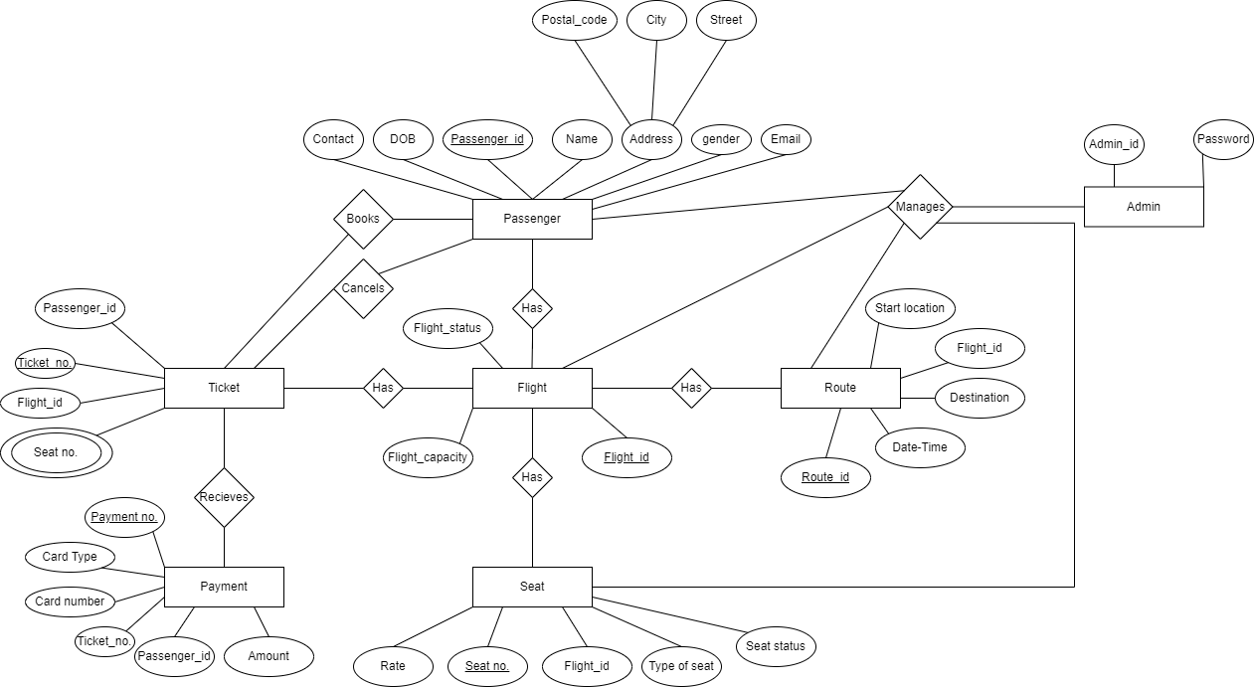

**Fig :** ER- DIAGRAM (FLIGHT RESERVATION SYSTEM )

**RELATIONAL SCHEMA**

A relational schema is a blueprint used in database design to represent the data to be entered into the database and describe how that data is structured in tables (called relations in relational schemas). The schema describes how those tables relate to each other.

In the relational schema, the table, or relation, consists of a set of named, but unsorted, columns (called attributes in relational schemas) and an undefined number of unnamed and unsorted rows (called tuples in relational schemas). Each row is unique, but the rows can be moved around as needed and stored in any order, modified, or deleted without impacting the efficient operation of the database.

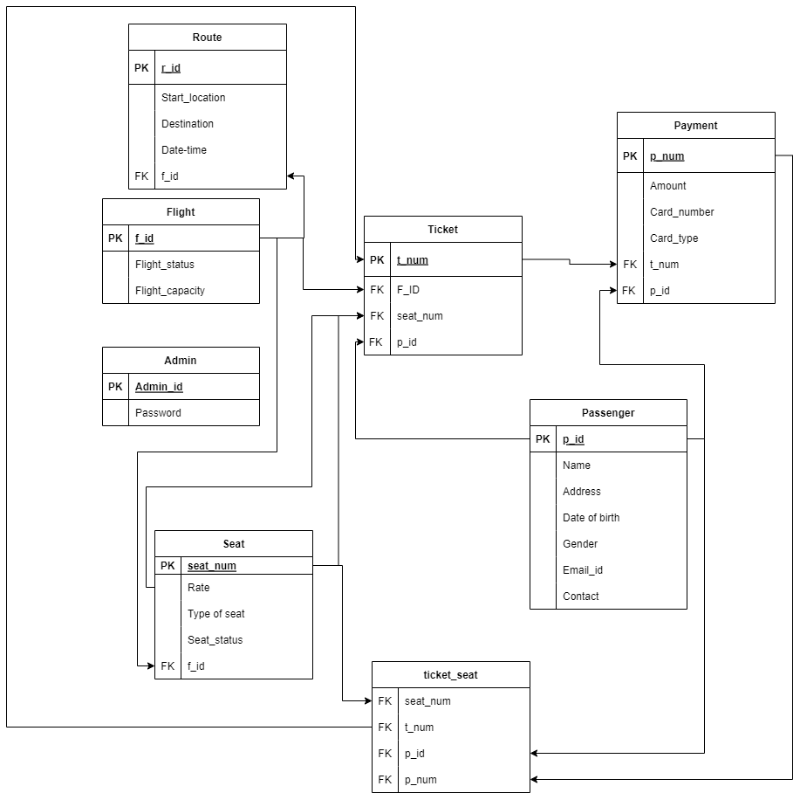

FIG: RELATIONAL SCHEMA

SOME SQLS USED IN THE PROJECT :

|  |
| --- |
| 'select * from flight NATURAL JOIN ROUTE' |

|  |
| --- |
| 'select * from flight NATURAL JOIN ROUTE' |

|  |
| --- |
| `UPDATE flight SET f_status ='${s}' WHERE f_id =${id} |

|  |
| --- |
| 'select * from flight NATURAL JOIN ROUTE WHERE f_id ='+id |

|  |
| --- |
| UPDATE route SET origin ='${o}', destination='${d}',date='${date}', time='${time}' WHERE f_id =${id} |

|  |
| --- |
| DELETE FROM flight WHERE f_id =${id}` |

|  |
| --- |
| INSERT INTO passenger(name, city, state, zip, gender, dob, email, contact) VALUES ('${a.name}','${a.city}','${a.state}',${zip},'${a.gender}','${a.dob}','${a.email}','${a.contact}' |

|  |
| --- |
| `SELECT * from passenger where name ='${a.name}' AND city='${a.city}' AND state='${a.state}' AND zip='${zip}' AND gender='${a.gender}' AND dob='${a.dob}' AND email ='${a.email}' AND contact ='${a.contact}' |

|  |
| --- |
| UPDATE seat SET seat_status ='o' WHERE seat_num ='${a.seat}' |

|  |
| --- |
| UPDATE flight SET empty_seats=empty_seats-1 WHERE f_id ='${a.f_id}' |

|  |
| --- |
| select * from passenger Natural Join payment WHERE p_id =${a} |

|  |
| --- |
| `select * from Flight Natural Join Seat WHERE f_id =${a}` |

|  |
| --- |
| select * from Flight Natural Join Seat WHERE f_id =${f_id} |

|  |
| --- |
| UPDATE seat SET rate=${f} WHERE s_type ='f' |

|  |
| --- |
| UPDATE seat SET rate=${b} WHERE s_type ='b' |

|  |
| --- |
| UPDATE seat SET rate=${f} WHERE s_type ='f' |

**ADMINISTRATION FEATURES**

The system administrator must be able to: add, update and modify flights and view the customer details.

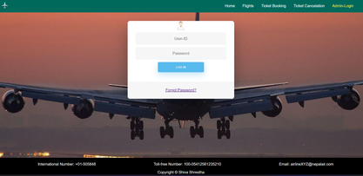

FIG:ADMIN LOGIN

**Passenger Features**

On the register form, passengers should enter all their detail such as their name, passport number, Email and contact number.

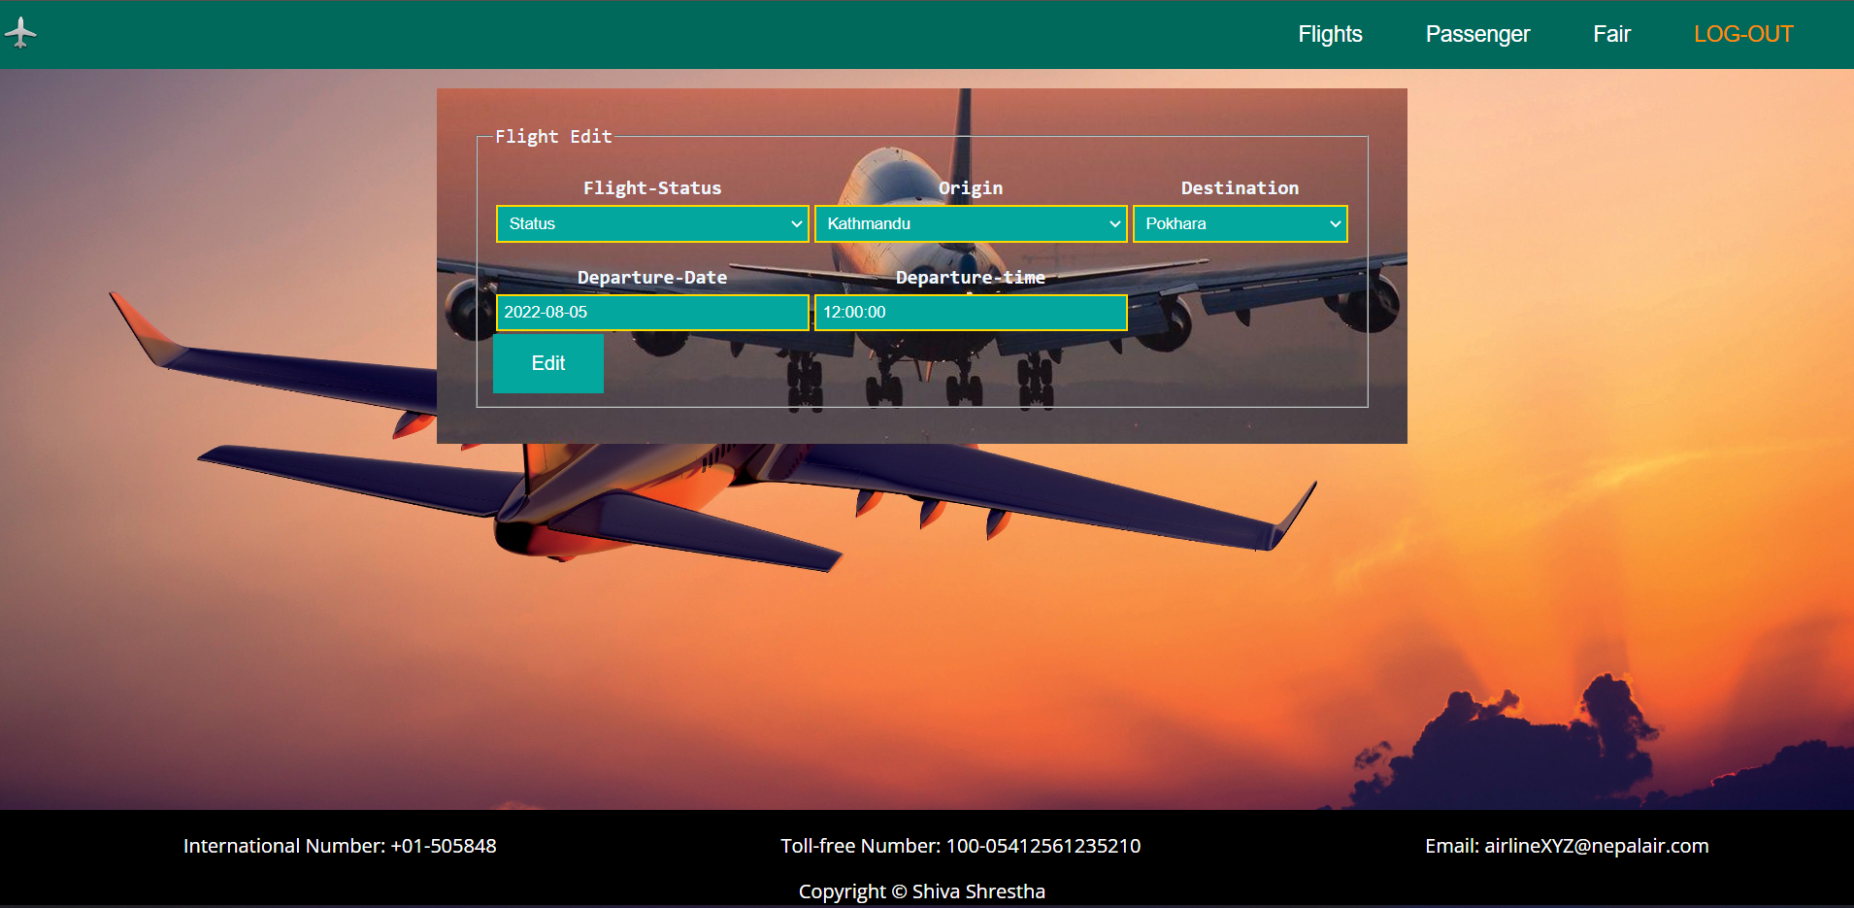

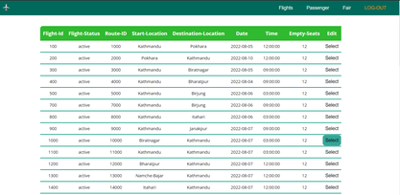

FIG:PASSENGERS RECORDS

**BOOKING**

**B**ooking allows the passenger to book their tickets online .

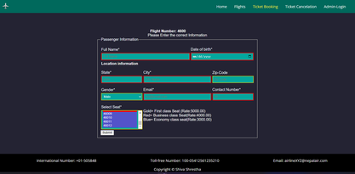

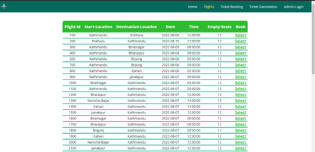

FIG: BOOKING

**CANCELLATION**

After the booking has been made passengers are also allowed to cancel their booking

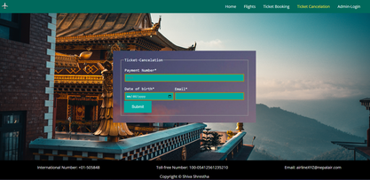

FIG:TICKET CANCELLATION

**CONCLUSION**

The main aim of this project is to convert the tedious manual reservation method to a full computerized system .

This AIRLINE RESERVATION SYSTEM has been an attempt to help the user to minimize his workload along with minimizing the paperwork and saving of time.

The system has been developed in a way to make it very user friendly. It provides an on-line message and an error detection and error messages every time the user needs.

Almost all the difficulties of manual reservation have been removed by this system.

**References**

* Software Requirement Specifications from the Internet.
* Software Requirement Specifications, Airline Reservation System.
* IEEE (Institute of Electrical and Electronics Engineers) Guide to Software

Requirements Specifications.

* [www.google.com](http://www.google.com)
* [www.wikipedia.com](http://www.wikipedia.com)
* [www.project-airline-system-basics.com](http://www.project-airline-system-basics.com)
* <https://www.w3schools.com>
* [www.youtube.com](http://www.youtube.com)
* And several other books through the internet .