**PRACTICAL- 02**

**AIM:- Installation of HDP Sandbox and import in the VM box to visualize what’s going on in the Hadoop.**

**STEP-1 Download the VM box from the browse:**

Link: <https://www.virtualbox.org/wiki/Downloads>

**STEP-2 Download the HDP Sandbox file:**

Link: <https://www.cloudera.com>

**Step 3: Import the file in the VM box.**

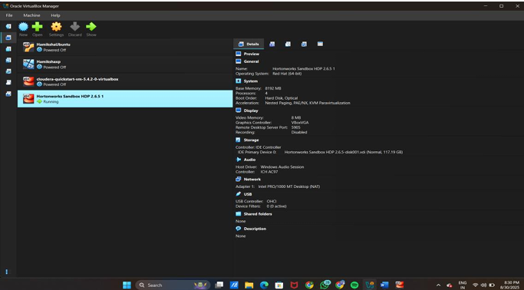

**Step 4:** Run the HDP Sandbox in the VMbox.

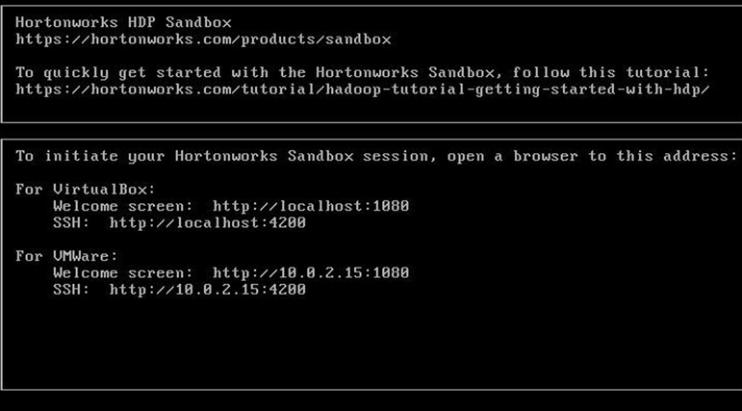

**Step 5**: Run the link in the browser.

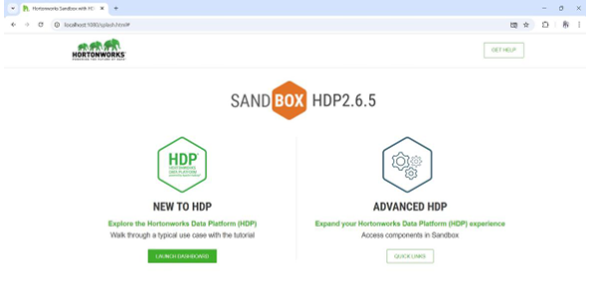

**Step 6**: Login in the Ambari Sandbox.

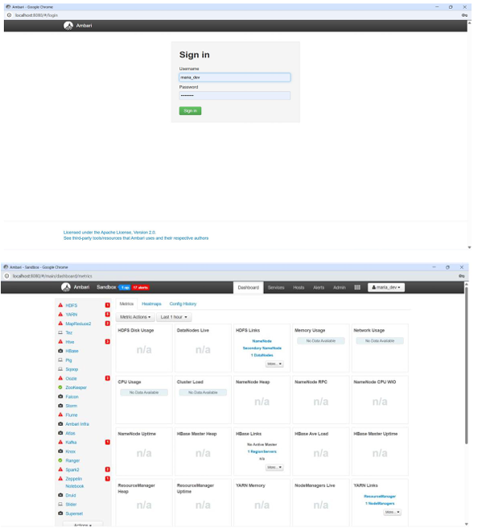

**Step 7**:Download any two Datasets file. Step 8:Upload the files in the Ambari Sandbox.We will import the data from the local file there to import data open the hive view After hive view click on the upload table option Select the csv file type & set the file delimiter type to the 9 (i.e horixontal tab) Choose the file from your local system ) i.e u.dat a file) Rename the table

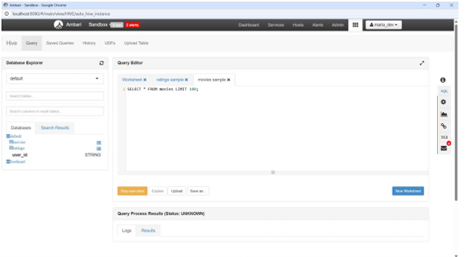

**Step 8**: Write the SQL Query to perform operations.

