**PRACTICAL :- 01**

**AIM:-** Installation of Java in your machine.

**THEORY:**

**JAVA**: Java is a high-level, class-based, object-oriented programming language developed by Sun Microsystems in 1995, now owned by Oracle Corporation. It is designed to have as few implementation dependencies as possible and is known for its platform independence.

**Step 1: Choose the latest version of java.**

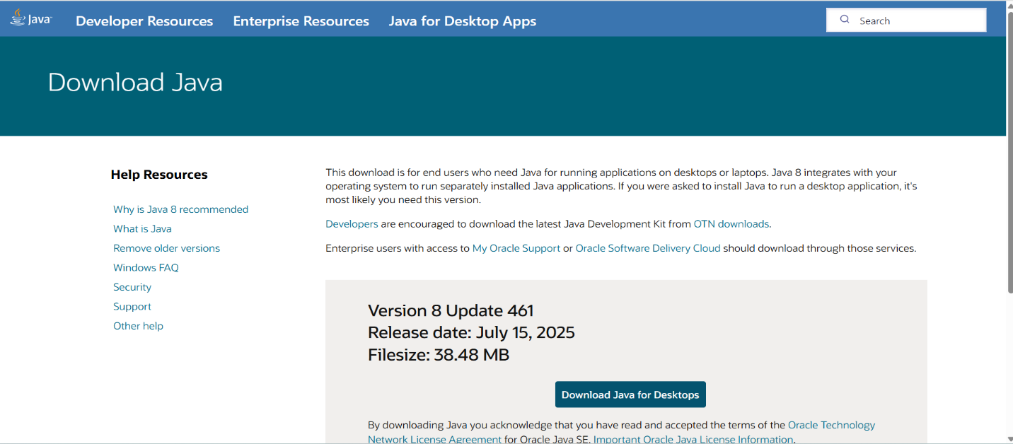

**Step 2: Install the java**

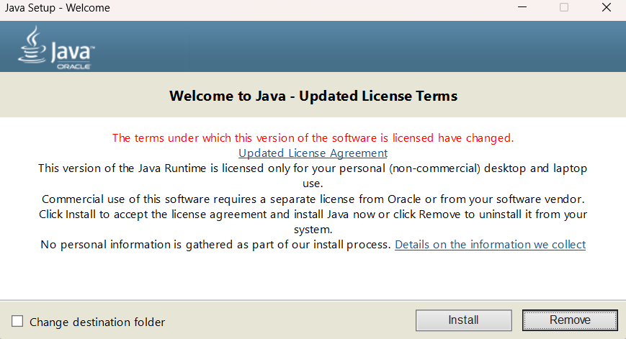

**Step 3: Click on Install button.**

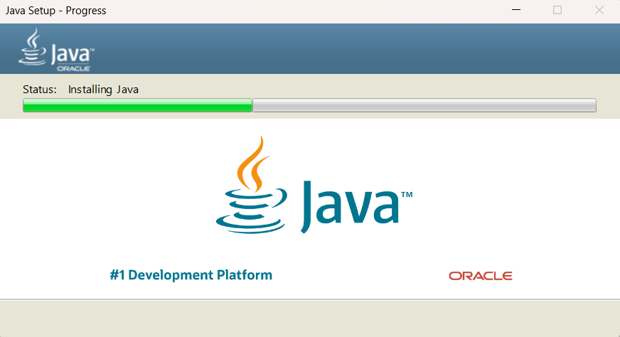

**Step 4: Java Installed Successfully**

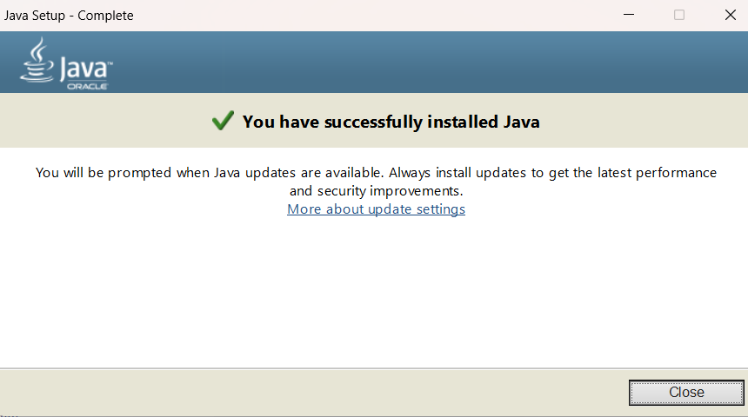

**Step 5: Again download JDK and Install.**

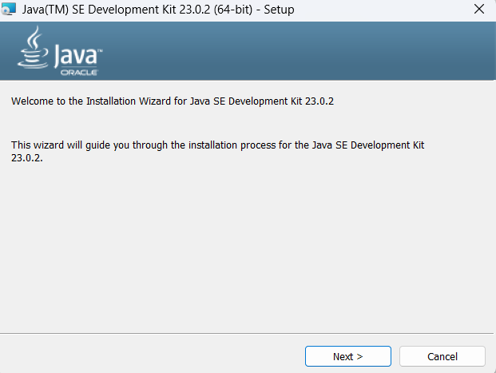

**Step 6: Select the installation folder.**

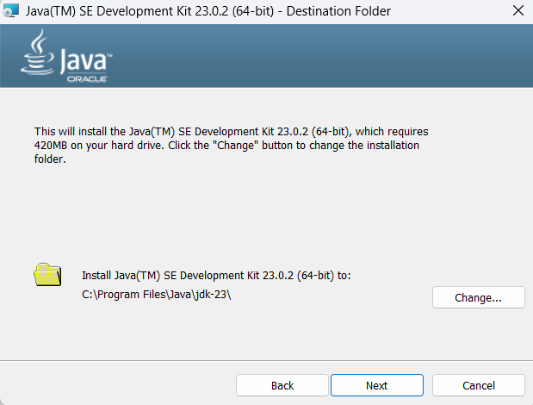

**Step 7: Start installing.**

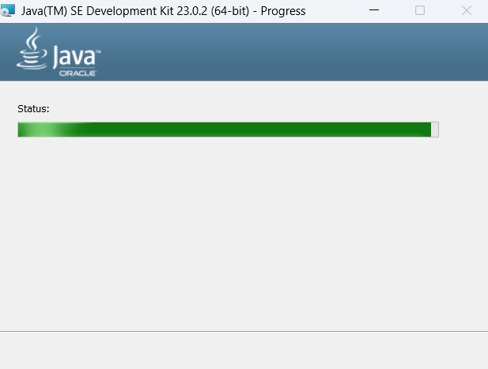

**Step 7: JDK installed Successfully.**

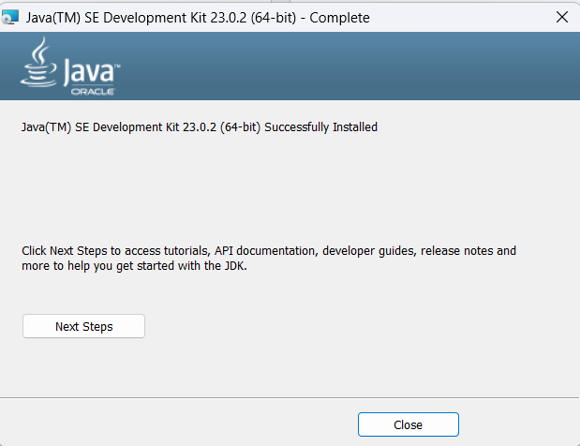

**Step 8: Java Run Successfully.**

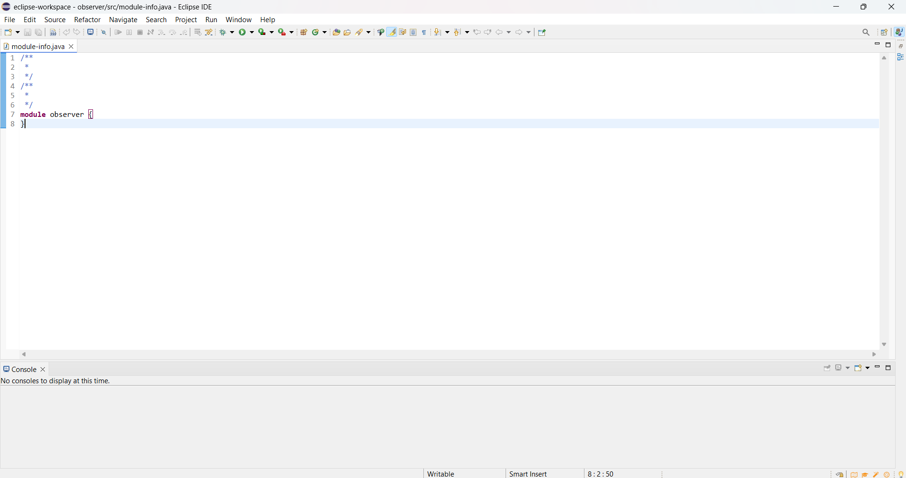

**Results:** Installation of Java in my machine has been successfully completed.