Shane Yanes
MAN 7916 – Assignment 1

Python Script Output
"Python1-Shane-sit"
"Python2-86-Integer"

Disease Stigma
Repository Created January 13th, 2022
Last Update: Nov 2nd, 2023
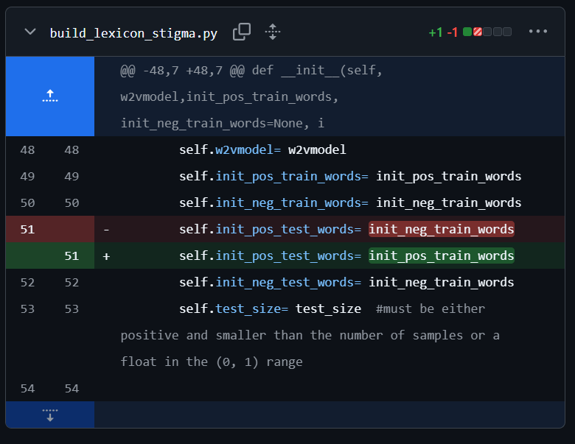
The positive test words had been incorrectly named neg_train words, and was fixed to pos.

Kiley’s CARMA Repository
13 Releases
# CARMA Short Course 2021: Introduction to Python for Research
29 changed files

