Table of Contents
Create “FOUNDATION1” ADOM 2
Create device groups 2
Provisioning templates 2
System template 2
Pre-Run CLI Template 3
Create the “SETTINGS.DEVICES” Post-Run jinja template 3
Import the jinja templates 3
Create an “SD-WAN-zones” template 4
Provisioning WEST-DC-1 4
Create a model device 4
Fill meta-data and location 5
Install config on model device 5
Import policy-package from the device 5
Import SD-WAN template from the device 6
Rename some normalized interfaces 6
Change the provisioning templates assignment for this device 6
Assign this device to group “WEST-DATACENTERS” 6
Install Wizard Policy Package “PP-DATACENTERS” 6
On-board the real device (low-touch provisioning) 7
Provisioning WEST-DC-2 8
Create a model device 8
Fill meta-data and location 8
Install config on model device 8
Normalize the interfaces used as “input-device” in SDWAN 9
Assign this device to group “WEST-DATACENTERS” 9
Install Wizard Policy Package “PP-DATACENTERS” 9
On-board the real device (low-touch provisioning) 10
Provisioning EAST-DC-3 11
Create a model device 11
Fill meta-data and location 11
Install config on model device 11
Install SD-WAN config on model device 11
Assign this device to group “EAST-DATACENTERS” 12
Install Wizard Policy Package “PP-DATACENTERS” 12
On-board the real device (low-touch provisioning) 12
Provisioning WEST-BRANCH-1 13
Create a model device 13
Fill meta-data and location 13
Install config on model device 13
Import policy-package from the device 14
Import SD-WAN template from the device 14
Change the provisioning templates assignment for this device 14
Assign this device to group “WEST-BRANCHES” 15
Install Wizard Policy Package “PP-BRANCHES” 15
On-board the real device (low-touch provisioning) 15
Low-touch Provisioning of WEST-BRANCH-2 and EAST-BRANCH-3 16
Create a model device 16
Fill meta-data and location 16
Install config on model device 17
On-board the real device (low-touch provisioning) 18
Final status 19

Written and tested with FMG 7.0.3 and FGT 7.0.5

Create “FOUNDATION1” ADOM

Create device groups

* WEST-DATACENTERS
* WEST-BRANCHES
* EAST-DATACENTERS
* EAST-BRANCHES

Provisioning templates

System template
Configure the “default” system template:

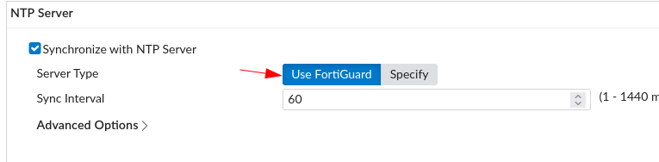
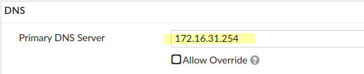
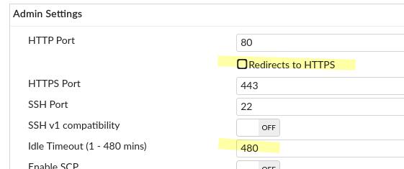

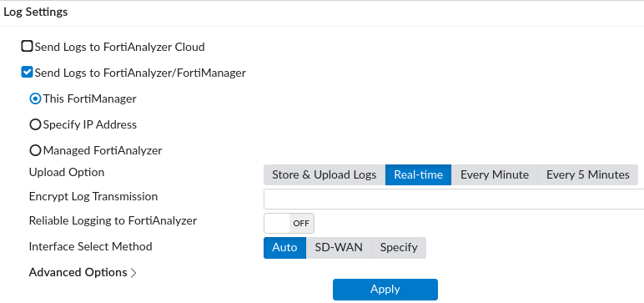

System templates cannot be assigned to groups. It’s FMG bug which complains the groups do not have meta-data.
Individual devices are therefore assigned to this template groups during on-boarding.

Pre-Run CLI Template
Models based off FGT-VM have a single interface.
Need to create a Jinja script Pre-Run CLI template which creates the 10 interfaces for our FGT-VM models.

{# EXAMPLE: Use this file as a Pre-Run CLI Template for FGT-VM Model Devices #}

{# Create physical interface from port1 to port10 #}
config system interface
{% for i in range(1,11) %}
edit "port{{i}}"
set vdom "root"
set type physical
next
{% endfor %}
end

{# Use this for successful onboarding, when your FGT is preconfigured (Low-Touch Provisioning) #}
config system admin
edit "admin"
set password fortinet
next
end

Create the “SETTINGS.DEVICES” Post-Run jinja template

Import the jinja templates
Import the CLI jinja templates.

* Jinja files in BRANCHES and DATACENTERS folders of PoC6
Select “routing.objects1.conf” or “routing.objects2.conf” depending on context:
* cross-region shortcut allowed => objects1.conf
* no cross-region shortcut => objects2.conf

* firewall.address from BOOTSTRAP PoC

Make “FMG_FORTIGATE_ID” a required Device meta-field.
Keep all other meta fields as Optional.

Create the template groups:

* Template groups for Branches

* Template groups for Datacenters

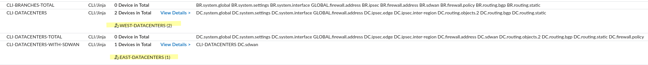

Assign the template groups to the corresponding device groups:

* CLI-DATACENTERS to device group “WEST-DATACENTERS”
* CLI-DATACENTERS-WITH-SDWAN to device group “EAST-DATACENTERS”
* “CLI-BRANCHES” to device groups “WEST-DATACENTERS” and “EAST-DATACENTERS”

Create an “SD-WAN-zones” template
Create empty zones “internet” and “overlay”.

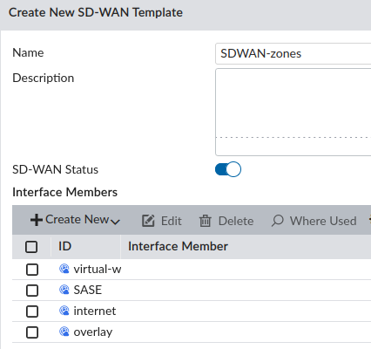
These zones are referenced in the SD-WAN default static routes.
So they are needed for the “routing.static” jinja template.

Provisioning WEST-DC-1
This device is a reference device which will be used to:
* create an SDWAN template from its SDWAN jinja file
* create a policy package from its fw-addr and fw-policy jinja files

Create a model device
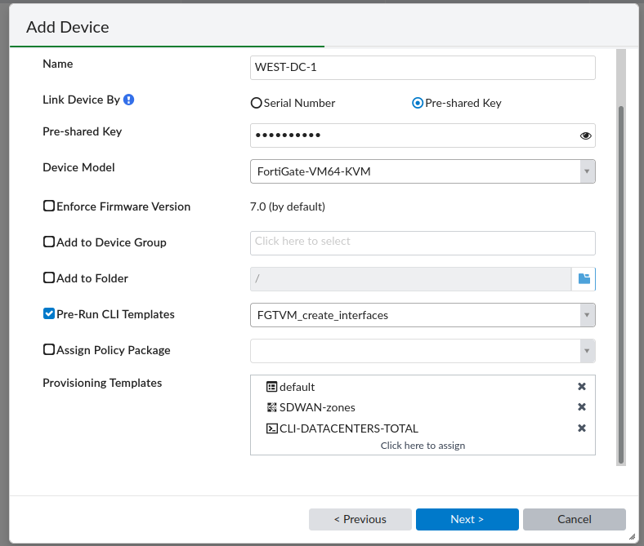
No device group is specified.
No PP is specified since the firewall addresses and policies are pushed by Jinja templates.

Fill meta-data and location
FMG_FORTIGATE_ID: FGT-W-DC1
dc_id: 1 will be used for the SD-WAN template to distinguish FGT-W-DC1 and FGT-W-DC2
location: Paris

Install config on model device
install device-db settings with “Quick Install (Device DB)”

Import policy-package from the device
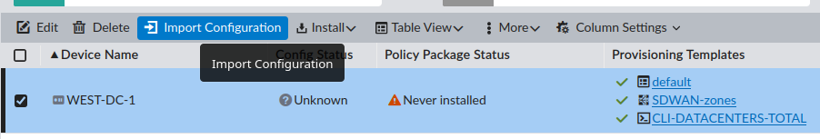
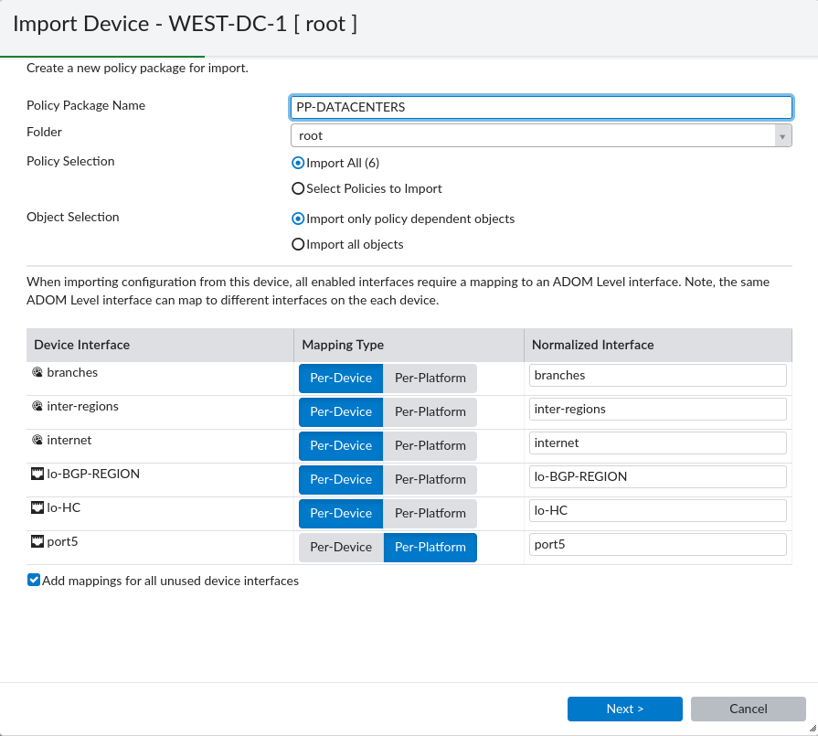
Go to the PP and change the “Installation Taget”
Remove “WEST-DC-1” and associate groups “WEST-DATACENTERS” and “EAST-DATACENTERS”

Import SD-WAN template from the device
Name= SDWAN-WEST-DATACENTERS
Assign this SDWAN template to the WEST-DATACENTERS device group
Edit the template to make it valid for both WEST-DC-1 and WEST-DC-2
Change:
100.64.11.254 to 100.64.$(dc_id)1.254 Internet_1
100.64.12.254 to 100.64.$(dc_id)2.254 Internet_2
W1E3_INET1 to W$(dc_id)E3_INET1 inter-region members AND “input-device” in rule 7
W1E3_INET2 to W$(dc_id)E3_INET2 inter-region members AND “input-device” in rule 8
W1E3_MPLS to W$(dc_id)E3_MPLS inter-region members AND “input-device” in rule 9

Rename some normalized interfaces

W1E3_INET1, W1E3_INET2 and W1E3_MPLS are used as “input-device” in sdwan rules 7,8,9
They must be normalized interfaces
We must make them generic name because they will be normalized for WEST-DC1 and WEST-DC2
Rename then WE_….

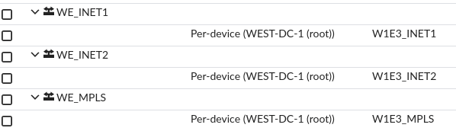
The interface name is automatically changed in the “input-device” of rules 7,8,9:

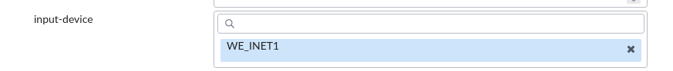

Change the provisioning templates assignment for this device
Remove “SDWAN-zones”
Remove “CLI-DATACENTERS-TOTAL”

Assign this device to group “WEST-DATACENTERS”
WEST-DC-1 gets assigned the SD-WAN template, the PP and the CLI template from its group:

Install Wizard Policy Package “PP-DATACENTERS”

On-board the real device (low-touch provisioning)

# exec central-mgmt register-device FMG-VM0A13000123 <psk-of-model-device>

Provisioning WEST-DC-2
SDWAN-WEST-DATACENTERS has manual sdwan rules with “input-device” referencing interfaces.
These interfaces must be normalized interfaces :-(
It complicates the on-boarding since these normalized interfaces must be created. And to do so, they must exists in the device-db. And to do so, we must create the overlay interfaces on the model device.

Simplest approach I found is to model this device with almost the same logic as WEST-DC-1.
Except that, here, the CLI group is “CLI-DATACENTERS” which only contains underlay, overlay and routing. It does not contain SDWAN and FW-POLICIES (unlike “CLI-DATACENTERS-TOTAL”).
SDWAN and FW-policies will be associated to this device after it is assigned to its group.

Create a model device

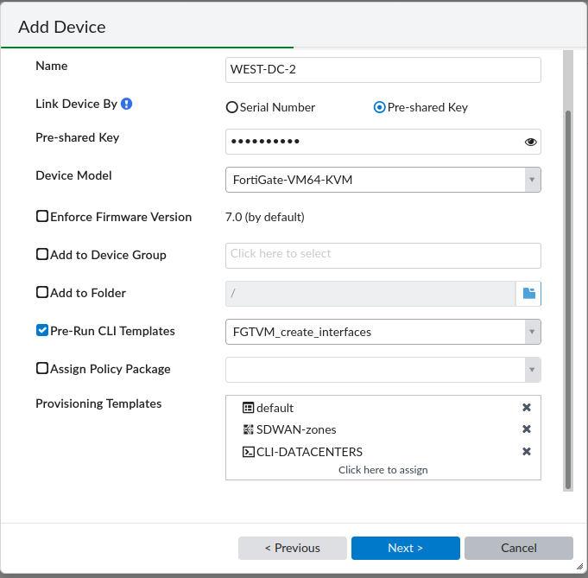

Fill meta-data and location
FMG_FORTIGATE_ID: FGT-W-DC2
dc_id: 2 will be used for the SD-WAN template to distinguish FGT-W-DC1 and FGT-W-DC2
location: Lyon

Install config on model device
install device-db settings with “Quick Install (Device DB)”

Normalize the interfaces used as “input-device” in SDWAN
EDGE_INET1, EDGE_INET2 and EDGE_MPLS are used as “input-device” in rules 1-6

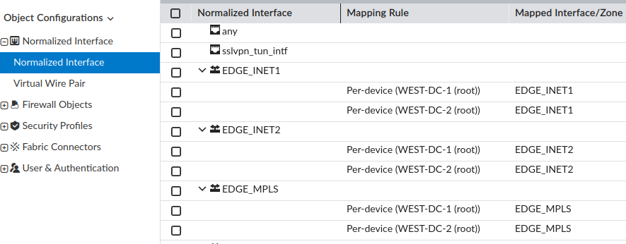
W2E3_INET1, W2E3_INET2, W2E3_MPLS are used as “input-device” in rules 7,8,9

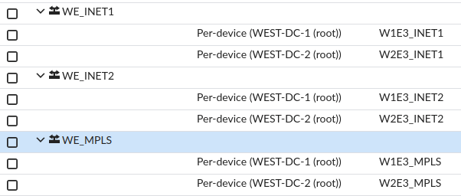

Assign this device to group “WEST-DATACENTERS”

Remove “SDWAN-zones” and “CLI-DATACENTERS” as provisioning templates

Assign this device to its group “WEST-DATACENTERS” so that it gets assigned its SD-WAN template, its PP and its CLI template.

Install Wizard Policy Package “PP-DATACENTERS”

On-board the real device (low-touch provisioning)

# exec central-mgmt register-device FMG-VM0A13000123 <psk-of-model-device>

Provisioning EAST-DC-3
EAST-DC-3 has more SD-WAN rules than WEST-DC-{1,2}
As a consequence, this device cannot be provisioned with a simple on-boarding method (like BR2 and BR3 for e.g.).
Since there is no other DC in EAST region, I will not create an SDWAN template for this device, I will rely on the jinja sdwan template.
This is to avoid the complexity of having to define normalized interfaces for all the interfaces listed as “input-device”
EDGE_INET1, EDGE_INET2 and EDGE_MPLS are used as “input-device”
W1E3_INET1, W1E3_INET2 and W1E3_MPLS are used as “input-device”
W2E3_INET1, W2E3_INET2 and W2E3_MPLS are used as “input-device”

Create a model device
EAST-DC-3

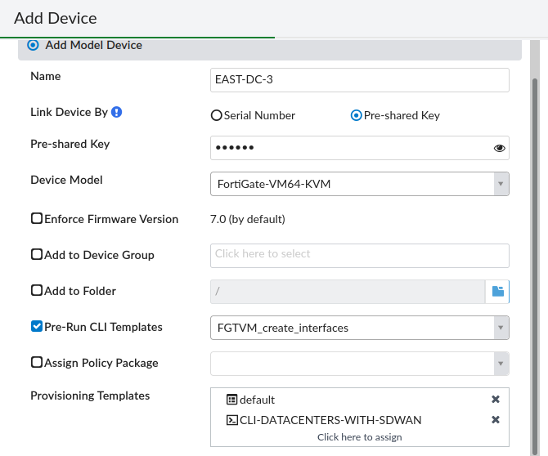

Fill meta-data and location
FMG_FORTIGATE_ID: FGT-E-DC3
dc_id: 3 Not sure it is actually needed since there is no other DC in this region
location: Prague

Install config on model device
install device-db settings with “Quick Install (Device DB)”

Assign this device to group “EAST-DATACENTERS”

Remove “CLI-DATACENTERS-WITH-SDWAN” as provisioning template
Assign this device to its group “EAST-DATACENTERS” so that it gets assigned its PP and its CLI template

Install Wizard Policy Package “PP-DATACENTERS”

On-board the real device (low-touch provisioning)

# exec central-mgmt register-device FMG-VM0A13000123 <psk-of-model-device>

Provisioning WEST-BRANCH-1
This device is a reference device which will be used to:
* create an SDWAN template from its SDWAN jinja file
* create a policy package from its fw-addr and fw-policy jinja files

Create a model device
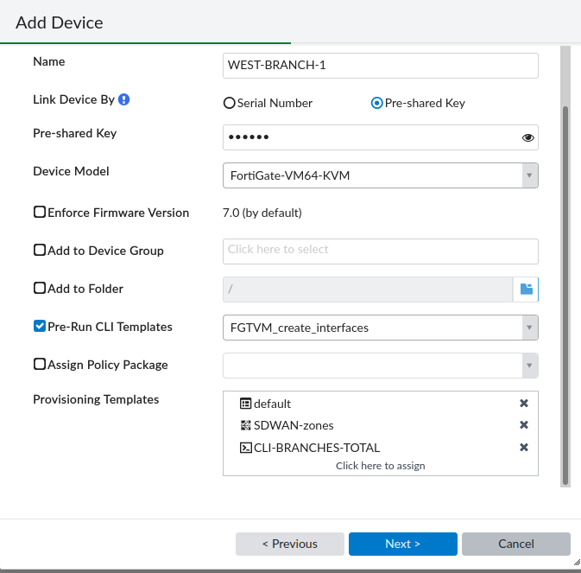

No device group is specified.
No PP is specified since the firewall addresses and policies are pushed by Jinja templates.

Fill meta-data and location
FMG_FORTIGATE_ID: FGT-W-BR1
branch_id: 1 will be used for the SD-WAN template to distinguish west/east branches
wan: 3 will be used for the underlay IP@ of the INET1/INET2 router
location: Bordeaux

Install config on model device
install device-db settings with “Quick Install (Device DB)”

Import policy-package from the device

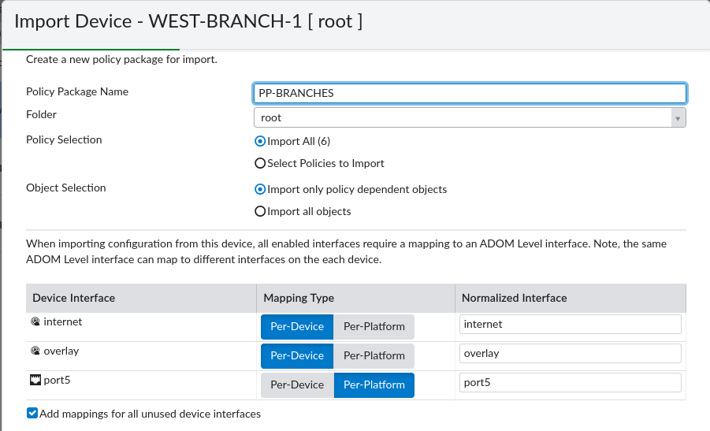

Go to the PP and change the “Installation Taget”
Remove “WEST-BRANCH-1” and associate groups “WEST-BRANCHES” and “EAST-BRANCHES”

Import SD-WAN template from the device
Name= SDWAN-BRANCHES (used by both West and East regions)

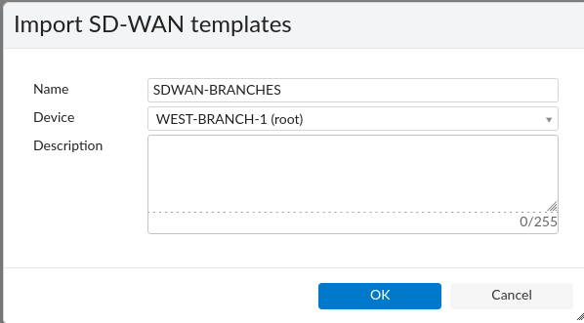

Assign this SDWAN template to the WEST-BRANCHES and EAST-BRANCHES device groups
Edit the template to make it valid for both WEST-BR-1/BR-1 and EAST-BR-3
Change:
100.64.31.254 to 100.64.$(dc_id)1.254 Internet_1
100.64.32.254 to 100.64.$(dc_id)2.254 Internet_2

Change the provisioning templates assignment for this device
Remove “SDWAN-zones” and “CLI-DATACENTERS-TOTAL”

Assign this device to group “WEST-BRANCHES”
WEST-DC-1 gets assigned the SD-WAN template, the PP and the CLI template from its group:

Install Wizard Policy Package “PP-BRANCHES”

On-board the real device (low-touch provisioning)
# exec central-mgmt register-device FMG-VM0A13000123 <psk-of-model-device>

Low-touch Provisioning of WEST-BRANCH-2 and EAST-BRANCH-3

Create a model device

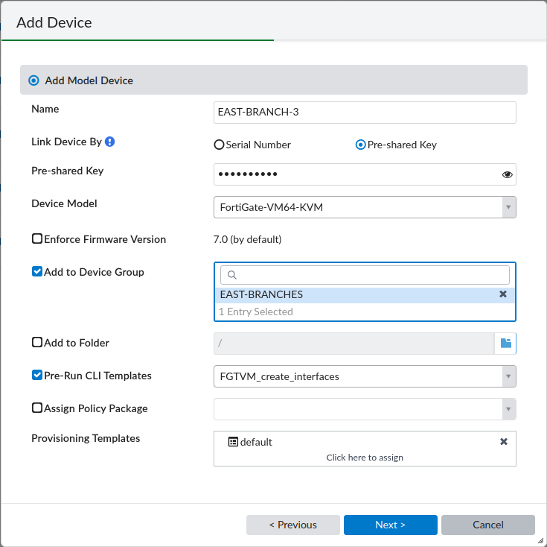
The provisioning templates (SDWAN-BRANCHES, CLI-BRANCHES) and the policy package (PP-BRANCHES) are inherited from the device group.
Only add the “system default” template which configured logging to FMG.

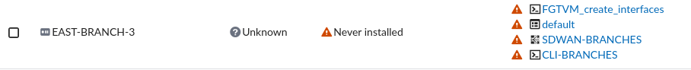

Fill meta-data and location

Edit the device:

* Fill the meta-data:

- WEST-BRANCH-2: FMG_FORTIGATE_ID: FGT-W-BR2
wan: 4
- EAST-BRANCH-3: FMG_FORTIGATE_ID: FGT-E-BR3
wan: 4

The ‘wan’ meta-field digit is used for the ‘gateway’ IP of the INET1/INET2 sd-wan members

* Enter a location: e.g., W-BR2= Sophia-Antipolis ; E-BR3 = Budapest

Install config on model device

I tried to install full config (device-db settings + PP) at once but it failed.

It works in a two steps process:
- 1st step: install device-db settings with “Quick Install (Device DB)”
- 2nd step: install PP

1st step: Install the settings with “Quick Install (Device DB)”

Check the device config: Underlay, Overlay, SD-WAN, Routing config is in the device DB.

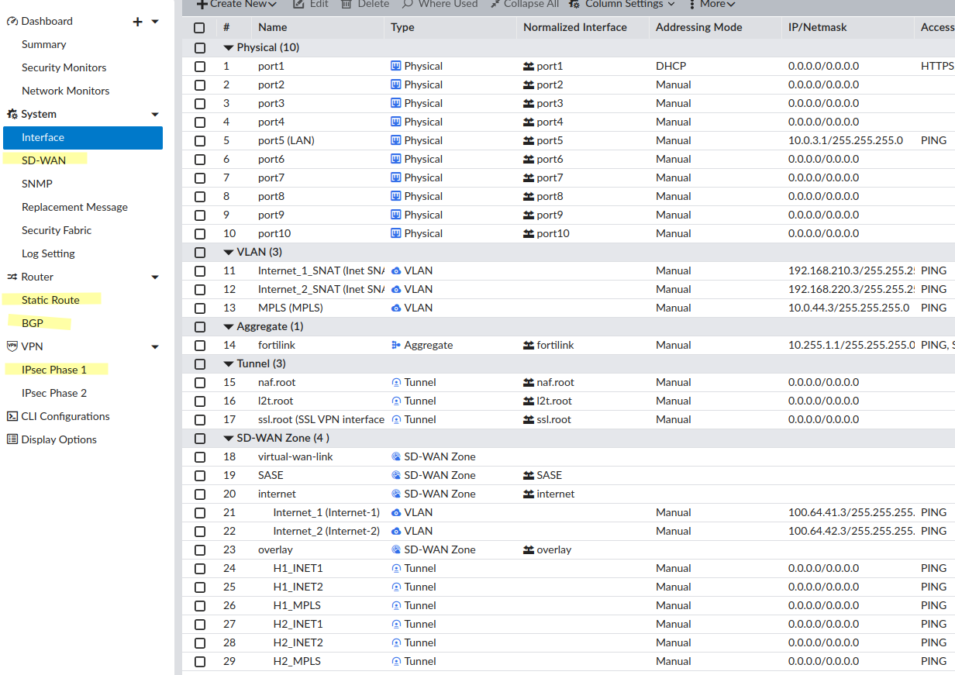
2nd step:
* In “policy & Objects”, create a dynamic mapping for “LAN” address: BR2= 10.0.2.0/24, BR3=10.0.3.0/24
* “Install Wizard” → “Install Policy Package & Device Settings” → choose “PP-BRANCHES”

Check that the policy were installed on model device:

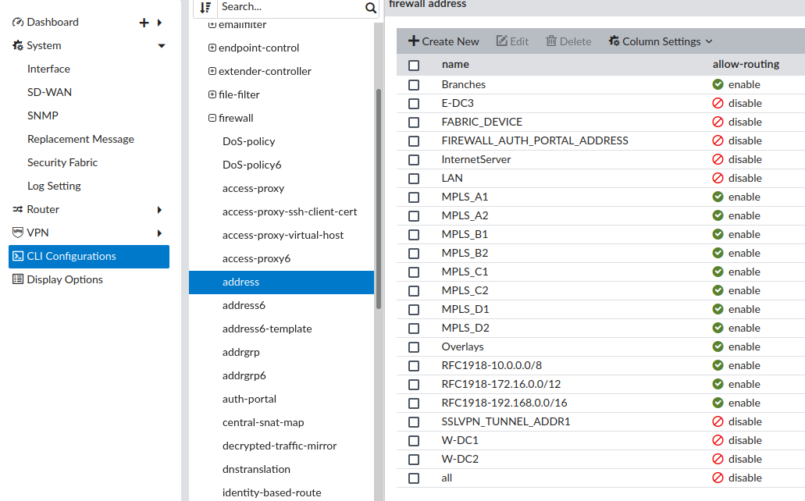

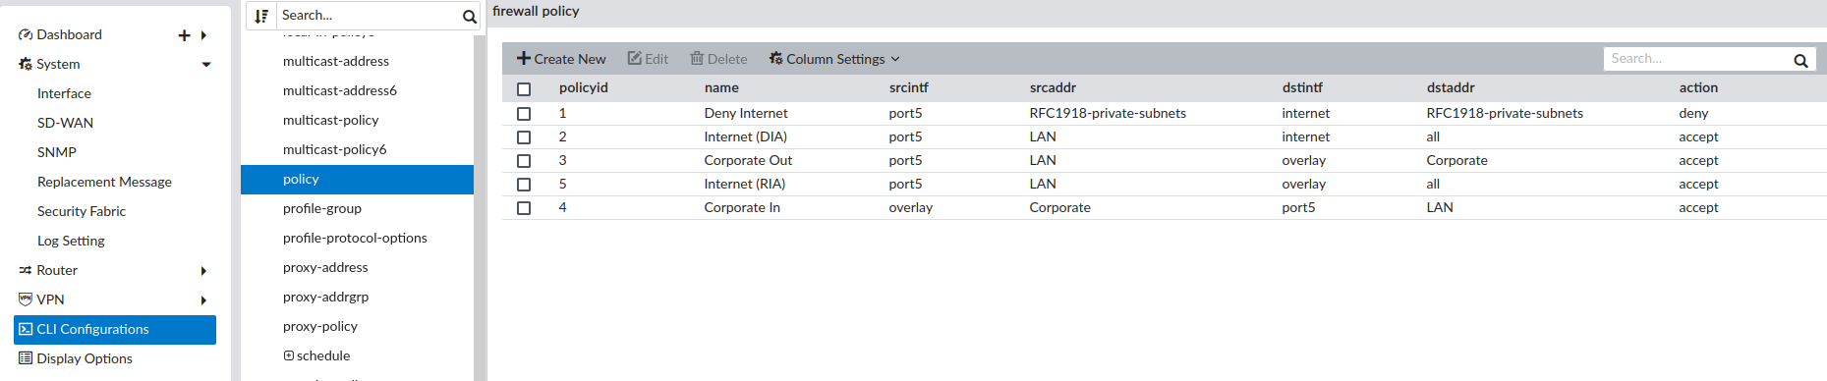

On-board the real device (low-touch provisioning)
# exec central-mgmt register-device FMG-VM0A13000123 <psk-of-model-device>

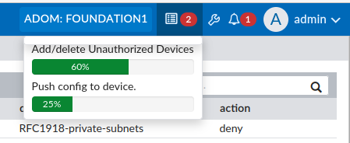

Final status
