LM358
Audio Amplifier
  - Single-supply non-inverting amplifier
Design and laboratory evaluation
AUTHORS | ACADEMIC CONTEXT
Shakeeb M.A (Shakeeb Aduham)  Achchuthai A | SLIIT, Faculty of Computing  IE2014 Circuit Theory  Year 2, Semester 1 | 2026
Two-person team project | Laboratory assessment: 7 October 2026

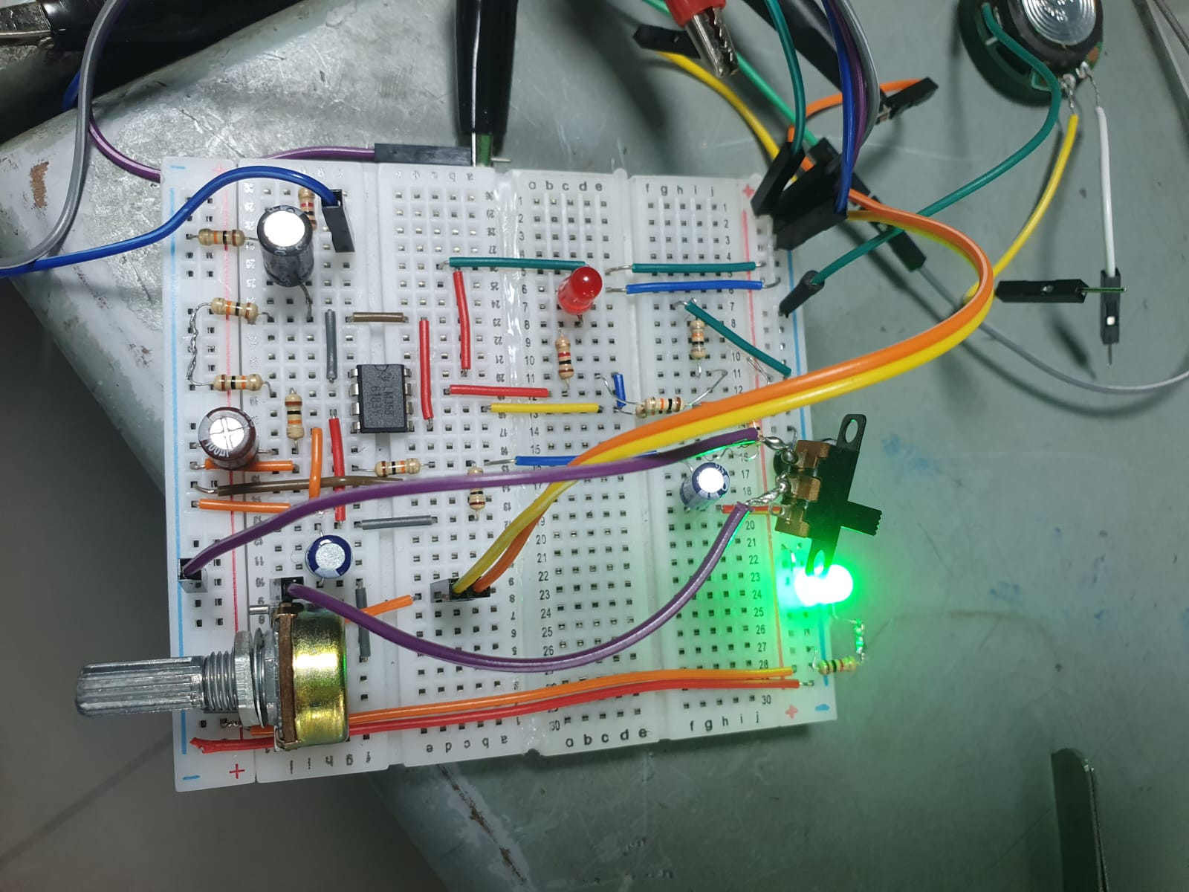
A breadboard prototype connecting op-amp feedback theory with practical waveform measurement.

Project summary
The team designed and built an LM358 non-inverting amplifier powered from a single 9 V supply, targeting a voltage gain of 3. Laboratory evidence demonstrates approximately 3× voltage amplification at 1 kHz and output clipping at a higher input amplitude. The circuit also includes volume control, a mute switch, a power LED, and an overload-indicator stage.
The prototype achieved the required voltage gain at 1 kHz. This report presents the circuit design, laboratory observations, unresolved test limitations, and proposed improvements.

Circuit architecture
The amplifier uses one half of the LM358 for non-inverting voltage amplification. The second half is configured as an overload comparator. A resistive divider establishes a nominal mid-supply bias, while coupling capacitors isolate the AC signal from the DC operating point.
DESIGN ITEM | VALUE / PURPOSE
Supply and bias | 9 V single supply; nominal bias 4.5 V
Gain-setting network | Rf = 20 kΩ (two 10 kΩ resistors); R1 = 10 kΩ
Mid-band gain | Av = 1 + Rf/R1 = 1 + 20/10 = 3 V/V
Acceptance range | 2.7 to 3.3 V/V (±10% of target)
Input control | 10 kΩ potentiometer; mute switch before the input coupling capacitor

Original circuit schematic
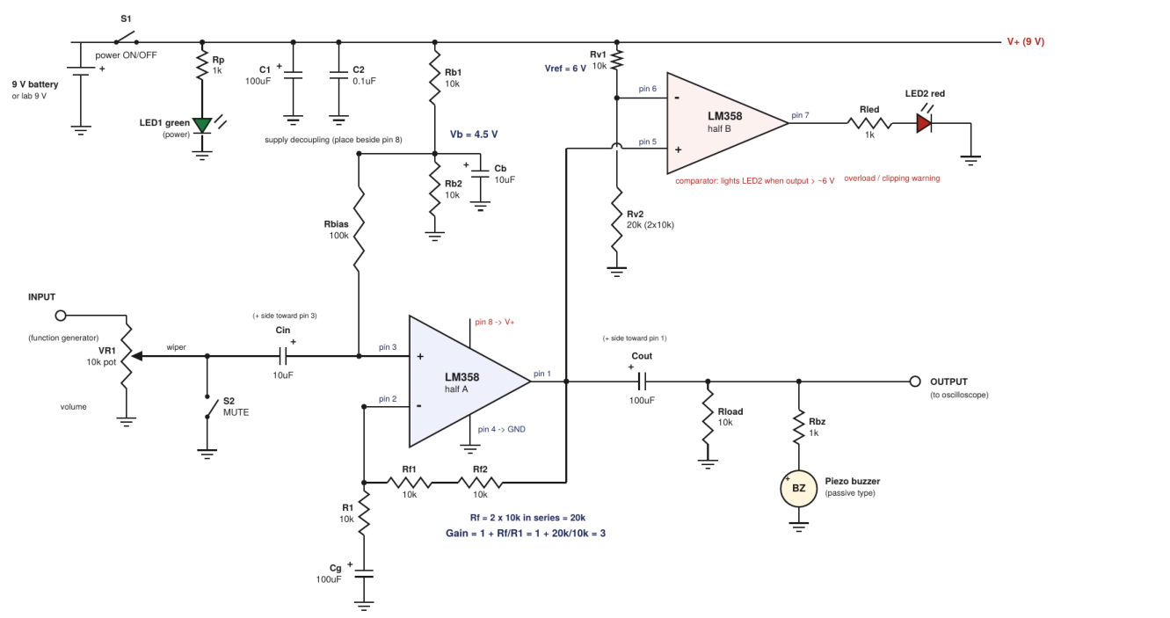
Figure 1. Schematic reproduced from the team report. It documents the intended design; it is not an independently verified reconstruction of every breadboard connection.

Calculated behavior
At full volume, a 0.5 Vpp input ideally produces 1.5 Vpp output in the linear region. With 5% gain-resistor tolerances, the calculated worst-case gain is approximately 2.81 to 3.21. These are design predictions, not additional measurements.

Components and test setup
COMPONENT / GROUP | SPECIFICATION | ROLE
U1 | LM358, DIP-8 | Amplifier and comparator
R1; Rf1, Rf2 | 10 kΩ; 2 × 10 kΩ | Gain network
Rb1, Rb2; Rbias | 2 × 10 kΩ; 100 kΩ | Bias divider and input bias
Rv1, Rv2 | 10 kΩ; 20 kΩ | Comparator reference divider
Rload; Rp, Rled, Rbz | 10 kΩ; 3 × 1 kΩ | Load and current limiting
VR1; S1, S2 | 10 kΩ potentiometer; switches | Volume, power and mute
Cin, Cb | 2 × 10 µF | Input coupling and bias filtering
Cg, Cout, C1 | 3 × 100 µF | Gain-leg/output coupling and supply filtering
C2 | 0.1 µF, shown in schematic | Fitting status not confirmed
LEDs; output transducer | Green/red LEDs; passive buzzer in design | Indicators and intended audible output

Construction
The prototype was assembled on a solderless breadboard. The amplifier, signal generator, oscilloscope, and supply share a common ground. The input is applied through the volume potentiometer, and the output is observed after the output coupling capacitor. The report records checking polarity, IC orientation, and wiring before power-up.

Laboratory instrumentation
Keysight DSOX1202A oscilloscope; Tektronix AFG1022 function generator; Tenma 72-7245 DC supply. The generator photograph shows a 1 kHz sine wave, 500 mVpp, zero offset, and High Z load setting. The supply photograph shows 9.0 V on the active channel.

Measurement approach
For the nominal gain test, the report specifies maximum volume and mute off. Input and output peak-to-peak voltages are compared using Av = Vout/Vin. A separate high-amplitude capture records clipping. The photographs do not document every probe, coupling, and load setting, so the reported operating points are kept distinct.

DC checks and troubleshooting
The original report contains the following DC readings. They are retained as reported observations, rather than treated as a fully consistent set of measurements made under one verified supply condition.
MEASUREMENT POINT | NOMINAL DESIGN | REPORTED READING
Supply, pin 8 | 9.0 V | 9.0 V laboratory; 9.8 V home battery
Ground, pin 4 | 0 V | 0.001 V
Bias-divider node | 4.5 V at 9 V supply | 3.69 V; marked as battery test
Non-inverting input, pin 3 | About 4.5 V | 4.462 V
Inverting input, pin 2 | About 4.5 V | 4.505 V
Amplifier output, pin 1 | About 4.5 V | 4.506 V
Comparator reference, pin 6 | 6.0 V at 9 V supply | 5.562 V
Comparator signal input, pin 5 | About 4.5 V | 4.505 V
Comparator output, pin 7 | Low with no signal | 0.009 V
AC-coupled output DC | About 0 V | Not recorded

Interpretation and unresolved differences
The recorded 3.69 V bias-divider reading does not match the intended half-supply value, particularly for the reported 9.8 V battery condition. The 5.562 V comparator-reference reading is also below the nominal 6.0 V design value. These differences require repeat measurements with the supply and measurement points documented; they should not be silently corrected or presented as design agreement.

Troubleshooting recorded by the team
The red LED initially illuminated with no input signal. The report describes checking the amplifier and comparator wiring and correcting the gain-leg/feedback connections. After correction, amplifier pins 1, 2, and 3 returned to approximately 4.5 V and the red LED turned off. This documents a successful wiring correction, but does not validate the overload threshold.
The powered-prototype photograph independently confirms the green LED illuminating. The DC values above are taken from the report; the supplied standalone photos do not independently verify each reading.

Voltage gain at 1 kHz
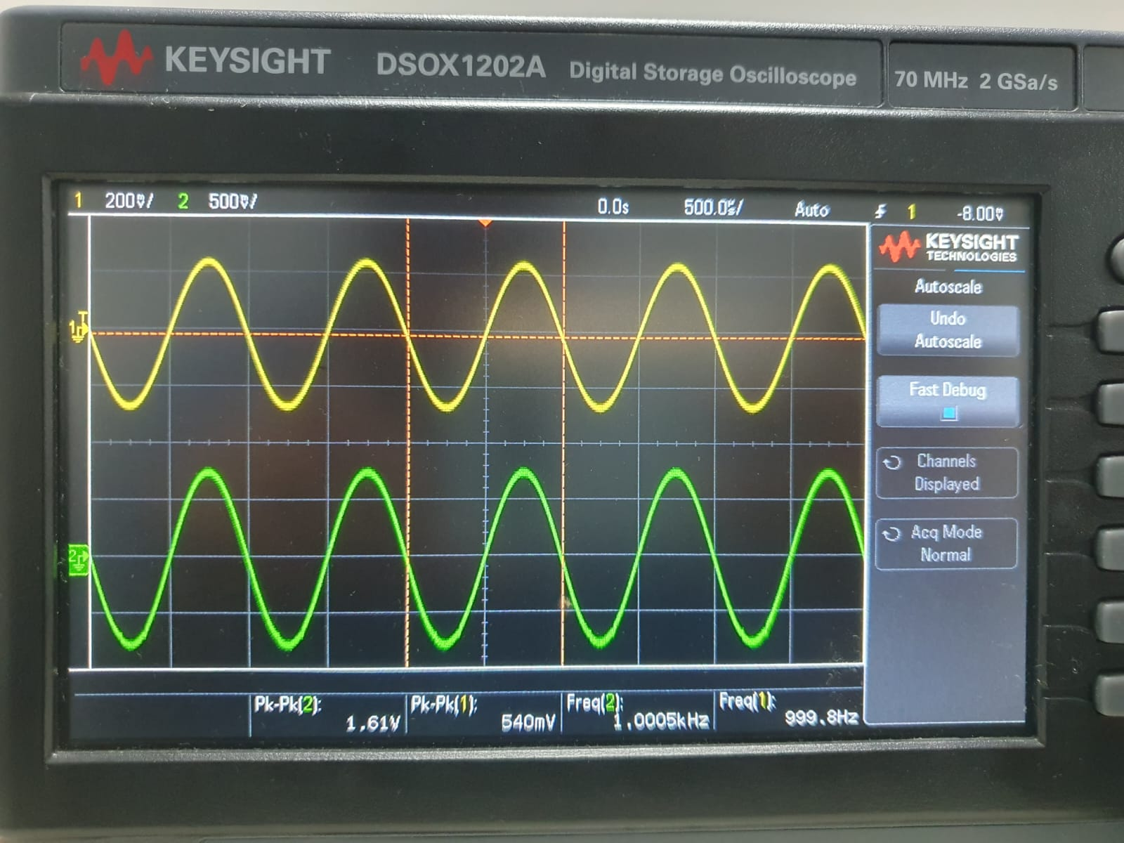
Figure 2. Supplied oscilloscope photograph: CH1 input and CH2 output, approximately in phase.
SOURCE | INPUT / OUTPUT | GAIN / TARGET ERROR
Standalone scope photograph | 0.540 Vpp / 1.61 Vpp | 2.9815 V/V / 0.62%
Separate report operating point | 0.504 Vpp / 1.54 Vpp | 3.0556 V/V / 1.85%

Calculation
Av = 1.61 / 0.540 = 2.9815 V/V
Target-relative error = |3 - Av| / 3 × 100 = 0.62%
The standalone photograph displays 999.8 Hz on CH1 and 1.0005 kHz on CH2. Both traces are sinusoidal and approximately in phase, consistent with non-inverting amplification. Both documented gain values fall within the assignment range of 2.7 to 3.3.
The report operating point and the standalone photograph have different readings and are treated as separate observations. No numerical total harmonic distortion or measurement uncertainty was recorded. The clean waveform is visual evidence, not a quantified distortion specification.

Clipping and feature checks
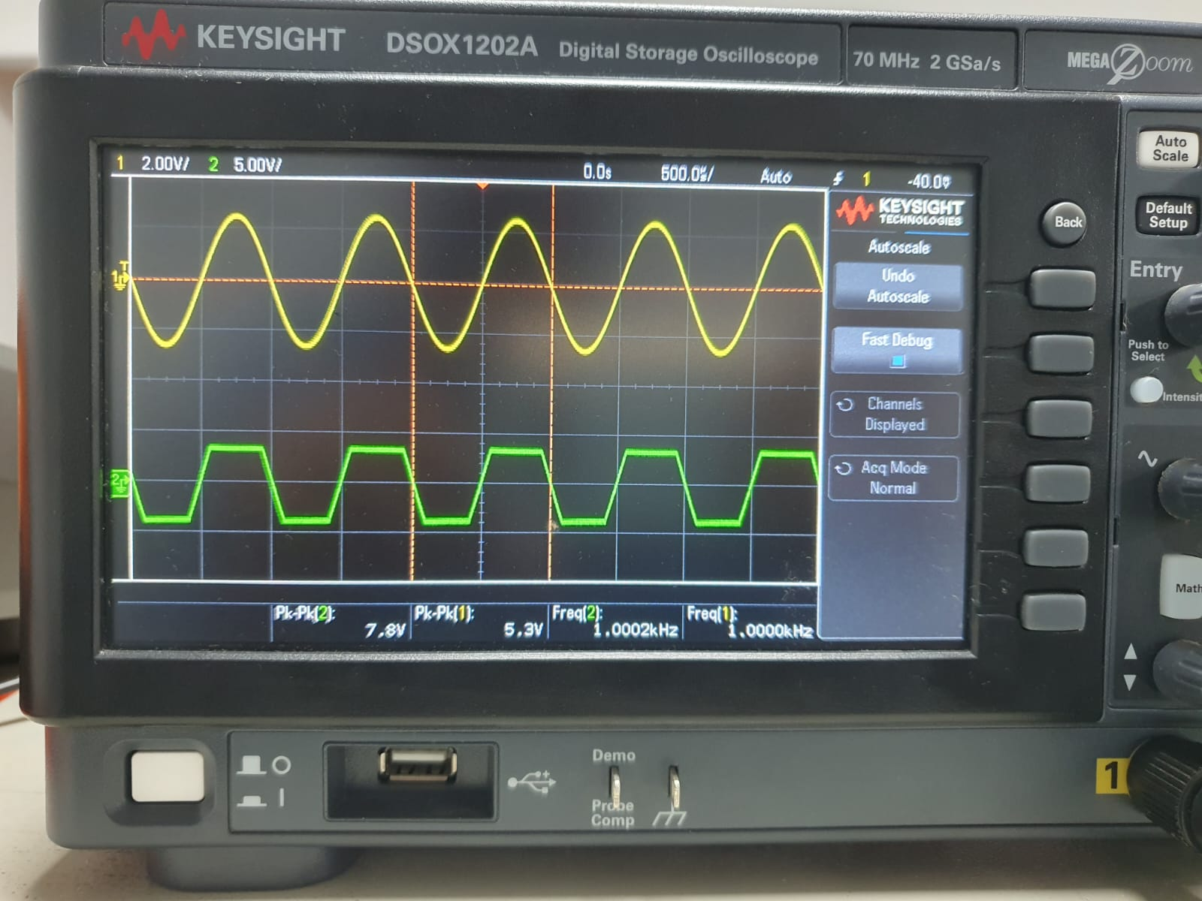
Figure 3. A separate capture shows output clipping at a larger input amplitude.
The scope displays an input of 5.3 Vpp at 1.0000 kHz and an output of 7.8 Vpp at 1.0002 kHz. The output has visibly flattened peaks. This confirms clipping at that operating point; it does not establish the exact onset of clipping or the linear gain at high amplitude.
FEATURE | EVIDENCE / STATUS
Volume control | Implemented; the report describes output amplitude varying with the control.
Power LED | Green LED visibly illuminated in the powered-prototype photograph.
Mute switch | Included in the design; quantitative output attenuation was not recorded.
Overload indicator | Implemented, but switching threshold and behavior during clipping were not fully verified.
Audible output | The report states that the passive buzzer produced no audible sound. A speaker is visible in the supplied photos, but successful operation is not established.
Frequency response | No complete measured sweep or experimentally confirmed -3 dB bandwidth is available.

Overload reference is not clipping onset
The intended comparator reference is 6.0 V DC. Relative to a nominal 4.5 V bias, its crossing corresponds to a positive signal peak of 1.5 V (3 Vpp for a centered sine wave). That is a calculated indicator threshold, not a measured amplifier clipping voltage. The recorded DC-reference discrepancy further limits any threshold claim.

Discussion and conclusion

What the evidence establishes
The team built an educational single-supply voltage-amplifier prototype that achieved approximately 3× gain at 1 kHz. The measured gain agrees with the design target within the specified tolerance, and the observed phase relationship is consistent with the non-inverting configuration. A separate photograph demonstrates clipping under a larger input.

Limits of the evaluation
Estimated input-sweep and frequency-response entries from the original report are not reproduced as measured datasets. The available evidence does not establish a full audio-band response, an exact clipping threshold, verified overload indication, or a successful loudspeaker output stage. The DC bias and reference discrepancies also remain unresolved.

Sources of variation
Possible contributors to differences between calculated and observed behavior include component tolerances, breadboard connections, supply variation, potentiometer position, instrument settings, and loading. The available records are insufficient to assign a numerical contribution to any one factor.

Recommended next measurements
1. Repeat the DC checks under a documented 9.0 V supply and resolve the bias/reference discrepancies.
2. Sweep input amplitude in small steps and record clipping onset alongside red-LED behavior.
3. Record gain and phase across frequency with fixed amplitude and load.
4. Measure mute attenuation and investigate the audible-output connection.
5. After validation, transfer the circuit to soldered construction for improved connection reliability.

Conclusion
This two-person project demonstrated the practical design and testing of an LM358 non-inverting amplifier. Its strongest result is verified gain near the target of 3 at 1 kHz. The work also provided experience in troubleshooting and in distinguishing theoretical expectations from experimental evidence. Further tests are required before claiming complete audio performance.

Sources and attribution
Primary sources: the team laboratory report, Design and Build Your Own Audio Amplifier, assessed 7 October 2026; and six supplied prototype/instrument photographs. The original report cites the IE2014 practical-assessment brief; that brief was not supplied separately.
Technical background listed in the original report: Texas Instruments, LM358 Industry-Standard Dual Operational Amplifiers datasheet; and Application Design Guidelines for LM324 and LM358 Devices. This edition does not rely on unverified bandwidth or slew-rate figures as experimental results.
Joint project credit: Shakeeb M.A (Shakeeb Aduham) and Achchuthai A. Individual task ownership is not specified in the source report.

